Additional information

- Heat map and Ingenuity Pathway Analysis. Using microarray heat map (left) and ingenuity pathway analysis (IPA, right), differential gene expression between MCF-7 cells, MCF-7 o/e Snail cells and MCF-7 o/e Snail bone metastasis tissue demonstrated that ERα played a central role during bone metastasis process.
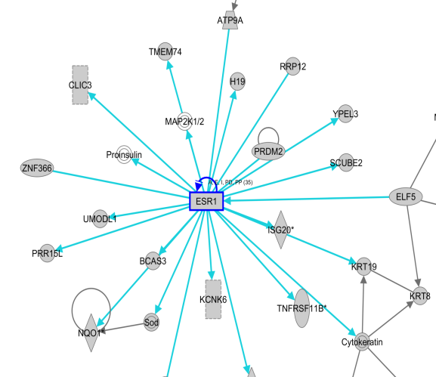
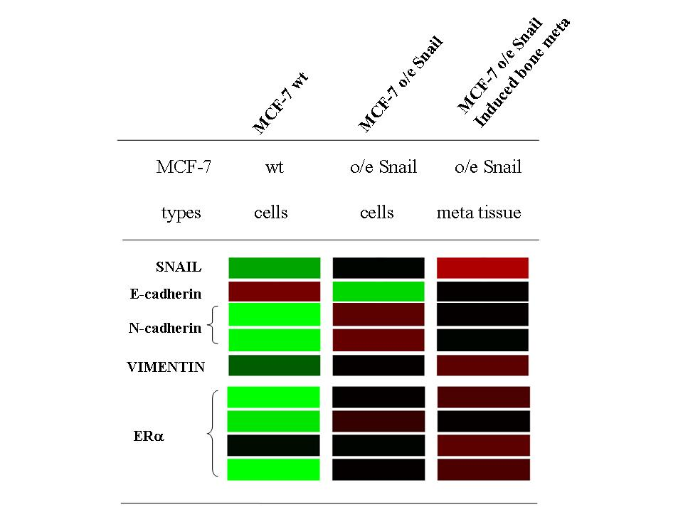
- Ingenuity Pathway Analysis. Using ingenuity pathway analysis (IPA), differential gene expression between MCF-7 cells, MCF-7 o/e Snail cells and MCF-7 o/e Snail bone metastasis tissue demonstrated that ERα has direct interaction with Src signaling pathway during bone metastasis process.

