HLA alleles modulate EBV viral load in Multiple Sclerosis

Simone Agostini¹, Roberta Mancuso¹, Franca R. Guerini¹, Sandra D’Alfonso², Cristina Agliardi¹, Ambra Hernis¹, Milena Zanzottera¹, Nadia Barizzone², Maurizio A. Leone³, Domenico Caputo¹, Marco Rovaris¹, Mario Clerici^{1,4}.

¹Don C. Gnocchi Foundation IRCCS – ONLUS, Piazzale Morandi 3, 20121, Milano, Italy
²Department of Health Sciences, University of Eastern Piedmont, Novara, Italy
³IRCCS Casa Sollievo della Sofferenza, San Giovanni Rotondo, Foggia, Italy
⁴Department of Pathophysiology and Transplantation, University of Milan, Via Fratelli Cervi 93, 20090, Milano, Italy

Additional file

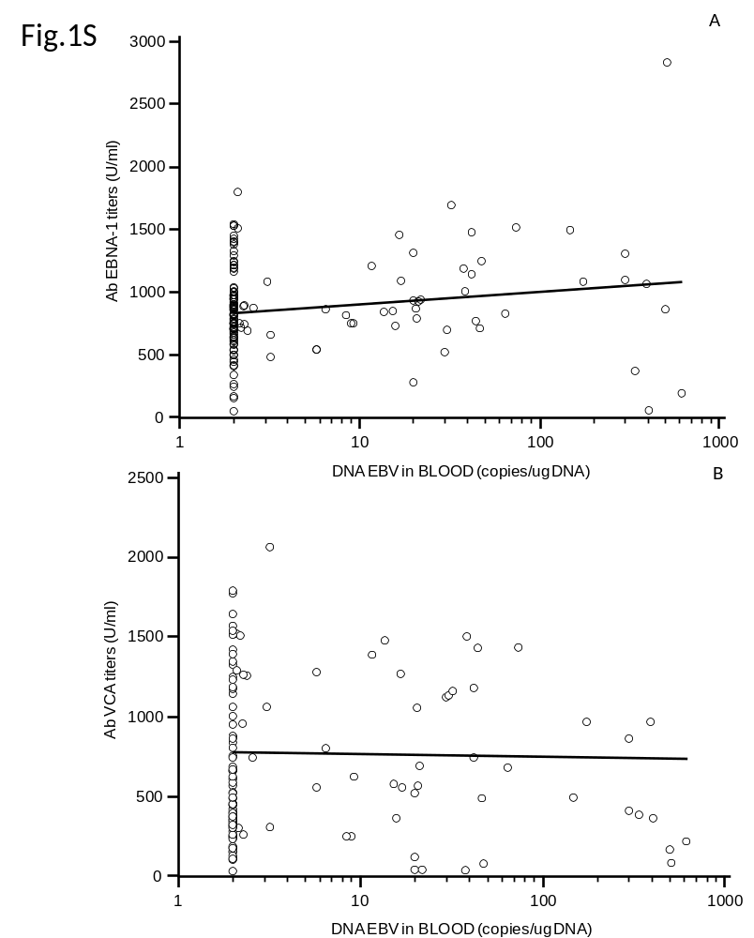

Figure 1S: Correlation between DNA EBV viral load and EBV Ab titers in study population. Correlation between DNA EBV viral load and Ab EBNA-1 titers (panel A) or Ab VCA titers (panel B) in study population.

