FGFR1 expression defines clinically distinct subtypes in pancreatic cancer
Farhan Haq^{*1}, You-Na Sung*², Inkeun Park³, Mahmood Akhtar Kayani¹, Faiza Yousuf¹, Seung-Mo Hong^{2#}, Sung-Min Ahn^{3,4#}

¹Department of Biosciences, COMSATS University, Islamabad, Pakistan
²Department of Pathology, Asan Medical Center, University of Ulsan College of Medicine, Seoul, Korea
³Division of Oncology, Department of Internal Medicine, Gachon University Gil Hospital, Incheon, South Korea
⁴Department of Genome Medicine and Science, College of Medicine, Gachon University, Seongnam, South Korea

*These authors contributed equally to the study
#Correspondence to:

Sung-Min Ahn, M.D., PhD

Div. of Oncology, Dept. of Internal Medicine
Dept. of Genome Medicine and Science
Gachon Institute of Genome Medicine and Science
Gachon University Gil Medical Center
smahn@gachon.ac.kr/ ahnsungmin@gmail.com
032-460-2177 / 010-3648-7437

Seung-Mo Hong M.D., PhD
Department of Pathology,
Asan Medical Center,
University of Ulsan College of Medicine,
Olympic-Ro 43Gil 88, Songpa-Gu, Seoul,
smhong28@gmail.com
82-2-3010-4558

Additional Material
Figure S1. Over workflow of the study.
Figure S2: LogR expression values of FGFR pathway genes in cohort 1
Figure S3: LogR expression values of FGFR pathway genes in cohort 2
Figure S4: Expression and Kaplan Meier Analysis of FGFR pathway genes in cohort 2. A) The frequency of overexpression of FGFR1, KLB, FGF19, FGFR4 and FGF21 according z-score is shown. Only FGFR1 overexpression was associated with better overall (B) and disease-free survival (C) of pancreatic cancer patients.
Table S1: Clinicopathological features of 65 pancreatic cancer patients of cohort 1

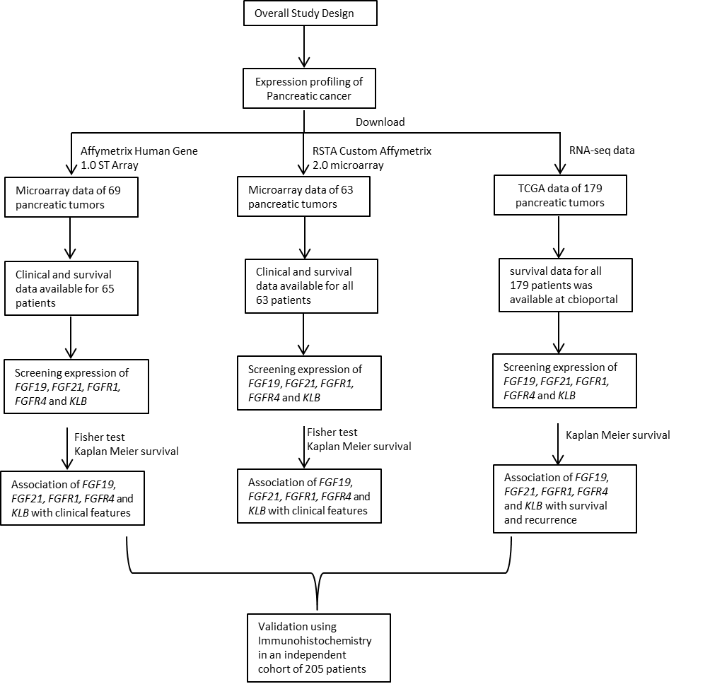

Figure S1

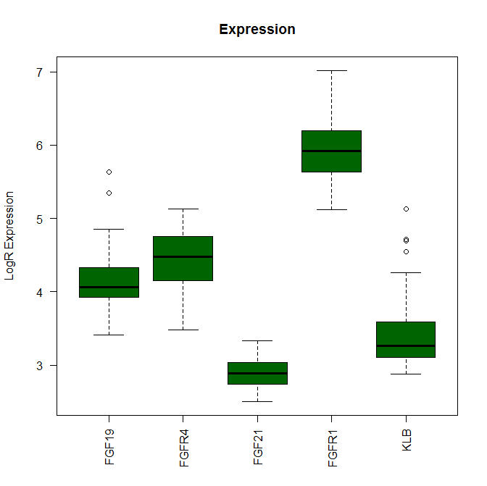
Figure S2
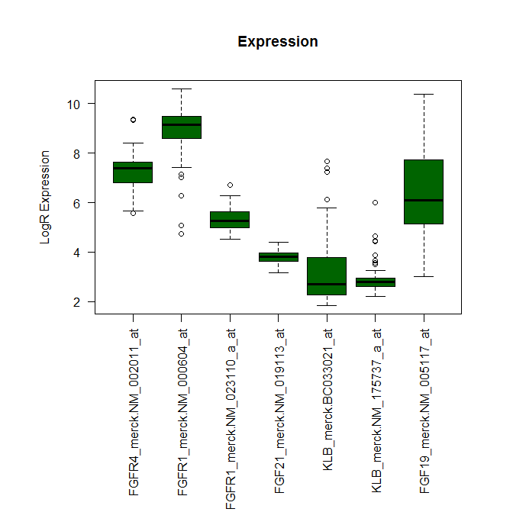

Figure S3

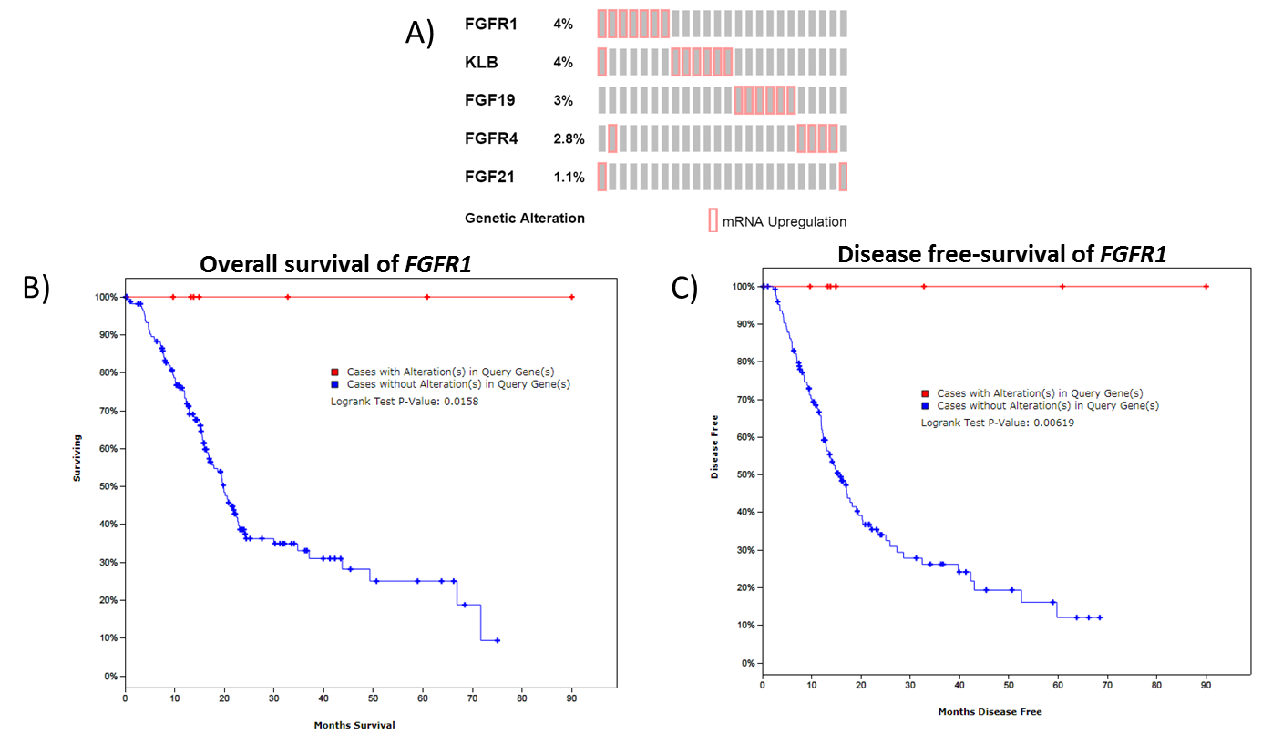
Figure S4
Table S1
Total patients | 65
Tumor stage
Stage 1 | 4 (6.15%)
Stage 2 | 45 (69.23%)
Stage 3 | 10 (15.38%)
Stage 4 | 6 (9.23%)
Tumor grade
Grade 1 | 2 (3.07%)
Grade 2 | 32 (49.23%)
Grade 3 | 29 (44.61%)
Grade 4 | 1 (1.53%)
NA | 1 (1.53%)
Mortality status
Dead | 49 (75.38%)
Alive | 16 (24.62)

