

The ARRIVE Guidelines Checklist
Animal Research: Reporting In Vivo Experiments
Carol Kilkenny¹, William J Browne², Innes C Cuthill³, Michael Emerson⁴ and Douglas G Altman⁵
¹The National Centre for the Replacement, Refinement and Reduction of Animals in Research, London, UK, ²School of Veterinary Science, University of Bristol, Bristol, UK, ³School of Biological Sciences, University of Bristol, Bristol, UK, ⁴National Heart and Lung Institute, Imperial College London, UK, ⁵Centre for Statistics in Medicine, University of Oxford, Oxford, UK.

 | ITEM | RECOMMENDATION |  | Section/  Paragraph
 |  |  | Title
 |  |  | Abstract
INTRODUCTION
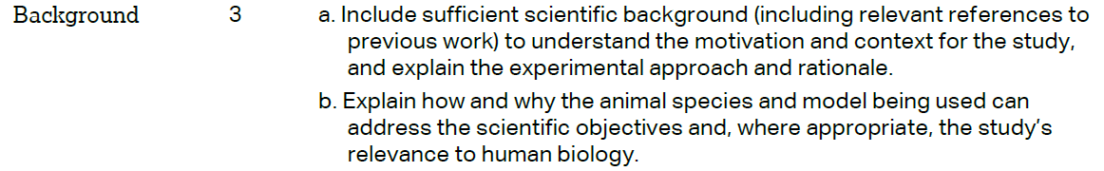 |  |  | Paragraphs  1-3  Paragraphs  2-3
 |  |  | Paragraph 3
METHODS
 |  |  | Paragraph 1
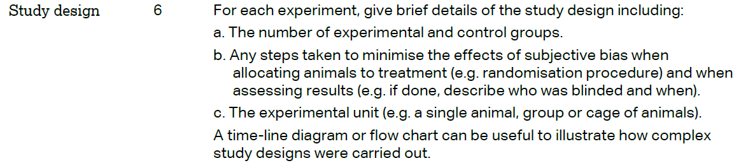 |  |  | Paragraphs 2, 3, 4 + Fig. 5  Not appplicable  Paragraph 1
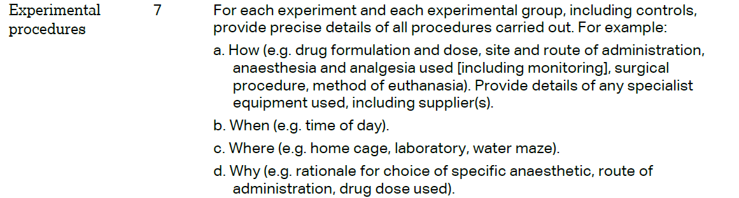 |  |  | Paragraphs  1-7
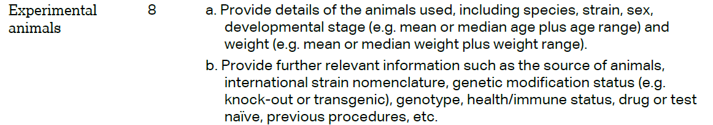 |  |  | Paragraphs  1-4
The ARRIVE guidelines. Originally published in PLoS Biology, June 2010¹
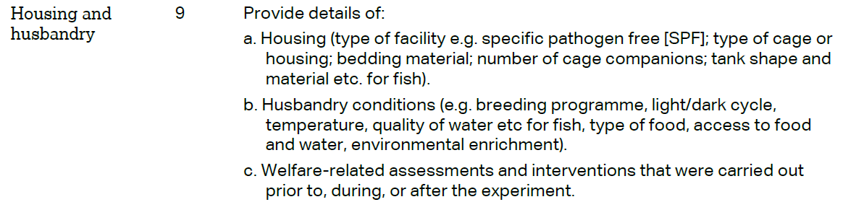 | Paragraph 1
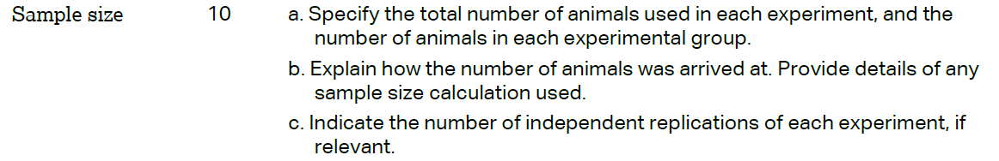 | Paragraphs 1-4 + Fig. 5  + Additional file 2 (Table S1 and figure S1)
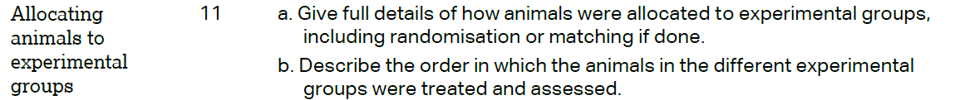 | Not applicable
 | Paragraphs 3-7
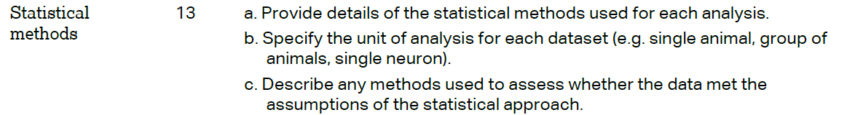 | Paragraph 8
RESULTS
 | Not applicable
 | Table1, figure 5, Additional file 2 (figure S1)
Paragraphs 1-7
Figures 1-5
 | Not applicable
DISCUSSION
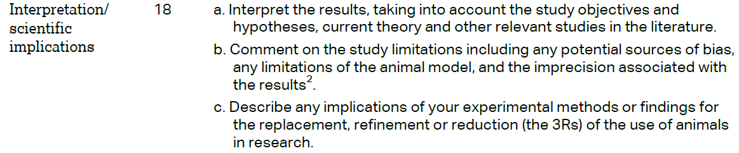 | Paragraphs 3-5  Paragraphs 2-4  Paragraph 4
 | Paragraphs 1, 2, 4, 6
 | Funding sources



