Origin | Species | Cell lines | Source
Long bones osteosarcoma | Mouse | MOS-J | Jackson Laboratoy®
Long bones osteosarcoma | Mouse | POS-1 | Jackson Laboratoy®
Long bones osteosarcoma | Mouse | K7-M2 | ATCC® CRL-2836™
Long bones osteosarcoma | Human | HOS-1544 | ATCC® CRL-1544™
Long bones osteosarcoma | Human | HOS-1547 | ATCC® CRL-1547™
Long bones osteosarcoma | Human | MG-63 | ATCC® CRL-1427™
Long bones osteosarcoma | Human | SaOS-2 | ATCC® HTB-85™

Table S1. Murine and human osteosarcoma cell lines used for the development of syngenic and xenogenic JOS animal models.

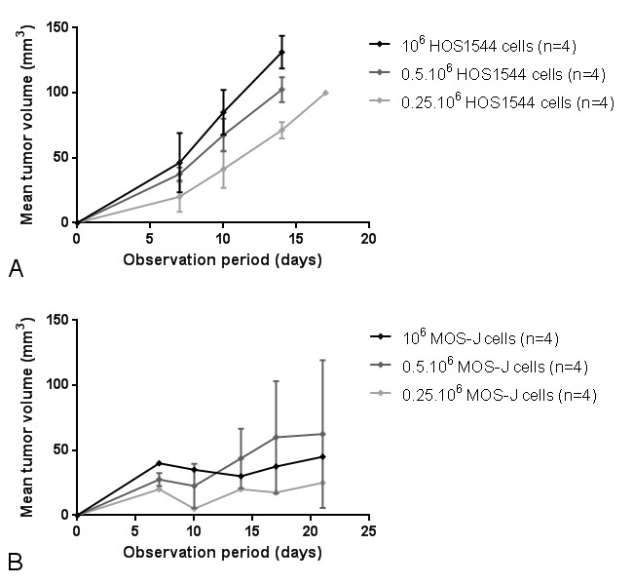
Figure S1. Mean mandibular tumor volume over time, as a function of tumor cell number injected in the xenogenic HOS1544 (A) or the syngenic MOS-J (B) models in NMRI-nude or C57Bl/6 mice respectively.

