Additional Tables:

S1. Total Nucleated Cells (TNC) and total monocytes from apheresis bag and RO fraction enriched monocytes
Donor # | Apheresis Bag |  | Elutriated RO fraction
Donor # | TNC | Total monocytes | TNC | Total monocytes
1 | 6.17E+09 | 2.47E+09 | 1.41E+09 | 1.27E+09
2 | 6.72E+09 | 2.08E+09 | 1.55E+09 | 1.38E+09
3 | 7.25E+09 | 6.52E+08 | 1.67E+09 | 1.14E+09
4 | 1.32E+10 | 3.29E+09 | 3.03E+09 | 2.42E+09

S2. Percentages and total number of cells from the elutriation fraction from Figures 1B and 1C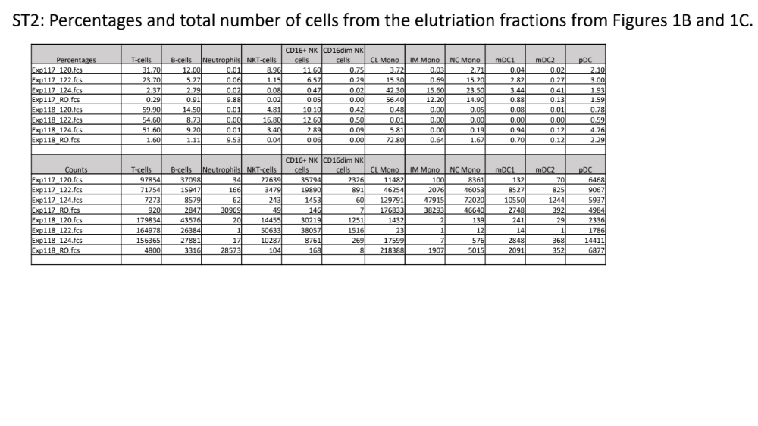
S3. Supplemented monocytes prior to overnight storage (day 0)
Donor # | Volume (mL) | Cell concentration/mL | Total Nucleated Cells | % viability | % Viable monocytes (FACs)
1 | 202 | 8.47E+06 | 1.71E+09 | 99 | 83.7
2 | 201 | 7.51E+06 | 1.51E+09 | 99 | 76.3
3 | 210 | 7.41E+06 | 1.56E+09 | 97 | 67.0
4 | 298 | 1.03E+07 | 3.07E+09 | 99 | 75.1
S4. Stored bag cell viability and purity (day 1)
Donor # | Volume (mL) | Cell concentration/mL | Total Nucleated Cells | % viability | % Viable monocytes (FACs)
1 | 202 | 8.34E+06 | 1.68E+09 | 97 | 83.1
2 | 201 | 7.17E+06 | 1.44E+09 | 99 | 81.5
3 | 209 | 6.90E+06 | 1.44E+09 | 98 | 65.6
4 | 296 | 1.00E+07 | 2.96E+09 | 95 | 74.8
S5. Cell recovery after overnight storage
Donor # | Cell recovery
1 | 98%
2 | 95%
3 | 92%
4 | 96%

S6. Final product safety assays
Donor | FN bacterial sterility | FN fungal sterility | Mycoplasma PCR | Endotoxin
1 | No growth | No growth of fungus | Negative | NA
2 | No growth | No growth of fungus | Negative | <5 EU/mL
3 | No growth | No growth of fungus | Negative | <5 EU/mL
4 | No growth | No growth of fungus | Negative | <5 EU/mL

S7: Cryopreserved cell recovery
Sample | TNC |  |  | CD14+/CD16+
Sample | Pre Thaw | Post Thaw | Recovery | Pre Thaw | Post Thaw | Recovery
1 | 3.50E+08 | 3.50E+08 | 100.0% | 2.85E+08 | 2.94E+08 | 103.3%
2 | 4.22E+08 | 3.97E+08 | 94.1% | 3.16E+08 | 3.12E+08 | 98.6%
3 | 3.33E+08 | 2.93E+08 | 88.0% | 2.60E+08 | 2.37E+08 | 91.3%

S8: Frequency of CD14/CD16 monocytes

Sample | Fresh sample |  |  | Cryo sample
Sample | Bag | SM | FN | Day 1 | FN
1 | 15.30% | 81.40% | 79.10% | 84.10% | 87.60%
2 | 14.00% | 74.80% | 79.10% | 78.40% | 74.80%
3 | 43.50% | 78.10% | 76.80% | 81.00% | 80.60%

S9: Absolute cell number and recovery of CD14/CD16 monocytes, day 1 through FN

Sample | Fresh sample |  |  | Cryo sample
Sample | Day 1 | FN | Recovery | Day 1 | FN | Recovery
1 | 7.50E+07 | 7.55E+07 | 100.67% | 2.45E+08 | 2.25E+08 | 91.84%
2 | 2.16E+08 | 2.20E+08 | 101.85% | 2.80E+08 | 2.43E+08 | 86.82%
3 | 7.50E+07 | 7.03E+07 | 93.73 | 2.61E+08 | 2.36E+08 | 90.34%

S10: Functional assay (% Killing)

Sample | Fresh sample | Cryo sample
1 | 94.1% | 95.8%
2 | 96.1% | 94.7%
3 | 95.7% | 95.3%

S11: Materials used in development of the final product
