Supporting information for
Spray drying OZ439 nanoparticles to form stable,
water-dispersible powders for oral malaria therapy
Kurt D. Ristroph¹, Jie Feng¹, Simon A. McManus¹, Yingyue Zhang¹, Kai Gong^{2,3}, Hanu Ramachandruni⁴, Claire E. White^{2,3}, Robert K. Prud’homme¹
¹Department of Chemical and Biological Engineering, ²Department of Civil and Environmental Engineering, ³Andlinger Center for Energy and the Environment, Princeton University, Princeton, New Jersey 08854, United States.
⁴Medicines for Malaria Venture, Route de Pré-Bois 20, 1215 Meyrin, Switzerland
Author e-mails, respectively: ristroph@princeton.edu, jiefeng@princeton.edu, smcmanus@princeton.edu, yingyuez@princeton.edu, kaig@princeton.edu, ramachandrunih@mmv.org, whitece@princeton.edu, prudhomm@princeton.edu

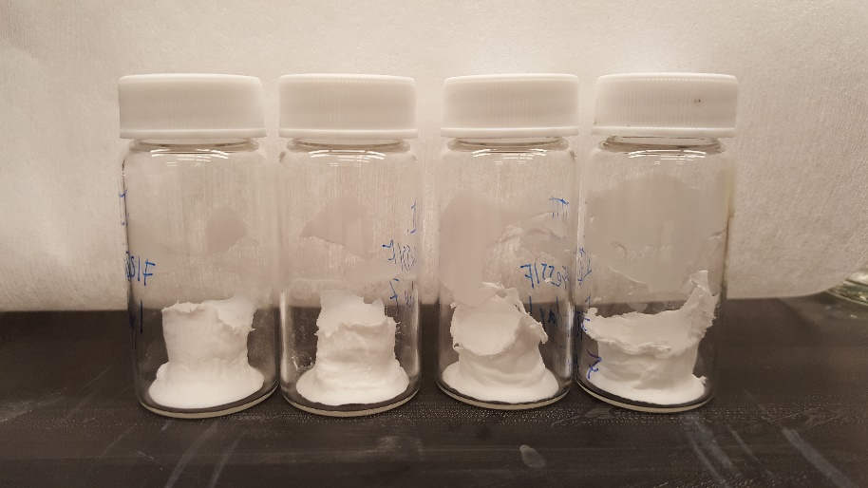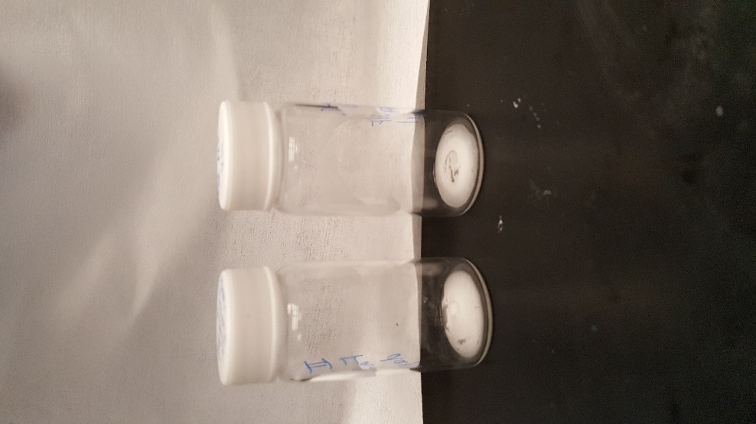

Figure S1. Lyophilized NP powder (left) before being placed in an oven uncapped at 50°C and 75% RH and (right) after 1 day in the oven.

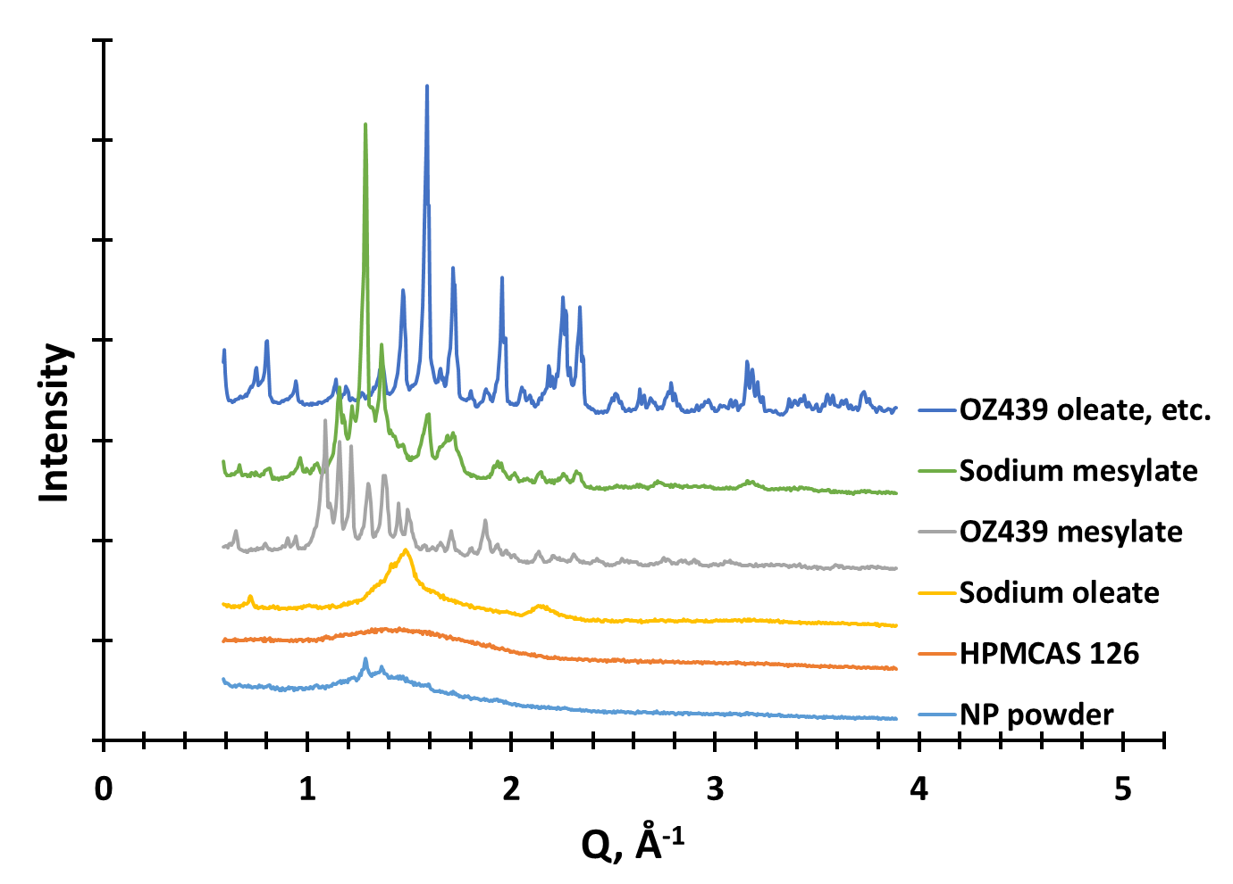
Figure S2. XRPD profiles of the raw individual components used in the study, along with the t=0 spray dried nanoparticle powder (light blue, bottom). The signal of ‘OZ439 oleate, etc.’ was obtained by physically mixing OZ439 mesylate dissolved in methanol and sodium oleate dissolved in methanol with water. The resulting solution became cloudy, indicating the formation of an insoluble OZ439:oleate complex. The solution was dried and XRPD was performed. This profile can be thought of as a physical mixture of sodium oleate, sodium mesylate, OZ439 mesylate, and OZ439 oleate. The peaks at Q = 1.3, 1.4, and 1.6 nm⁻¹ in the NP powder align closely with similar peaks in sodium mesylate (green, second from top), suggesting these peaks are due to sodium mesylate that formed from spectator sodium and mesylate ions during drying. These sodium mesylate crystals likely formed outside the NPs and are not associated with the amorphous OZ439 oleate core.

