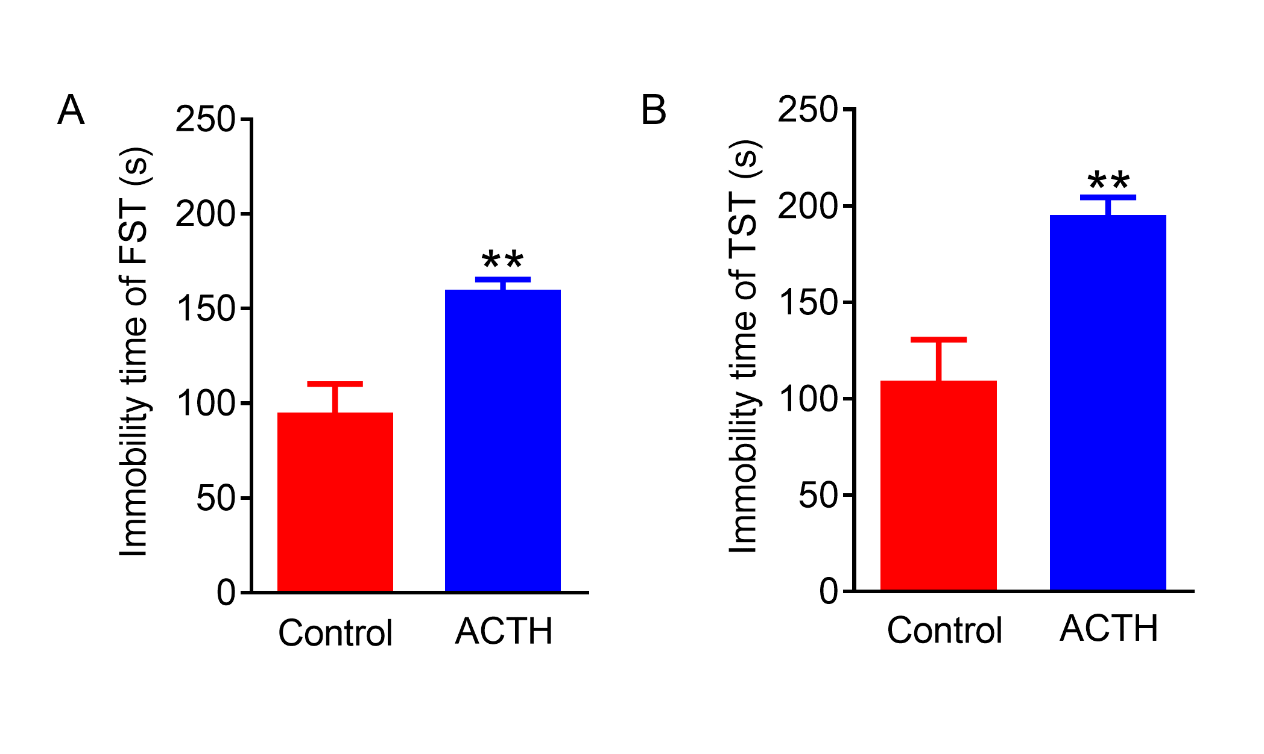Fig. S1 Neurobehavioral alternations in ACTH-treated rats. (A) Immobile time of forced swimming test (FST). (B) Immobile time of tail suspension test (TST). Data are expressed as mean ± SD (n = 10). ** P <0.01 compared with Control group.

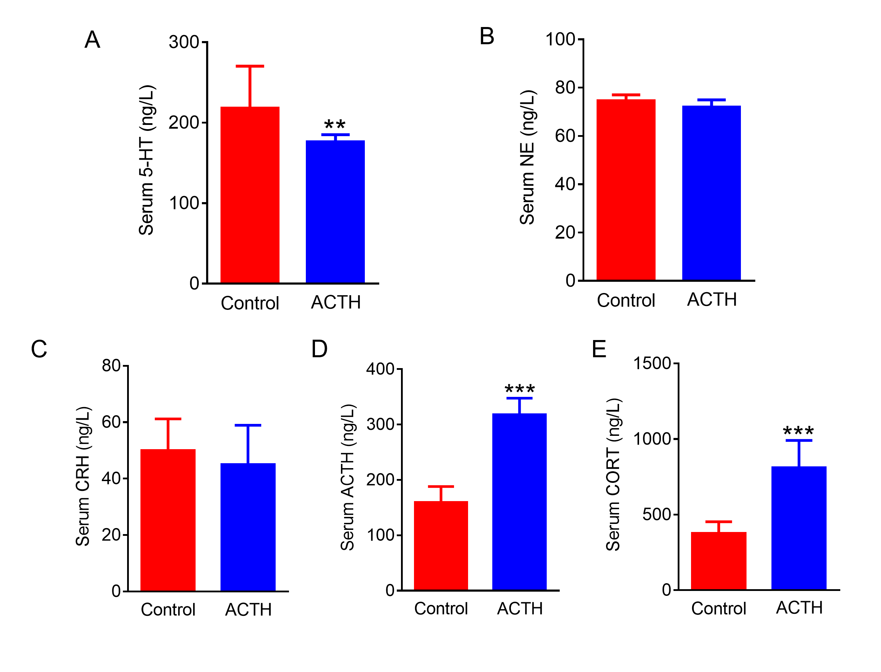Fig. S2 Changes of serum biochemical parameters in ACTH-induced depression rats. The serum concentrations of 5-HT (A), NE (B), CRH (C), ACTH (D), and CORT (E). Data are expressed as mean ± SD (n = 10). *** P <0.001, ** P <0.01 compared with Control group.

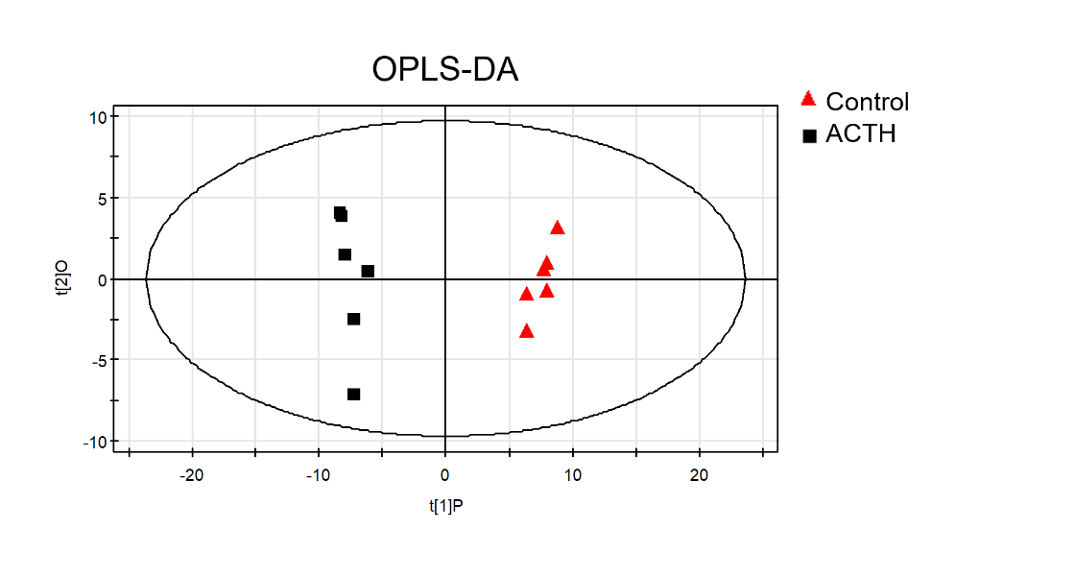
Fig. S3 OPLS-DA score plots showing the distributions of urinary metabolites in ACTH group and Control group (n = 6).

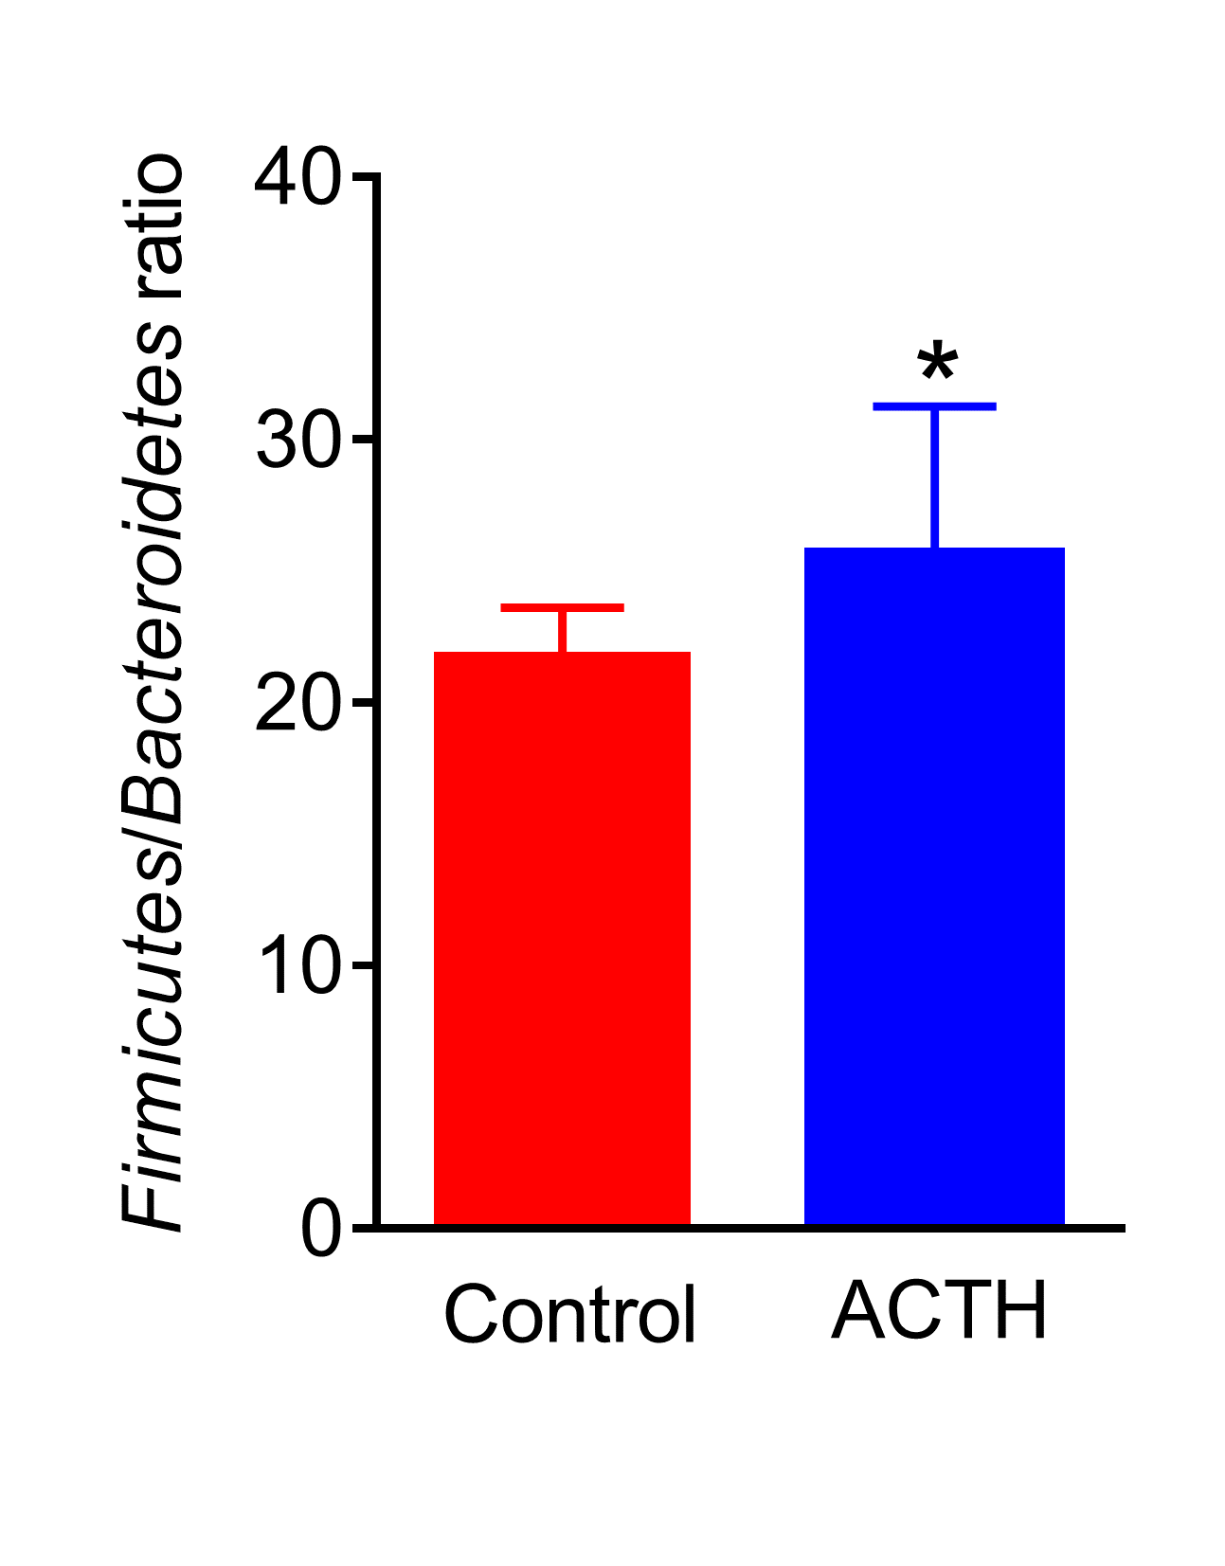
Fig. S4 Ratio of Firmicutes to Bacteroidetes in ACTH group and Control group. Data are expressed as mean ± SD (n = 6). *P < 0.05 compared with Control group.

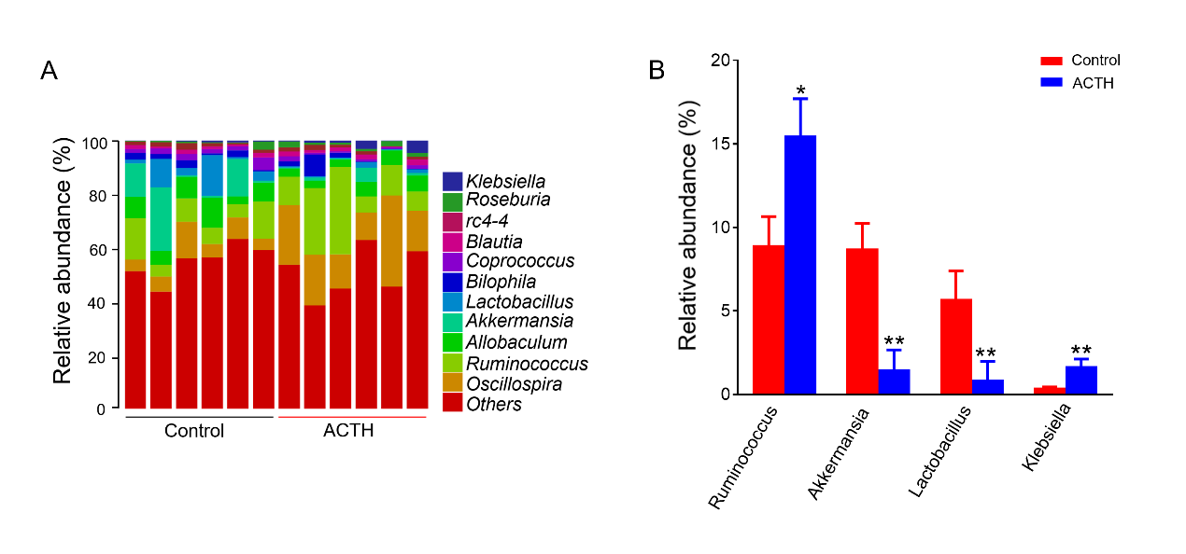Fig. S5 (A) Genus-level taxonomic distributions of the microbial communities in fecal contents. (B) The relative abundance of bacterial genus detected in fecal samples. Data are expressed as mean ± SD (n = 6). *P <0.05, **P <0.01 compared with Control group.

