Title: Cocaine and Amphetamine-Regulated Transcript Prepropeptide gene (CARTPT) polymorphism interacts with Diet Quality Index-International (DQI-I) and Healthy Eating Index (HEI) to affect hypothalamic hormones and cardio-metabolic risk factors among obese individuals
Authors: Mahsa Mahmoudi-Nezhad ¹, Mahdieh Abbasalizad Farhangi ²*, Houman Kahroba ³
¹ Nutrition Research Center, Tabriz University of Medical Sciences, Tabriz, Iran.
² Drug Applied Research Center, Tabriz University of Medical Sciences, Tabriz, Iran.
³ Molecular Medicine Research Center, Tabriz University of Medical Sciences, Tabriz, Iran
Running title: CART gene-diet interactions in obesity.
Corresponding author E-mail: abbasalizad_m@yahoo.com. Postal code: 5165665931
Attar-Neishabouri Ave, Golgasht St, Tabriz, Iran.

Additional file
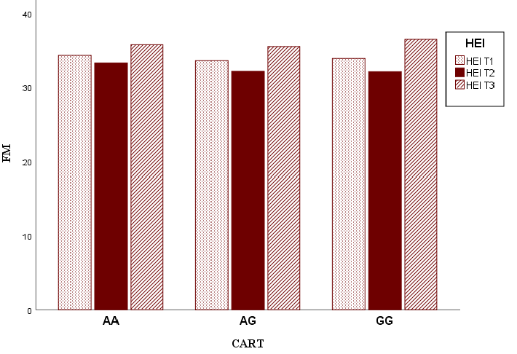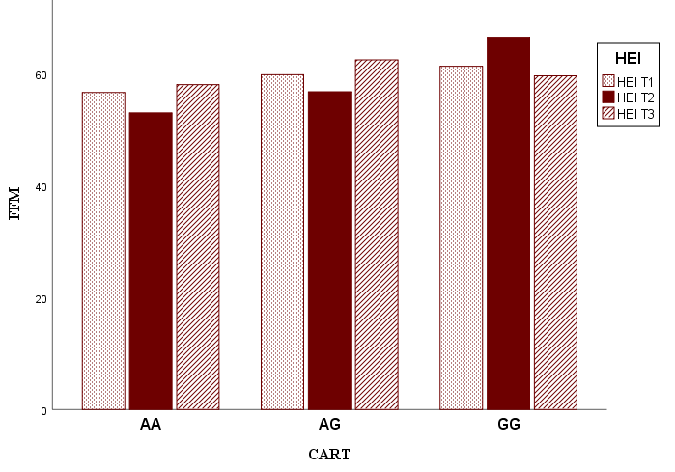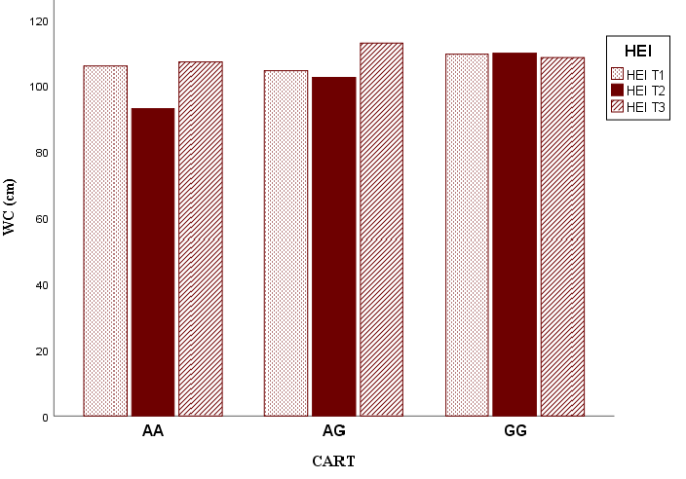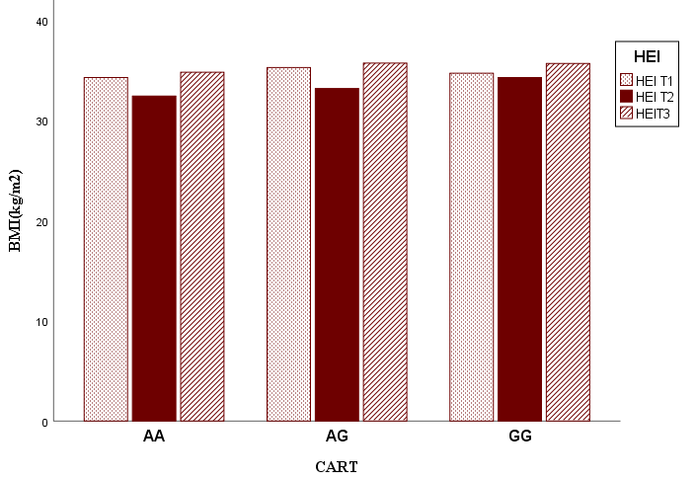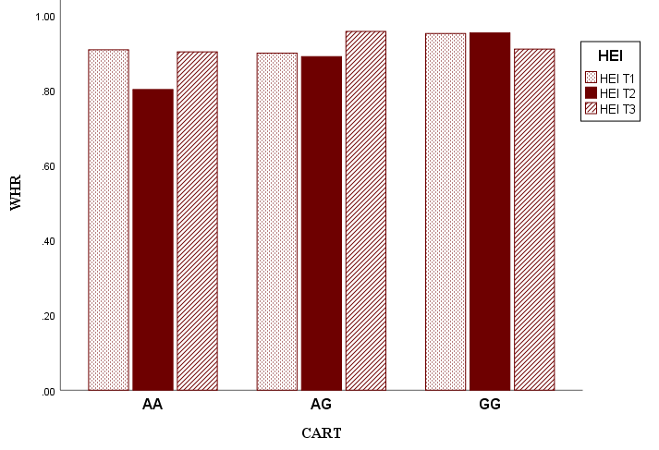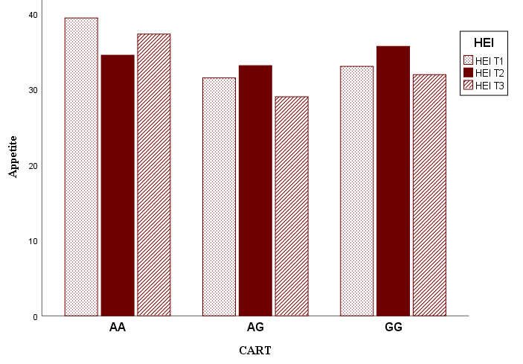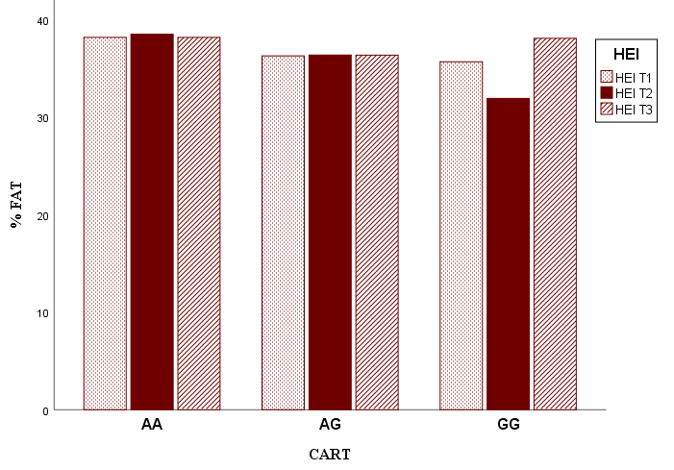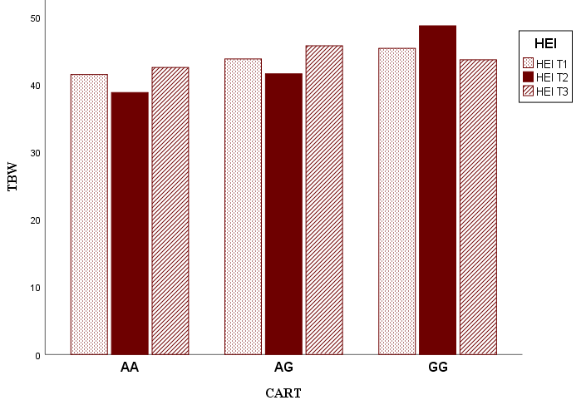
P _{interaction} = 0.993
P _{interaction} = 0.700
P _{interaction} = 1.00
P _{interaction} = 0.175
P _{interaction} = 0.553
P _{interaction} = 0.682
P _{interaction} = 0.933
P _{interaction} = 0.702
Figure S1. P for interaction between HEI, anthropometric and biochemical variables according to CARTPT genotype.
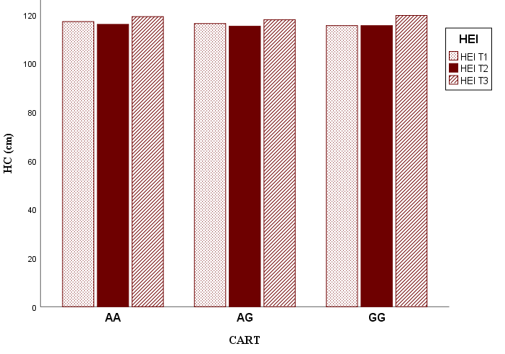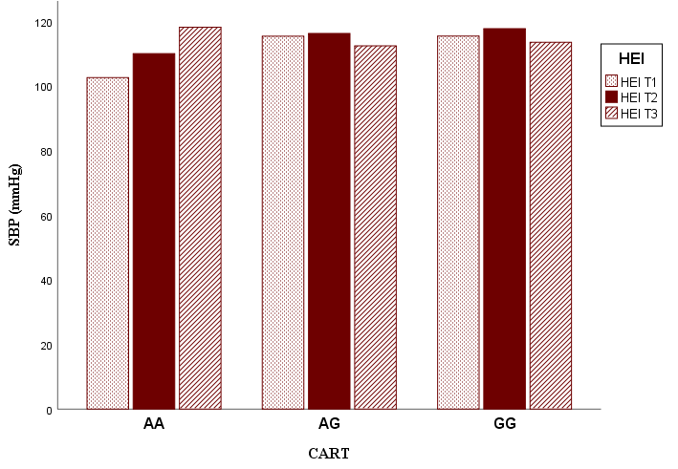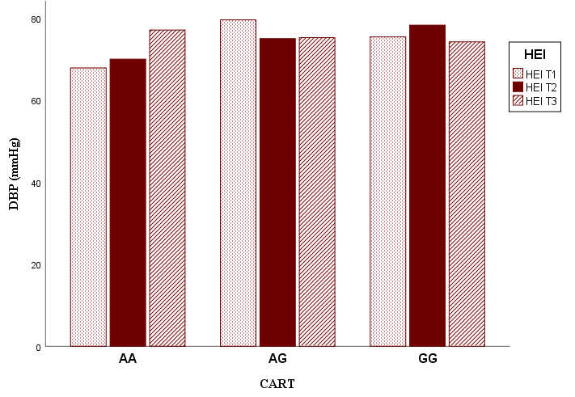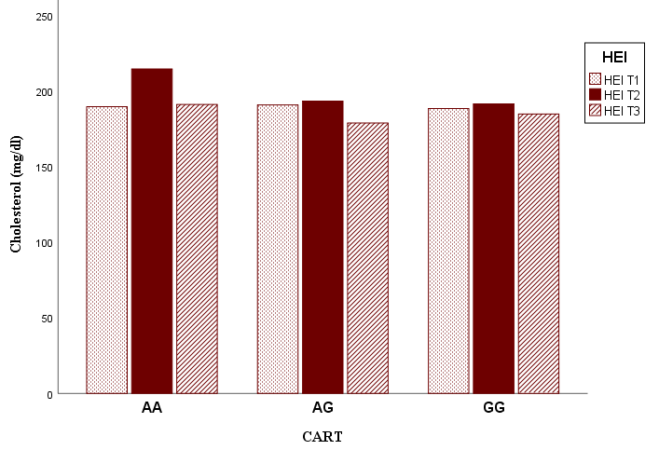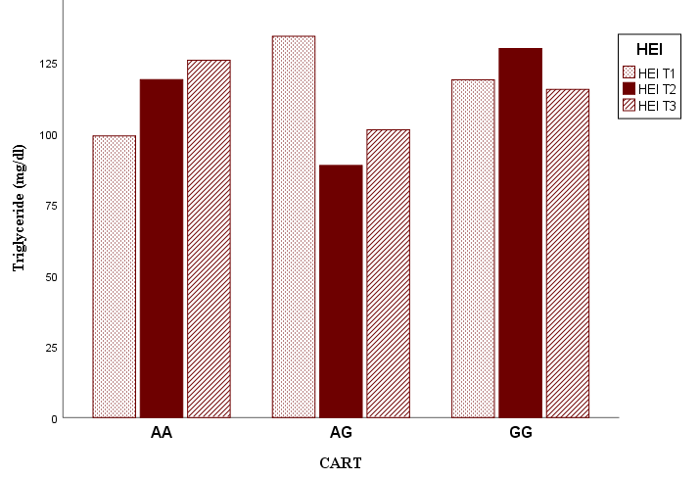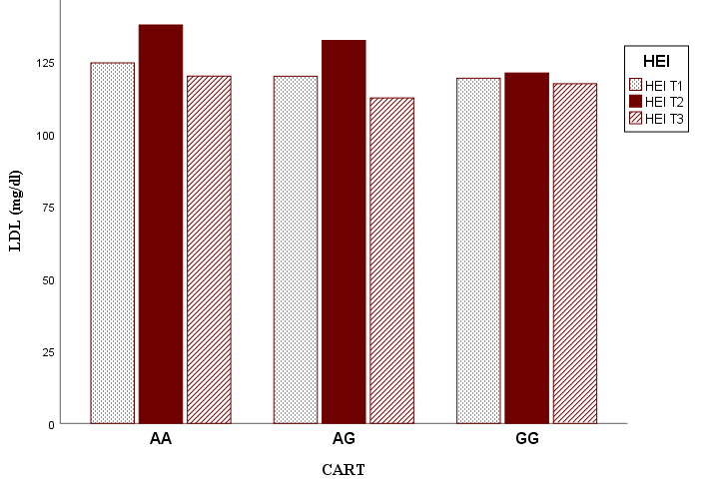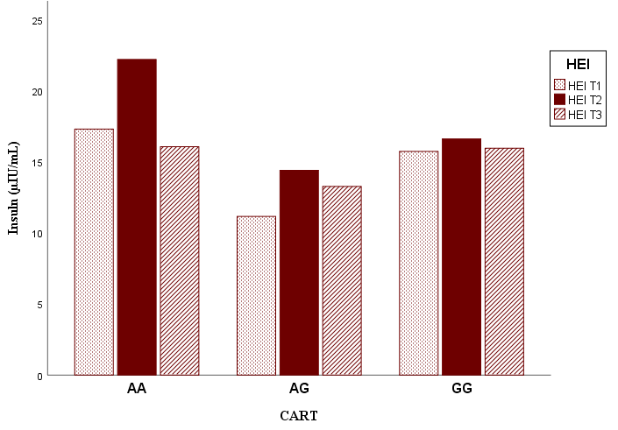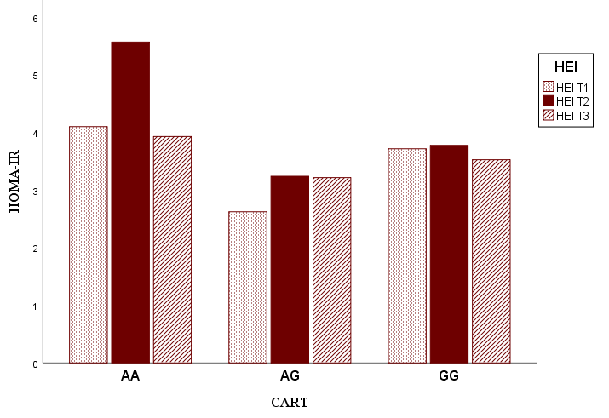
P _{interaction} = 0.711
P _{interaction} = 0.658
P _{interaction} = 0.650
P _{interaction} = 0.921
P _{interaction} = 0.857
P _{interaction} = 0.490
P _{interaction} = 0.906
P _{interaction} = 0.760
Figure S1-cont’d.
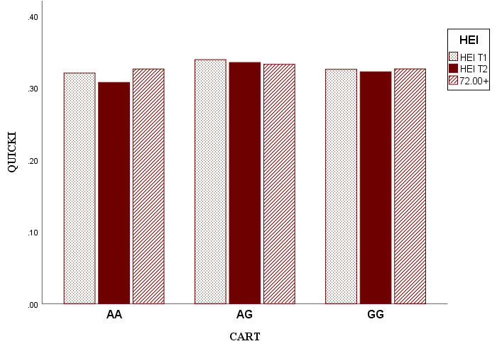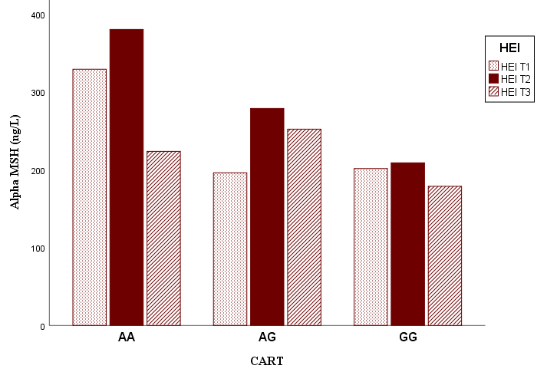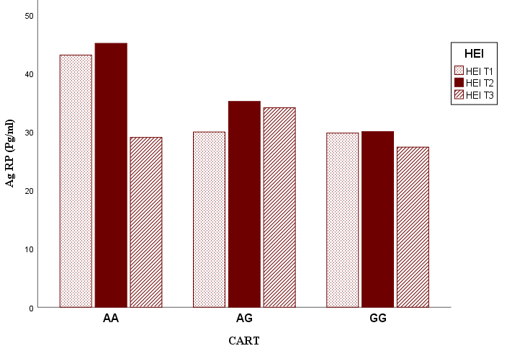
P _{interaction} = 0.270
P _{interaction} = 0.310
P _{interaction} = 0.723
Figure S1-cont’d.

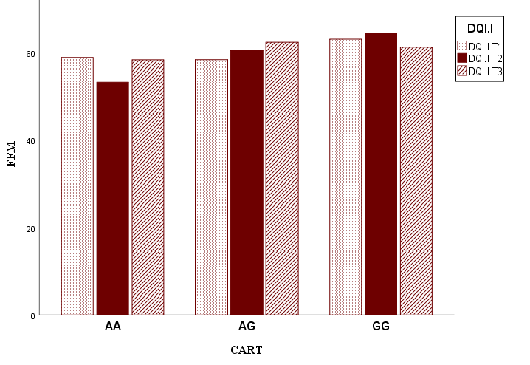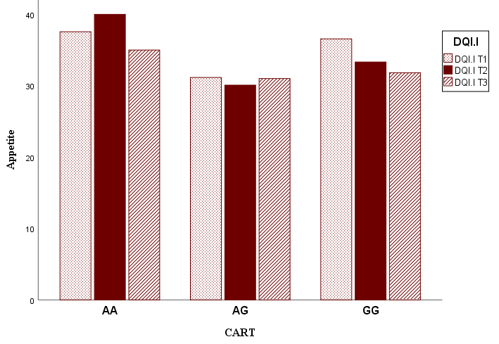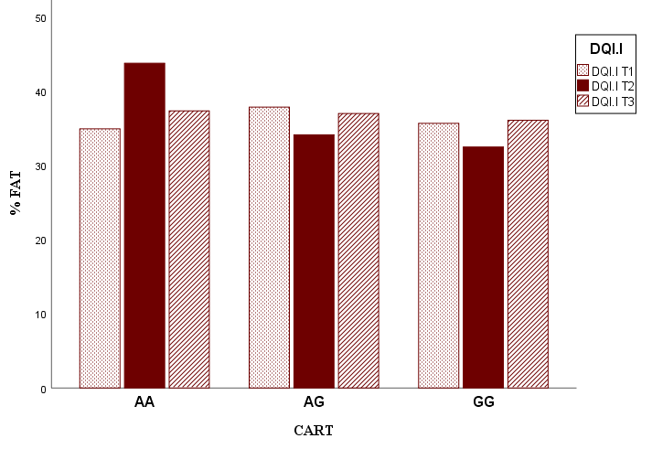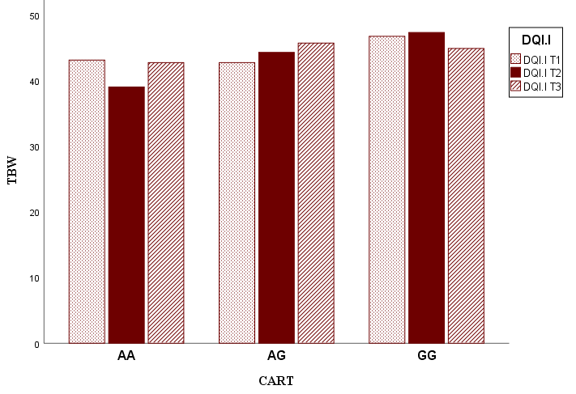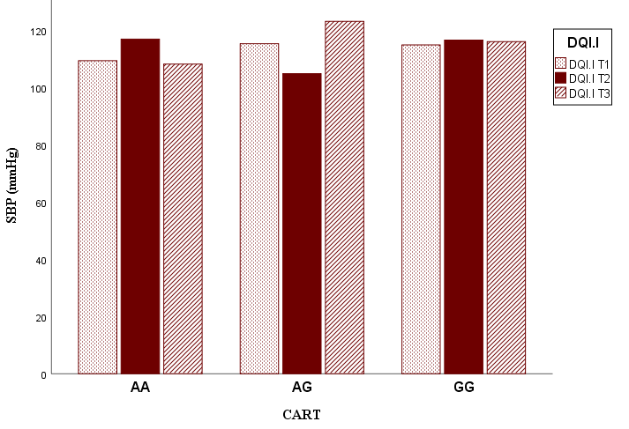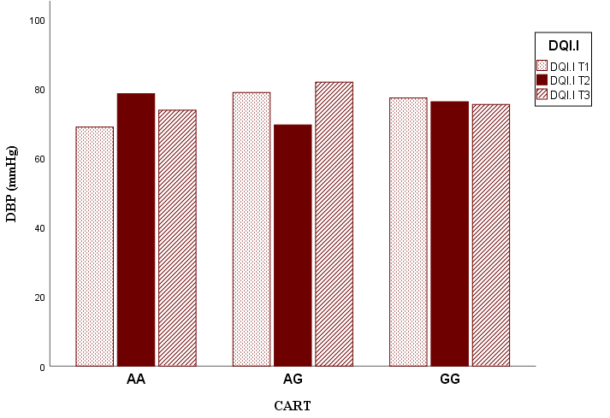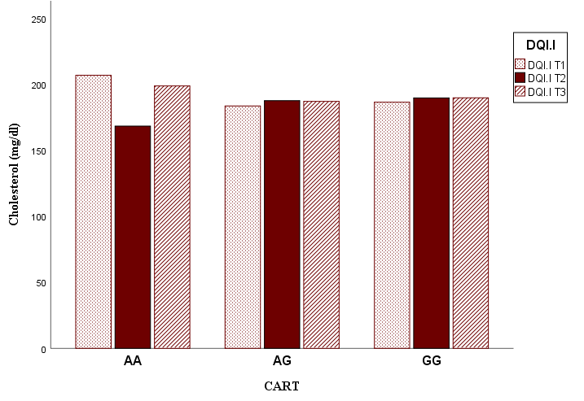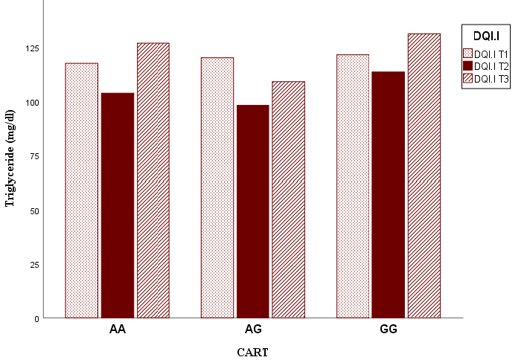
P_{interaction} = 0.906
P_{interaction} = 0.448
P_{interaction} = 0.649
P_{interaction} = 0.279
P_{interaction} = 0.978
P_{interaction} = 0.958
P_{interaction} = 0.956
P_{interaction} = 0.862
Figure S2. P for interaction between DQI-I, anthropometric and biochemical variables according to CARTPT genotype.
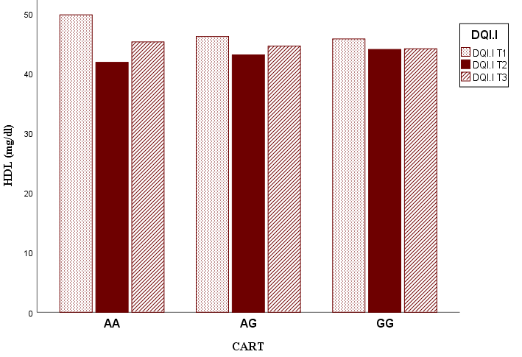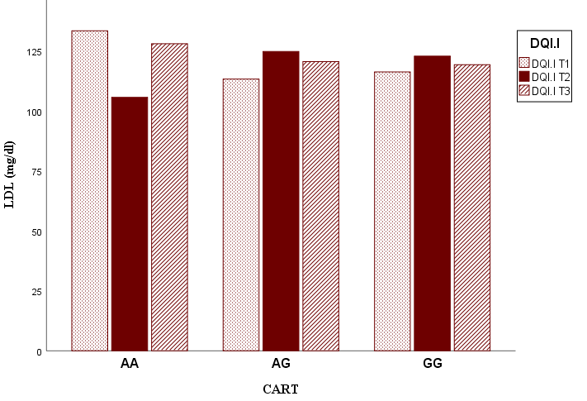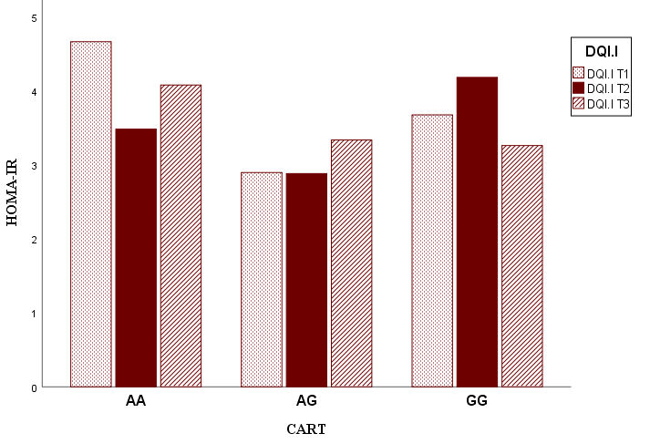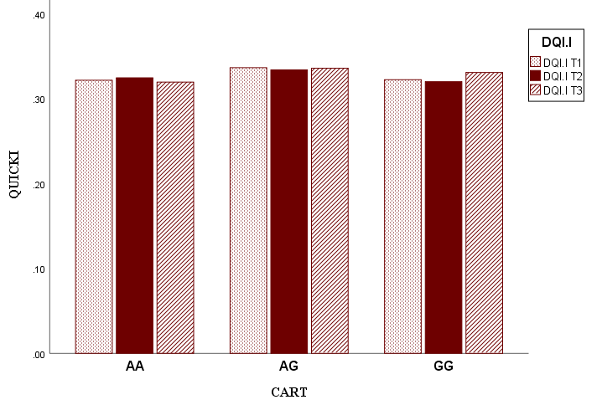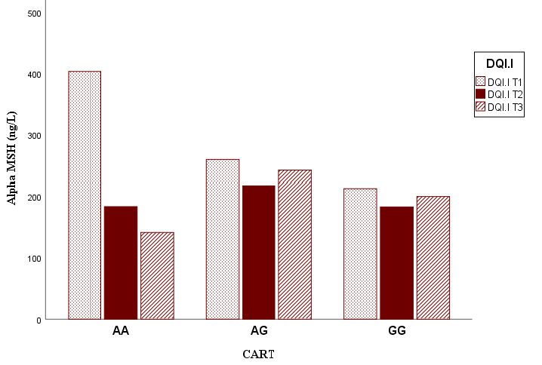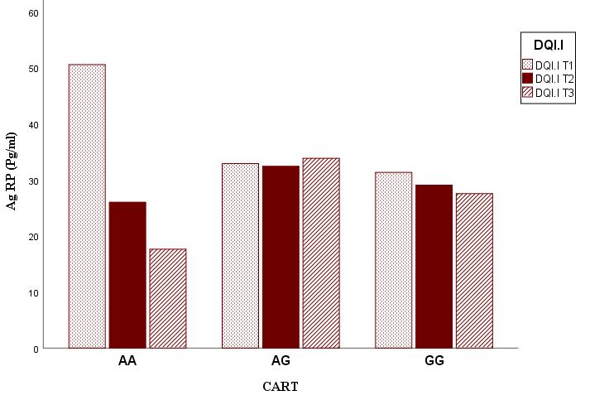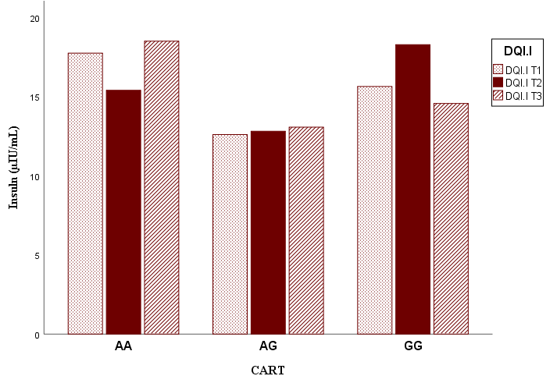
P_{interaction} = 0.538
P_{interaction} = 0.050
P_{interaction} = 0.197
P_{interaction} = 0.308
P_{interaction} = 0.405
P_{interaction} = 0.585
P_{interaction} = 0.480
Figure S2. Cont’d.

