Additional file 5.
Additional file 5.jpg
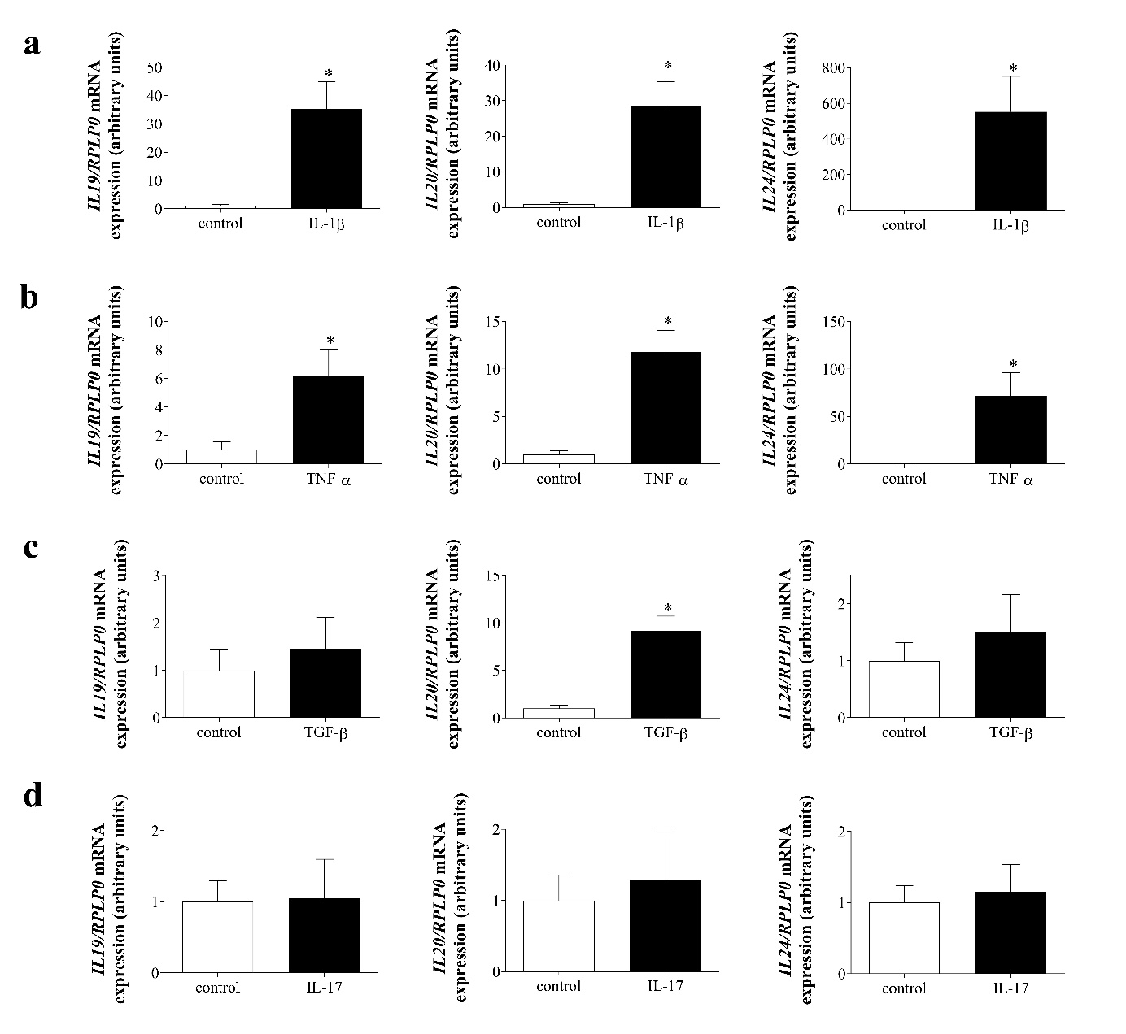
Additional file 5. Effect of IL-1β (a), TNF-α (b), TGF-β (c) or IL-17 (d) treatment on the mRNA expression of IL19, IL20 and IL24 of pdMFs. The mRNA expression of IL19, IL20 and IL24 was measured by real-time RT-PCR (n=6). Relative mRNA expression was determined by comparison with RPLP0 as internal control. Results are presented as mean+SD. *p<0.05 vs. control (Mann-Whitney U-test).

