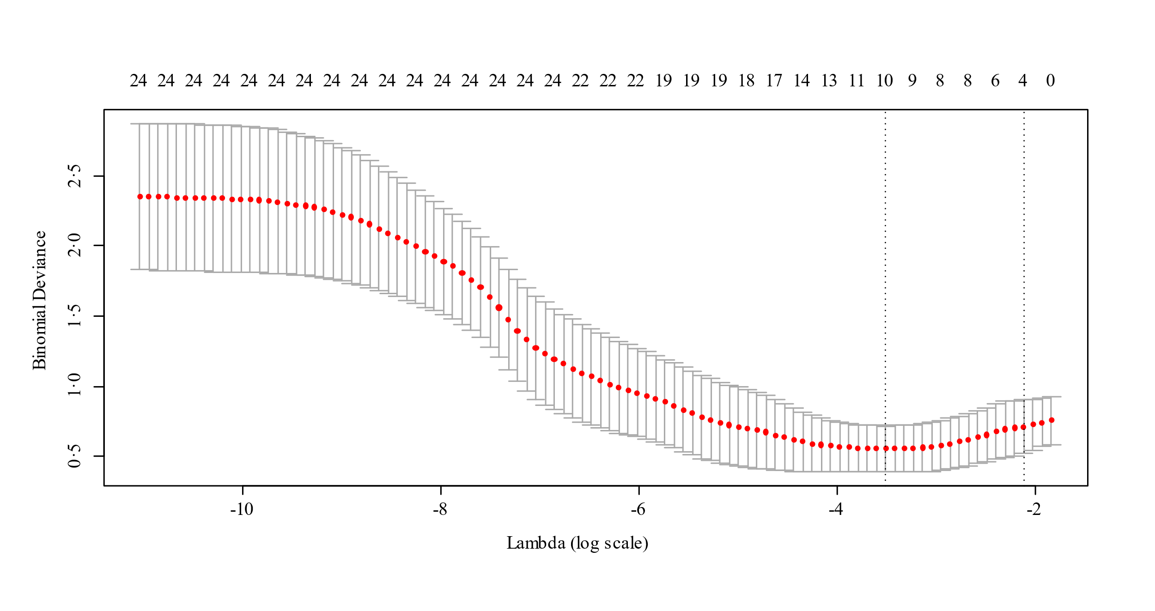

Additional Fig. S1 Five-fold cross-validation to select the Lambda.1SE for LASSO based on binominal deviance. From left to right, the first dotted line represents the location of the minimal of lambda and the second represents the Lambda.1SE. Based on “one-standard-error” rule, Lambda.1SE of 0.1206015 (-2.115264 in log scale) was selected as the tune parameter for LASSO through 5-fold cross-validation, which resulted in 4 predictors with nonzero coefficients including age, neutrophils-to-lymphocytes ratio, D-dimer and C-reactive protein. Lambda.1SE, lambda within 1 standard error; LASSO, least absolute shrinkage and selection operator.

