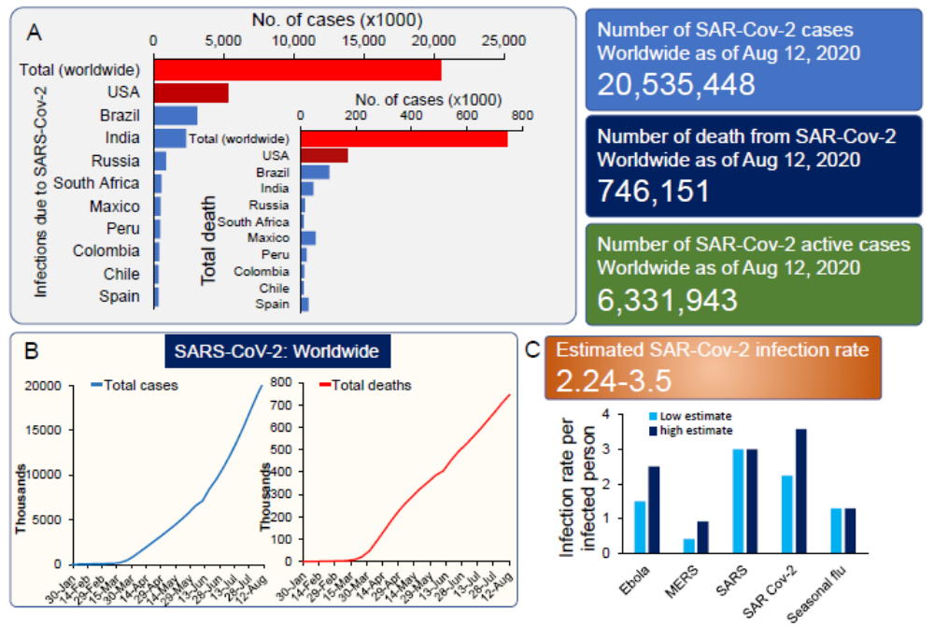

Figure S1. Worldwide reported SARS-CoV-19 cases and deaths. Top 10 massively impacted countries by SARA-Cov-19 (A). Worldwide infection and mortality graph of SARS-CoV-2 (B), estimated infection rates of common viral outbreaks (C).

