Supplementary Information
Supplementary Table 1 CircRNA–miRNA interactions identified by both CircInteractome and Circbank databases.
Supplementary Table 2 Permuted results of the three compounds by CMap analysis.
Supplementary Figure 1 Flow chart of the present study. GC, gastric cancer; RNA-seq, RNA sequencing; DECs, differently expressed circRNAs; AGO2, Argonaute2; MRE, miRNA response element; DEGs, differently expressed genes; TCGA, The Cancer Genome Atlas; KEGG, Kyoto Encyclopedia of Genes and Genomes; PPI, protein–protein interaction; ceRNA competing endogenous RNA; MCODE, Molecular Complex Detection; CMap, connectivity map.
Supplementary Figure 2 The circRNA–miRNA–mRNA regulatory networks of hsa_circ_0000615, hsa_circ_0001438, hsa_circ_0002190 and hsa_circ_0002449 in GC. CircRNAs, miRNAs, and mRNAs are respectively represented by red ellipses, diamonds, and blue ellipses. (A) hsa_circ_0000615, (B) hsa_circ_0001438, (C) hsa_circ_0002190, and (D) hsa_circ_0002449.
Supplementary Figure 3 The circRNA–miRNA–mRNA regulatory networks of hsa_circ_0000390 and hsa_circ_0003012 in GC. CircRNAs, miRNAs, and mRNAs are respectively represented by red ellipses, yellow diamonds, and blue ellipses. (A) hsa_circ_0000390. (B) hsa_circ_0003012.
Supplementary Figure 4 Expression of fifiteen hubgenes in GC by RT-qPCR. (A) ATF3, BTG2, DUSP1, EGR1, (B) FGF2, FOSB, GNAI1, GNAO1, (C) GNAZ, GNG7, ITPKB, ITPR1, (D) JUND, NR4A3, PRKCB. GC, gastric cancer; ANT, adjacent normal tissues.
Supplementary Table 1 CircRNA–miRNA interactions identified by both CircInteractome and Circbank databases
CircRNA-miRNA interactions | CircInteractome |  |  |  |  | Circbank
CircRNA-miRNA interactions | miRNA ID | Site Type | Start | End | Sites | miRNA ID | miRanda binding site | Targetscan  binding site
hsa_circ_0000390 | hsa-miR-1248 | 8mer-1a | 281 | 288 | 1 | hsa-miR-1248 | 261 | 281 288
hsa_circ_0000390 | hsa-miR-136 | 8mer-1a | 195 | 202 | 1 | hsa-miR-136-5p | 180 | 195 202
hsa_circ_0000390 | hsa-miR-518a-5p | 7mer-m8 | 26 | 32 | 1 | hsa-miR-518a-5p | 14 | 26 32
hsa_circ_0000390 | hsa-miR-527 | 7mer-m8 | 26 | 32 | 1 | hsa-miR-527 | 14 | 26 32
hsa_circ_0000390 | hsa-miR-578 | 7mer-m8 | 324 | 330 | 1 | hsa-miR-578 | 311 | 324 330
hsa_circ_0000390 | hsa-miR-629 | 7mer-m8 | 257 | 263 | 1 | hsa-miR-629-3p | 223 | 198 237 203 243
hsa_circ_0000390 | hsa-miR-646 | 7mer-m8 | 303 | 309 | 1 | hsa-miR-646 | 293 | 303 309
hsa_circ_0000615 | hsa-miR-1200 | 7mer-m8 | 499 | 505 | 1 | hsa-miR-1200 | 485 | 499 505
hsa_circ_0000615 | hsa-miR-1224-3p | 8mer-1a 7mer-m8 | 107 294 | 114 300 | 2 | hsa-miR-1224-3p | 281 | 107 294 114 300
hsa_circ_0000615 | hsa-miR-1236 | 7mer-m8 | 88 | 94 | 1 | hsa-miR-1236-3p | 76 | 88 94
hsa_circ_0000615 | hsa-miR-1248 | 7mer-1a 8mer-1a | 603 629 | 609 636 | 2 | hsa-miR-1248 | 611 | 558 603 629 563 609 636
hsa_circ_0000615 | hsa-miR-1272 | 7mer-m8 | 228 | 234 | 1 | hsa-miR-1272 | 211 | 228 234
hsa_circ_0000615 | hsa-miR-142-3p | 7mer-m8 | 326 | 332 | 1 | hsa-miR-142-3p | 312 | 326 332
hsa_circ_0000615 | hsa-miR-145 | 8mer-1a | 270 | 277 | 1 | hsa-miR-145-5p | 257 | 270 277
hsa_circ_0000615 | hsa-miR-149 | 8mer-1a | 818 | 825 | 1 | hsa-miR-149-5p | 801 | 687 818 692 825
hsa_circ_0000615 | hsa-miR-432 | 7mer-m8 | 456 | 462 | 1 | hsa-miR-432-5p | 444 | 456 462
hsa_circ_0000615 | hsa-miR-487a | 7mer-m8 | 718 | 724 | 1 | hsa-miR-487a-3p | 705 | 718 724
hsa_circ_0000615 | hsa-miR-623 | 8mer-1a | 371 | 378 | 1 | hsa-miR-623 | 357 | 371 378
hsa_circ_0000615 | hsa-miR-767-5p | 7mer-m8 | 507 | 513 | 1 | hsa-miR-767-5p | 495 | 507 513
hsa_circ_0000615 | hsa-miR-942 | 7mer-m8 7mer-m8 | 556 636 | 562 642 | 2 | hsa-miR-942-5p | 587 621 539 | 556 602 636 562 607 642
Supplementary Table 1 CircRNA–miRNA interactions identified by both CircInteractome and Circbank databases (Continued)
CircRNA-miRNA interactions | CircInteractome |  |  |  |  | Circbank
CircRNA-miRNA interactions | miRNA ID | Site Type | Start | End | Sites | miRNA ID | miRanda binding site | Targetscan  binding site
hsa_circ_0001438 | hsa-miR-942 | 7mer-m8 7mer-m8 | 176 190 | 182 196 | 2 | hsa-miR-942-5p | 177 162 | 176 190 182 196
hsa_circ_0002190 | hsa-miR-323-3p | 7mer-m8 | 85 | 91 | 1 | hsa-miR-323a-3p | 71 | 85 91
hsa_circ_0002190 | hsa-miR-513a-5p | 7mer-m8 | 283 | 289 | 1 | hsa-miR-513a-5p | 271 | 283 289
hsa_circ_0002190 | hsa-miR-515-5p | 7mer-m8 | 52 | 58 | 1 | hsa-miR-515-5p | 35 | 52 58
hsa_circ_0002190 | hsa-miR-598 | 7mer-m8 | 70 | 76 | 1 | hsa-miR-598-3p | 56 | 70 76
hsa_circ_0002449 | hsa-miR-1200 | 7mer-m8 | 184 | 190 | 1 | hsa-miR-1200 | 166 | 184 190
hsa_circ_0002449 | hsa-miR-1261 | 7mer-m8 | 80 | 86 | 1 | hsa-miR-1261 | 69 | 45 80 50 86
hsa_circ_0002449 | hsa-miR-659 | 7mer-m8 | 23 | 29 | 1 | hsa-miR-659-3p | 9 | 23 91 29 96
hsa_circ_0003012 | hsa-miR-1184 | 7mer-m8 | 478 | 484 | 1 | hsa-miR-1184 | 466 | 379 478 384 484
hsa_circ_0003012 | hsa-miR-1282 | 7mer-m8 | 348 | 354 | 1 | hsa-miR-1282 | 336 | 348 354
hsa_circ_0003012 | hsa-miR-1322 | 7mer-m8 7mer-m8 | 468 637 | 474 643 | 2 | hsa-miR-1322 | 625 456 | 468 637 474 643
hsa_circ_0003012 | hsa-miR-140-3p | 7mer-m8 | 113 | 119 | 1 | hsa-miR-140-3p | 99 | 113 119
hsa_circ_0003012 | hsa-miR-621 | 7mer-m8 | 670 | 676 | 1 | hsa-miR-621 | 656 | 670 676
hsa_circ_0003012 | hsa-miR-548p | 8mer-1a | 667 | 674 | 1 | hsa-miR-548p | 653 | 667 674
hsa_circ_0003012 | hsa-miR-548g | 7mer-m8 7mer-m8 | 427 687 | 433 693 | 2 | hsa-miR-548g-3p | 413 | 427 687 433 693
hsa_circ_0003012 | hsa-miR-653 | 7mer-1a | 66 | 72 | 1 | hsa-miR-653-3p | 292 | 306 312

Supplementary Table 2 Permuted results of the three compounds by CMap analysis
Rank | Batch | cMap name | Dose | Cell | Score | Up | Down | Instance_id
6018 | 603 | vorinostat | 10 µM | PC3 | -0.791 | -0.764 | 0.272 | 1220
6012 | 513 | vorinostat | 10 µM | MCF7 | -0.789 | -0.625 | 0.408 | 1058
5964 | 506 | vorinostat | 10 µM | MCF7 | -0.756 | -0.647 | 0.343 | 1000
5891 | 725 | vorinostat | 10 µM | MCF7 | -0.728 | -0.533 | 0.42 | 5217
5792 | 767 | vorinostat | 10 µM | MCF7 | -0.691 | -0.665 | 0.24 | 6939
5707 | 757 | vorinostat | 10 µM | MCF7 | -0.665 | -0.407 | 0.464 | 5580
5540 | 626 | vorinostat | 10 µM | MCF7 | -0.628 | -0.392 | 0.431 | 1645
5379 | 750 | vorinostat | 10 µM | HL60 | -0.595 | -0.488 | 0.291 | 6179
5017 | 727 | vorinostat | 10 µM | PC3 | -0.529 | -0.383 | 0.31 | 4444
4988 | 765 | vorinostat | 10 µM | MCF7 | -0.525 | -0.33 | 0.358 | 6980
4630 | 602 | vorinostat | 10 µM | HL60 | -0.47 | -0.36 | 0.256 | 1161
4427 | 650 | vorinostat | 10 µM | HL60 | -0.442 | -0.3 | 0.28 | 2680
6098 | 725 | trichostatin A | 100 nM | MCF7 | -0.957 | -0.789 | 0.465 | 5209
6096 | 632 | trichostatin A | 100 nM | MCF7 | -0.944 | -0.841 | 0.396 | 1471
6091 | 663 | trichostatin A | 100 nM | MCF7 | -0.908 | -0.771 | 0.418 | 2794
6085 | 647 | trichostatin A | 100 nM | MCF7 | -0.886 | -0.777 | 0.384 | 3227
6082 | 726 | trichostatin A | 100 nM | MCF7 | -0.868 | -0.618 | 0.519 | 5260
6074 | 656 | trichostatin A | 100 nM | MCF7 | -0.845 | -0.697 | 0.409 | 2835
6071 | 706 | trichostatin A | 100 nM | MCF7 | -0.838 | -0.713 | 0.384 | 4954
6063 | 637 | trichostatin A | 100 nM | MCF7 | -0.83 | -0.744 | 0.344 | 2268
6058 | 764 | trichostatin A | 100 nM | PC3 | -0.828 | -0.788 | 0.297 | 7136
6055 | 766 | trichostatin A | 100 nM | MCF7 | -0.827 | -0.648 | 0.435 | 7005
6051 | 752 | trichostatin A | 100 nM | MCF7 | -0.817 | -0.662 | 0.408 | 6085
6050 | 636 | trichostatin A | 100 nM | MCF7 | -0.816 | -0.64 | 0.429 | 2247
6041 | 704 | trichostatin A | 100 nM | PC3 | -0.808 | -0.74 | 0.319 | 4565
6031 | 506 | trichostatin A | 100 nM | MCF7 | -0.8 | -0.598 | 0.449 | 992
6027 | 705 | trichostatin A | 100 nM | MCF7 | -0.797 | -0.668 | 0.375 | 4388
6017 | 1079 | trichostatin A | 1 µM | PC3 | -0.791 | -0.78 | 0.256 | 7105
6014 | 506 | trichostatin A | 1 µM | MCF7 | -0.79 | -0.678 | 0.357 | 1014
6011 | 689 | trichostatin A | 100 nM | PC3 | -0.788 | -0.643 | 0.389 | 4072
6003 | 691 | trichostatin A | 100 nM | MCF7 | -0.783 | -0.626 | 0.4 | 4153
6002 | 701 | trichostatin A | 100 nM | PC3 | -0.781 | -0.744 | 0.28 | 4302
6013 | 744 | astemizole | 9 µM | MCF7 | -0.789 | -0.671 | 0.363 | 6807
5935 | 636 | astemizole | 9 µM | MCF7 | -0.745 | -0.464 | 0.512 | 2211
5250 | 616 | astemizole | 9 µM | PC3 | -0.568 | -0.421 | 0.323 | 2049
4989 | 728 | astemizole | 9 µM | PC3 | -0.525 | -0.29 | 0.398 | 4471
4669 | 614 | astemizole | 9 µM | HL60 | -0.477 | -0.419 | 0.205 | 1365

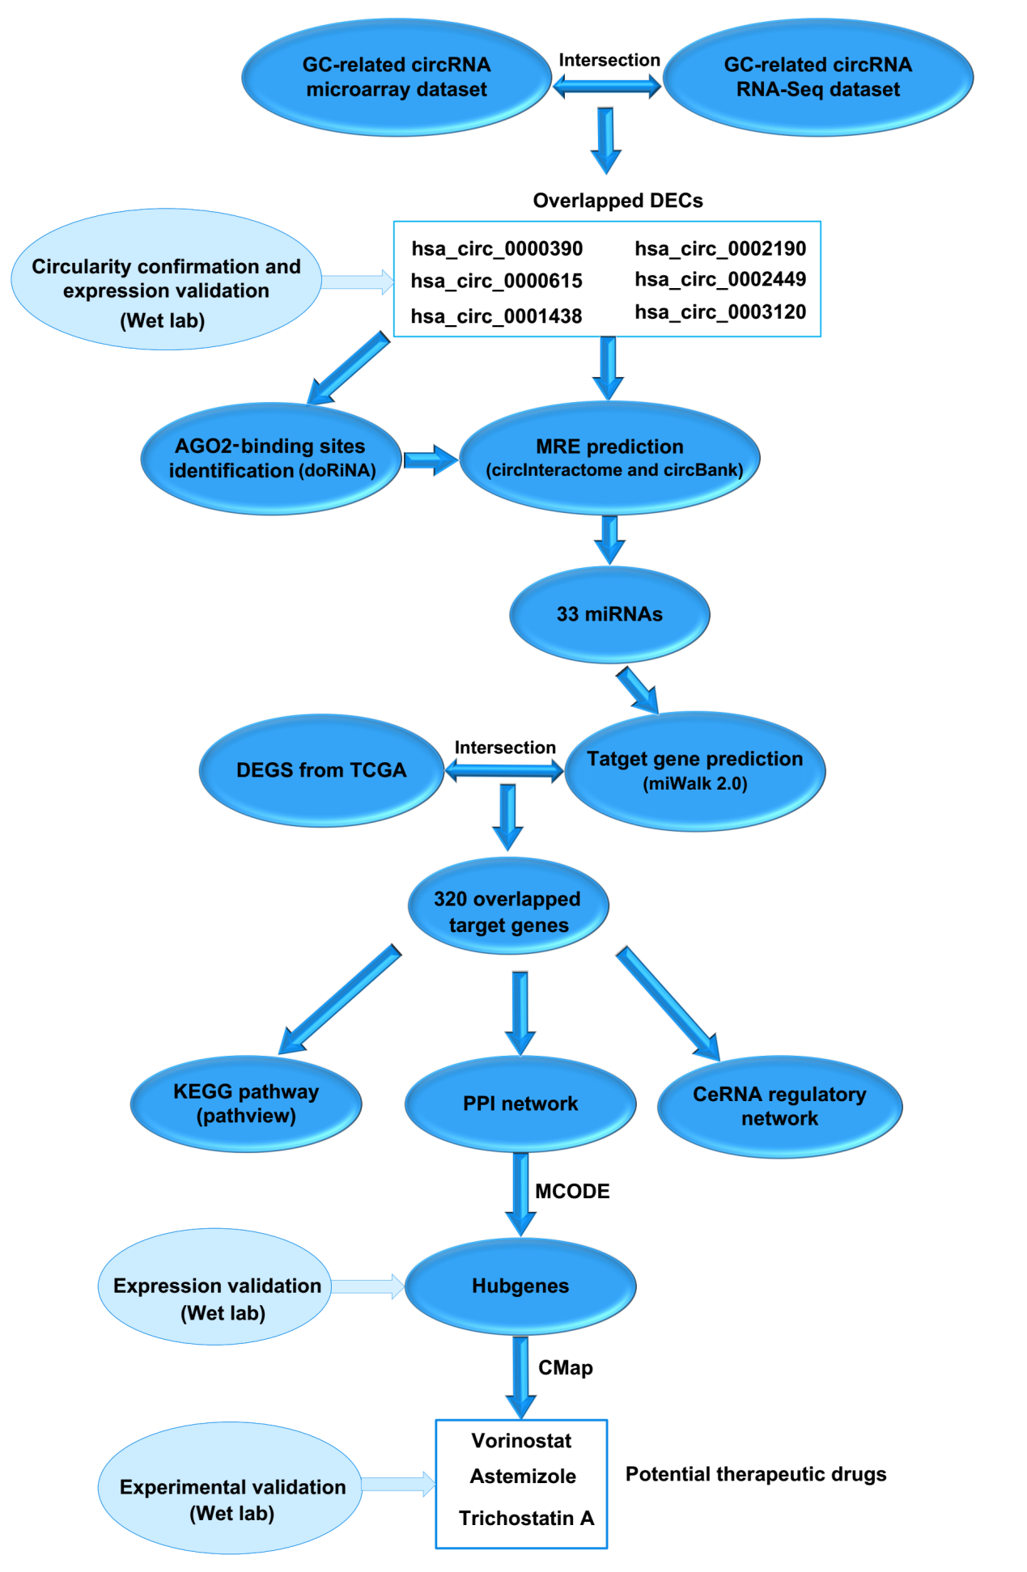
Supplementary Figure 1

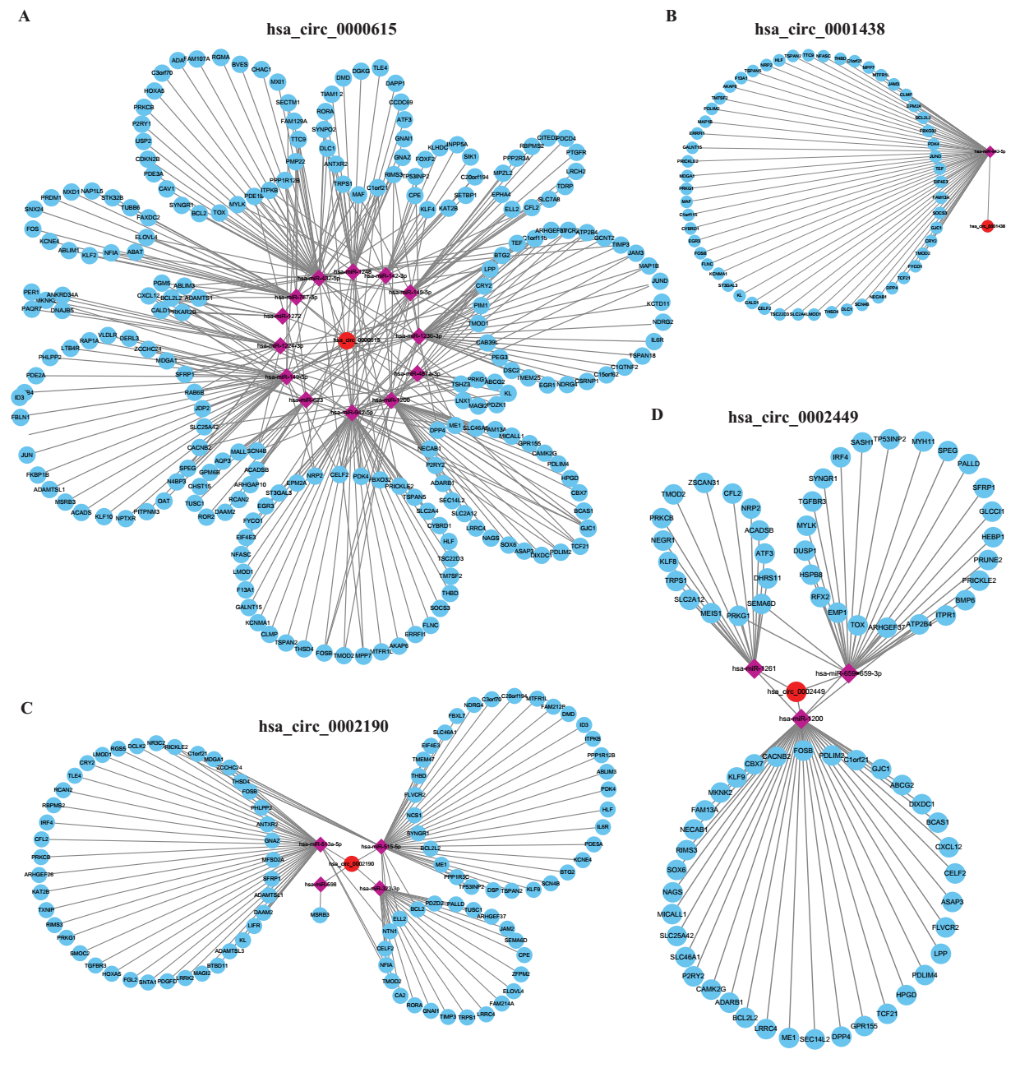
Supplementary Figure 2

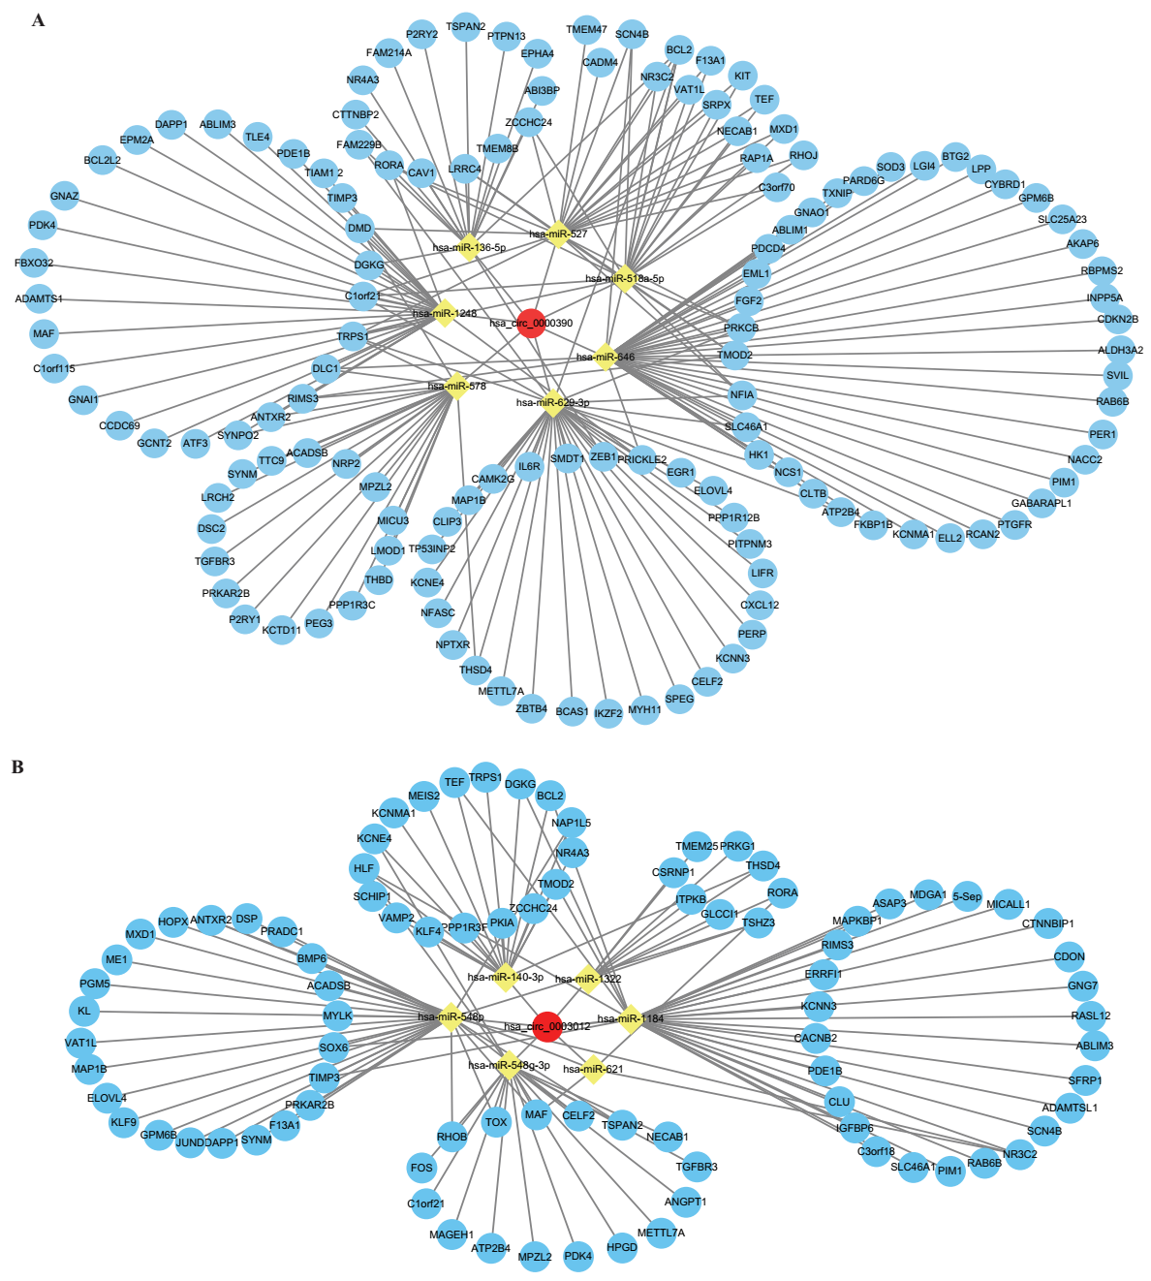
Supplementary Figure 3

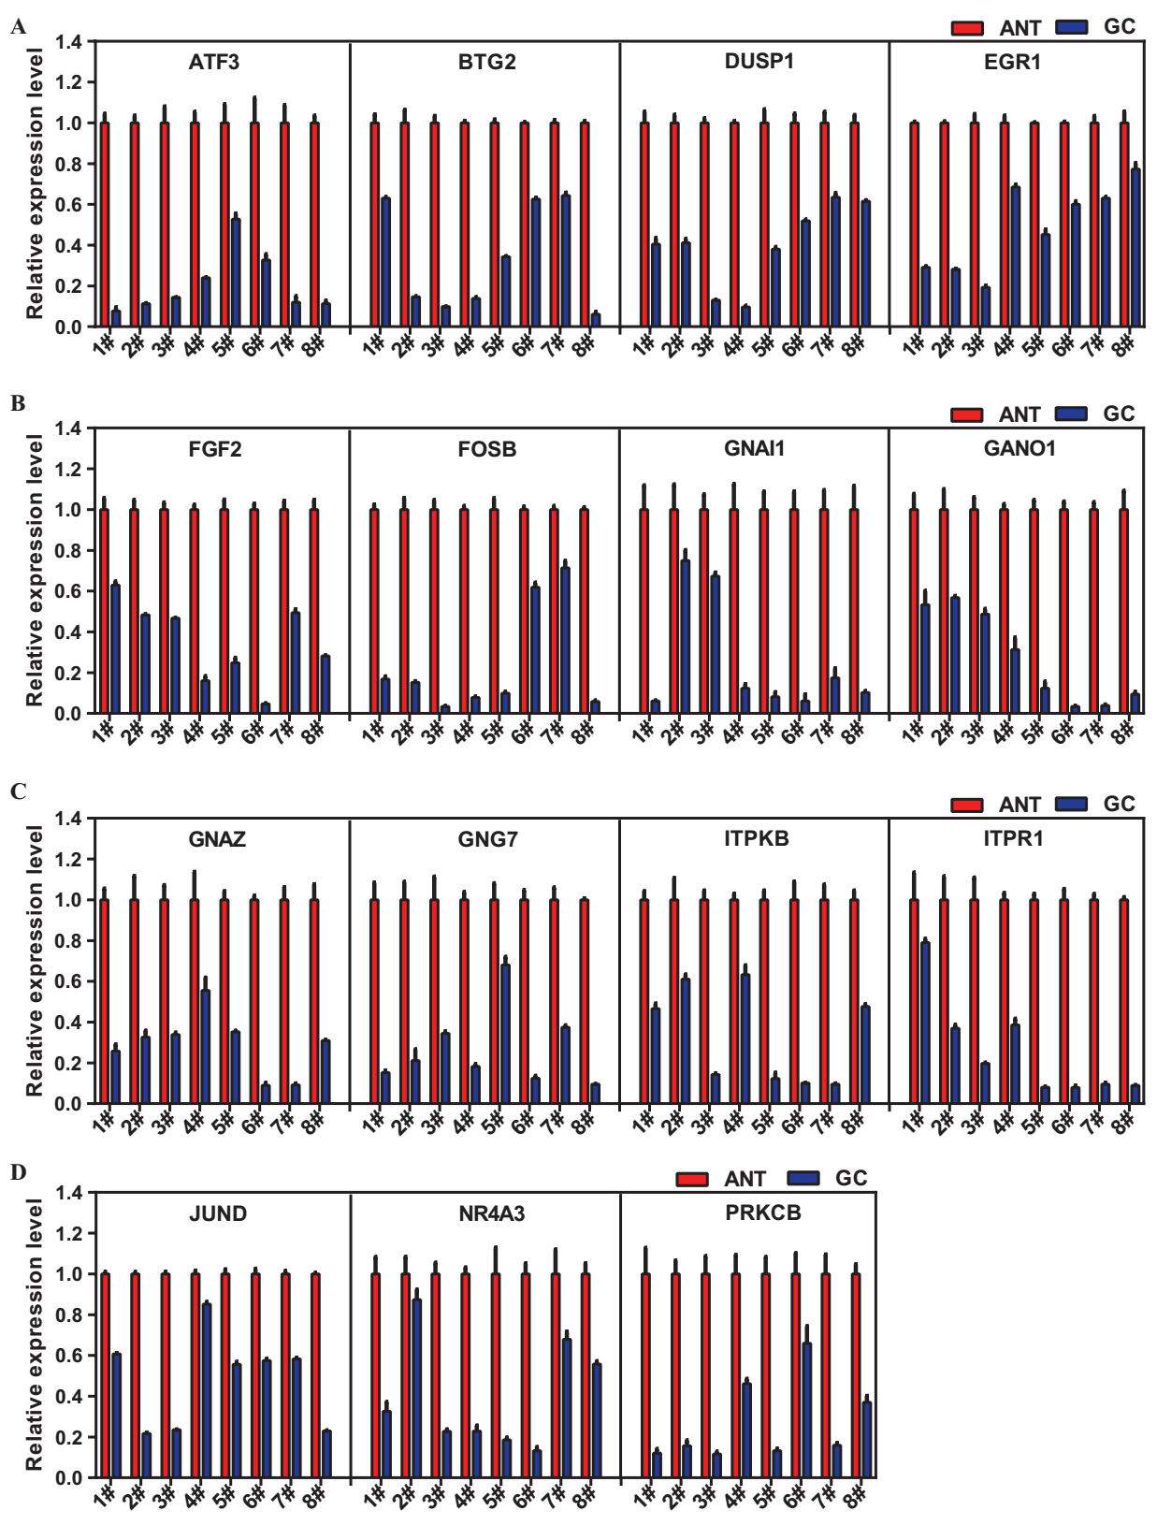
Supplementary Figure 4

