Appendix S2: Model Development, Validation and SHapley Additive exPlanation

Model development and validation
Table S1 The best hyperparameters of each classifier
 | Hyperparameters Set | Optimal Hyperparameters | AUC
LR | L1 Regularization term: [0.0001, 0.0008, 0.006, 0.046,0.36, 2.78, 21.54, 168.81,1291.54, 10000]  (Smaller value specifies greater regularization strength) | L1 Regularization term: 0.006 | 0.73
SVM | Regularization term: {0.1,1,10,20};  Gamma {0.1,1,10,20} | Kernel: Radial Basis  Regularization term: 3  Gamma: 0.01 | 0.75
RF | Number of estimators {10,50,100,500};  Maximum features {3,4,5,6} | Number of estimators: 500  Maximum features: 2  Criteria: Gini | 0.75
ADA | Number of estimators {10,100,500};  Learning Rate: {0.005,0.05,0.01} | Number of estimators: 100  Learning rate: 0.01 | 0.75
GBM | Number of estimators: {10,50,100,500};  Learning rate: {0.01,0.05,0.1} | Number of estimators: 100  Learning rate: 0.1 | 0.76
LR = logistic regression; SVM = support vector machine; RF = random forest; ADA = adaptive boosting; GBM = gradient boosting machine implemented by decision tree.

AKI prediction score
Kalisvaart M. et al. developed an AKI prediction score according to the Framingham risk scheme. We used the methods offered in their thesis to calculate this score (1).

Table S2 Comparison between the development set and the internal validation set
Characteristics | Development set  (n = 546) | Internal validation set  (n = 234) | P value
Diagnosis of AKI | 301(55.13%) | 129(55.13%) | 1
Predicting variables
IBIL (μmol/L) | 90.34(97.04) | 91.0(95.51) | 0.93
UO (ml/(kg*h)) | 3.09(2.2) | 3.14(2.01) | 0.774
Time under GA(min) | 543.0(121.0) | 541.04(126.97) | 0.838
PLT(10^9/L) | 94.45(80.83) | 99.69(76.01) | 0.399
Steatosis grade ≥ 1 | 147(26.92%) | 59(25.21%) | 1
Preoperative LOS (d) | 18.23(21.82) | 17.21(21.18) | 0.545
EBL (ml) | 2066.68(1906.18) | 2016.45(2285.95) | 0.751
ALB (g/L) | 35.56(4.89) | 35.92(4.94) | 0.341
Bicarbonate (ml) | 124.04(211.47) | 133.93(280.73) | 0.589
Colloid (ml) | 111.14(301.5) | 154.6(629.12) | 0.193
Pre-operative HE (n) | 129(23.63%) | 51(21.79%) | 1
Cryoprecipitate(U) | 30.42(15.98) | 30.2(15.48) | 0.853
ALT (U/L) | 131.08(433.19) | 115.08(308.83) | 0.609
Pre-operative HM (n) | 209(38.28%) | 103(44.02%) | 0.633
AKI = acute kidney injury; IBIL = indirect bilirubin; UO = urine output; GA = general anesthesia; PLT = platelets; LOS = length of stay; EBL = estimated blood loss; ALB = albumin; HE= hepatic encephalopathy; ALT = alanine transaminase; HM = hepatic malignancy.

Table S3 Performance of machine learning models and AKI prediction score
Model | AUC | Accuracy | F1 | Sensitivity | Specificity
AKI Prediction Score | 0.52(0.45, 0.6) | 0.46(0.4, 0.52) | 0.03(0.0, 0.08) | 0.02(0.0, 0.04) | 1.0(1.0, 1.0)
LR | 0.73(0.66, 0.79) | 0.65(0.59, 0.71) | 0.66(0.58, 0.72) | 0.61(0.52, 0.69) | 0.7(0.61, 0.79)
SVM | 0.75(0.68, 0.81) | 0.68(0.62, 0.74) | 0.68(0.61, 0.74) | 0.62(0.54, 0.71) | 0.74(0.66, 0.82)
RF | 0.75(0.68, 0.81) | 0.66(0.6, 0.71) | 0.69(0.62, 0.75) | 0.7(0.62, 0.77) | 0.61(0.51, 0.7)
ADA | 0.75(0.69, 0.81) | 0.7(0.64, 0.76) | 0.73(0.67, 0.79) | 0.74(0.67, 0.82) | 0.65(0.55, 0.73)
GBM | 0.76(0.7, 0.82) | 0.7(0.64, 0.75) | 0.73(0.66, 0.78) | 0.74(0.66, 0.8) | 0.65(0.55, 0.73)
LR = logistic regression; SVM = support vector machine; RF = random forest; ADA = adaptive boosting; GBM = gradient boosting machine implemented by decision tree.

Table S4 Comparison of performance between GBM model and other models
Model | Test | AUC | Accuracy | Sensitivity | Specificity
AKI Prediction Score | T statistics | 153.857 | 170.547 | 581.48 | -234.443
 | P Value | p<0.001 | p<0.001 | p<0.001 | p<0.001
LR | T statistics | 21.477 | 33.48 | 71.644 | -28.447
 | P Value | p<0.001 | p<0.001 | p<0.001 | p<0.001
SVM | T statistics | 8.424 | 14.974 | 64.541 | -47.438
 | P Value | p<0.001 | p<0.001 | p<0.001 | p<0.001
RF | T statistics | 8.491 | 28.232 | 22.205 | 17.833
 | P Value | p<0.001 | p<0.001 | p<0.001 | p<0.001
ADA | T statistics | 6.055 | -3.147 | -4.975 | 0.4
 | P Value | p<0.001 | 0.002 | p<0.001 | 0.689
LR = logistic regression; SVM = support vector machine; RF = random forest; ADA = adaptive boosting; GBM = gradient boosting machine implemented by decision tree.

Table S5 Performance of GBM and AKI prediction score in the cohort excluded preoperative CRRT
Model | AUC | Accuracy | F1 | Sensitivity | Specificity
AKI Prediction Score | 0.52(0.44, 0.59) | 0.47(0.39, 0.54) | 0.03(0.0, 0.09) | 0.02(0.0, 0.05) | 1.0(1.0, 1.0)
GBM | 0.74(0.67, 0.8) | 0.66(0.59, 0.73) | 0.67(0.6, 0.74) | 0.64(0.56, 0.73) | 0.68(0.59, 0.77)
According to the work of Kalisvaart M et al., they excluded patients receiving preoperative CRRT in their study. Therefore, we further validated and compared the performance of their AKI prediction score to our GBM model in a subset derived out of our test set that also excluded patients requiring preoperative CRRT. GBM = gradient boosting machine implemented by decision tree.

Table S6 Comparison between the development set and external validation set
Characteristics | Development set  (n = 546) |  | External Validation set  (n = 195） |  | P values
Diagnosis of post-LT AKI |  | 301(55.13%) |  | 98(50.26%) | 0.867
Demographics
Gender (male, n) |  | 472(86.45%) |  | 171(87.69%) | 1
Age (y) |  | 50.61(10.76) |  | 47.02(10.07) | <0.001
Height (cm) |  | 167.77(9.55) |  | 168.55(6.42) | 0.292
Weight (kg) |  | 64.25(11.42) |  | 65.13(11.14) | 0.35
BMI |  | 22.71(3.33) |  | 23.09(3.06) | 0.164
Predicting variables
IBIL (μmol/L) |  | 90.34(97.04) |  | 96.91(109.27) | 0.433
UO (ml/(kg*h)) |  | 3.09(2.2) |  | 3.03(1.99) | 0.73
Time under GA(min) |  | 543.0(121.0) |  | 498.86(111.18) | <0.001
PLT(10^9/L) |  | 94.45(80.83) |  | 93.89(76.62) | 0.932
Steatosis grade ≥ 1 |  | 147(26.92%) |  | 85(43.59%) | 0.001
Preoperative LOS (d) |  | 18.23(21.82) |  | 15.78(21.13) | 0.175
EBL (ml) |  | 2066.38(1906.18) |  | 1559.1(1918.04) | 0.002
ALB (g/L) |  | 35.56(4.89) |  | 34.74(6.96) | 0.133
Bicarbonate (ml) |  | 124.04(211.47) |  | 169.92(203.77) | 0.009
Colloid (ml) |  | 111.24(301.53) |  | 32.31(117.68) | <0.001
Pre-operative HE (n) |  | 129(23.63%) |  | 37(18.97%) | 0.899
Cryoprecipitate(U) |  | 30.46(16.03) |  | 26.53(15.13) | 0.003
ALT (U/L) |  | 131.08(433.19) |  | 72.26(211.4) | 0.069
Pre-operative HM (n) |  | 209(38.28%) |  | 91(46.67%) | 0.249
AKI = acute kidney injury; BMI = body mass index; IBIL = indirect bilirubin; UO = urine output; GA = general anesthesia; PLT = platelets; LOS = length of stay; EBL = estimated blood loss; ALB = albumin; HE= hepatic encephalopathy; ALT = alanine transaminase; HM = hepatic malignancy.

Table S7 Performance of GBM model in the original internal validation set and in the external validation set
Dataset | AUC | Accuracy | F1 | Sensitivity | Specificity
Internal validation set | 0.76 (0.7, 0.82) | 0.7 (0.64, 0.75) | 0.73 (0.66, 0.78) | 0.74 (0.66, 0.8) | 0.65 (0.55, 0.73)
External validation set | 0.75 (0.67, 0.81) | 0.7 (0.64, 0.76) | 0.73 (0.66, 0.8) | 0.82 (0.73, 0.89) | 0.59 (0.49, 0.69)

Attempts of feature elimination
We attempted to simplify our model by using only the features of the highest importance to reduce the difficulty of data collection during prospective external validation. However, when we trimmed the predicting features like down to the top 5 variables, the resulting performance was not as satisfactory as the current one. We present here the result of predictive performance by GBM based on top 3, top5 and the current variables.
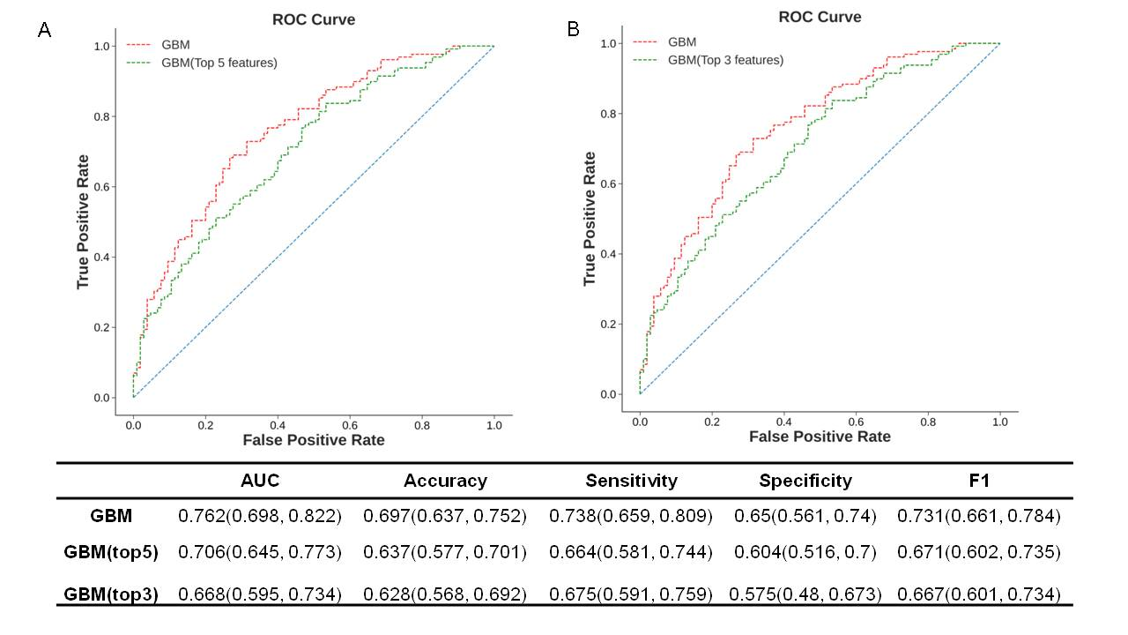
Figure S1. Predicting performance using the top variables identified by SHAP importance plot. GBM = gradient boosting machine.

SHapley Additive exPlanation
To interpret the predicting process of our GBM-based AKI predictor, the Shapley Additive explanation (SHaP) values were used to provide consistent and locally accurate attribution values for each feature, which inherit simultaneously the black-box local estimation advantages of local interpretable model-agnostic explanations (LIME) and the global consistency of the game theory from Shapley value.
SHAP value can interpret the model prediction by calculating the contribution of each feature to the prediction, that is, the prediction output of weighting and summing all possible feature value combinations (GBM log odds). Such contribution is defined as the Shapley value.
For a model including $p$ features {$x_{1},…, x_{p}\}$, the Shapley value of feature $x_{i}$ can be expressed as a weighted sum for all possible coalitions with weights, i.e.,
$$ϕ_{i}(val)=\sum_{S⊆F\backslash \{i\}}{\frac{\left|S\right|!\left(\left|F\right|-\left|S\right|-1\right)!}{\left|F\right|!}\left(val(x_{S∪\left\{i\right\}})-val\left(x_{S}\right)\right)}$$
Where $S$ is a subset of the features used in the model, $F=\{x_{1},…, x_{p}\}$, $x_{i}$ is the vector of feature values of the instance to be explained and $F$ is the number of features, and $val_{x}(S)$ is the prediction for feature values in set $S$ that are marginalized over features that are not included in set $S$:
$$val_{x}\left(S\right)=\int{\hat{f}\left(x_{1},…, x_{p}\right)dP_{x∉S}-E_{X}(\hat{f}(X)})$$

In this study, SHAP value was applied on GBM model to reveal feature contribution to model output on individual level.
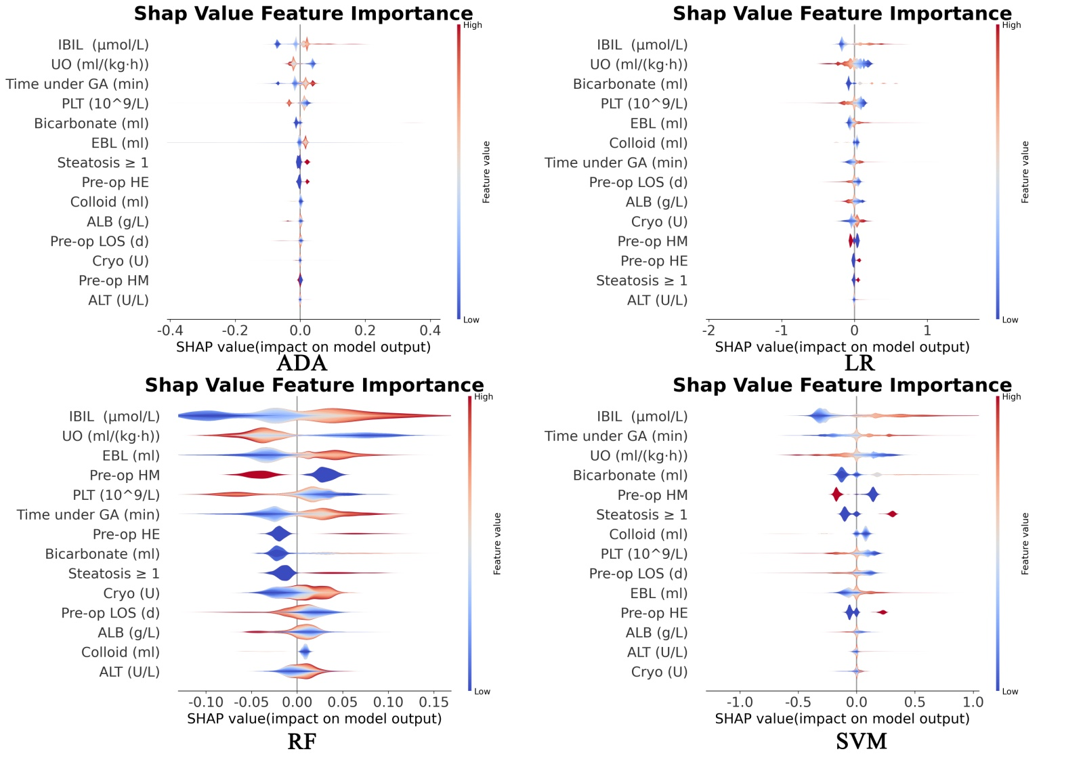
Figure S2. SHAP summary plot of 4 machine learning models besides GBM. ADA = adaptive boosting; LR = logistic regression; RF = random forest; SVM = support vector machine; GBM = gradient boosting machine.

1. Kalisvaart M, Schlegel A, Umbro I, de Haan JE, Polak WG, JN IJ, Mirza DF, et al. The AKI Prediction Score: a new prediction model for acute kidney injury after liver transplantation. HPB (Oxford) 2019;21:1707-1717.

