Additional file 1
Different modulation effects of 1 Hz and 20 Hz transcutaneous auricular vagus nerve stimulation on the functional connectivity of the periaqueductal gray in patients with migraine

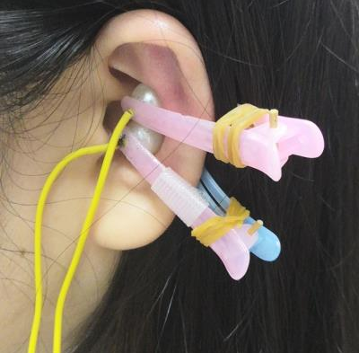
Figure S1. Electrodes and clips used in this study.

