Supplemental Figure 1. Associations of the ratio of STAT1:STAT3 gene expression with expression of selected ICH genes. Scatter plots of (A) CXCL9, (B) CCL5, (C) CCL19, (D) CXCL13, (E) ITGB2, (F) CCL21 with PRF1 gene expression are shown, along with their associated r and p values. (G) Tumors with low (L) and high (H) expression of STAT1:STAT3 are grouped, showing expression levels for the 10 Top ICH genes, and CCL21 for comparison. P value <0.05 (*), <0.01 (**), <0.001 (***), <0.0001 (****).

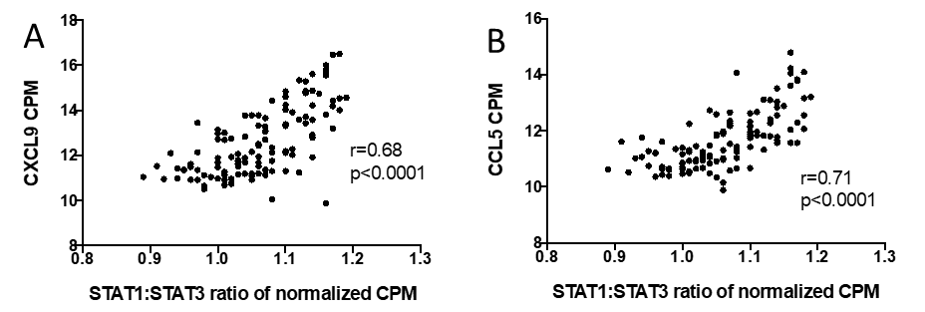
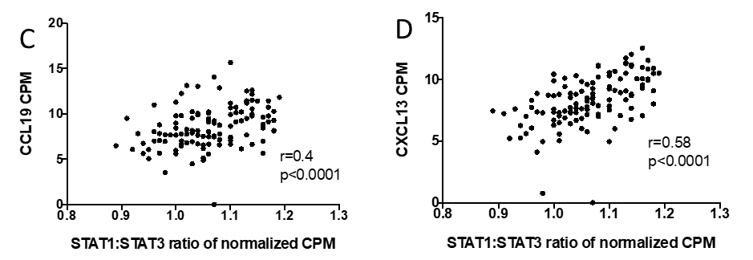
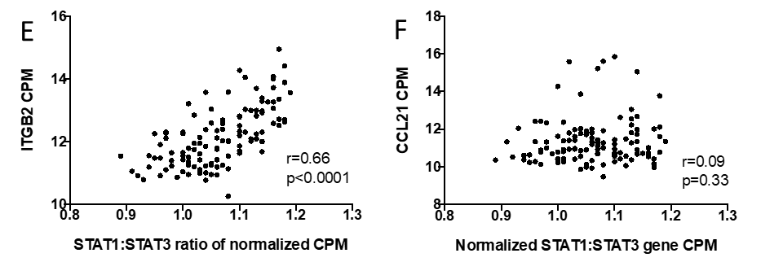
G

Supplemental Figure 2. Associations of IRF1 gene expression with expression of selected ICH genes. Scatter plots of (A) CXCL9, (B) CCL5, (C) CCL19, (D) CXCL13, (E) ITGB2, (F) CCL21 with PRF1 gene expression are shown, along with their associated r and p values. (G) Tumors with low (L) and high (H) expression of IRF1 are grouped, showing expression levels for the 10 Top ICH genes, and CCL21 for comparison. P value <0.05 (*), <0.01 (**), <0.001 (***), <0.0001 (****).

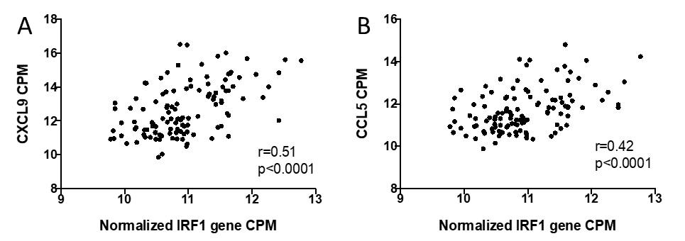

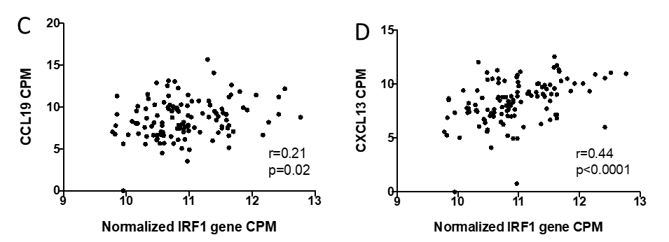

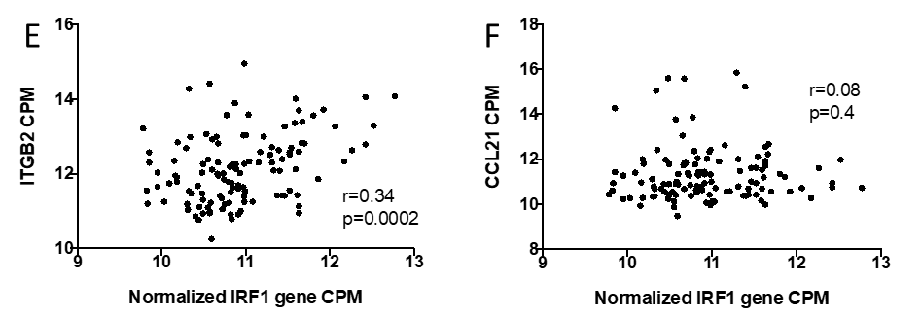
G

