Analysis of changes in microbiome compositions related to the prognosis of colorectal cancer patients based on tissue-derived 16S rRNA sequences

Sukjung Choi¹, Jongsuk Chung², Mi-Ra Jo³, Donghyun Park², and Sun Shim Choi^{1*}

¹Division of Biomedical Convergence, College of Biomedical Science, Institute of Bioscience & Biotechnology, Kangwon National University, Chuncheon 24341, Korea

²GENINUS Inc., Seoul 05836, Korea

³Department of Medical Life Science, College of Medicine, Catholic University of Korea, Seoul 06591, Republic of Korea

*Corresponding author:
Tel: +82-33-250-6487
E-mail: schoi@kangwon.ac.kr

Additional Table and Figures:

Table S1. Clinical characteristics of the enrolled participants
Characteristics | crc_nRC (n=33) | crc_RC (n=18) | P value
Age (mean±SD) | 62.06±11.06 | 64.83±11.26 | 0.230*
BMI (mean±SD) | 23.85±2.85 | 23.12±3.06 | 0.241*
Tumor Locations
Ascending colon | 7 (21.2%) | 3 (16.7%) | 1*
Transverse colon | 1 (3%) | 1 (5.6%) | 1*
Descending colon | 14 (42.4%) | 7 (38.9%) | 1*
Rectum | 10 (30.3%) | 6 (33.3%) | 1*
Cecum | 1 (3%) | 1 (5.6%) | 1*
tumor size (mean±SD) | 6.13±1.66 | 6.04±2.19 | 0.836*
TNM Stage
Stage 0 | 1 (3%) | - | 1#
Stage I | 2 (6.1%) | 1 (5.6%) | 1#
Stage II | 12 (36.4%) | 3 (16.7%) | 0.422#
Stage III | 17 (51.5%) | 6 (33.3%) | 0.607#
Stage IV | 1 (3%) | 8 (44.4%) | 0.009#
*Unpaired two sample t-test
#Pearson's Chi-squared test

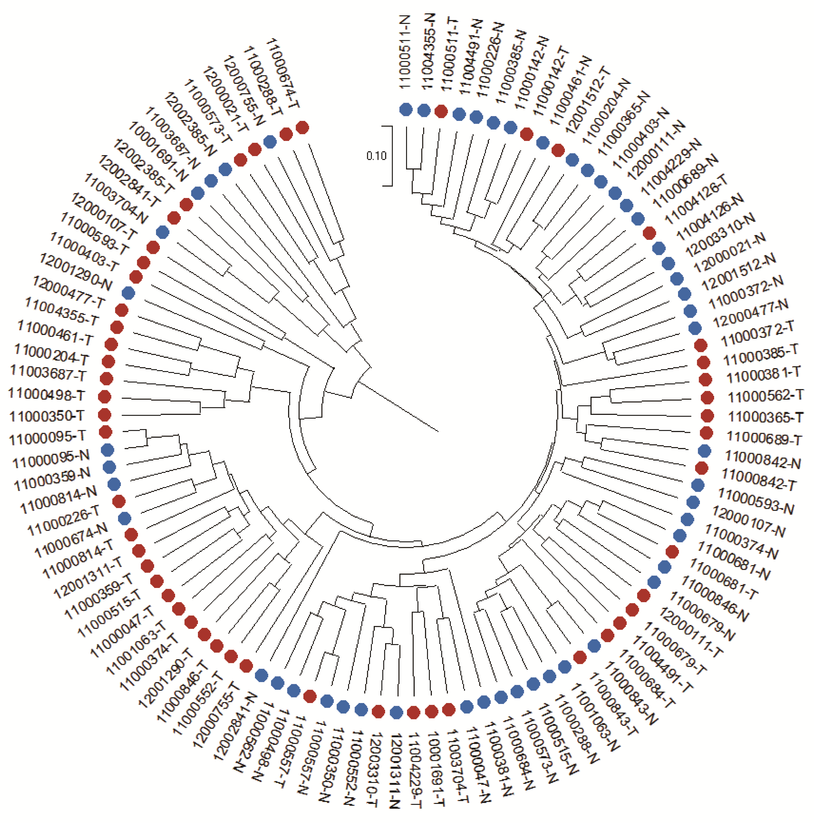
Fig. S1 Hierarchical clustering of ‘phylotypes’ based on OTUs derived from the CRC tissues of 51 Korean patients. A dendrogram was constructed by the UPGMA weighted UniFrac method.

Fig. S2 Differential enrichment of bacteria in normal and tumor colon tissues. A cladogram was produced by LEfSe: (red) taxa enriched in tumor tissues, (green) taxa enriched in normal tissues.

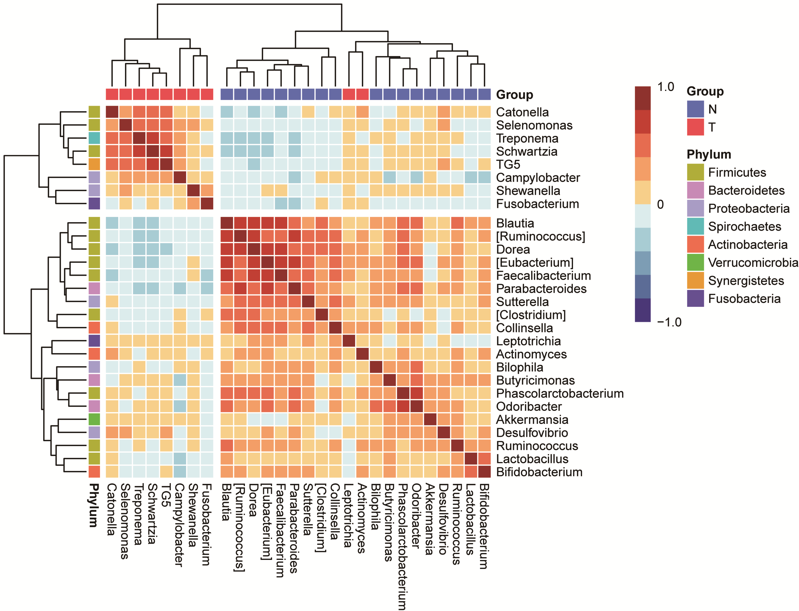
Fig. S3 The genera co-occurring in normal and tumor tissues. Heatmap of Spearman correlation coefficients of 28 genera in normal (18) and tumor (10) tissues.

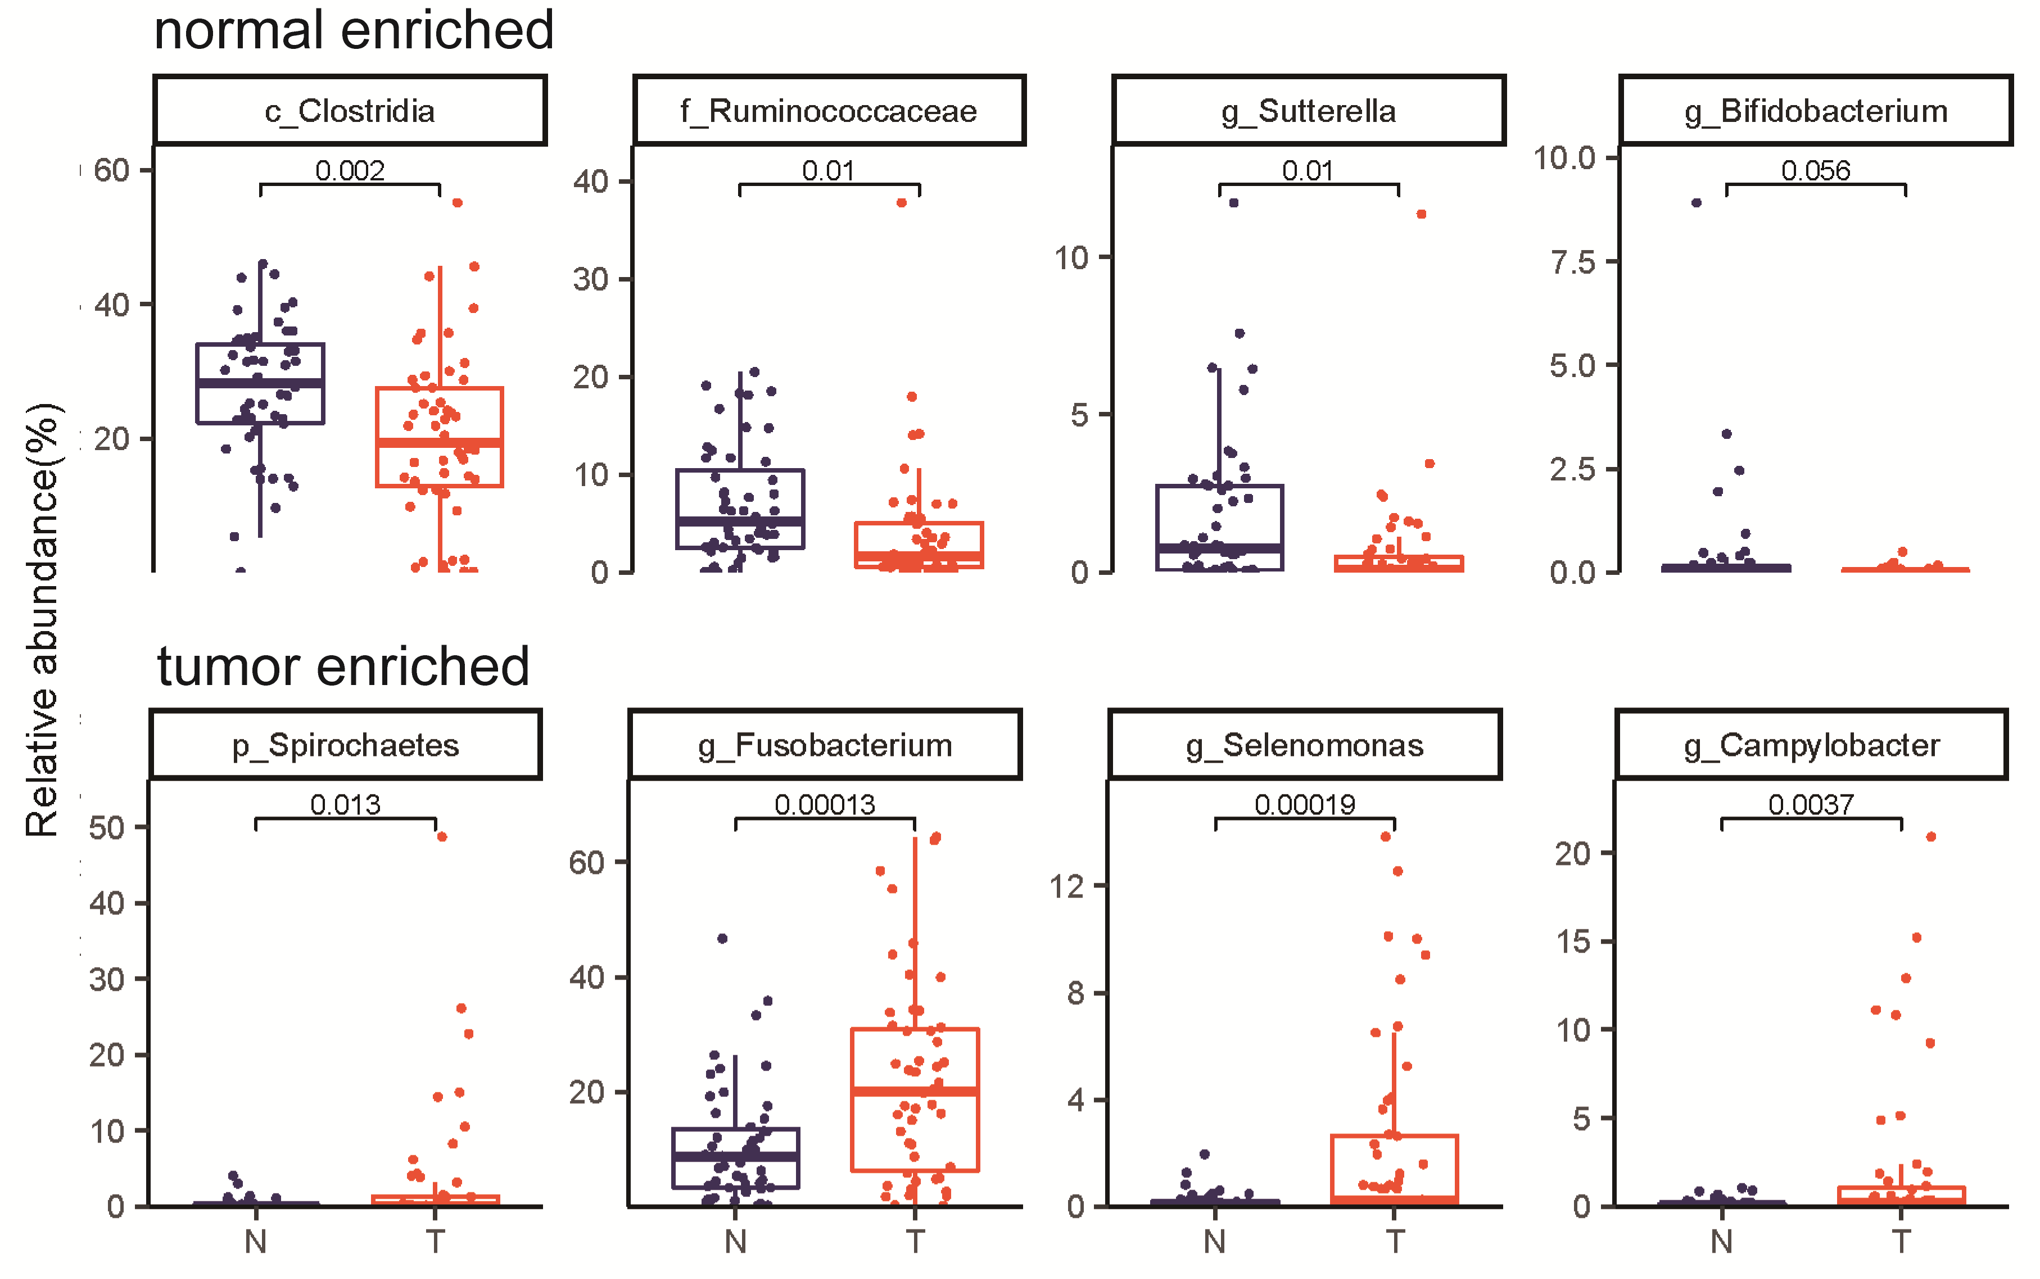
Fig. S4 Additional taxa showing differences in composition between tumors and normal tissues. N: normal, T: tumor

