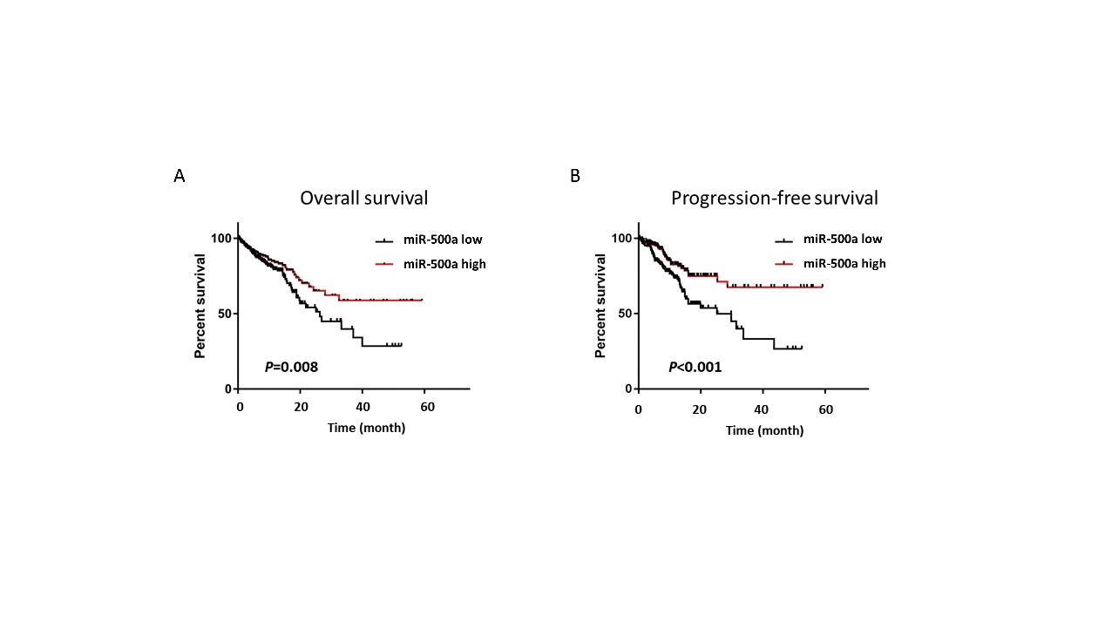
Figure S1
(A-B) Low miR-500 expression was significantly associated with poor overall survival (A) and progression-free survival (B) of CRC patients in cBioportal database.
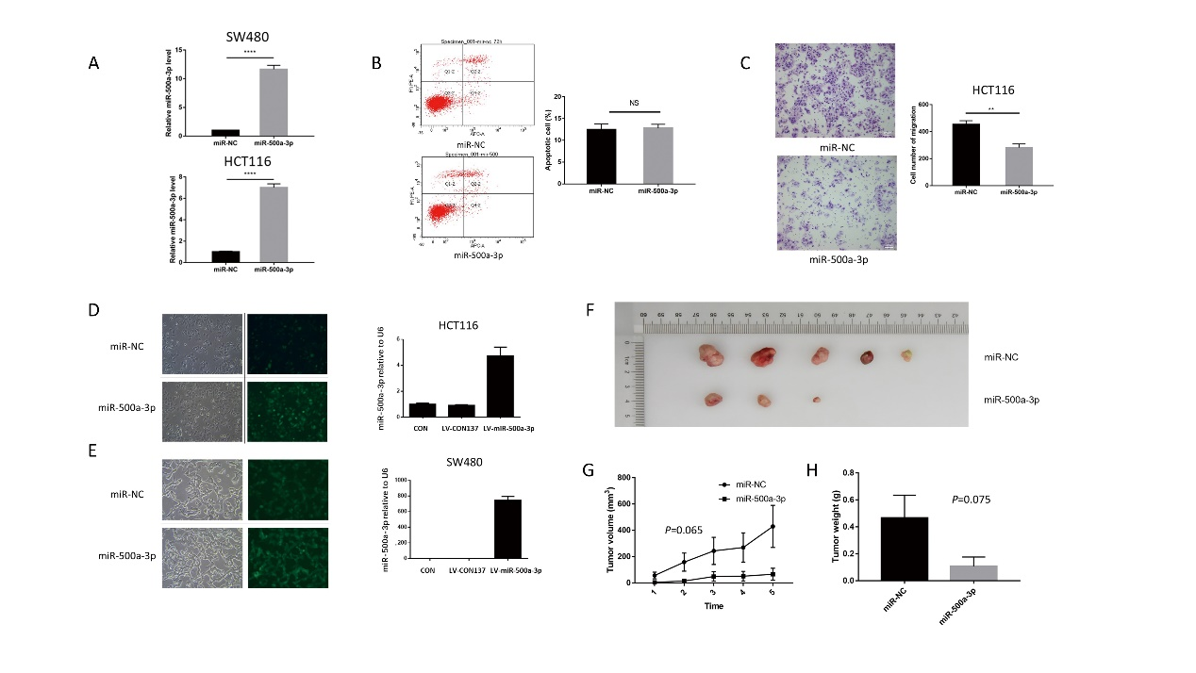
Figure S2
(A) qRT-PCR was carried out to detect the level of miR-500a-3p in SW480 and HCT116 cells transfected with miR-NC or miR-500a-3p.
(B) miR-500a-3p mimics did not increase apoptosis in HCT116 cells.
(C) miR-500a-3p mimics inhibited cell migration in HCT116 cells.
(D-E) Verification of miR-500a-3p overexpression efficiency in SW480 and HCT116 cells
(F) Representative tumor diagrams in different groups were shown.
(G-H) Tumor volume and weight in the miR-500a-3p group were significantly lower than those in the miR-NC group.
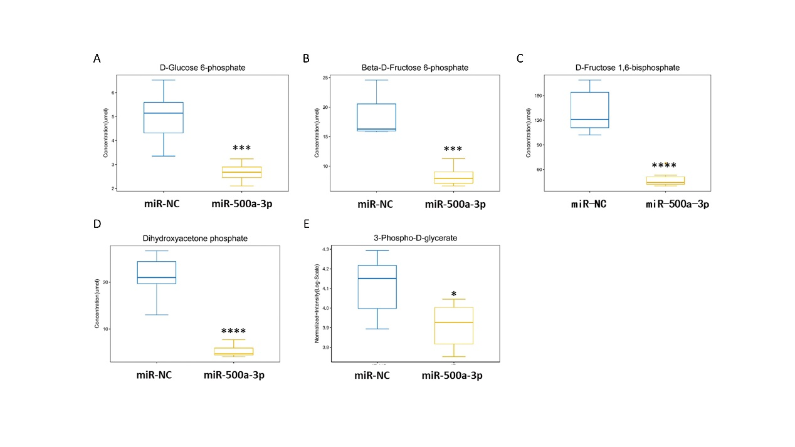
(I) Ki-67 expression was significantly higher in tumors of miR-500a-3p group than that of miR-NC group.
Figure S3
(A-E) Glucose 6-phosphate (A), fructose 6-phosphate (B), fructose 1,6-bisphosphate (C), dihydroxyacetone phosphate (D) and 3-phospho-glycerate (E) in the miR-500a-3p group were significantly lower than those in the miR-NC group.

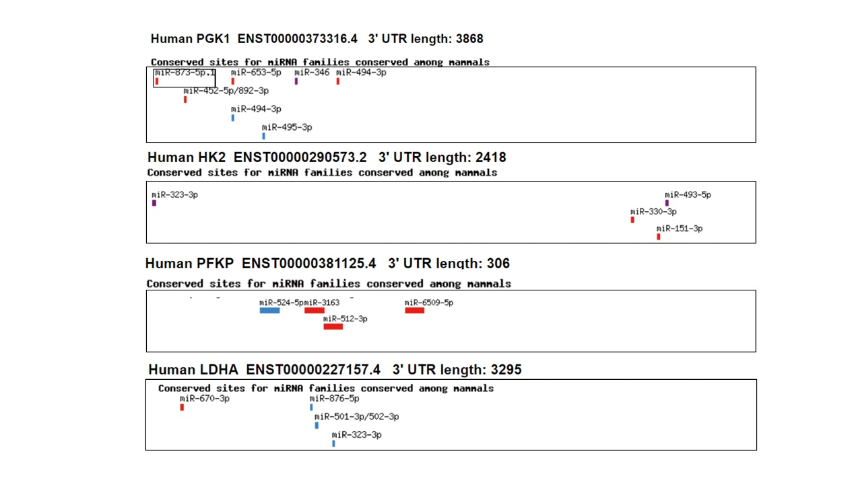
Figure S4
The 3’UTR of glycolysis enzymes did not have conserved binding site of miR-500a-3p.

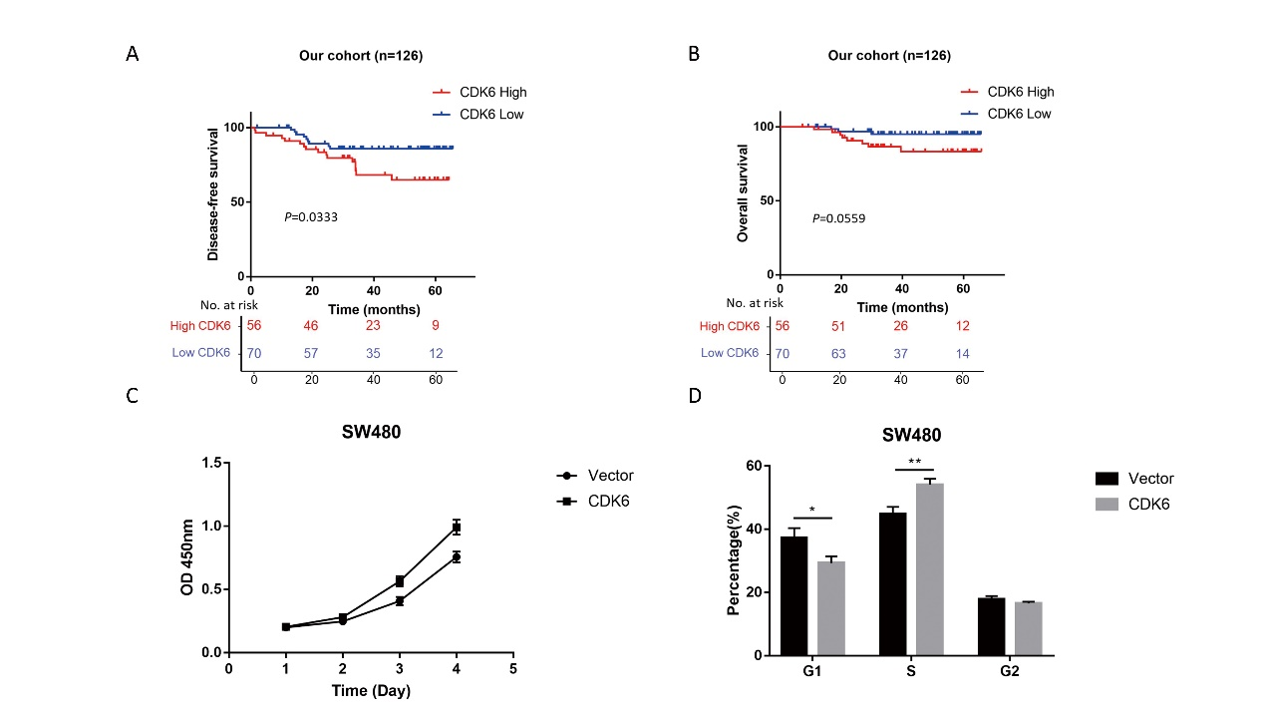
Figure S5
(A-B) CDK6 high expression was significantly associated with poor overall survival (A) and disease-free survival (B) in CRC specimens.
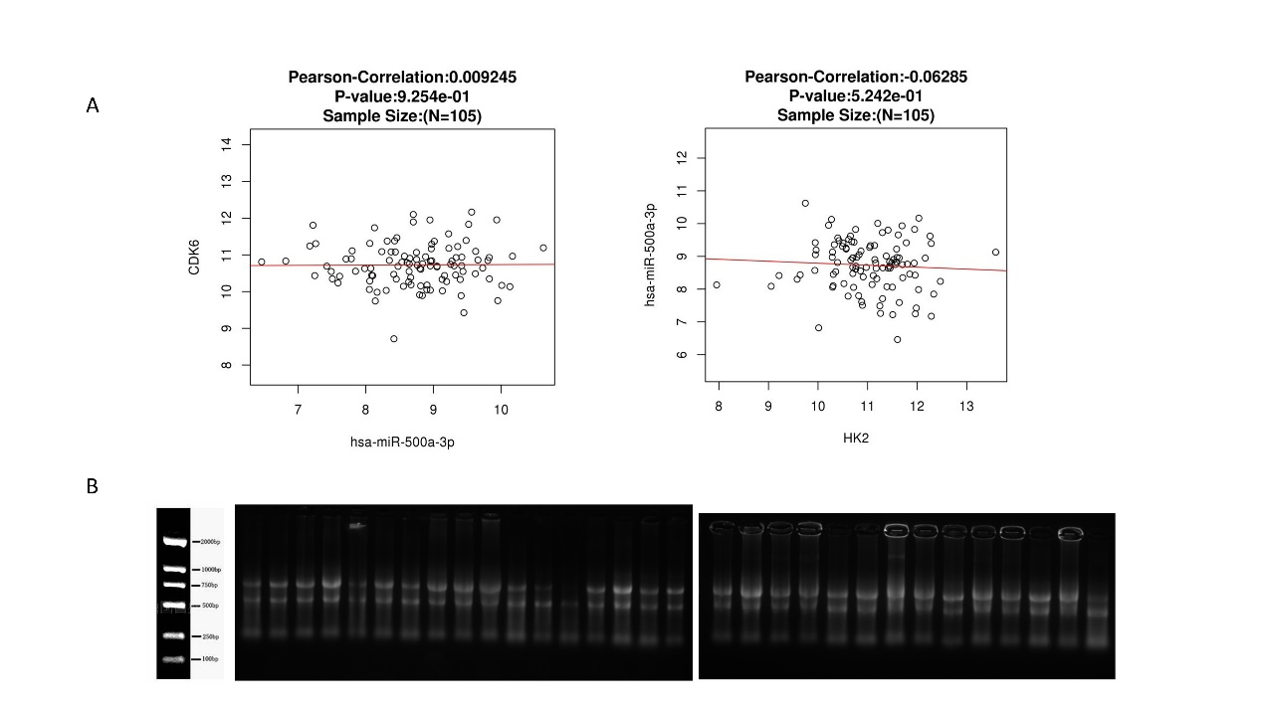
(C-D) CDK6 enhanced CRC cell proliferation using CCK-8 (C) and cell cycle assays (D). Figure S6
(A) The correlation between miR-500a-3p and CDK6 in CPTAC_COAD database (n=105).
(B) The correlation between miR-500a-3p and HK2 in CPTAC_COAD database (n=105).
(C) The representative images of RNA electrophoresis.

