Additional File

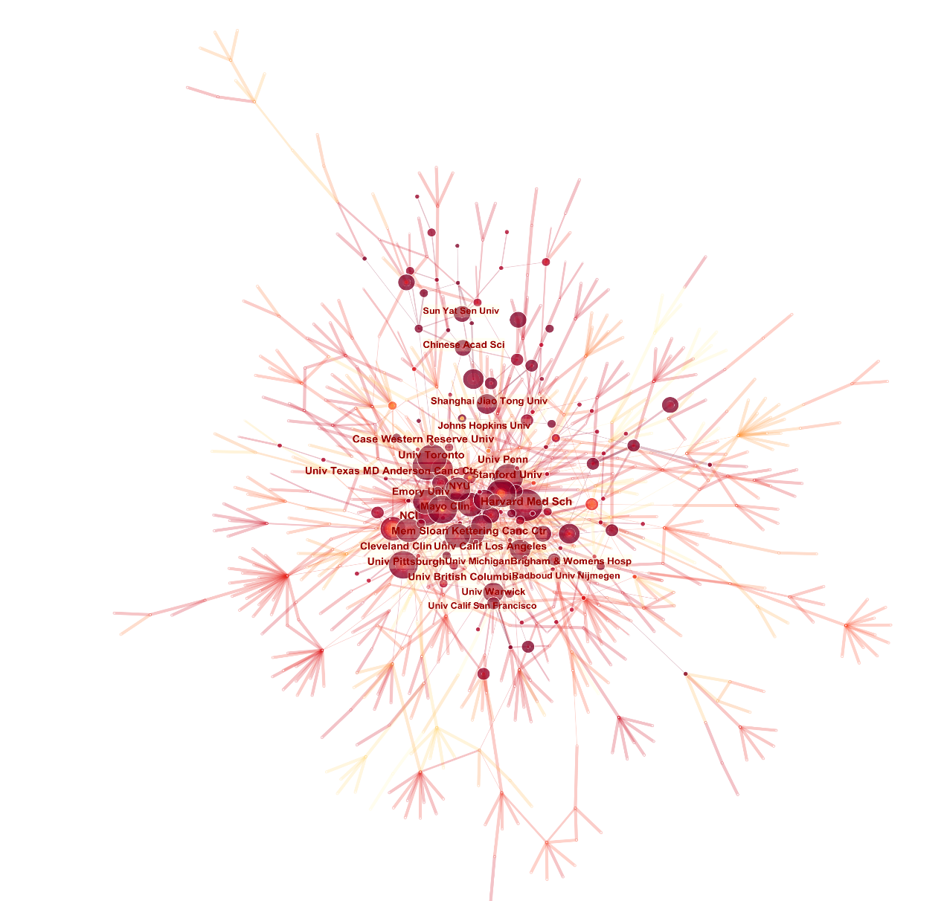
Additional file 1 Figure S1 The institutional cooperation map created with Citespace.
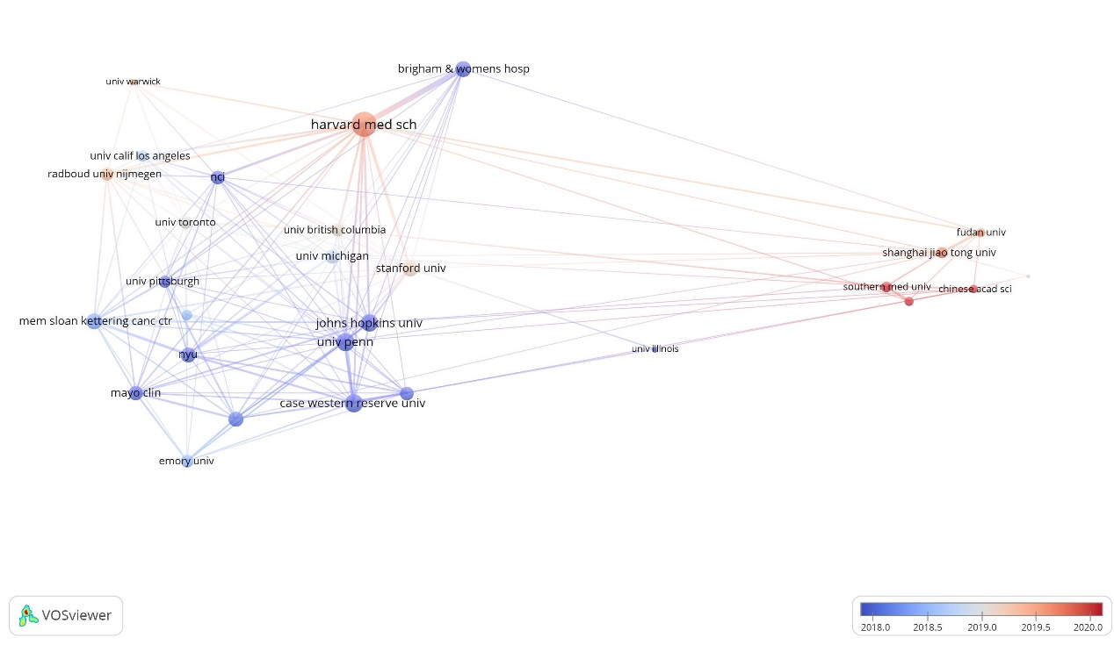
Additional file 1 Figure S2 The overlay visualization map of institution co-authorship analysis generated by VOSviewer.

Additional file 1 Table S1 The options and settings of VOSviewer for AI-based tumor pathology study.
Analysis | Unit of analysis | thresholds | Visualization methods
Co-authorship | Country/region | Minimum number of documents of a country: 20 | Overlay visualization
Co-authorship | Author | Minimum number of documents of an author: 5  Minimum number of citations of an author: 200 | Overlay visualization
Co-authorship | Institution | Minimum number of documents of an institution: 25 | Overlay visualization
Co-citation | Journal | Minimum number of documents of a source: 300 | Network visualization
Co-citation | Cited Reference | Minimum number of citations of a cited reference: 50 | Network visualization
Co-occurrence | Author keywords | Minimum number of occurrences of a keyword: 15 | Overlay visualization

Additional file 1 Table S2 The top 20 commonly investigated cancers/tumors in the field of AI-based tumor pathology based on the frequency of author keywords co-occurrence.
Rank | Keywords | Frequency | Rank | Keywords | Frequency
1 | breast cancer | 196 | 11 | head and neck cancer | 19
2 | prostate cancer | 178 | 12 | melanoma | 18
3 | colorectal cancer | 56 | 13 | colon cancer | 17
4 | lung cancer | 46 | 14 | endometrial cancer | 17
5 | gastric cancer | 29 | 15 | hepatocellular carcinoma | 17
6 | cervical cancer | 24 | 16 | oropharyngeal cancer | 17
7 | rectal cancer | 24 | 17 | non-small cell lung cancer | 16
8 | renal cell carcinoma | 23 | 18 | squamous cell carcinoma | 13
9 | bladder cancer | 19 | 19 | urothelial carcinoma | 13
10 | glioma | 19 | 20 | kidney cancer | 12

