Title page
Title: Comprehensive characterization of ubiquitinome of human colorectal cancer and identification of potential survival-related ubiquitination
Running title: Ubiquintome of human colorectal cancer
Authors and affiliations: Yan Yang^{1,2*}, Wei Zhang^{1, 3*}, Liewen Lin³, Jingquan He³, Jingjing Dong^{1,2}, Bin Yan³, Wanxia Cai³, Yumei Chen³, Lianghong Yin^{1,2}, Donge Tang^{3#}, Fanna Liu^{1,2#}, Yong Dai ^{3#}
Author details:
¹ The First Affiliated Hospital, Jinan University, Guangzhou 510632, China.
² Department of Nephrology, Institute of Nephrology and Blood Purification, the First Affiliated Hospital of Jinan University, Jinan University, Guangzhou 510632, China.
³ Department of Clinical Medical Research Center, The Second Clinical Medical College, Jinan University (Shenzhen People's Hospital), Shenzhen 518020, China.
#Corresponding authors:
Donge Tang, Department of Clinical Medical Research Center, Guangdong Provincial Engineering Research Center of Autoimmune Disease Precision Medicine, The Second Clinical Medical College, Jinan University (Shenzhen People's Hospital), Shenzhen 518020, China. E-mail address: donge66@126.com; Fanna Liu, Department of Nephrology, The First Affiliated Hospital of Jinan University, 613 W. Huangpu Avenue, Guangzhou, Guangdong 510632, China. E-mail address: tliufana@jnu.edu.cn; or Yong Dai, Department of Clinical Medical Research Center, Guangdong Provincial Engineering Research Center of Autoimmune Disease Precision Medicine, The Second Clinical Medical College, Jinan University (Shenzhen People's Hospital), Shenzhen 518020, China. Tel/Fax: (86) 0755-22942780. E-mail address: daiyong22@aliyun.com or dai.yong@szhospital.com.
Co-Authors: These authors contributed equally to this work.

Keywords: Ubiquintome, multi-omics study, colorectal cancer, FOCAD, DOCK2

Supplementary Figure S1
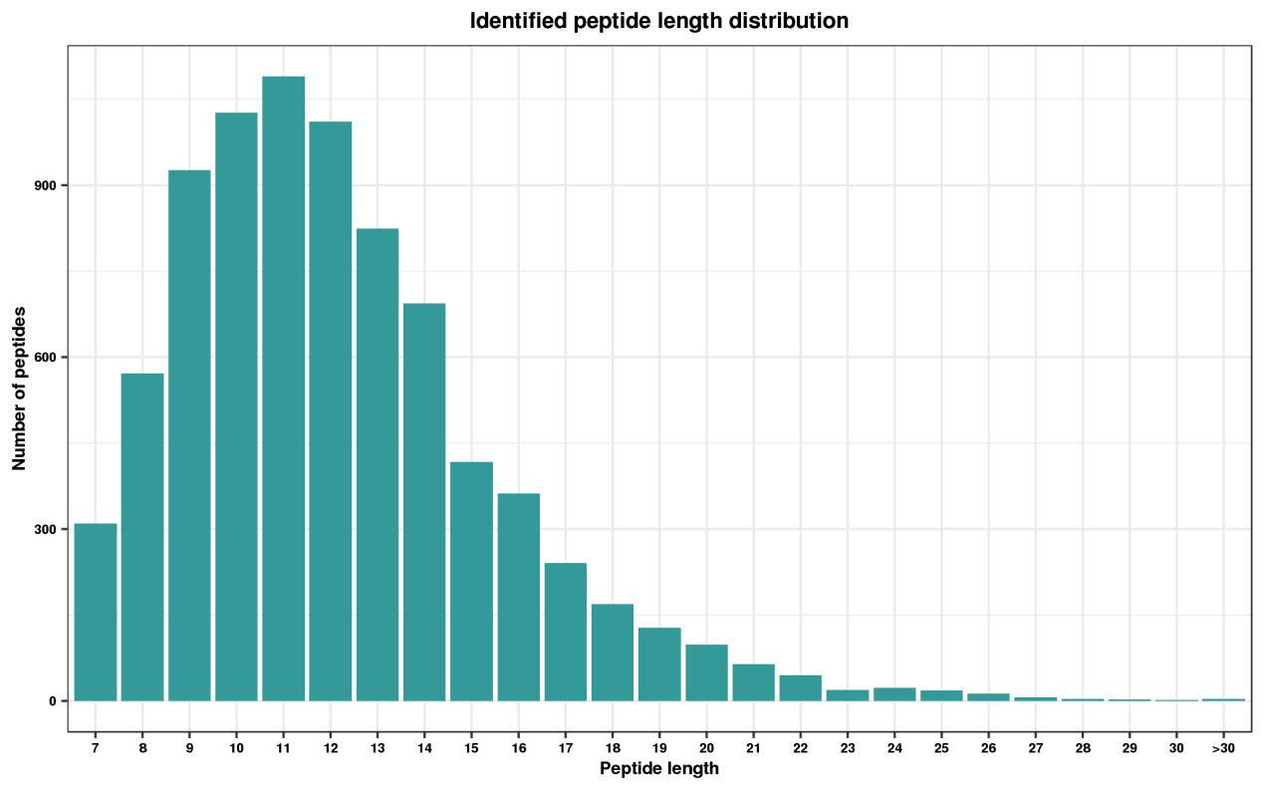
The length of all identified ubiquitinated peptides.

Supplementary Figure S2
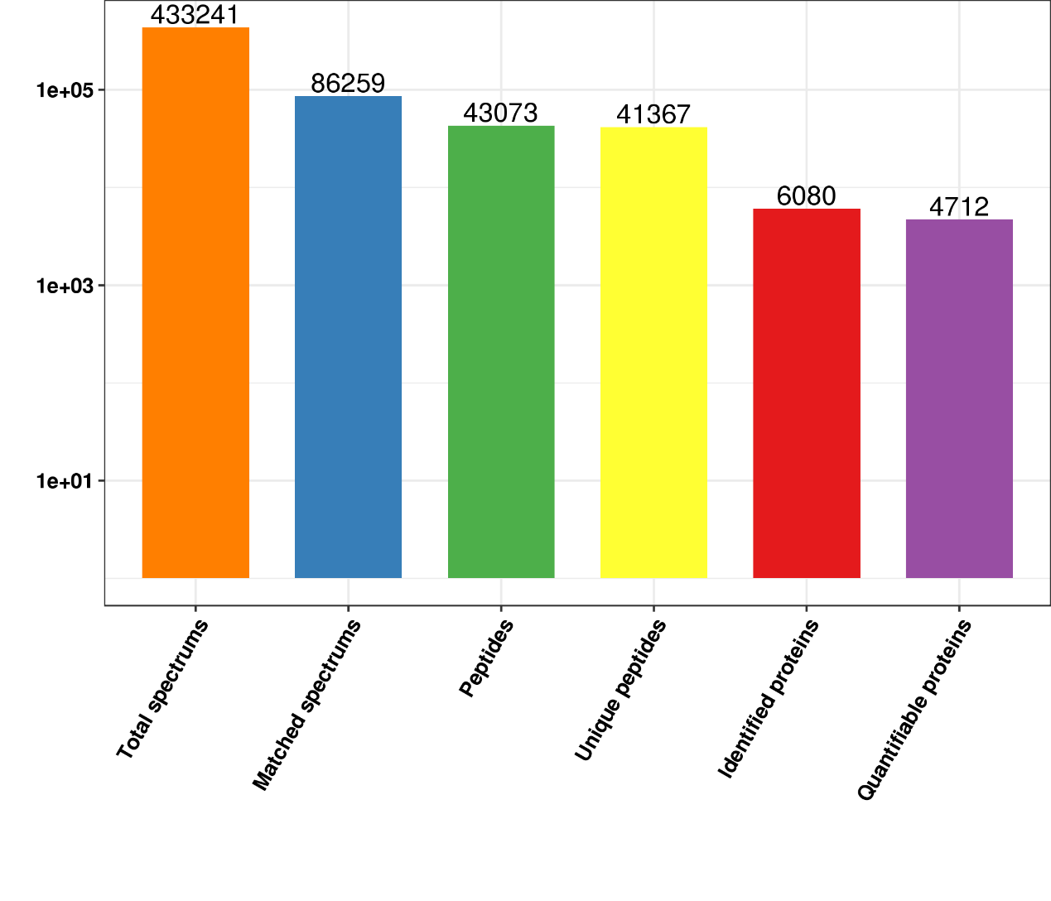 The numbers of all identified spectrums, peptides and proteins of proteomic examination
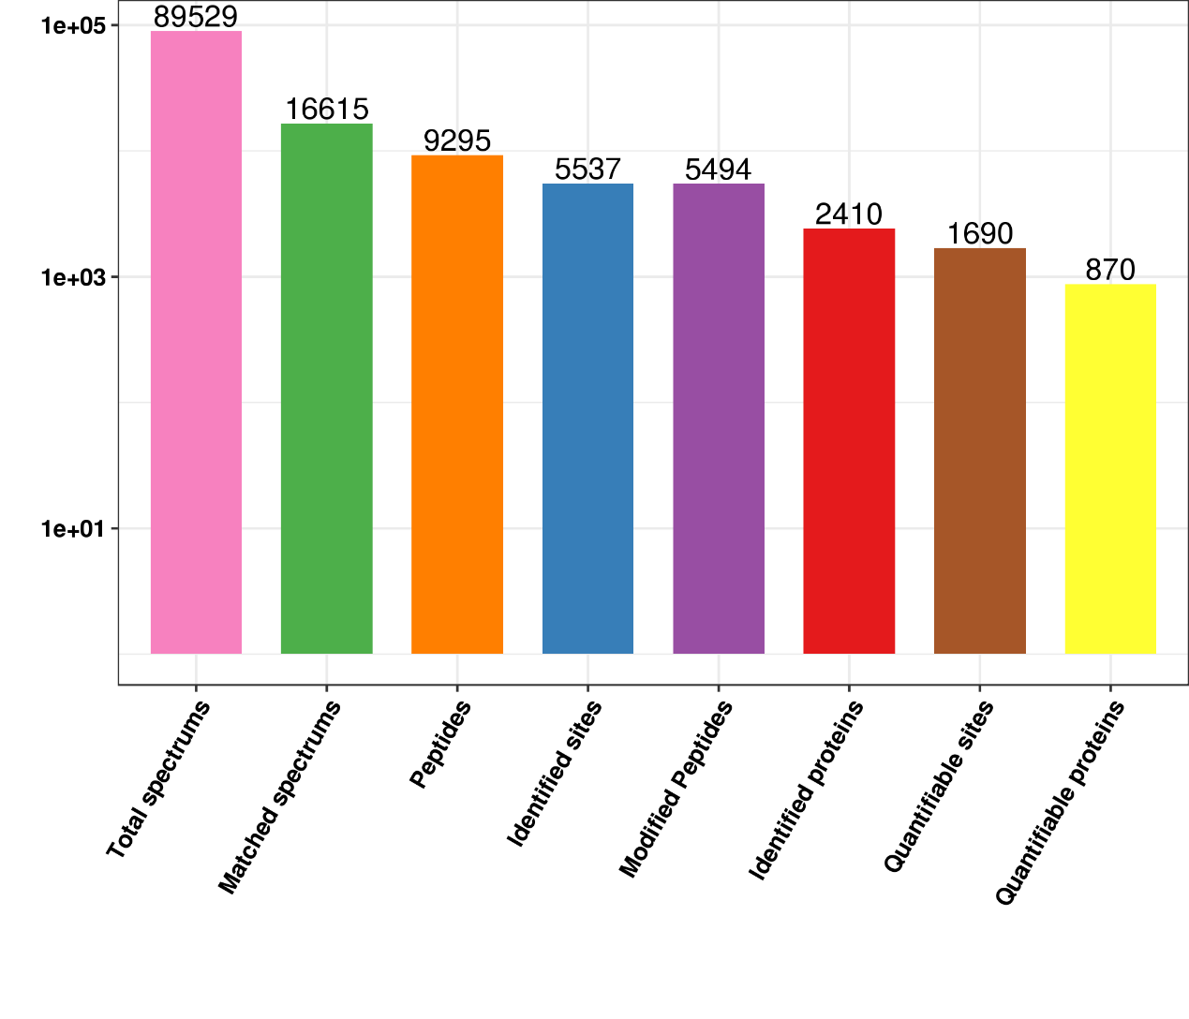The numbers of all identified spectrums, peptides and proteins of ubiquitinomic examination.

Supplementary Figure S3
The screening of potential functional ubiquitination in CRC patients.
(A) The overlapping analysis of 1172 up-regulated proteins and 1204 proteins with down-regulated ubiquitination. (B) The overlapping analysis of 1700 down-regulated proteins and 2242 proteins with up-regulated ubiquitination. (C) 53 up-regulated proteins identified by our proteomic datasets intersected with 796 up-regulated proteins the datasets of CPTAC. (D) 116 down-regulated proteins identified by our proteomic datasets intersected with 2051 down-regulated proteins the datasets of CPTAC. (E) The intersection analysis of 59 ubiquitin-modified proteins identified in Figures 5C, D, and 101 OS-relevant proteins.

