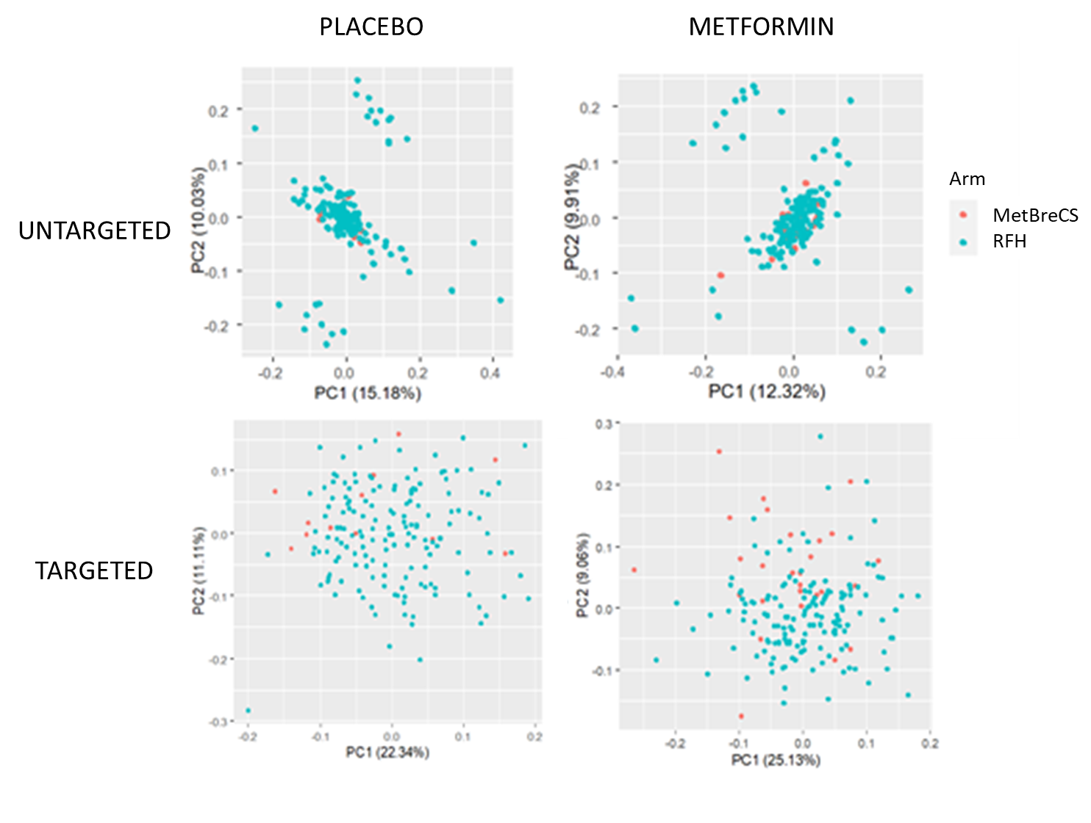
Supplementary Figure S1. Scaled scores of the first two components of the Principal Component Analysis of the changes between baseline and final evaluation of the placebo (left) and metformin arm (right), based on the untargeted (upper) and targeted (bottom) metabolomics data.

