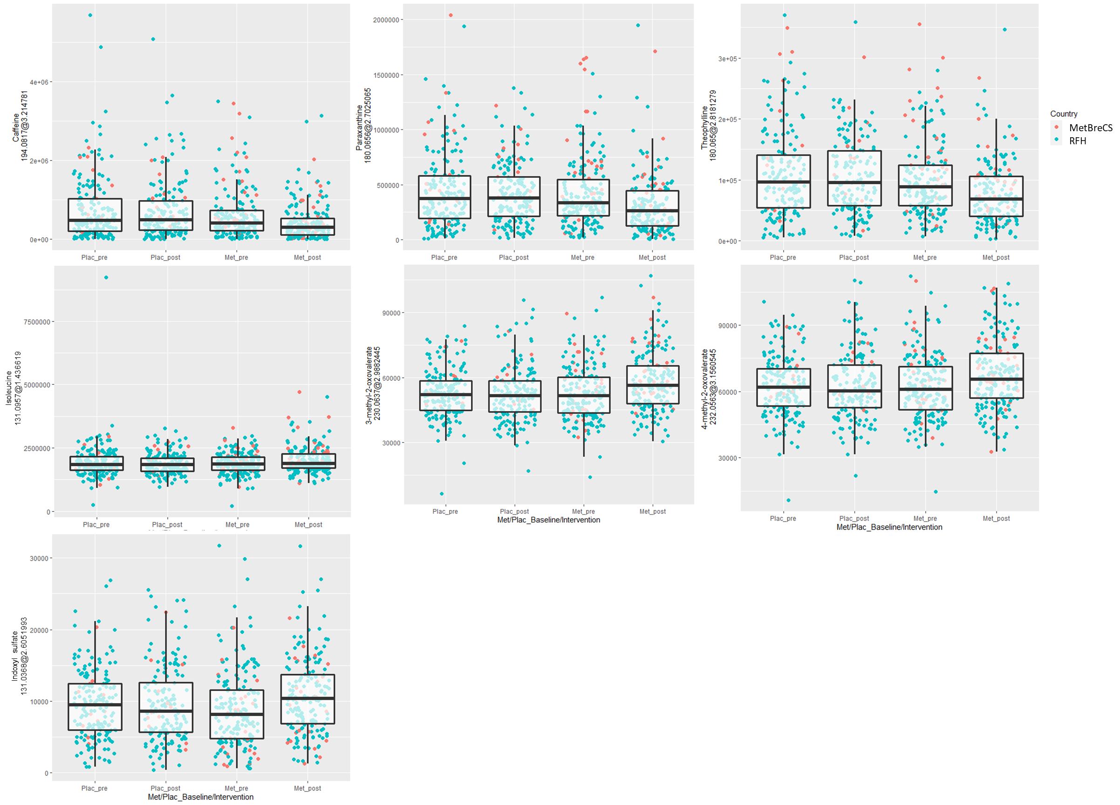
Supplementary Figure S3 Trends observed among the six Level 1 annotated metabolites among intervention arm and time point, colored by the study center.

