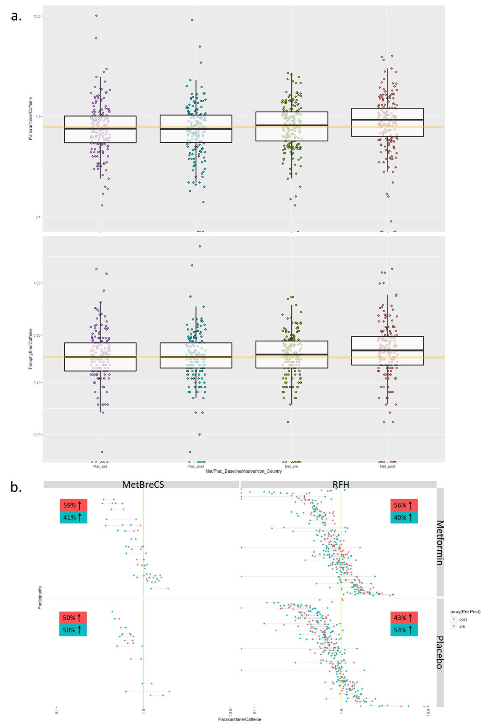
Supplementary Figure S4
a. Boxplots of the paraxanthine/caffeine and theophylline/caffeine ratios, by treatment group and time point (pre- and post- placebo intake, pre- and post- metformin intake).
b. The ratio of Paraxanthine/Caffeine presented by group (Placebo/Metformin) and country (Italy/USA). In the graph, each connected group of dots represents a participant, the color of the dot corresponds to the different time points and the percentages represent the number of sets that the ratio of paraxanthine/caffeine was higher in the pre- (blue) or post- (red) time point.

