Additional file 1

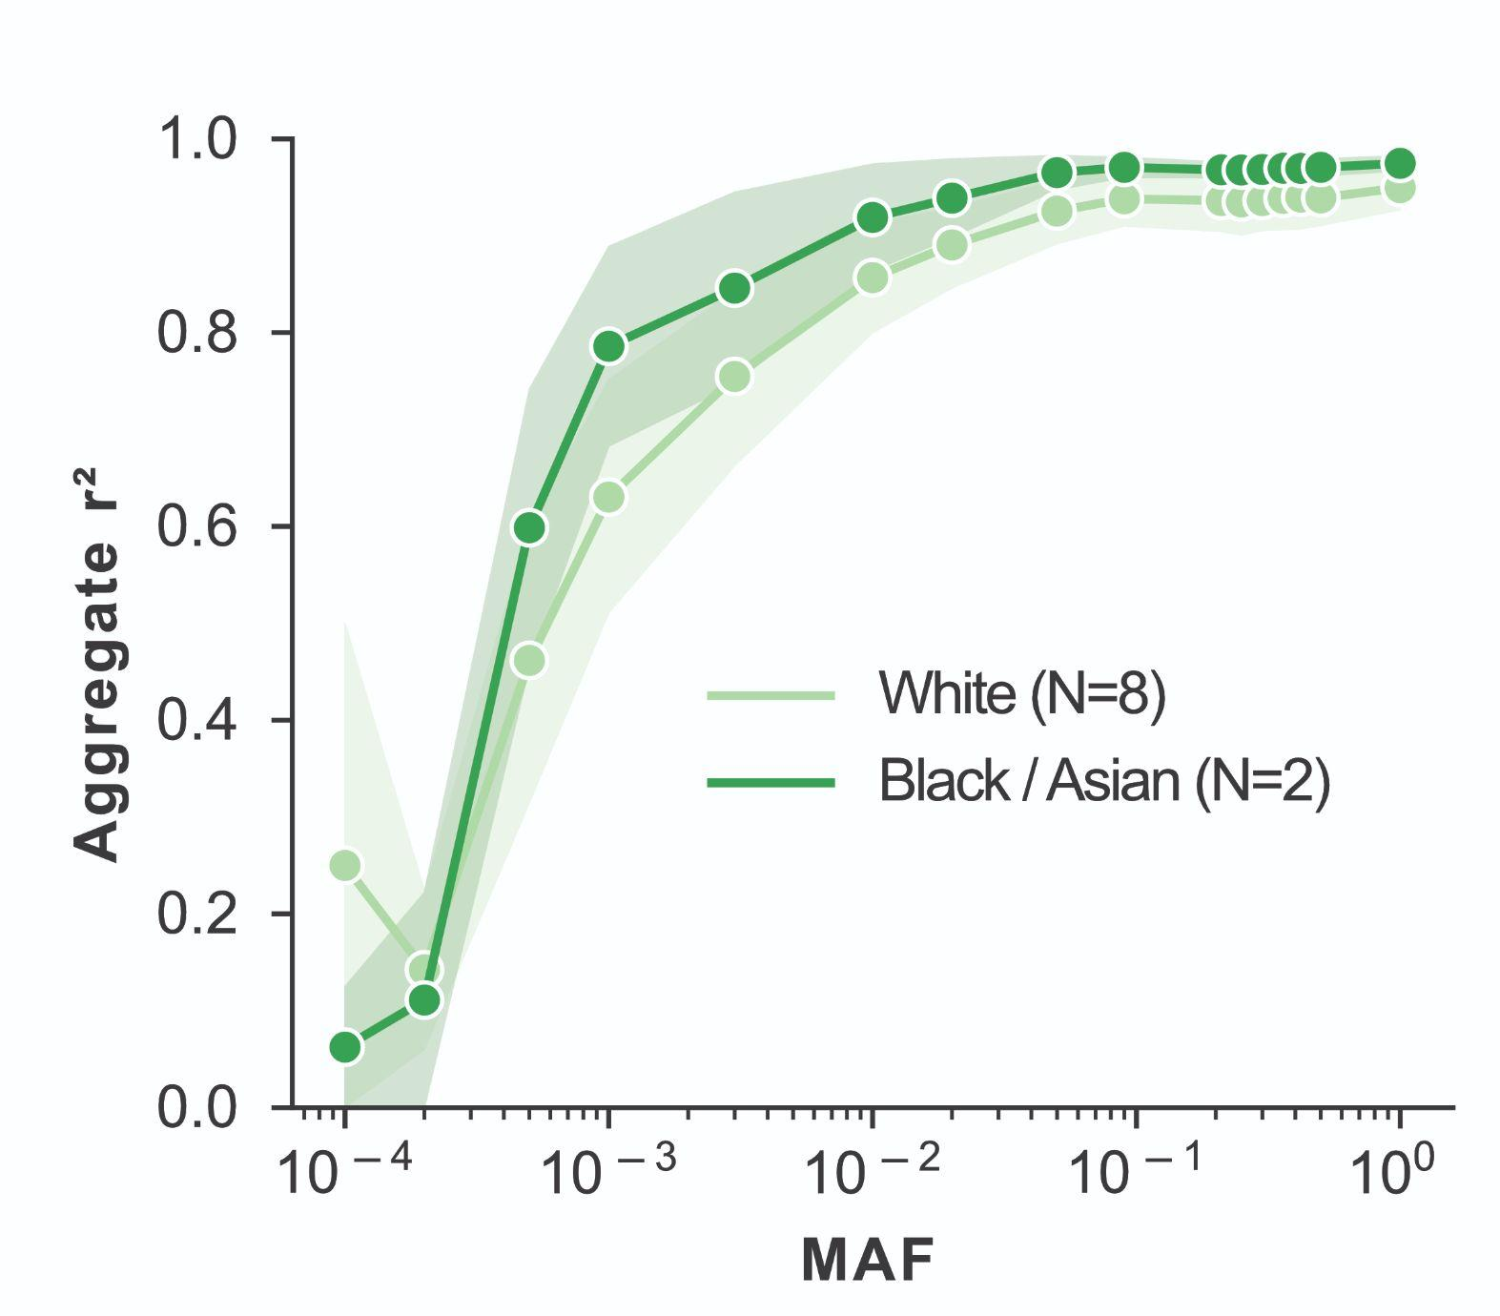
Figure S1. Effect of patient ancestry on lc-WGS imputation concordance between blood and tissue. Comparison of concordance between blood and tissue-based on ancestry background of the patient, with White ancestry in light green and Black or Asian ancestry in dark green. Pearson correlation squared (r²) is for all aggregated SNPs within a MAF bin. When available, 95% confidence intervals are shaded around the line based on 1000 bootstrap iterations.

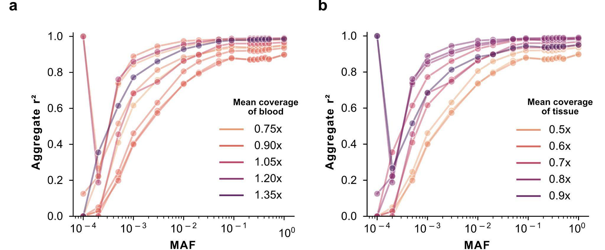
Figure S2. Effect of coverage-related features on lc-WGS imputation concordance between blood and tissue. (a,b) Comparison of concordance as measured by squared Pearson correlation (y-axis) between blood and tissue as a function of MAF (x-axis) based on mean sequencing genome coverage depth of blood (a) or tissue (b).

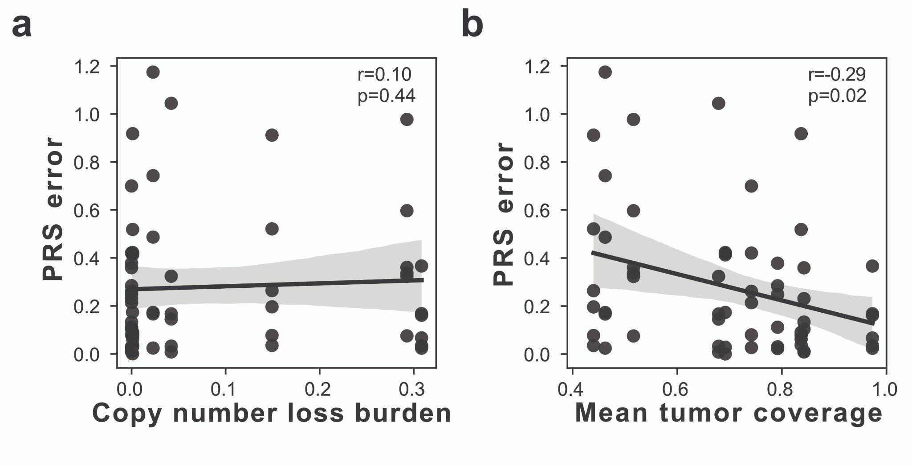Figure S3. Effect of coverage-related features on the error in non-cancer PRS calculation. (a-b) PRS error (y-axis), as measured by the absolute difference between blood and tissue PRS across all non-cancer PRS, as a function of (a) fraction of genome in a copy number loss or (b) mean tissue/tumor genome coverage (x-axis). The 95% confidence intervals are shaded around the line based on 1000 bootstrap iterations. Spearman correlation coefficient, r, and corresponding p-value are indicated as text in the upper right.

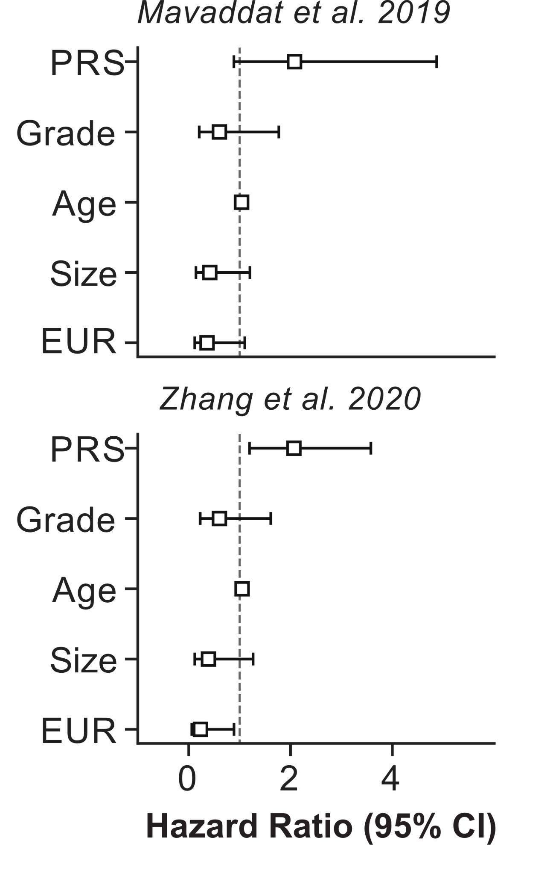

Figure S4. Cox proportional hazard models measuring BCSE outcome in DCIS patients for 6 breast cancer PRS. Forest plot representation of hazard ratios (square) and 95% confidence intervals (error-bars), for each normalized breast cancer PRS and covariates for DCIS BCSE risk including DCIS nuclear grade (Grade), age of the patient at diagnosis (Age), the size of the DCIS lesion (Size), and whether the ancestry of the individual was European (EUR). The dotted line represents a hazard ratio of 1, indicating no effect on BCSE risk, >1 indicating increased, and <1 indicating decreased risk.

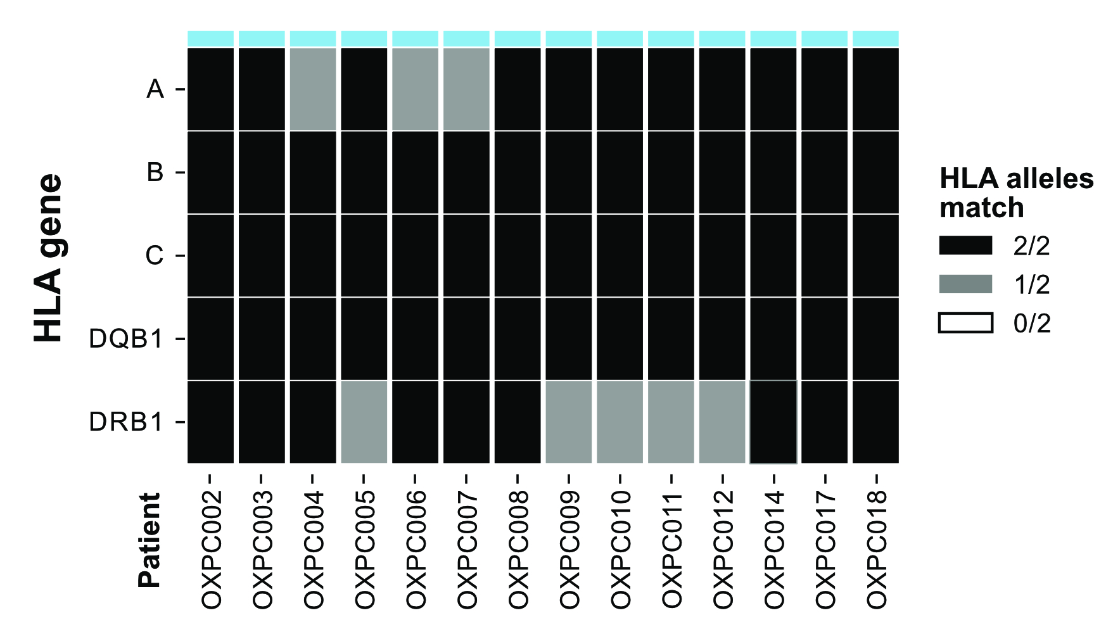Figure S5. Assessment of 2 field HLA-typing accuracy from lc-WGS. Number of concordant HLA alleles (0: white, 1: grey:, 2: black) between haplotypes from the clinical gold standard and those imputed using QUILT-HLA for class I (A, B, C) and class II (DQB1 and DRB1) HLA genes (rows) using blood DNA of 14 patients.

Table S1. Description of the studied samples.
Patient | DNA source | Ancestry | Input DNA (ng) | Coverage | CNA burden | Age of block (yr)¹ | Analysis²
OXPC002 | Blood | White | 68.4 | 1.11 | 0.00 | - | H
OXPC003 | Blood | White | 31.8 | 1.41 | 0.00 | - | GPH
OXPC003 | Tissue | White | 28.4 | 0.69 | 0.00 | 7 | GPH
OXPC004 | Blood | White | 32.1 | 0.84 | 0.00 | - | GPH
OXPC004 | Tissue | White | 5.5 | 0.44 | 0.15 | 7 | GPH
OXPC005 | Blood | White | 53.1 | 0.79 | 0.00 | 5 | GPH
OXPC005 | Tissue | White | 21.8 | 0.97 | 0.48 | - | GPH
OXPC006 | Blood | White | 48.9 | 0.95 | 0.00 | - | H
OXPC007 | Blood | White | 54.6 | 0.87 | 0.00 | - | GPH
OXPC007 | Tissue | White | 35.1 | 0.46 | 0.08 | 6 | GPH
OXPC008 | Blood | White | 45.3 | 0.89 | 0.00 | - | H
OXPC009 | Blood | White | 12.2 | 1.10 | 0.00 | - | GPH
OXPC009 | Tissue | White | 11.0 | 0.84 | 0.01 | 5 | GPH
OXPC010 | Blood | Black or African American | 16.9 | 0.85 | 0.00 | - | GPH
OXPC010 | Tissue | Black or African American | 176.4 | 0.84 | 0.01 | 5 | GPH
OXPC011 | Blood | White | 53.4 | 0.89 | 0.00 | - | GPH
OXPC011 | Tissue | White | 20.4 | 0.52 | 0.65 | 5 | GPH
OXPC012 | Blood | White | 66.0 | 0.71 | 0.00 | - | H
OXPC014 | Blood | White | 12.1 | 0.68 | 0.00 | - | GPH
OXPC014 | Tissue | White | 15.0 | 0.68 | 0.11 | 3 | GPH
OXPC017 | Blood | White | 24.2 | 0.71 | 0.00 | - | GPH
OXPC017 | Tissue | White | 30.6 | 0.79 | 0.01 | 3 | GPH
OXPC018 | Blood | Asian | 14.8 | 1.01 | 0.00 | - | GPH
OXPC018 | Tissue | Asian | 25.3 | 0.74 | 0.00 | 8 | GPH
- Age of block inferred as the difference in years from DNA extraction (2021) to the year of the diagnosis.
- Analysis type sample was used in, which was one of:
GPH: Genome wide, PRS and HLA
H: HLA only (for samples without both tissue and blood)

Table S2. PRS description.
Phenotype | # Variants | # SNPs | # SNPs imputed | # SNPs high-quality | PGSID | Publication source
Bladder cancer | 15 | 15 | 14 | 13 | PGS000071 | https://doi.org/10.1038/s41467-021-21288-z
Breast cancer  (Graff et al., 2021) | 187 | 172 | 167 | 153 | PGS000072 | https://doi.org/10.1038/s41467-021-21288-z
Cervical cancer | 10 | 9 | 9 | 9 | PGS000073 | https://doi.org/10.1038/s41467-021-21288-z
Colorectal cancer | 103 | 103 | 101 | 90 | PGS000074 | https://doi.org/10.1038/s41467-021-21288-z
Endometrial cancer | 9 | 9 | 9 | 9 | PGS000075 | https://doi.org/10.1038/s41467-021-21288-z
Kidney cancer | 19 | 19 | 16 | 16 | PGS000076 | https://doi.org/10.1038/s41467-021-21288-z
Lymphocytic leukemia | 75 | 75 | 69 | 65 | PGS000077 | https://doi.org/10.1038/s41467-021-21288-z
Lung cancer | 109 | 109 | 100 | 85 | PGS000078 | https://doi.org/10.1038/s41467-021-21288-z
Melanoma | 24 | 24 | 22 | 21 | PGS000079 | https://doi.org/10.1038/s41467-021-21288-z
Non-Hodgkin's lymphoma | 19 | 18 | 17 | 16 | PGS000080 | https://doi.org/10.1038/s41467-021-21288-z
Oral cavity and pharyngeal cancers | 14 | 13 | 8 | 8 | PGS000081 | https://doi.org/10.1038/s41467-021-21288-z
Ovarian cancer | 36 | 32 | 30 | 27 | PGS000082 | https://doi.org/10.1038/s41467-021-21288-z
Pancreatic cancer | 22 | 22 | 22 | 18 | PGS000083 | https://doi.org/10.1038/s41467-021-21288-z
Prostate cancer | 161 | 152 | 146 | 136 | PGS000084 | https://doi.org/10.1038/s41467-021-21288-z
Testicular cancer | 52 | 52 | 49 | 45 | PGS000086 | https://doi.org/10.1038/s41467-021-21288-z
Thyroid cancer | 12 | 11 | 11 | 10 | PGS000087 | https://doi.org/10.1038/s41467-021-21288-z
Type 1 Diabetes (T1D) | 825 | 825 | 818 | 747 | PGS001817 | https://doi.org/10.1016/j.ajhg.2021.11.008
Type 2 Diabetes (T2D) | 384 | 384 | 378 | 321 | PGS000832 | https://doi.org/10.1038/s41588-021-00948-2
High lipoprotein density (HLD) | 303 | 302 | 265 | 241 | PGS000845 | https://doi.org/10.1038/s41588-021-00948-2
Body mass index (BMI) | 122 | 122 | 122 | 117 | PGS000841 | https://doi.org/10.1038/s41588-021-00948-2
Cardiovascular disease (CVD) | 330 | 329 | 224 | 212 | PGS000863 | https://doi.org/10.1038/s41588-021-00948-2
Ulcerative colitis (UC) | 179 | 165 | 147 | 132 | PGS001306 | https://doi.org/10.1101/2021.09.02.21262942
Breast cancer  (Zhang et al., 2015) | 330 | 270 | 270 | 241 | PGS000212 | https://doi.org/10.1038/s41588-020-0609-2
Breast cancer  (Mavaddat et al., 2019) | 313 | 265 | 256 | 230 | PGS000004 | https://doi.org/10.1016/j.ajhg.2018.11.002

Table S3. DCIS cohort technical characteristic description.
Patient | Input DNA (ng) | Mean coverage | CNA burden | Age of block (yr)¹ | Passed QC?
OXPA002 | 68.4 | 0.93 | 0.05 | 18 | Yes
OXPA003 | 19.6 | 1.07 | 0.04 | 21 | Yes
OXPA006 | 106.8 | 0.96 | 0.06 | 14 | Yes
OXPA020 | 69.6 | 1.07 | 0.02 | 22 | Yes
OXPA021 | 99 | 1.11 | 0.03 | 21 | Yes
OXPA028 | 29.64 | 0.84 | 0.05 | 16 | Yes
OXPA032 | 38.4 | 1.09 | 0.04 | 15 | Yes
OXPA033 | 300 | 0.96 | 0.08 | 15 | Yes
OXPA036 | 12.7 | 0.88 | 0.07 | 14 | Yes
OXPA044 | 65.4 | 1.10 | 0.03 | 11 | Yes
OXPA064 | 15 | 1.12 | 0.04 | 7 | Yes
OXPA092 | 10.3 | 0.49 | 0.02 | 14 | Yes
OXPA146 | 24.06 | 0.81 | 0.08 | 25 | Yes
OXPA147 | 300 | 0.74 | 0.04 | 25 | Yes
OXPA150 | 30.9 | 0.92 | 0.04 | 24 | Yes
OXPA151 | 64.8 | 0.79 | 0.37 | 24 | Yes
OXPA153 | 201 | 0.96 | 0.05 | 24 | Yes
OXPA156 | 19.9 | 0.83 | 0.03 | 24 | Yes
OXPA161 | 15.4 | 0.95 | 0.04 | 24 | Yes
OXPA166 | 300 | 0.91 | 0.04 | 24 | Yes
OXPA172 | 28.02 | 1.16 | 0.03 | 23 | Yes
OXPA179 | 102 | 0.79 | 0.04 | 23 | Yes
OXPA182 | 31.2 | 0.83 | 0.28 | 23 | Yes
OXPA185 | 52.2 | 0.89 | 0.04 | 23 | Yes
OXPA246 | 109.2 | 1.16 | 0.04 | 20 | Yes
OXPA267 | 204 | 1.01 | 0.07 | 19 | Yes
OXPA295 | 25 | 1.65 | 0.02 | 18 | Yes
OXPA347 | 40.2 | 1.79 | 0.05 | 16 | Yes
OXPA392 | 6.6 | 1.36 | 0.04 | 15 | Yes
OXPA445 | 7.5 | 1.12 | 0.02 | 14 | Yes
OXPA501 | 119.4 | 0.93 | 0.04 | 13 | Yes
OXPA508 | 25.5 | 0.67 | 0.05 | 13 | Yes
OXPA527 | 48.9 | 0.68 | 0.10 | 13 | Yes
OXPA530 | 14.4 | 0.74 | 0.30 | 13 | Yes
OXPA540 | 72.6 | 0.96 | 0.05 | 12 | Yes
OXPA644 | 30.9 | 0.59 | 0.04 | 10 | Yes
OXPA007 | 82 | 0.15 | N/A | 11 | No (Low cov.)
OXPA035 | 17.5 | 0.31 | N/A | 14 | No (Low cov.)
OXPA619 | 35.2 | 0.31 | N/A | 11 | No (Low cov.)
OXPA066 | 300 | 0.34 | N/A | 7 | No (Low cov.)
OXPB024 | 53.7 | 0.47 | N/A | 6 | No (Low cov.)
OXPA025 | 300 | 0.49 | N/A | 17 | No (Contam.)
OXPA574 | 50.1 | 0.80 | N/A | 12 | No (Contam.)
OXPA005 | 18.6 | 0.81 | N/A | 15 | No (Contam.)
OXPA269 | 11.9 | 0.91 | N/A | 19 | No (Contam.)
OXPA165 | 81.6 | 0.92 | N/A | 24 | No (Contam.)
OXPA040 | 300 | 0.93 | N/A | 13 | No (Contam.)
OXPA169 | 300 | 0.97 | N/A | 24 | No (Contam.)
OXPB009 | 224.4 | 0.99 | N/A | 7 | No (Contam.)
OXPA029 | 170.4 | 1.04 | N/A | 16 | No (Contam.)
- Age of block inferred as the difference in years from DNA extraction (2021) to the year of the diagnosis.

Table S4. DCIS cohort covariate association with patient outcome.
Clinical feature |  | No BCSE²  (N=14) | BCSE  (N=22) | Significance³
Grade¹ | Low | 36% (5) | 41% (9) | p=0.59
Grade¹ | Intermediate | 50% (7) | 27% (6) | p=0.59
Grade¹ | High | 7% (1) | 9% (2) | p=0.59
ER status¹ | + | 71% (10) | 77% (17) | p=0.39
ER status¹ | - | 7% (1) | 0% (0) | p=0.39
Ethnicity¹ | Hispanic | 14% (2) | 9% (2) | p=0.63
Ethnicity¹ | Non-Hispanic | 86% (12) | 91% (20) | p=0.63
Race | Asian | 14% (2) | 9% (2) | p=0.63
Race | White | 86% (12) | 91% (20) | p=0.63
Pathologic size (cm)¹ |  | 1.35 | 0.85 | p=0.05
Age at diagnosis (yrs) |  | 56.3 | 60.1 | p=0.27
- Missing values not represented here, but can be found in Table S2.
- BCSE: Breast cancer subsequent event.
- P-values were computed using Fisher Exact test for ER status, Race, Ethnicity and Chi-square test for Grade. For continuous features, size and age, Mann-Whitney U test was used to compare groups.

