Figure S1.
Overall survival (OS) of adult subjects with AML according to SMIM3. OS of 236 AML subjects in ZZU
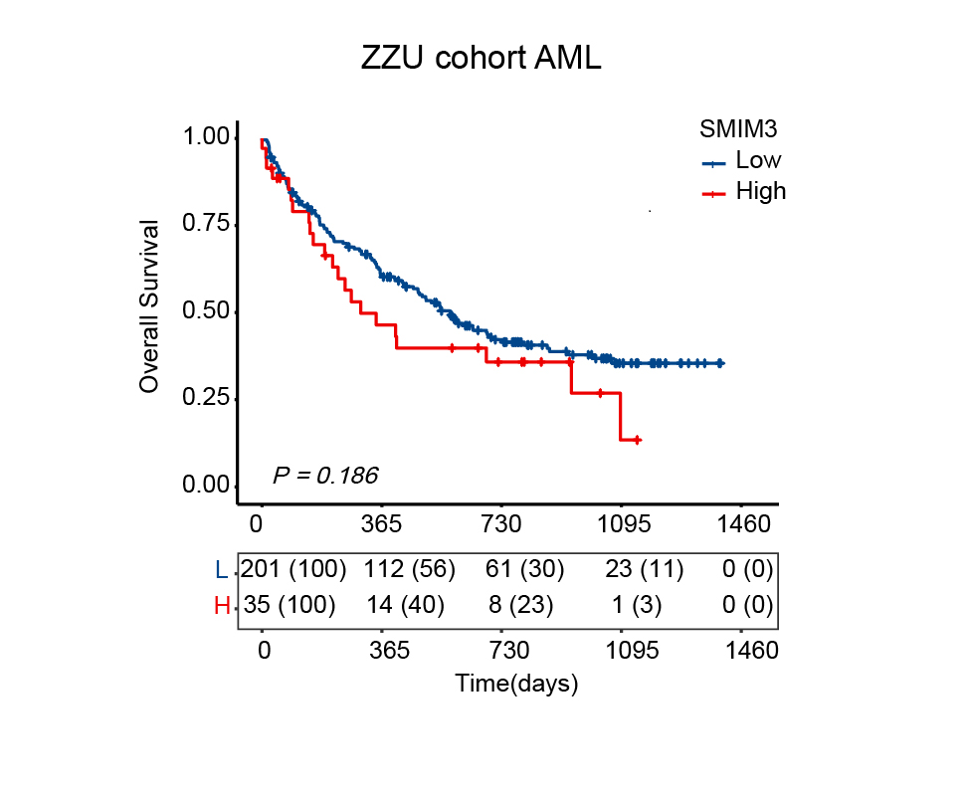

Figure S2.
Immunohistochemical analysis of tissues in tumor tissues.

