Figure S1. Functional enrichment analysis of cytokine antibody array.
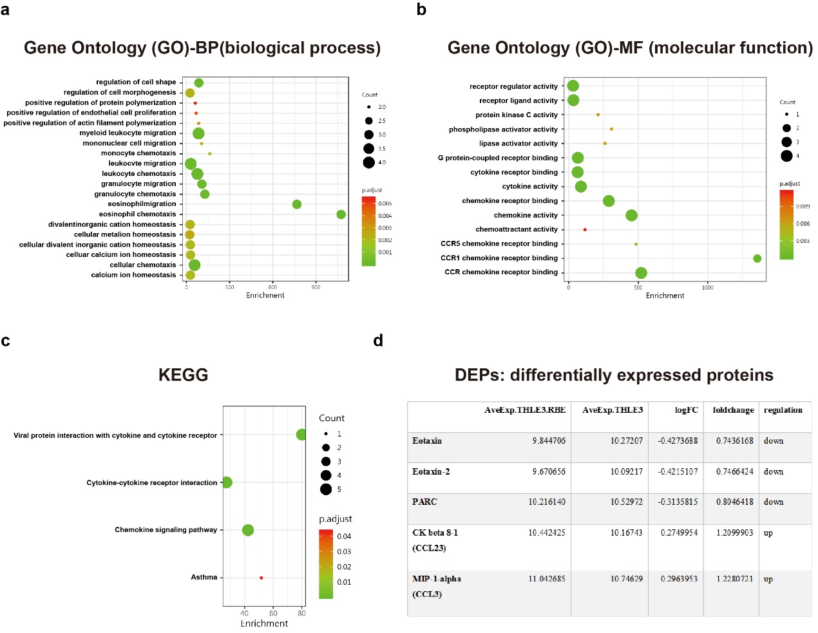

Figure S2. Validation of VIRMA knockdown and overexpression in ICC cells. (a) qRT-PCR (up) and western blot (down) analysis of VIRMA expression in VIRMA-knockdown ICC cells. siVIRMA-1 and siVIRMA-2 indicated VIRMA knockdown in both RBE and HuCCT1 cells. (b) qRT-PCR (up) and western blot (down) analysis of VIRMA expression in VIRMA-overexpression ICC cells. oeVIRMA indicated RBE cells and HuCCT1 cells transfected with an overexpressing plasmid. The relative quantification was calculated using the 2^{−ΔΔCt} method and normalized based on GAPDH.
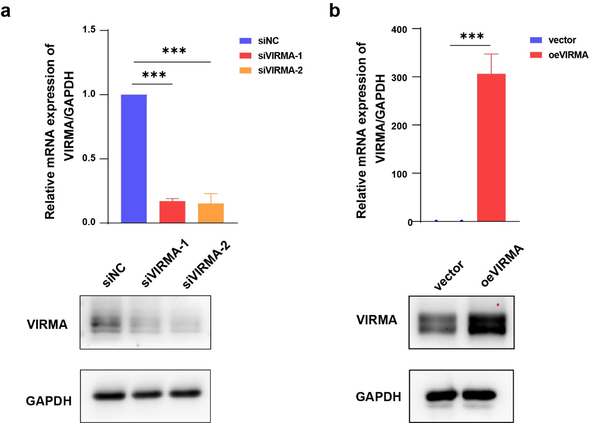

Figure S3. MeRIP-seq and RNA-seq analysis. (a) GO analysis of down-regulated genes identified for MeRIP-seq. (b) Motif analysis. (c) The peak annotation for m⁶A signal enrichment in MeRIP-seq. (d) GO analysis of down-regulated genes identified for RNA-seq. (e) KEGG analysis of down-regulated genes identified for RNA-seq. (f) GO analysis of up-regulated genes identified for RNA-seq. (g) KEGG analysis of up-regulated genes identified for RNA-seq.
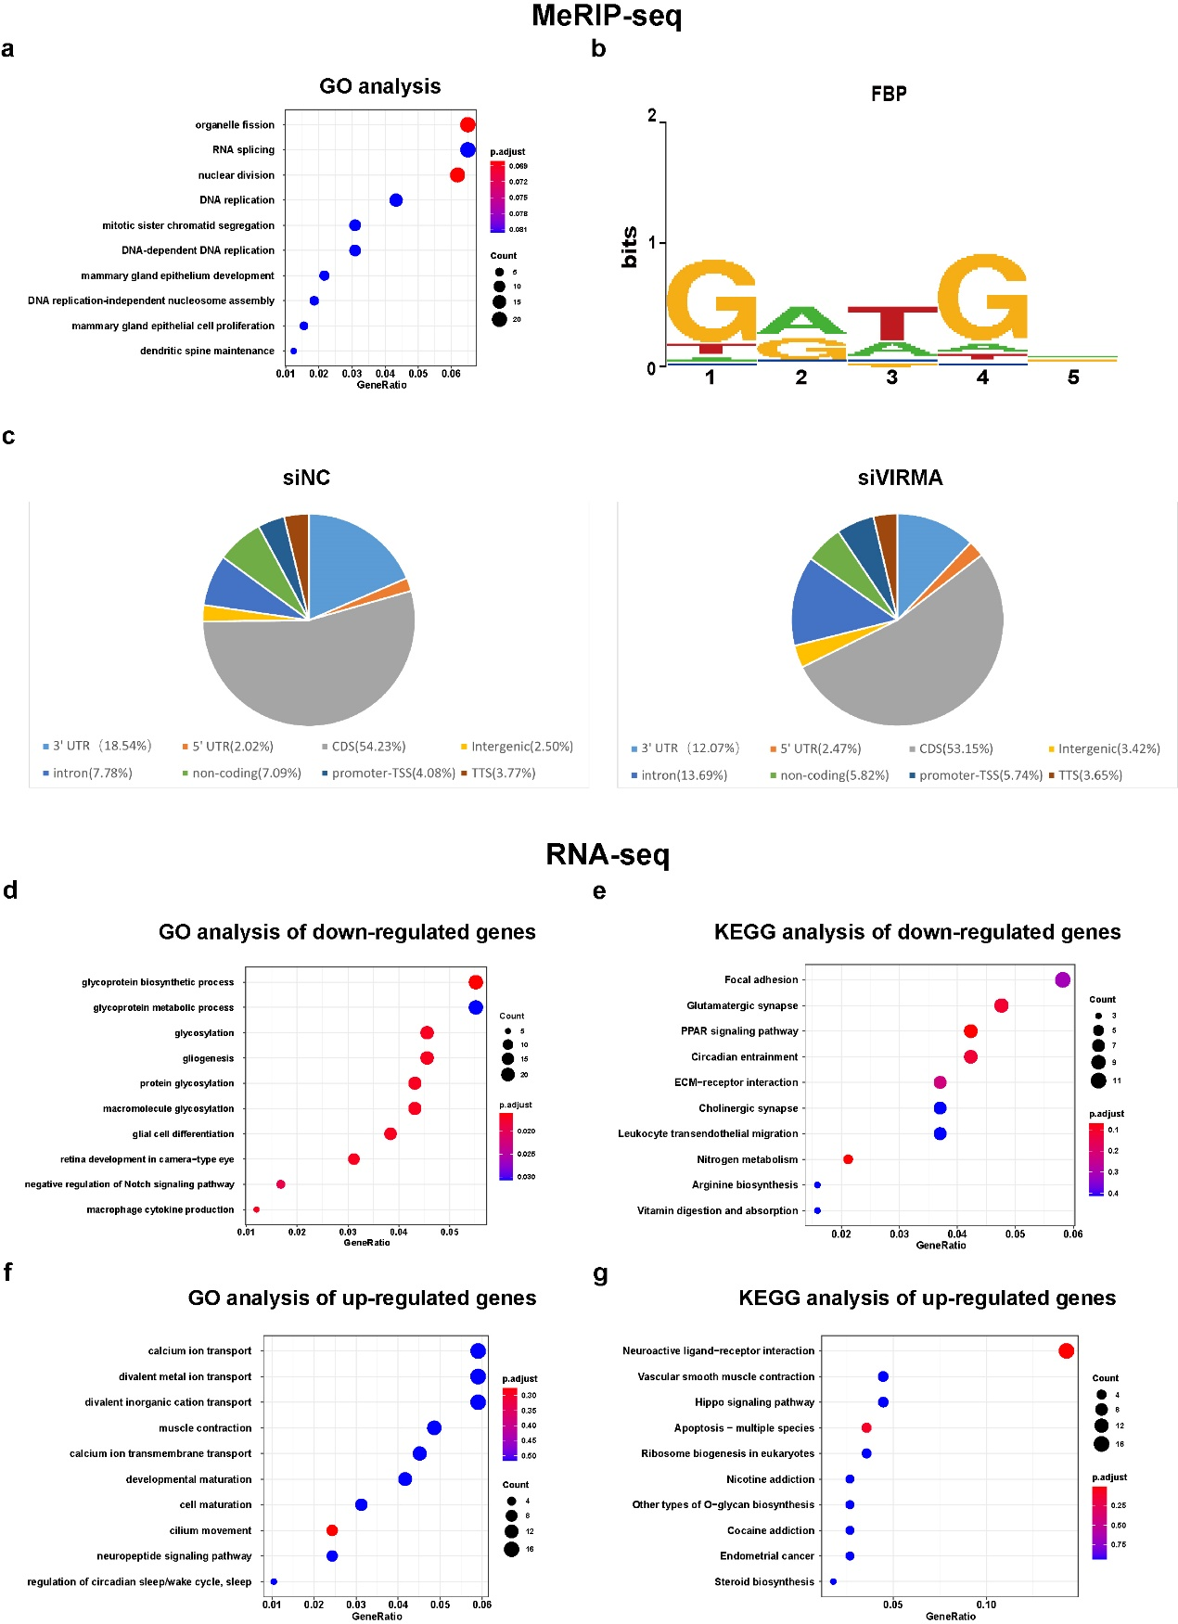
Figure S4. Quantification of rescue experiments.
