eFigure 1: ALSFRS-R slope for each patient in run-in, and 3-, 6- and 12-month follow up after AstroRx® treatment
1002/A
1005/A
1008/A
1001/A
1009/A
2010/B
2012/B
2015/B
2016/B
2017/B
(1 mo)
(9 mo)
(10 mo)

eFigure 2: Serum levels of Nfl for each patient

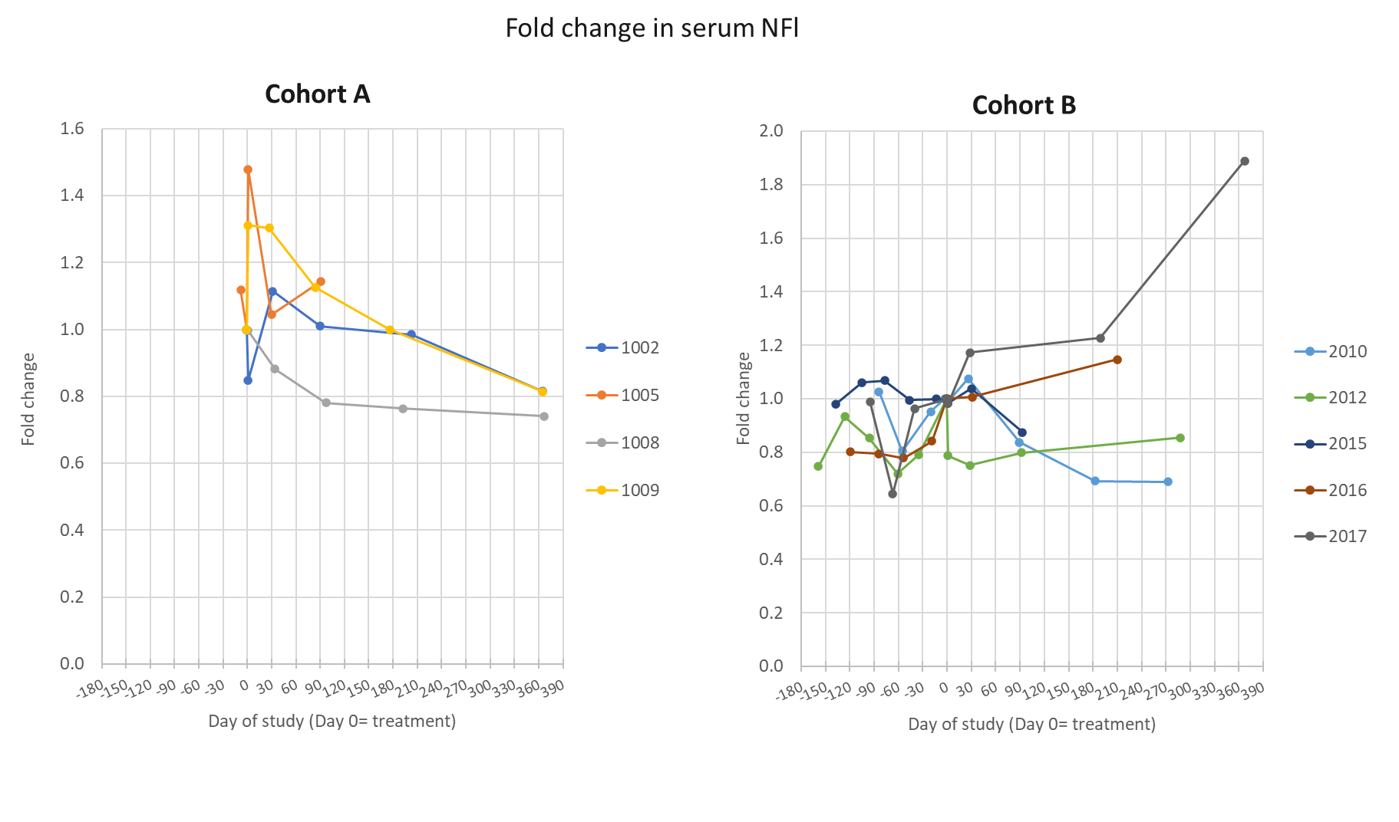

eTable 1: List of serious TEAEs
Patient ID/  cohort | AE preferred term | SAE start day (days after treatment) | SAE end day (days after treatment) | Relation to  drug product/  IT procedure/  immunosuppression | SAE outcome
1005/A | Gastrostomy | 70 | 71 | Not related | resolved
1005/A | Pneumonia aspiration | 165 | 178 | Not related | resolved
1005/A | Viral infection | 198 | 202 | Not related | resolved
1005/A | Respiratory failure | 274 | Death | Not related | Death
1008/A | Dysphagia | 153 | 155 | Not related | resolved
2012/B | Procedural headache | 0 | 17 | Related to IT procedure | resolved
2015/B | Respiratory failure | 289 | Death | Not related | Death
2016/B | Respiratory failure | 303 | Death | Not related | Death
2017/B | Cerebellar infarction | 188 | Ongoing | Not related | No clinical signs related to the SAE were reported
eTable 2: Treatment emergent adverse events (TEAE) reported in at least 20% of patients in both treatment arms
Preferred Term | A |  | B
Preferred Term | (n=5) |  | (n=5)
Preferred Term | Patients n (%) | Events n | Patients n (%) | Events n
Procedural Headache | 3 (60) | 3 | 2 (40) | 2
Oedema Peripheral | 3 (60) | 4 | 0 | 0
Respiratory failure | 1 (20) | 1 | 2 (40) | 2
Injection Site Pain | 1 (20) | 1 | 2 (40) | 2
Dyspnoea | 0 | 0 | 2 (40) | 3
Anaemia | 1 (20) | 1 | 1 (20) | 1
Nausea | 0 | 0 | 2 (40) | 2
Bronchitis | 1 (20) | 1 | 1 (20) | 1
Neck Pain | 2 (40) | 2 | 0 | 0
Ecchymosis | 2 (40) | 2 | 0 | 0

Preferred Term | Cohort A  (n=5) |  | Cohort B  (n=5) |  | Cohort A+B  (n=10)
Preferred Term | Patients  n (%) | Events  n | Patients  n (%) | Events  n | Patients  n (%) | Events  n
Procedural headache | 3 (80) | 3 | 2 (40) | 2 | 5 (50) | 5
Injection site pain | 1 (20) | 1 | 2 (40) | 2 | 3 (30) | 3
Arthralgia | 1 (20) | 1 | 0 | 0 | 1 (10) | 1
Back pain | 1 (20) | 1 | 0 | 0 | 1 (10) | 1
Muscle contractions involuntary | 0 | 0 | 1 (20) | 1 | 1 (10) | 1
Pain in extremity | 0 | 0 | 1 (20) | 1 | 1 (10) | 1
Total | 3 (60) | 6 | 4 (80) | 6 | 7 (70) | 12
Severity
Mild | 2 (40) | 4 | 2 (40) | 2 | 5 (50) | 8
Moderate | 3 (60) | 4 | 2 (40) | 2 | 4 (40) | 4
Severe | 0 | 0 | 0 | 0 | 0 | 0
eTable 3: AEs related to IT injection of AstroRx cells by lumbar puncture

Preferred Term | A |  | B |  | A+B
Preferred Term | (N=5) |  | (N=5) |  | (N=10)
Preferred Term | Patients n (%) | Events m | Patients n (%) | Events m | Patients n (%) | Events m
Headache | 1 (20) | 1 | 0 | 0 | 1 (10) | 1
Nausea | 1 (20) | 1 | 0 | 0 | 1 (10) | 1
Anemia | 0 | 0 | 1 (20) | 1 | 1 (10) | 1
Hyperhidrosis | 0 | 0 | 1 (20) | 1 | 1 (10) | 1
Total | 1 (20) | 2 | 2 (40) | 2 | 3 (30) | 4
Severity
Mild | 0 | 0 | 2 (40) | 2 | 2 (40) | 2
Moderate | 1 (20) | 2 | 0 | 0 | 1 (10) | 2
Severe | 0 | 0 | 0 | 0 | 0 | 0
eTable 4: AEs related to immunosuppression by Mycophenolate Mofetil

eTable 5: Slope analysis of handheld dynamometer megascore
 |  |  | Cohort
 |  | Statistics | A (n=5) | B (n=5) | A+B (n=10) | A+B Rapid Progressors (n=5)
Pre-treatment | Run-in (3-4 months) | Slope Estimate | -0.09 | -0.03 | -0.06 | -0.06
Pre-treatment | Run-in (3-4 months) | SE | 0.022 | 0.051 | 0.028 | 0.053
Post-treatment | 3 months | Slope Estimate | -0.08 | 0.04 | -0.02 | 0.01
Post-treatment | 3 months | SE | 0.024 | 0.059 | 0.031 | 0.060
Post-treatment | 3 months | p-value | 0.5797 | 0.2555 | 0.2430 | 0.2045
Post-treatment | 6 months | Slope Estimate | -0.08 | -0.08 | -0.08 | -0.10
Post-treatment | 6 months | SE | 0.022 | 0.043 | 0.023 | 0.039
Post-treatment | 6 months | p-value | 0.4537 | 0.4047 | 0.4740 | 0.4387
Post-treatment | 12 months | Slope Estimate | -0.07 | -0.07 | -0.07 | -0.08
Post-treatment | 12 months | SE | 0.023 | 0.031 | 0.019 | 0.033
Post-treatment | 12 months | p-value | 0.1247 | 0.5005 | 0.7153 | 0.7562

eTable 6: %SVC slopes analysis in run-in, and 3-, 6- and 12-month follow up after AstroRx® treatment

 |  |  | Cohort
 |  | Statistics | A (n=5) | B (n=5) | A+B (n=10) | A+B Rapid Progressors (n=5)
Pre-treatment | Run-in (3-4 months) | Slope Estimate (%) | -0.39 | -1.98 | -1.08 | -2.82
Pre-treatment | Run-in (3-4 months) | SE | 0.765 | 1.955 | 1.014 | 1.442
Post-treatment | 3 months | Slope Estimate (%) | -2.86 | -3.75 | -3.2 | -3.61
Post-treatment | 3 months | SE | 0.922 | 2.103 | 1.105 | 1.646
Post-treatment | 3 months | p-value | 0.0277 | 0.2154 | 0.0136 | 0.5567
Post-treatment | 6 months | Slope Estimate (%) | -3.03 | -4.60 | -3.82 | -4.48
Post-treatment | 6 months | SE | 0.747 | 1.764 | 0.922 | 1.339
Post-treatment | 6 months | p-value | <.0001 | 0.0098 | <.0001 | 0.0656
Post-treatment | 12 months | Slope Estimate (%) | -2.49 | -3.57 | -3.09 | -3.36
Post-treatment | 12 months | SE | 0.673 | 0.976 | 0.591 | 0.796
Post-treatment | 12 months | p-value | 0.0015 | 0.4508 | 0.0104 | 0.9448

