Robust SNP-based prediction of Rheumatoid Arthritis through Machine-Learning- Optimized Polygenic Risk Score.

Ashley J.W. Lim¹, Tyniana C. Tera², Lee Jin Lim¹, Justina Wei Lynn Tan³, Ee Tzun Koh³, TTSH Rheumatoid Arthritis Study Group³, Samuel S. Chong⁴, Chiea Chuen Khor⁵, Khai Pang Leong^{3,9}, Caroline G. Lee^{1,6,7,8*}

* Corresponding author’ emails: bchleec@nus.edu.sg

This file includes:

Supplementary Methods 3
Figure S1 4
Figure S2 5
Figure S3 6
Figure S4 7
Figure S5 8
Figure S6 9
Figure S7 10
Figure S8 11
Figure S9 13
Figure S10 14
Figure S11 15
Figure S12 16
Figure S13 17
Figure S14 18
Figure S15 19
Table S1 20
Table S2 20
Table S3 20
Table S4 20
Table S5 20

Supplementary Methods
Verification of underlying ‘Batch Effects’ using Principal Component Analysis (PCA).
Using PLINK 1.9, a Principal Component Analysis (PCA) was performed to identify for possible batch effects between sample data of cases and controls, which were derived from differing sources, whole-exome sequencing (WXS), and whole-genome sequencing (WGS), respectively. Figures for the were plotted in R. Focusing on the Top 2 principal components which contributed to most of the variance explained were shown in a PCA plot to showcase the clustering of samples from both data sources.
Batch identification of gene relevance to ‘Rheumatoid Arthritis’.
Using the Python PyMed library, a batch query interrogating the PubMed database using gene names and aliases of the selected SNPs together with the key term ‘Rheumatoid Arthritis’ was performed. Subsequently, returned results were manually curated for accuracy of gene relevancy to the disease, before being considered and evaluated within the study.
Identifying pfSNPs in linkage disequilibrium (LD) with selected SNPs without previously established potential function.
Using PLINK 1.9, the complete WGS data which comprises of only our control samples was used to identify all SNPs in LD with selected SNPs that were not found to have any previously established potential function at R² > 0.8. The use of the complete WGS data will extend our search by allowing interrogation of SNPs that are outside of regions available from the WXS data, especially given that a majority of the selected SNPs resided outside of the coding regions. SNPs identified to be in LD were then interrogated for predicted potential function against the pfSNP database.

Figure S1
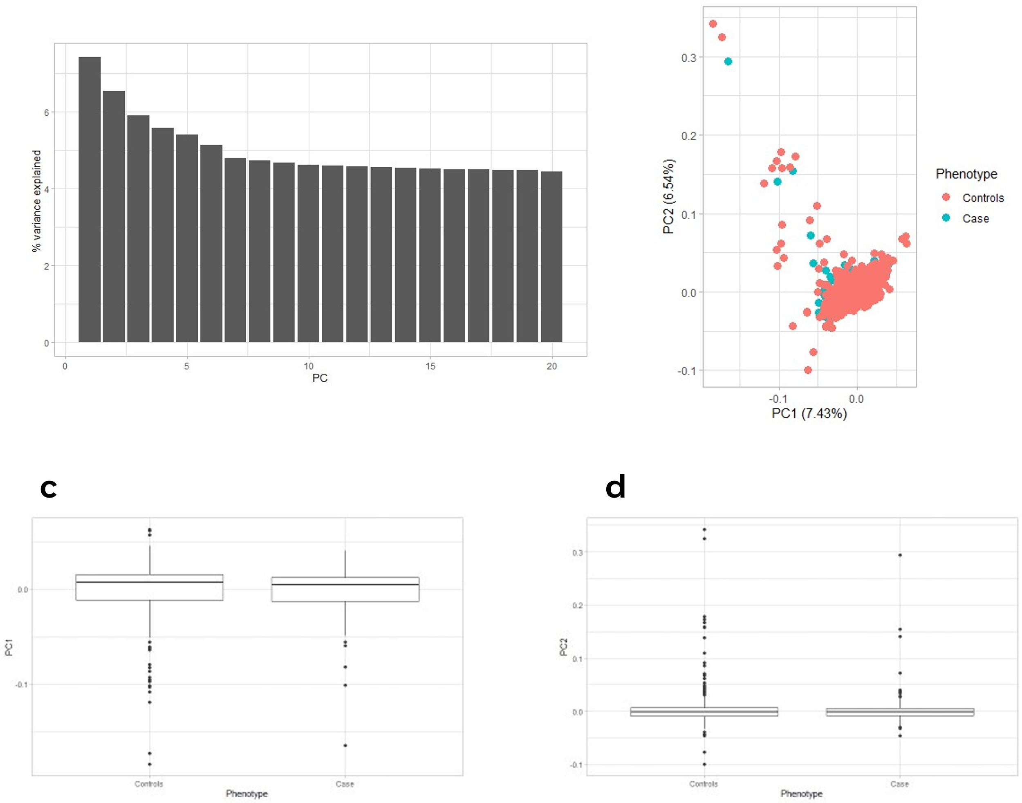
Figure S1. Principal Component Analysis (PCA) of Case and Control samples from WXS and WGS respectively for the evaluation of underlying batch effects. (a) Plot of % of variance explained by each principal component (PC). (b) PCA plot of the first two principal components of variation based on the combined case and control samples from differing data sources. (c) Boxplots of the case and control samples within PC1. (d) Boxplots of the case and control samples within PC2.

Figure S2
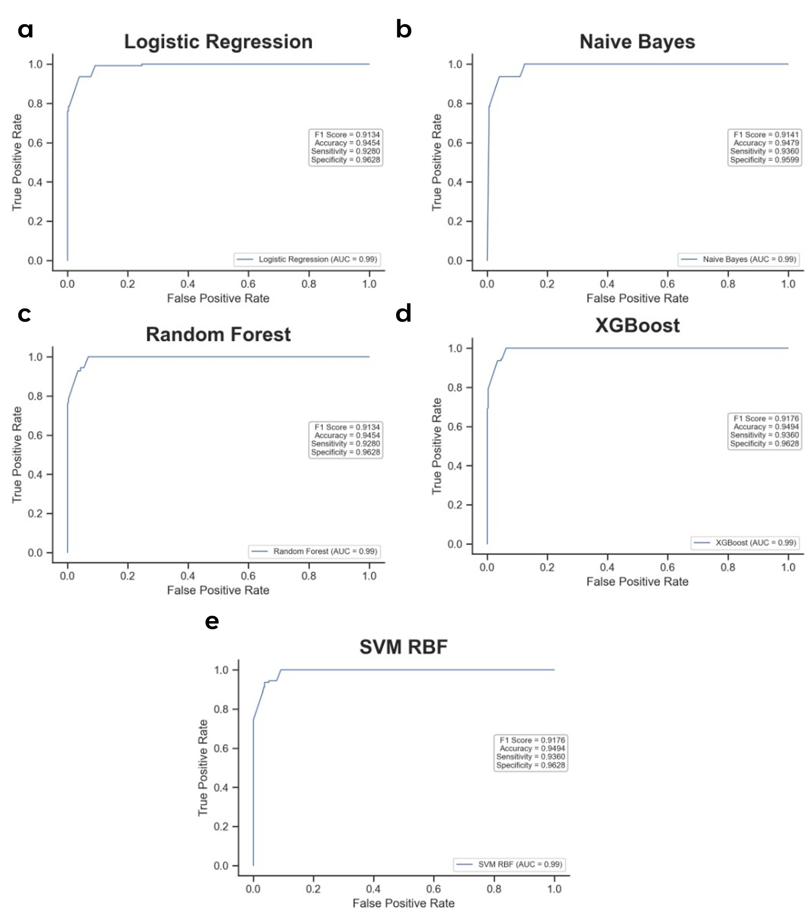
Figure S2. Predictive performance of 9 selected SNPs in unseen Test Set 1. ROC-AUC curves with F1 score, Accuracy, Sensitivity, and Specificity of 9 selected SNPs using (a) Logistic Regression, (b) Naïve Bayes, (c) Random Forest, (d) XGBoost, and (e) Support Vector Machine (SVM) classifiers.

Figure S3
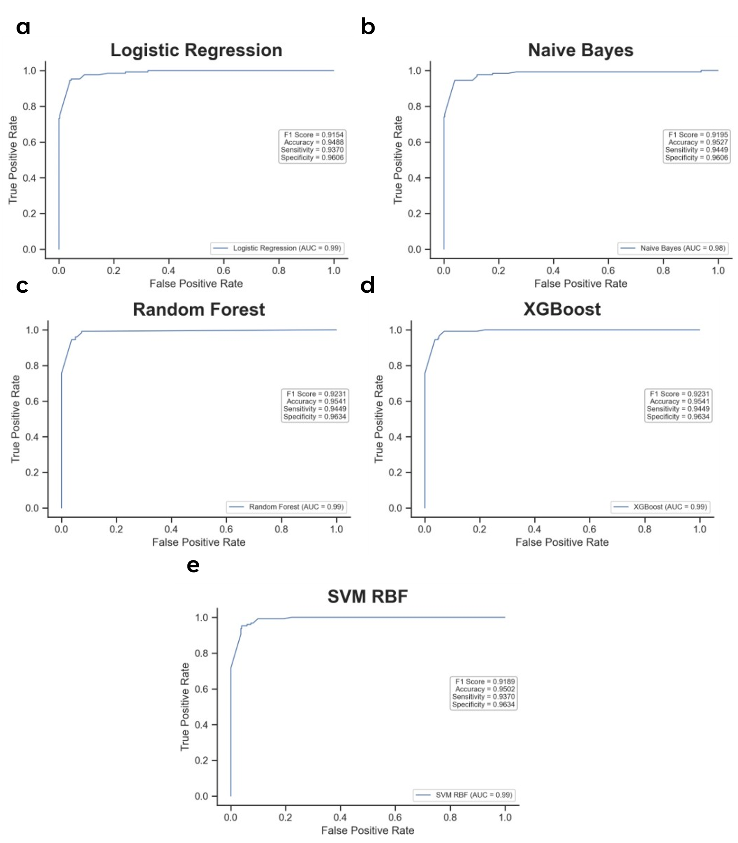
Figure S3. Predictive performance of 9 selected SNPs in unseen Test Set 2. ROC-AUC curves with F1 score, Accuracy, Sensitivity, and Specificity of 9 selected SNPs using (a) Logistic Regression, (b) Naïve Bayes, (c) Random Forest, (d) XGBoost, and (e) Support Vector Machine (SVM) classifiers.

Figure S4
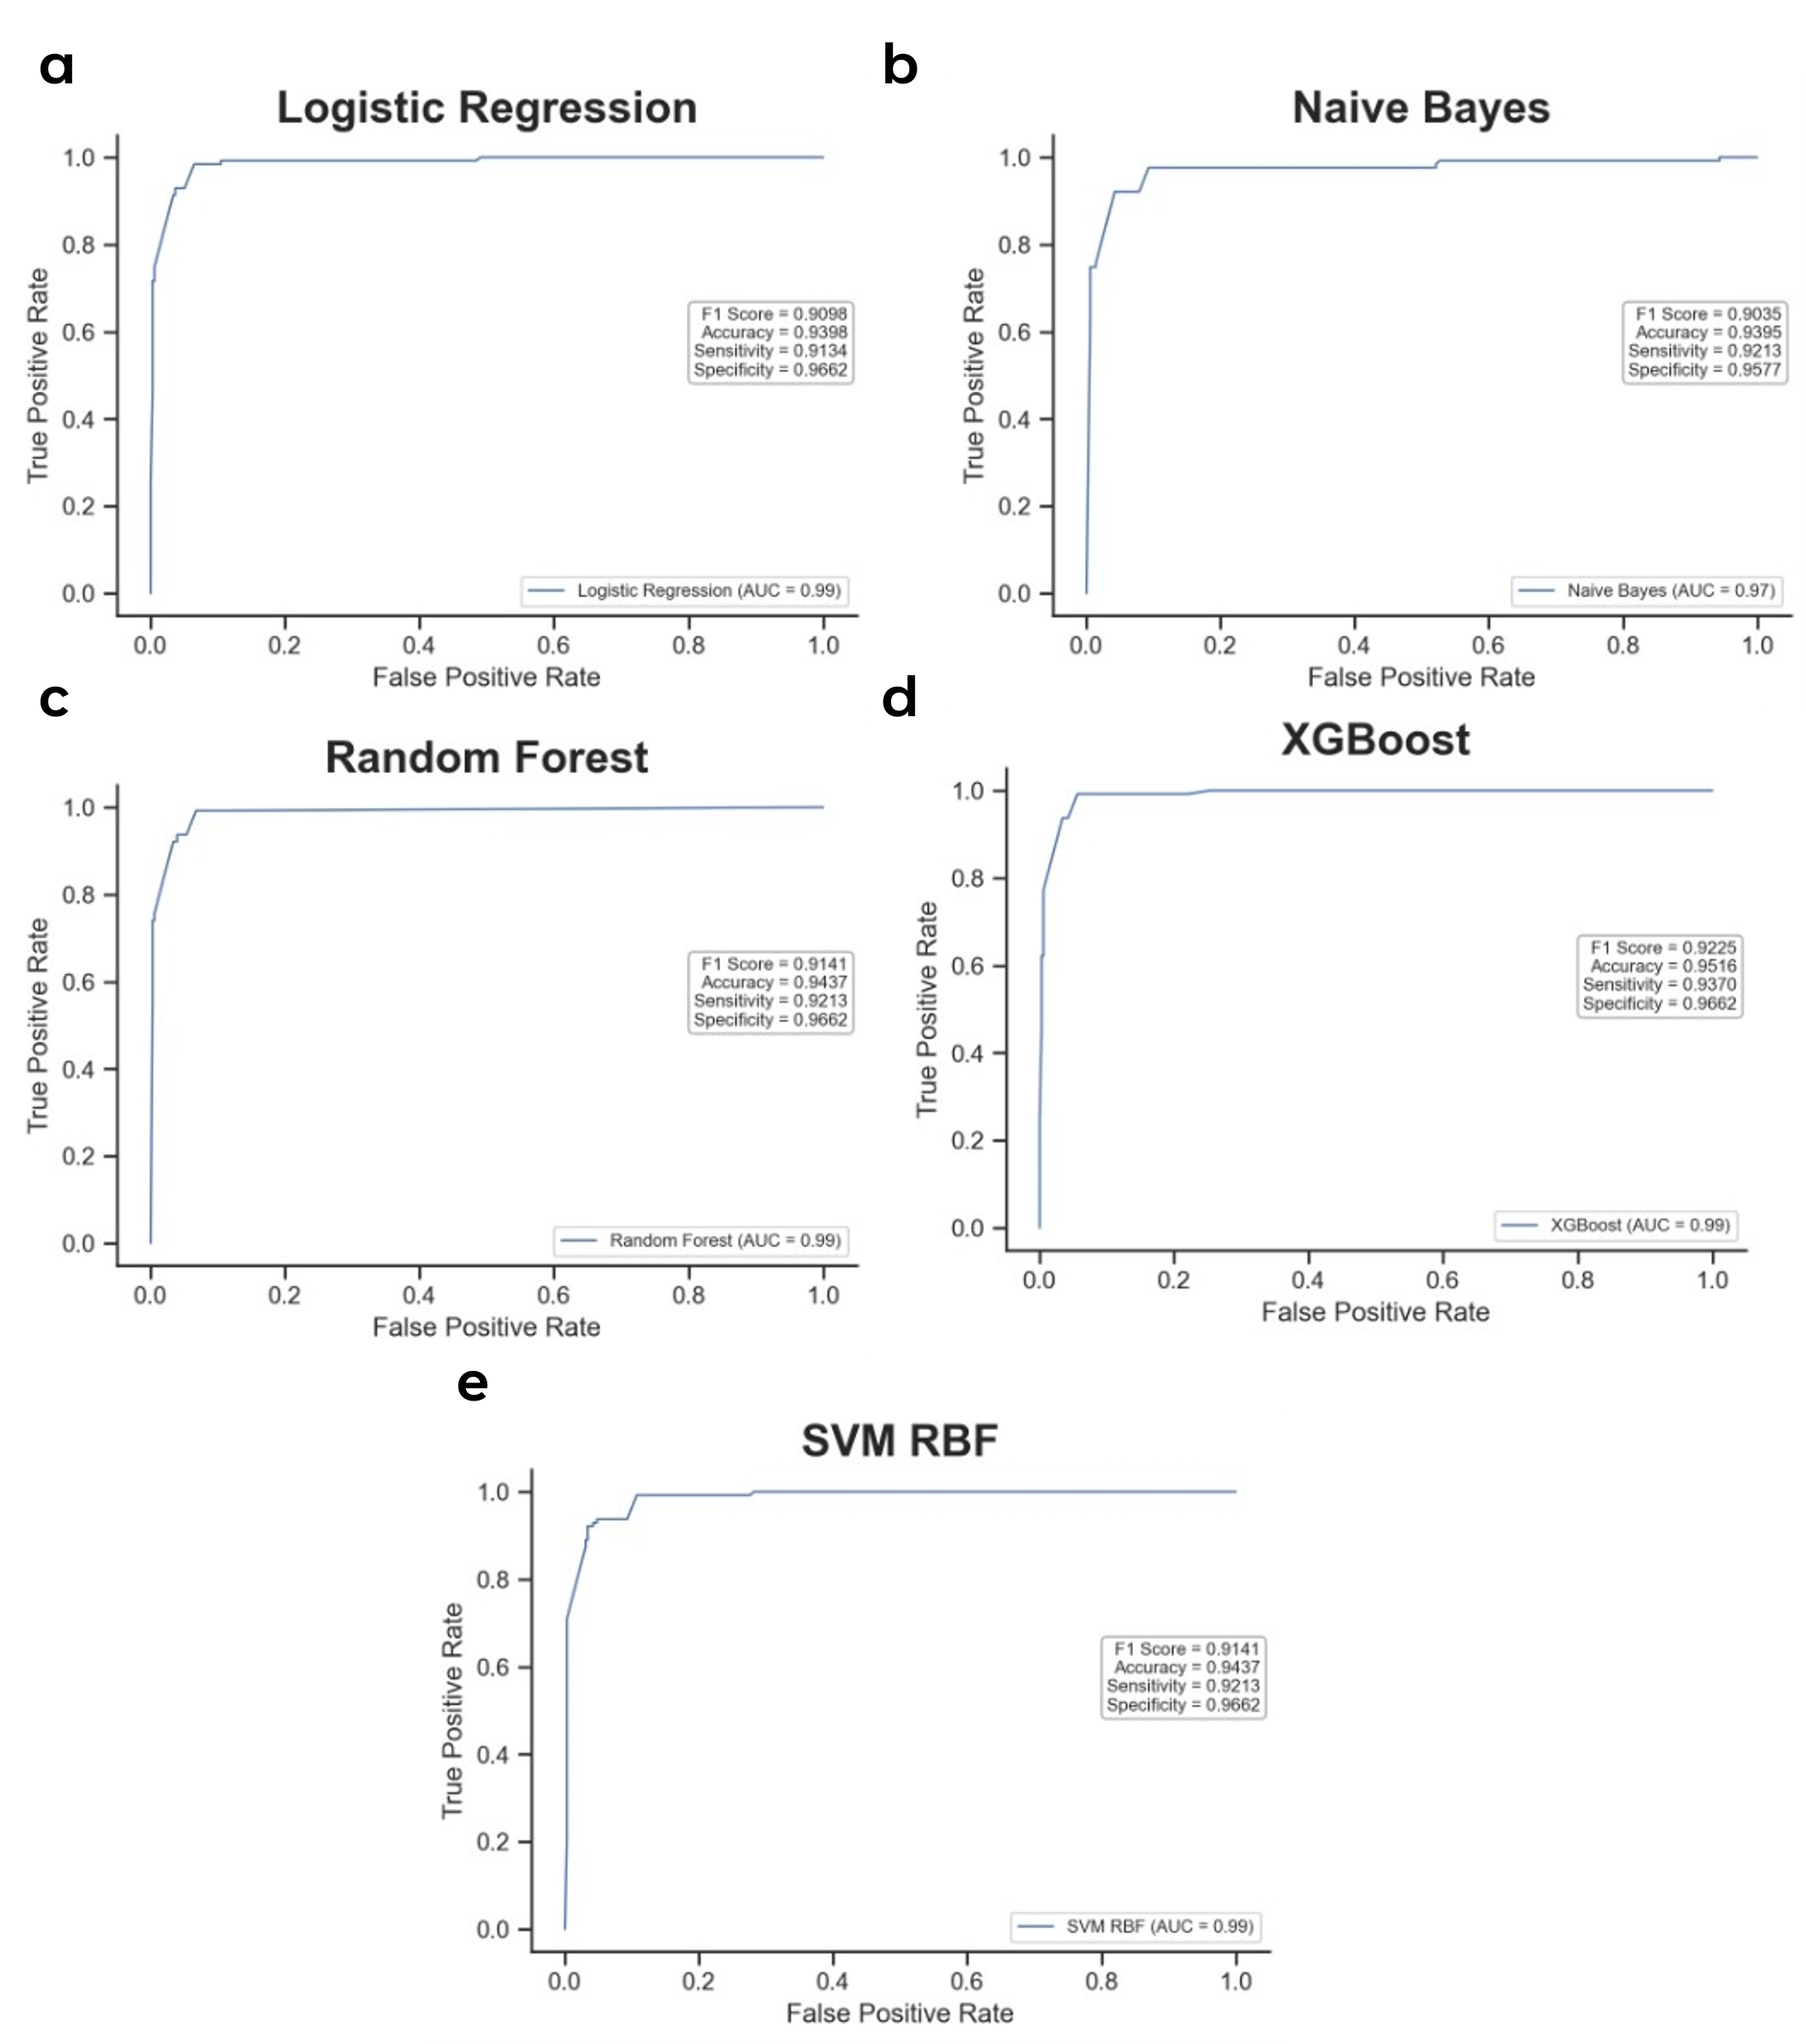
Figure S4. Predictive performance of 9 selected SNPs in unseen Test Set 3. ROC-AUC curves with F1 score, Accuracy, Sensitivity, and Specificity of 9 selected SNPs using (a) Logistic Regression, (b) Naïve Bayes, (c) Random Forest, (d) XGBoost, and (e) Support Vector Machine (SVM) classifiers.

Figure S5
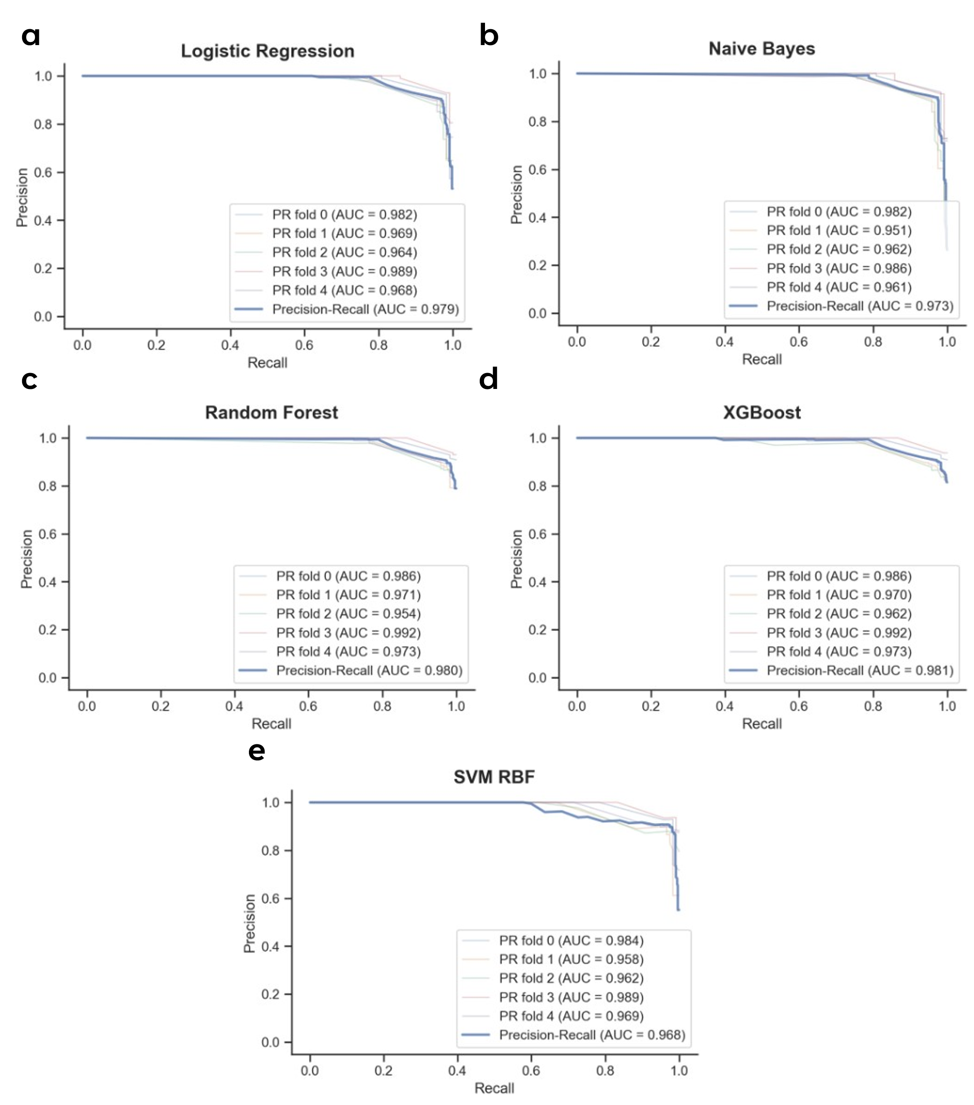
Figure S5. Predictive performance of 9 selected SNPs in training set using 5-fold cross-validation. Precision-Recall curves of 9 selected SNPs using (a) Logistic Regression, (b) Naïve Bayes, (c) Random Forest, (d) XGBoost, and (e) Support Vector Machine (SVM) classifiers.

Figure S6
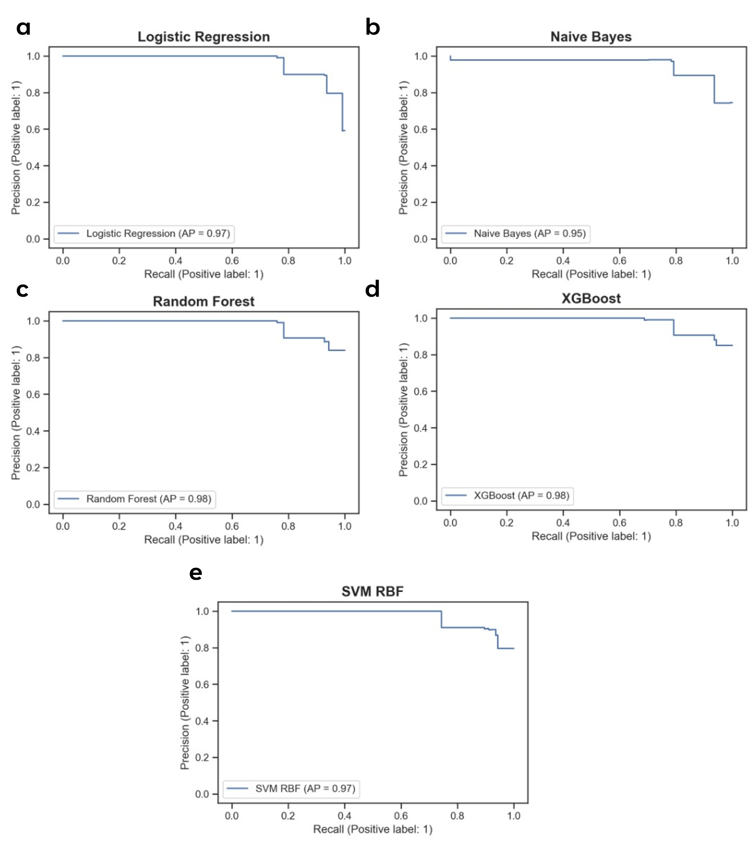
Figure S6. Predictive performance of 9 selected SNPs in unseen Test Set 1. Precision-Recall curves with of 9 selected SNPs using (a) Logistic Regression, (b) Naïve Bayes, (c) Random Forest, (d) XGBoost, and (e) Support Vector Machine (SVM) classifiers.

Figure S7
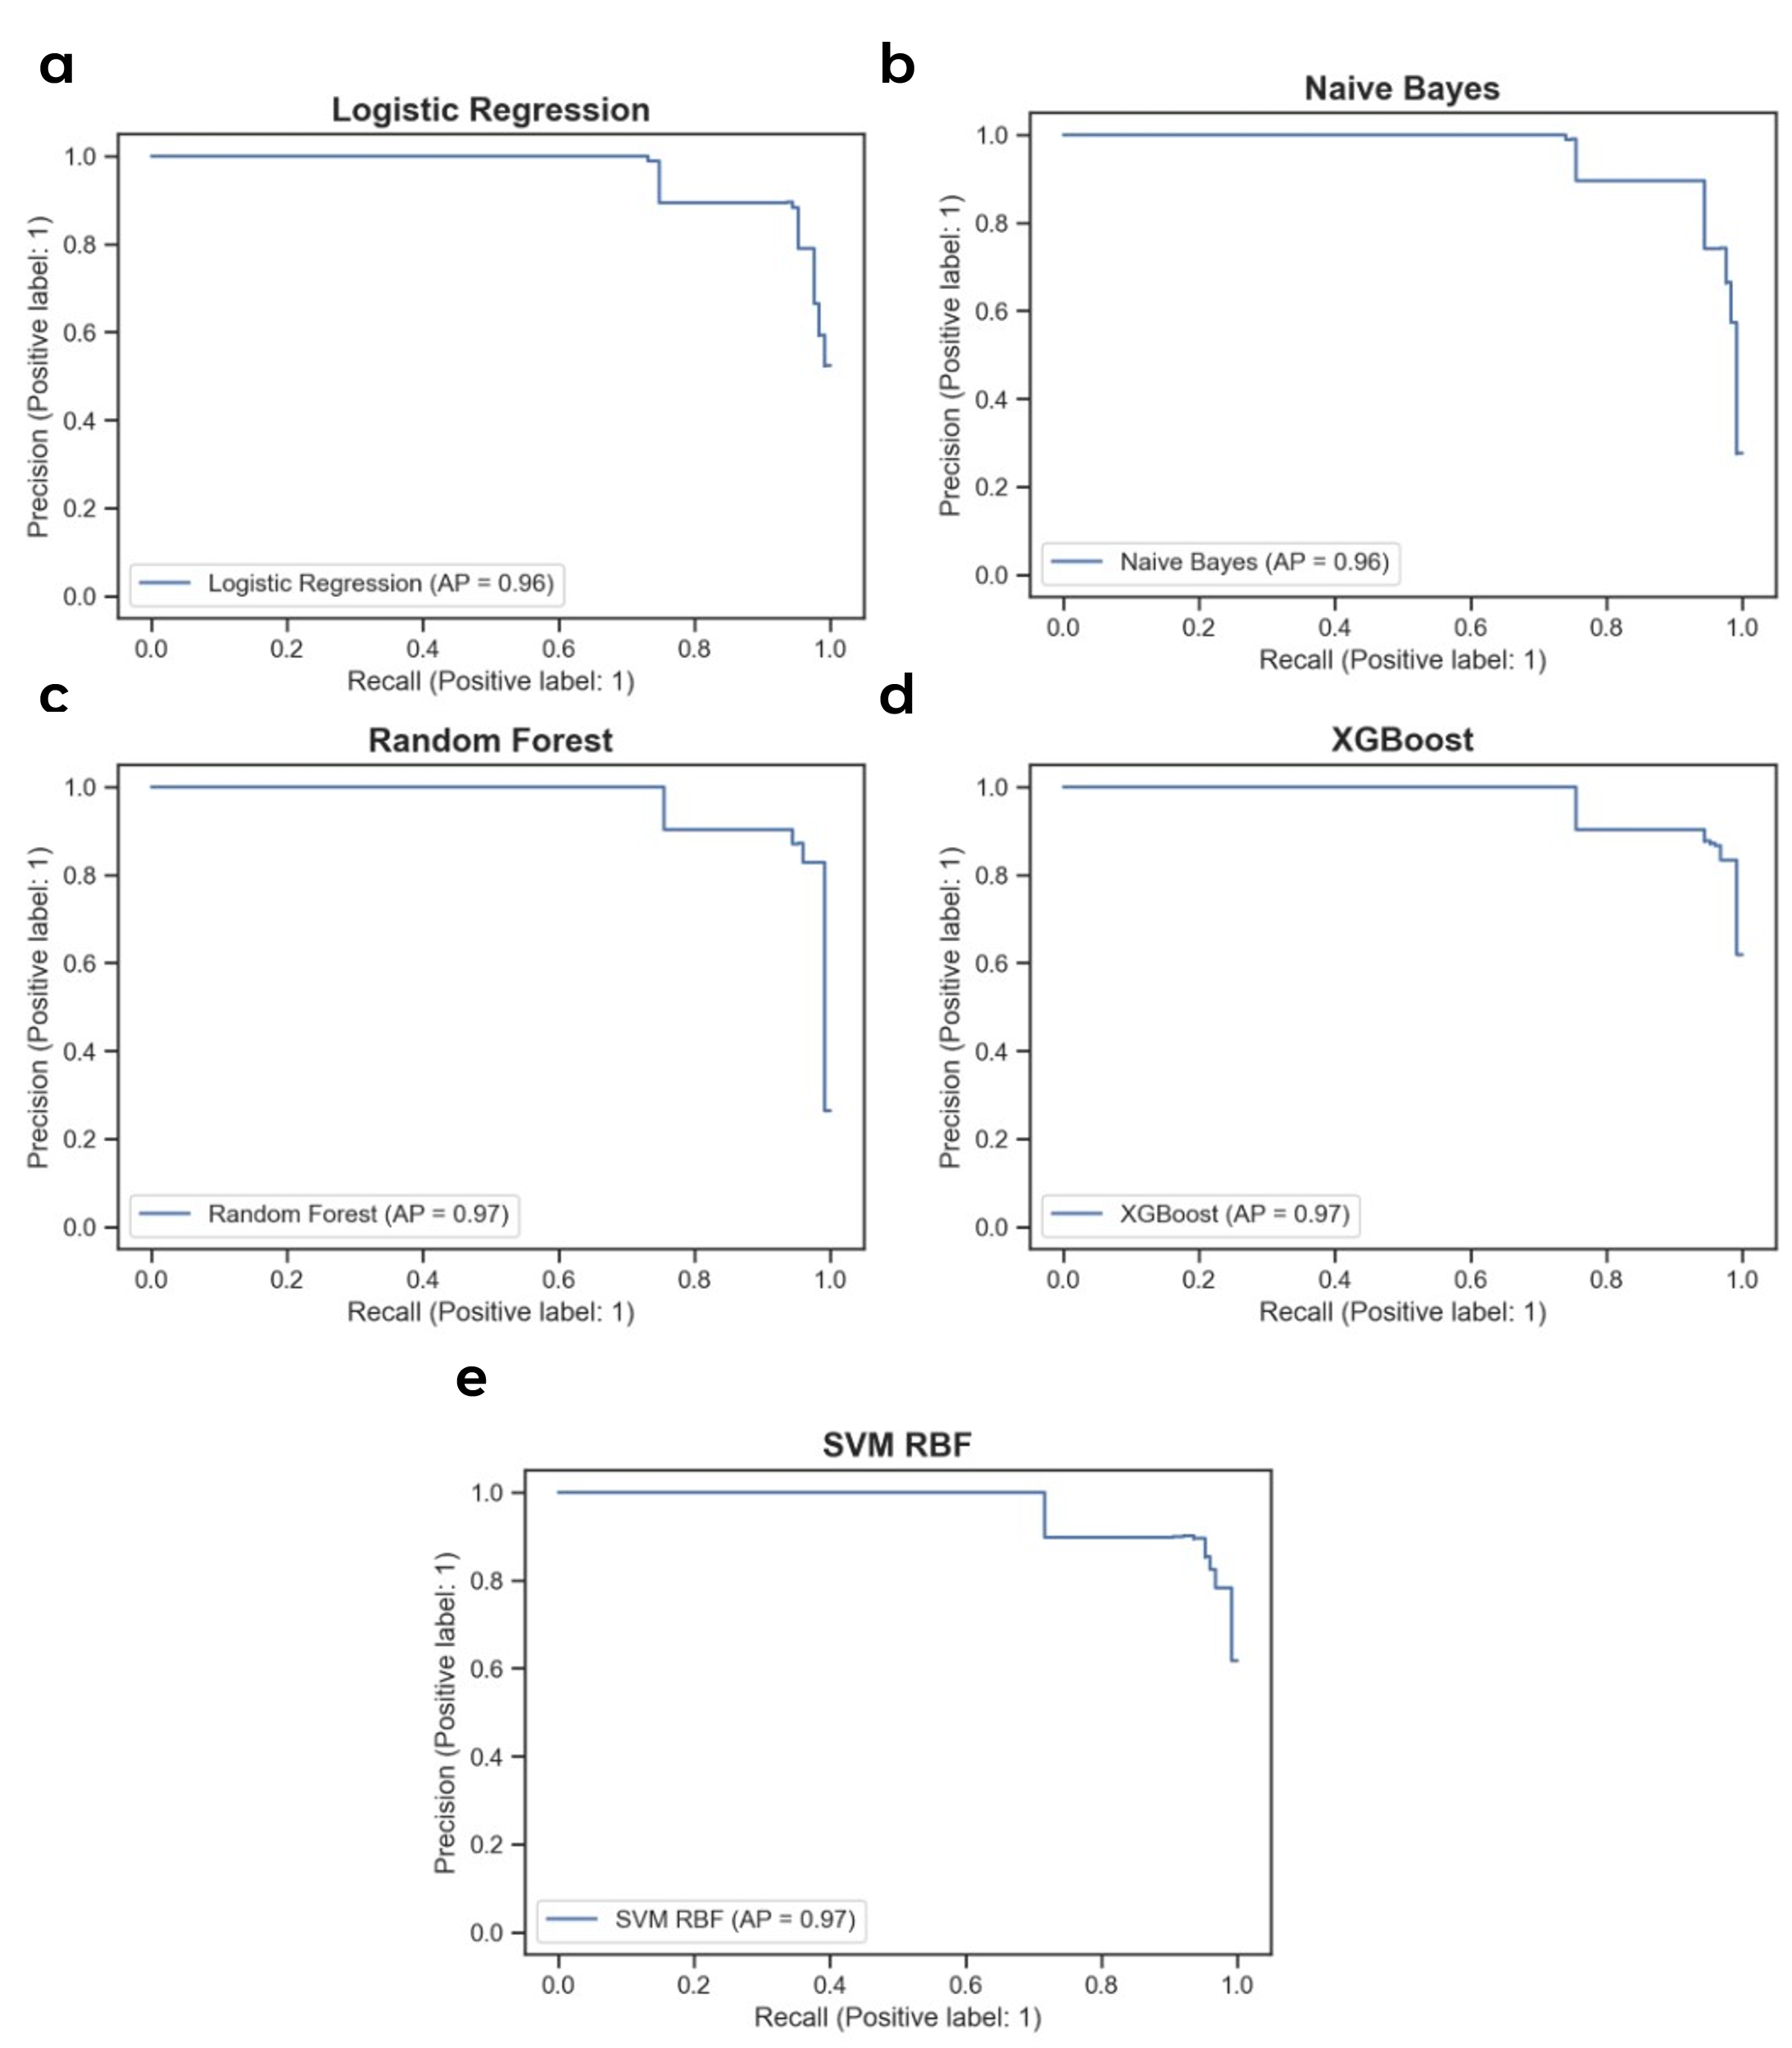
Figure S7. Predictive performance of 9 selected SNPs in unseen Test Set 2. Precision-Recall curves with of 9 selected SNPs using (a) Logistic Regression, (b) Naïve Bayes, (c) Random Forest, (d) XGBoost, and (e) Support Vector Machine (SVM) classifiers.

Figure S8
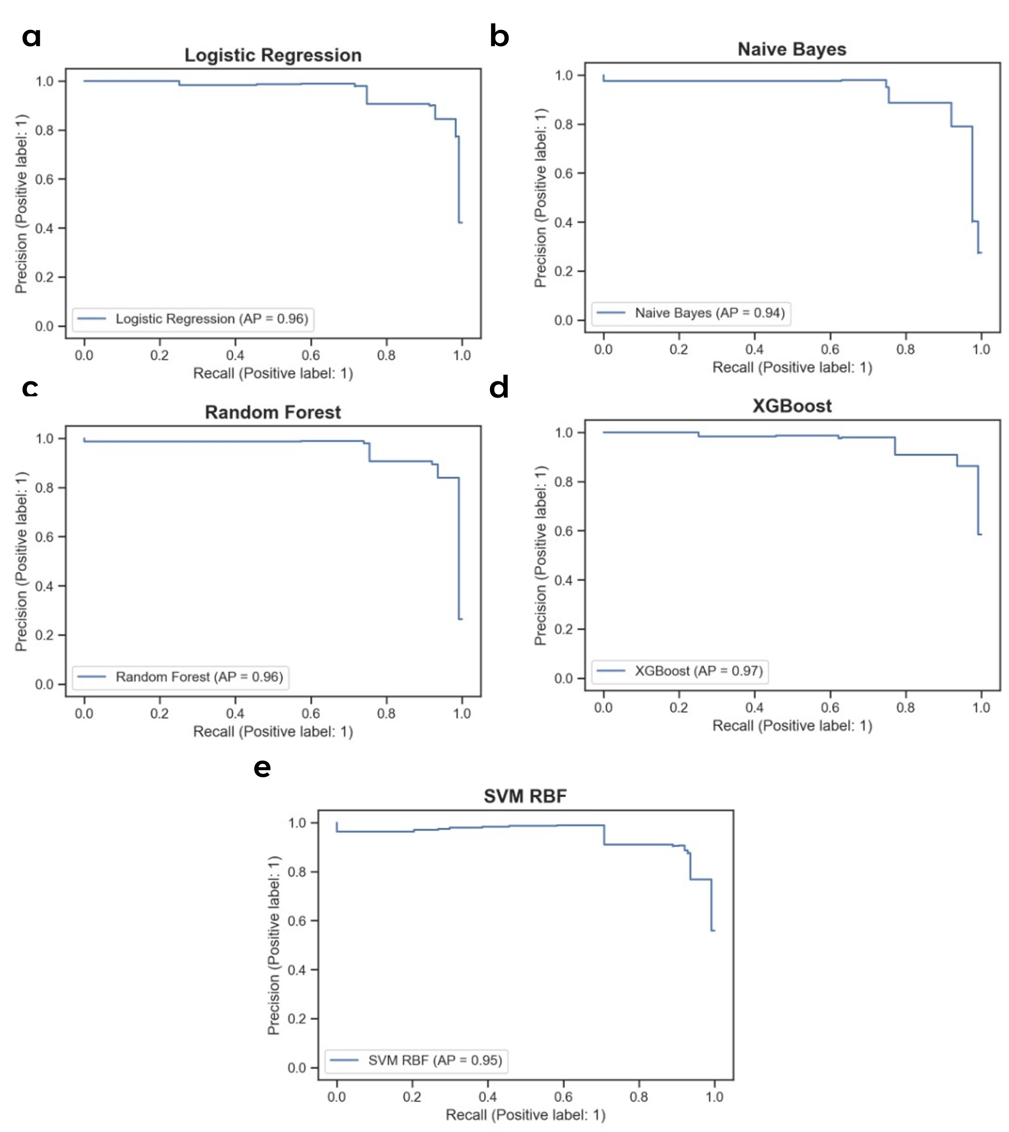
Figure S8. Predictive performance of 9 selected SNPs in unseen Test Set 3. Precision-Recall curves with of 9 selected SNPs using (a) Logistic Regression, (b) Naïve Bayes, (c) Random Forest, (d) XGBoost, and (e) Support Vector Machine (SVM) classifiers.

Figure S9
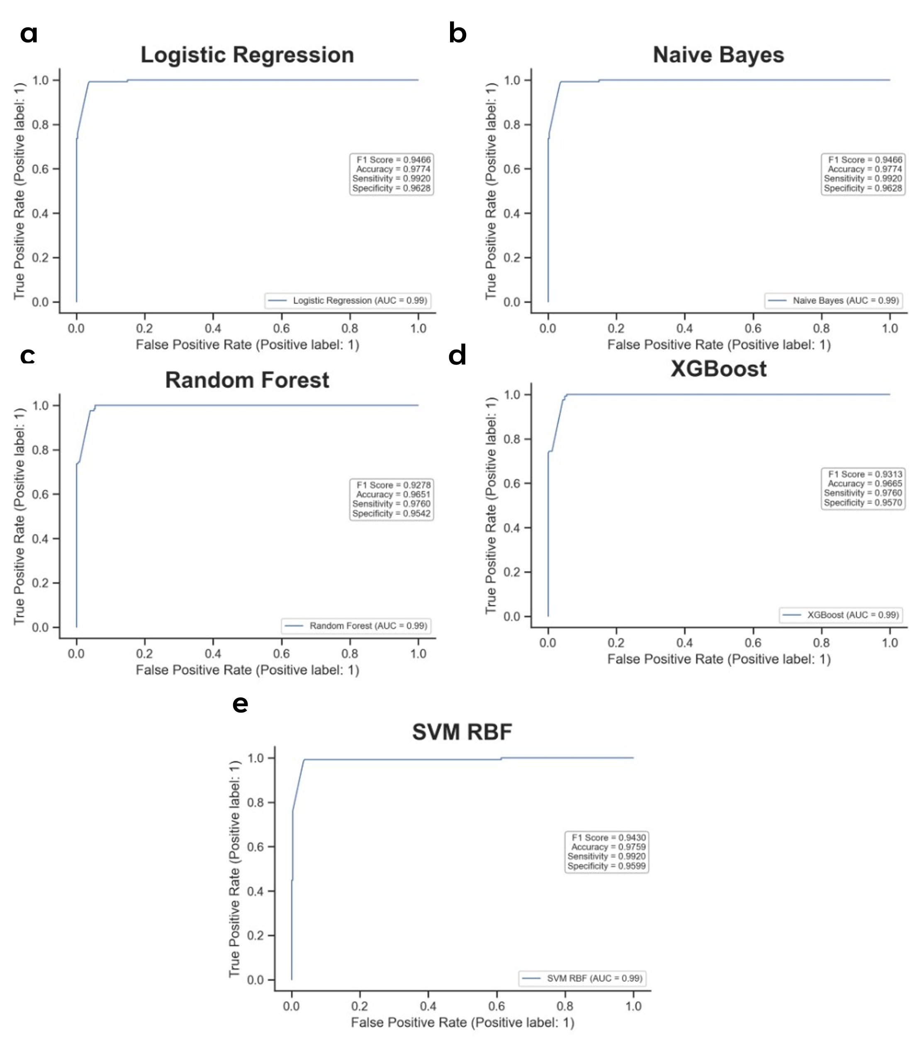
Figure S9. Predictive performance of calculated PRS in unseen Test Set 1. ROC-AUC curves with F1 score, Accuracy, Sensitivity, and Specificity of PRS using (a) Logistic Regression, (b) Naïve Bayes, (c) Random Forest, (d) XGBoost, and (e) Support Vector Machine (SVM) classifiers.

Figure S10
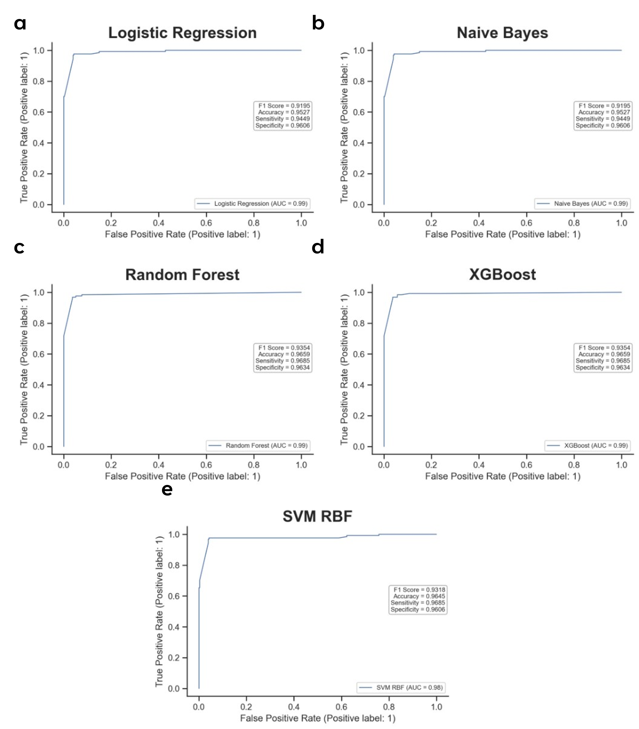
Figure S10. Predictive performance of calculated PRS in unseen Test Set 2. ROC-AUC curves with F1 score, Accuracy, Sensitivity, and Specificity of PRS using (a) Logistic Regression, (b) Naïve Bayes, (c) Random Forest, (d) XGBoost, and (e) Support Vector Machine (SVM) classifiers.

Figure S11
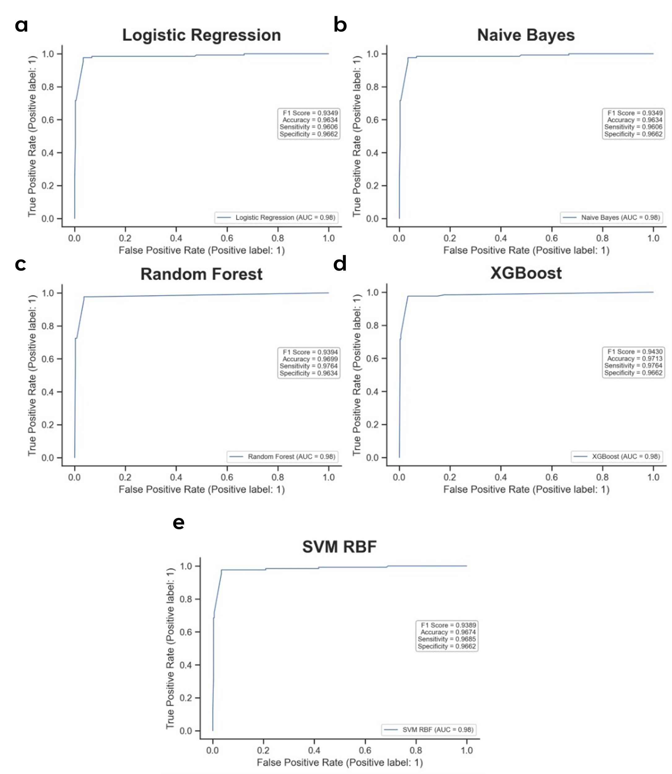
Figure S11. Predictive performance of calculated PRS in unseen Test Set 3. ROC-AUC curves with F1 score, Accuracy, Sensitivity, and Specificity of PRS using (a) Logistic Regression, (b) Naïve Bayes, (c) Random Forest, (d) XGBoost, and (e) Support Vector Machine (SVM) classifiers.

Figure S12
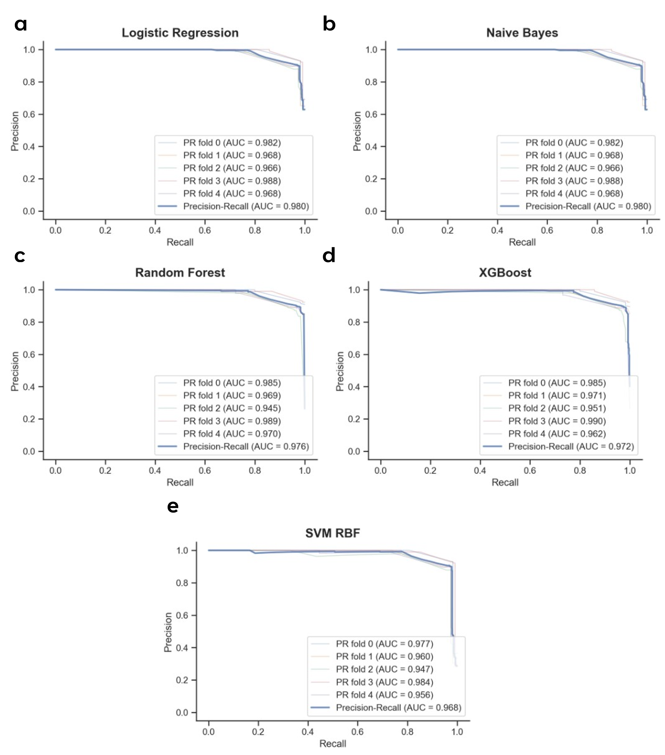
Figure S12. Predictive performance of calculated PRS in the training set using 5-fold cross-validation. Precision-Recall curves of PRS using (a) Logistic Regression, (b) Naïve Bayes, (c) Random Forest, (d) XGBoost, and (e) Support Vector Machine (SVM) classifiers.

Figure S13
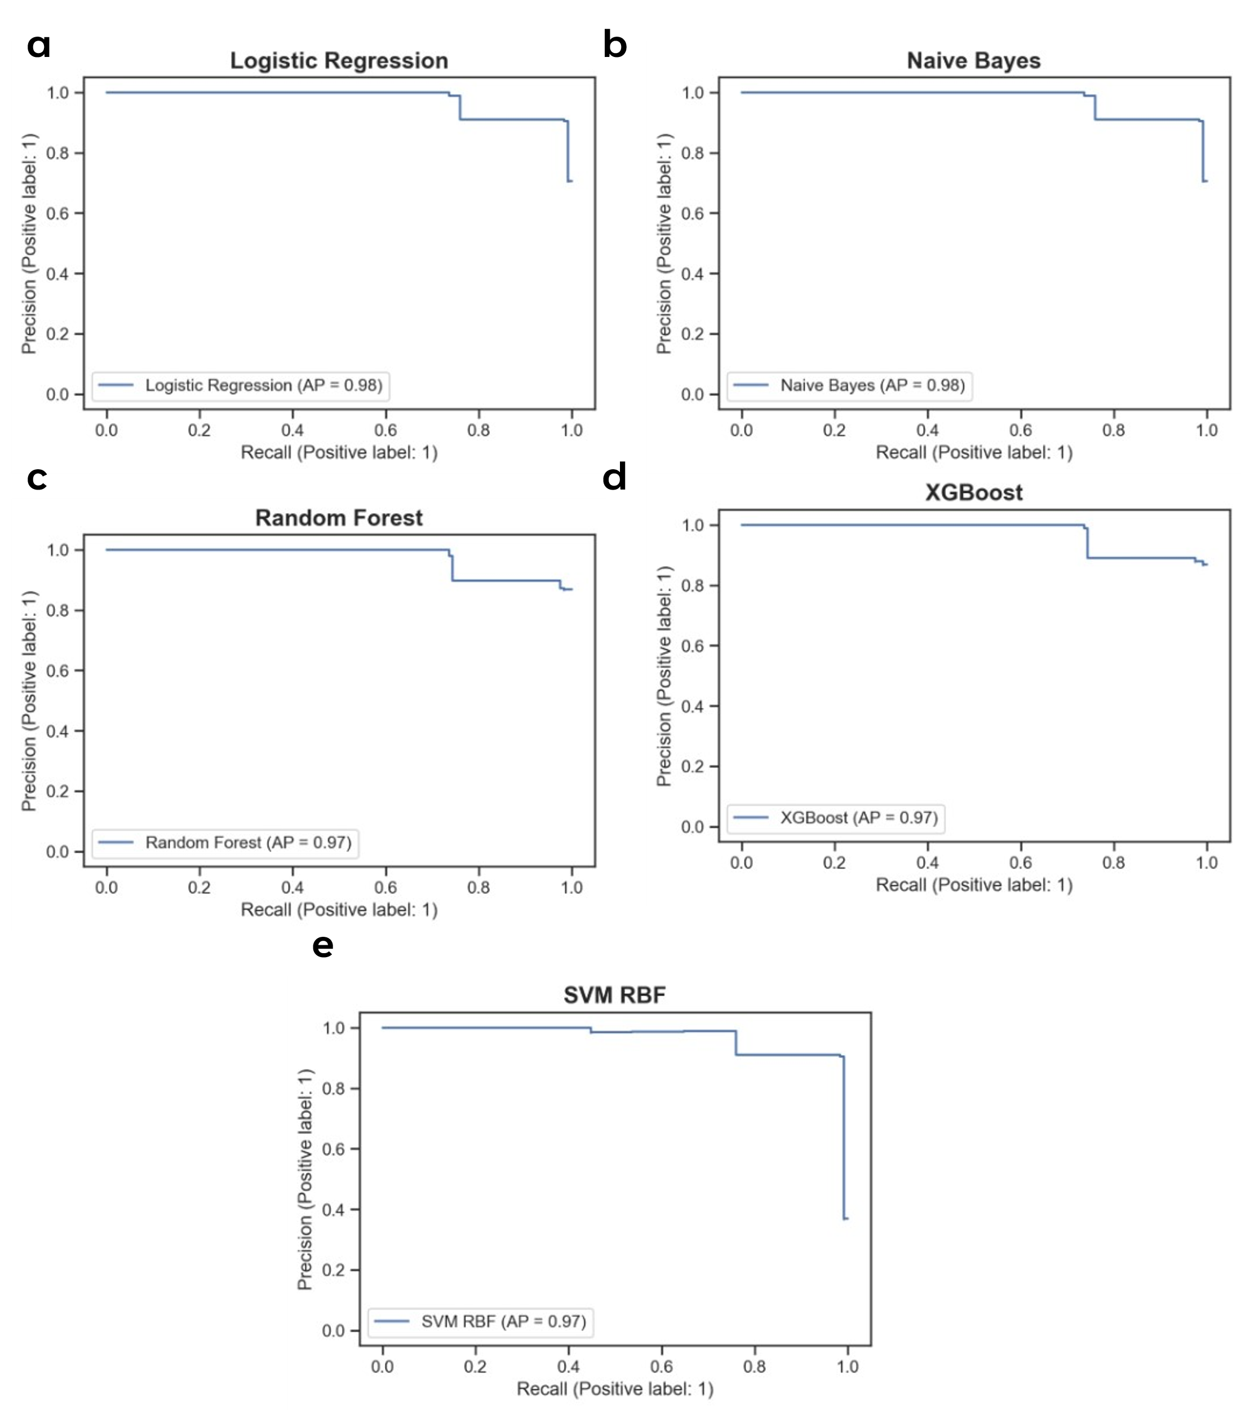
Figure S13. Predictive performance of calculated PRS in unseen Test Set 1. Precision-Recall curves of PRS using (a) Logistic Regression, (b) Naïve Bayes, (c) Random Forest, (d) XGBoost, and (e) Support Vector Machine (SVM) classifiers.

Figure S14
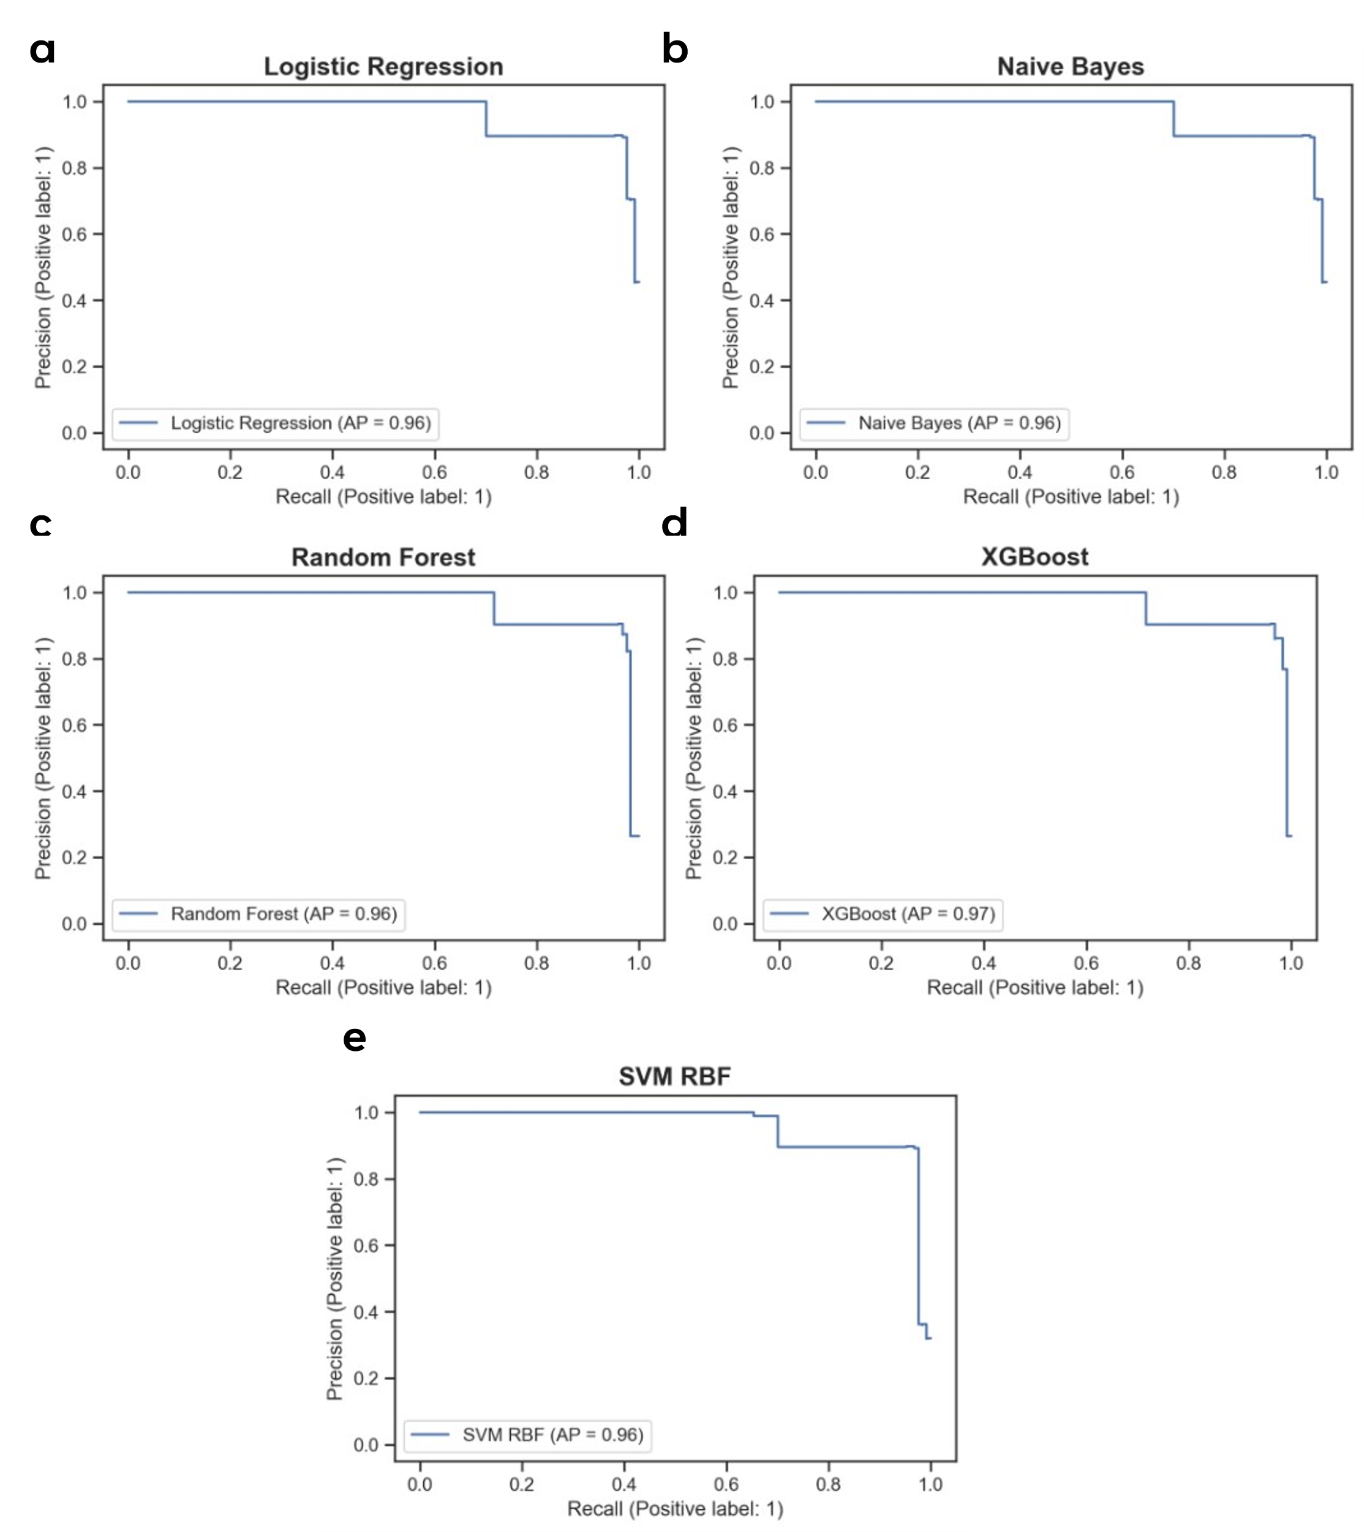
Figure S14. Predictive performance of calculated PRS in unseen Test Set 2. Precision-Recall curves of PRS using (a) Logistic Regression, (b) Naïve Bayes, (c) Random Forest, (d) XGBoost, and (e) Support Vector Machine (SVM) classifiers.

Figure S15
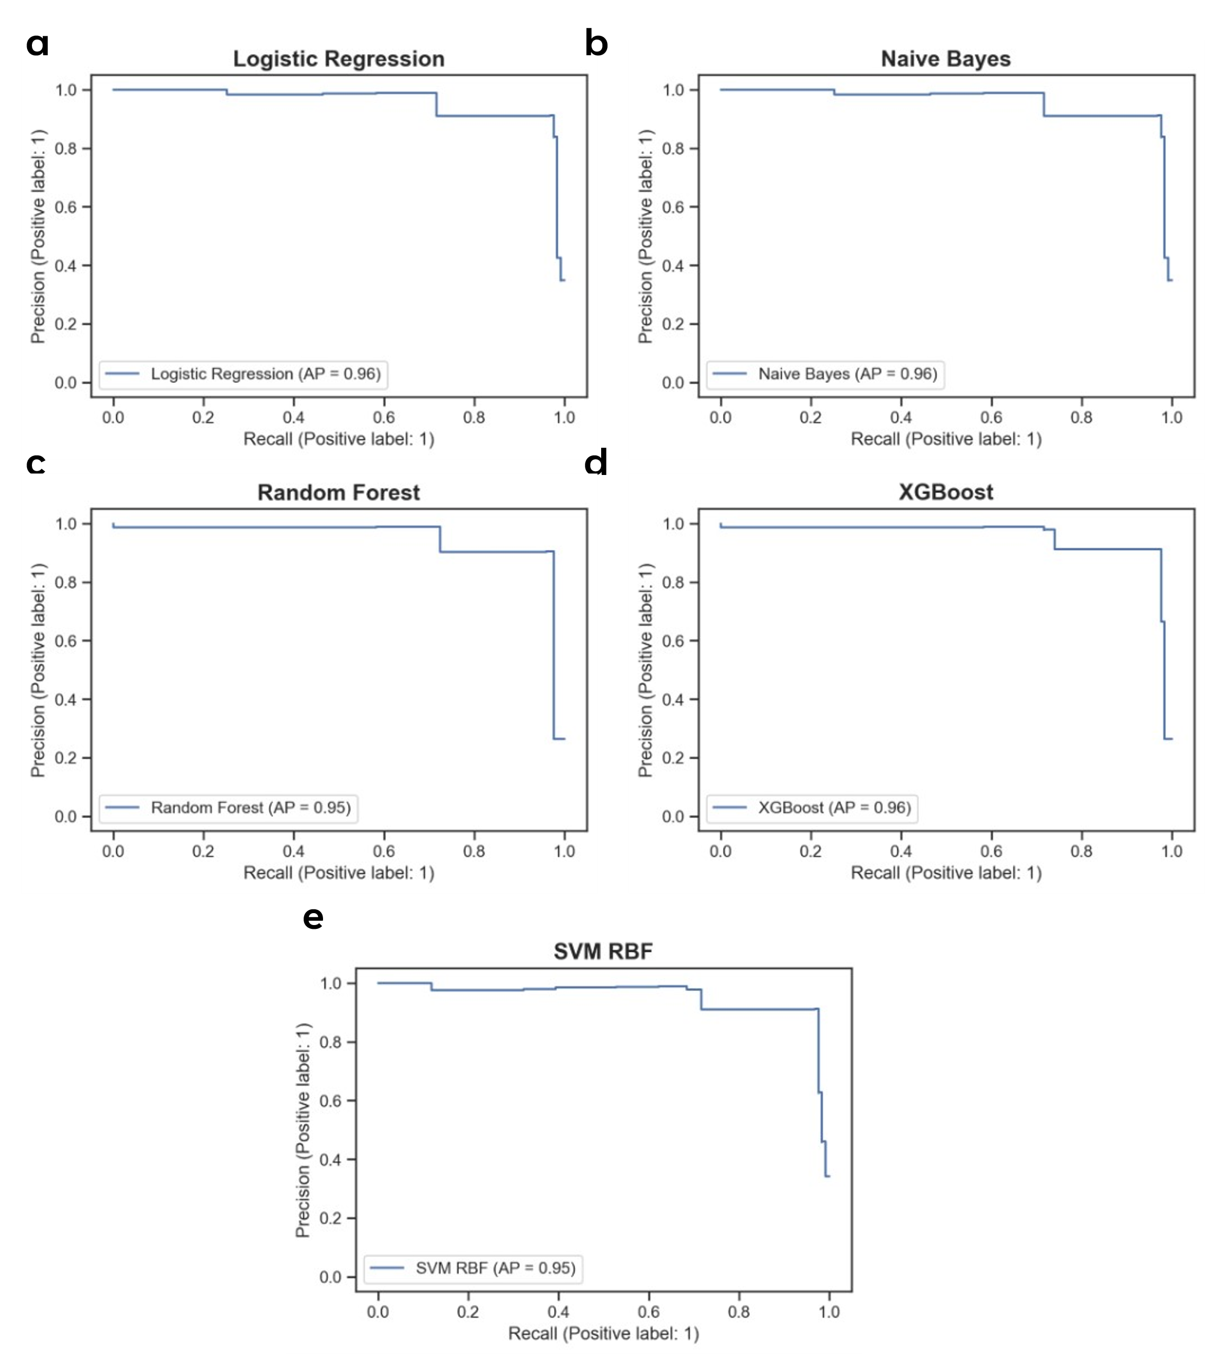
Figure S15. Predictive performance of calculated PRS in unseen Test Set 3. Precision-Recall curves of PRS using (a) Logistic Regression, (b) Naïve Bayes, (c) Random Forest, (d) XGBoost, and (e) Support Vector Machine (SVM) classifiers.

Table S1
Summary of studies that have used of genetics in the prediction of RA.

Table S2
Detailed information of the 9 selected SNPs and their genes from feature selection.

Table S3
Potentially functional SNPs (pfSNPs) in linkage disequilibrium with selected SNPs without previously established potential function.

Table S4
Previously identified GWAS associations of selected SNPs at p-value significance of 1 x 10⁻⁵ from BioBank Japan PheWeb, IEU Open GWAS Project, and GWAS Atlas.

Table S5
Predictive performance of Polygenic Risk Scores (PRS) calculated from the 9 selected SNPs in a 5-fold cross-validation of the Train dataset and in each of the 3 unseen Test datasets.

