Additional material
Figure S1. The expression of MLKL was not altered in IntMs (SiglecF^{lo} CD11b^{hi}) in ALI. A, Flow cytometry analysis of MLKL⁺ IntMs, n=3.

Figure S2. Mitochondrial membrane potential is dissipated by the treatment with Mab1187. Macrophages were incubated with plate-bound isotype-matched control or plate-bound anti-TREM-1 mAb (10 μg/mL). A-B, Twenty-four hours later, representative images of macrophages loaded with the mitochondrial membrane potential indicator JC‐1 (bar=50 μm) and quantification of mitochondrial membrane potential were analyzed by ImageJ, n=3.

Figure S3. Mdivi-1 simultaneously attenuated TREM-1-induced mitophagy. Macrophages were premixed with PBS control or Midvi-1 (100 nM) before incubating with plate-bound agonistic anti-TREM-1 mAb. A-B, the protein of Pink1, Beclin1, and LC3Ⅱ protein in cell lysate. n=3 biological replicates.

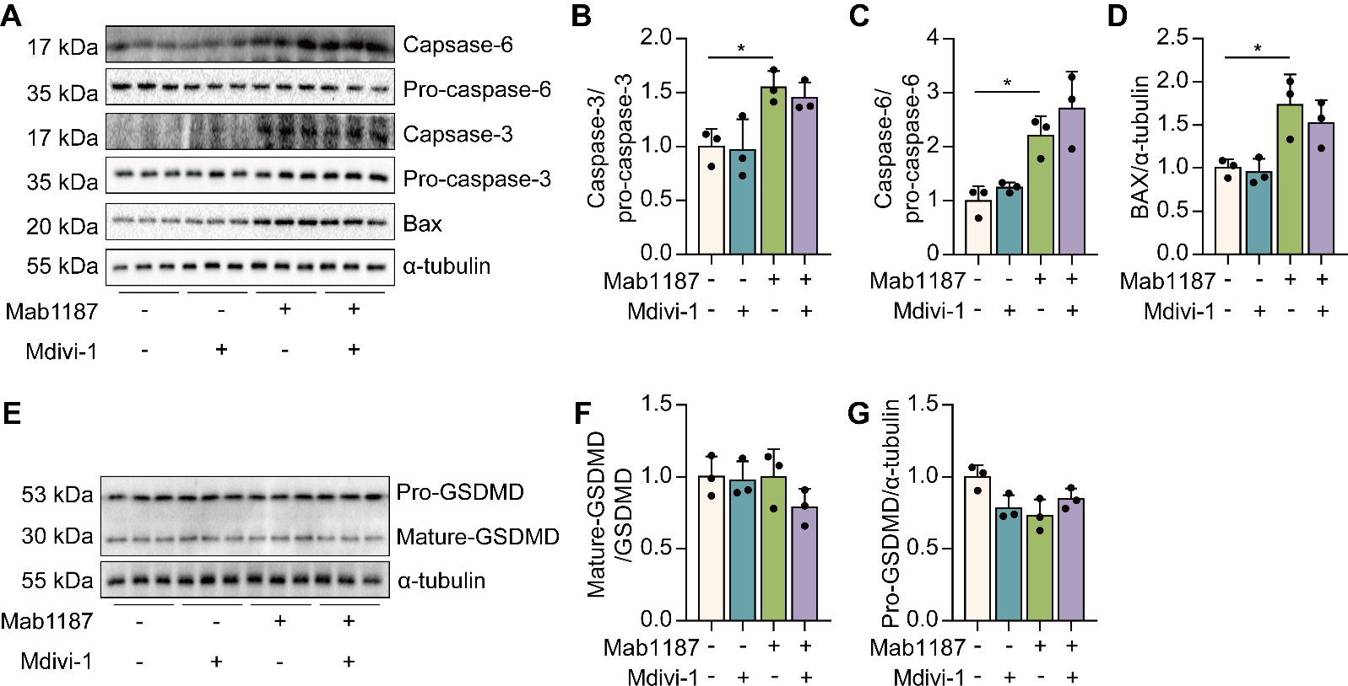
Figure S4. TREM-1 induces apoptosis of macrophages independent of mitochondria fission. A-D, the protein of caspase-6, pro-caspase-6, caspase-3, and pro-caspase-3. E-G, pro-GSDMD, and mature-GSDMD protein in cell lysate. n=3 biological replicates.

Figure S5. Inhibition of mTOR showed a partial restoration in mitochondrial membrane potential induced by TREM-1. A-B, macrophages were premixed with PBS control or rapamycin (10 nM) before incubating with plate-bound agonistic anti-TREM-1 mAb. Representative images of macrophages loaded with the mitochondrial membrane potential indicator JC‐1; bar=50 μm.

