Comparison of recurrence prediction power of machine learning models built with normal and tumor tissue-driven transcriptomes of colorectal cancers
Jinho Kim¹, Hyunjung Kim², Min-Seok Lee², Heetak Lee^{1,3}, Yeon Jeong Kim⁴, Woo Yong Lee⁵, Seong Hyeon Yun⁵, Hee Cheol Kim⁵, Hye Kyung Hong⁶, Sridhar Hannenhalli⁷ ,Yong Beom Cho^{5*}, Donghyun Park^{8*}, and Sun Shim Choi^{2*}

¹Precision Medicine Center, Future Innovation Research Division, Seoul National University Bundang Hospital, Seongnam, 13620 Korea
²Division of Biomedical Convergence, College of Biomedical Science, Institute of Bioscience & Biotechnology, Kangwon National University, Chuncheon 24341, Korea
³Center for genome Engineering, Institute for Basic Science, 55, Expo-ro, Yuseng-gu, Daejeon 34126, Korea
⁴Department of Surgery, Samsung Medical Center, Sungkyunkwan University School of Medicine, Seoul 06351, Korea
⁵Institute for Future Medicine, Samsung Medical Center, Seoul 06351, Korea
⁶Department of Health Sciences and Technology, SAIHST, Sungkyunkwan University, Seoul 06351, Korea
⁷Cancer Data Science Lab, Center for cancer research, National Cancer Institute, Bethesda, MD 20814

⁸Geninus Inc., 05836 Korea
*Corresponding authors

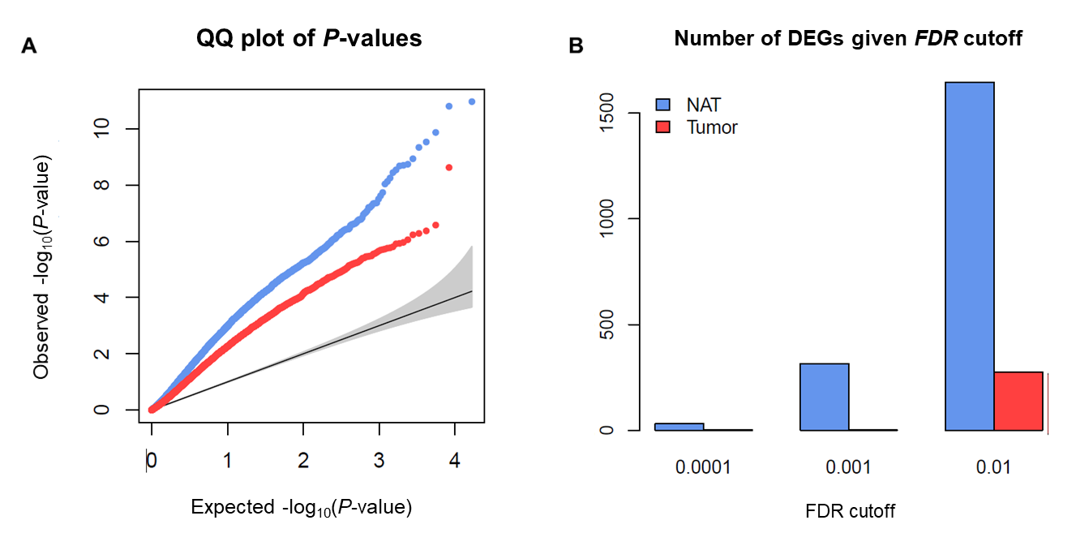
Figure S1. Comparison of P-values and FDRs between NAT-DEGs and tumor-DEGs
The same way of analysis that was done for Figure 2, but using only protein-coding genes. Refer to the legends of Figure 2.

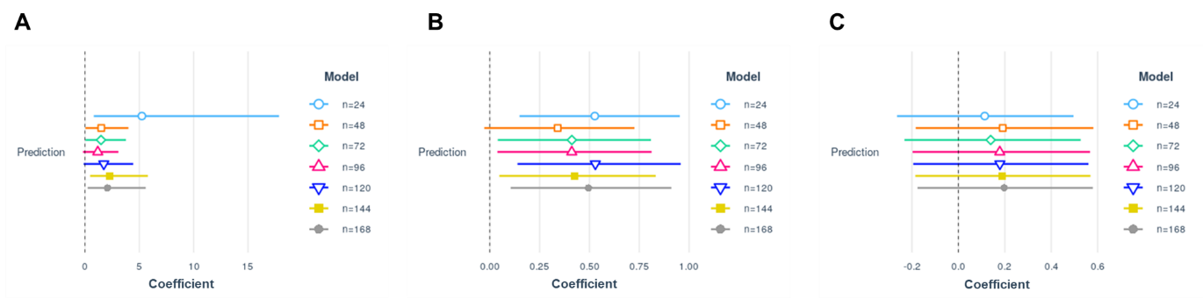
Figure S2. The accuracy of NAT- and tumor-based model after correcting the batch effect
The beta coefficients and 95% CIs are estimated, respectively, (A) when SMC NAT-based model was tested on the NAT-derived transcriptome of TCGA-COAD, (B) when SMC NAT-based model was tested on the tumor-derived transcriptome of TCGA-COAD, and (C) SMC tumor-based model was tested on the tumor-derived transcriptome of TCGA-COAD.

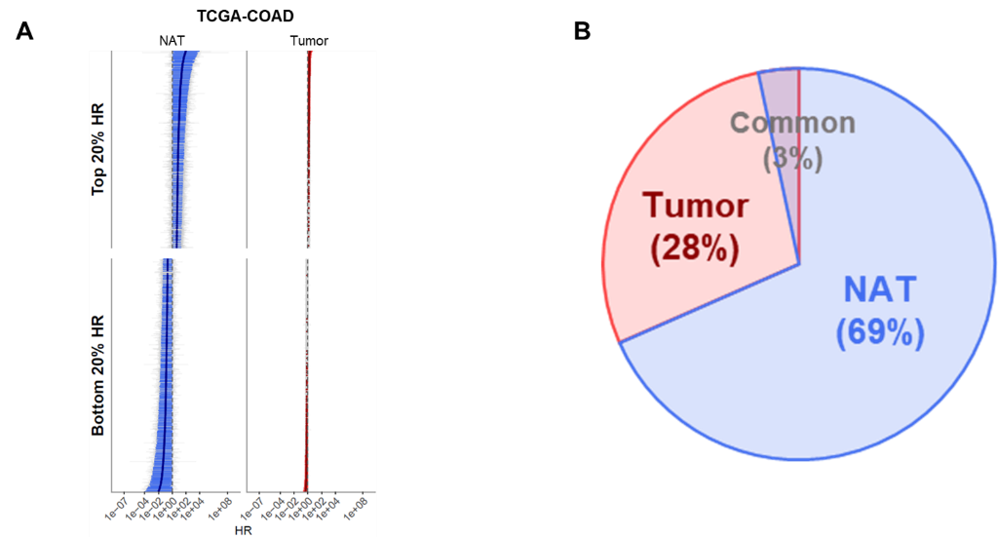
Figure S3. Comparison of proportions of genes associated with the survival of patients between NATs and tumors in TCGA-COAD with tumor purity adjusted
The same way of analysis that was done for Figure 6, but with tumor purity adjusted. Refer to the legends of Figure 6.

