Additional file

M1 polarization enhances the antitumor activity of chimeric antigen receptor macrophages in solid tumors
Yi Huo^{1,2,3†}, Han Zhang ^{2†}, Longqi Sa^{4†}, Wenjing Zheng², Yang He⁵, Haohan Lyu², Mengjie Sun², Lingling Zhang², Lequn Shan⁴*, Angang Yang¹* and Tao Wang ²*
¹ State Key Laboratory of Cancer Biology, Department of Immunology, Air Force Medical University, Xi’an, Shaanxi, China
² State Key Laboratory of Cancer Biology, Department of Medical Genetics and Developmental Biology, Air Force Medical University, Xi’an, Shaanxi, China
³ Department of Laboratory Medicine, 941 Hospital of Joint Logistics Support Force of PLA, Xining, Qinghai, China
⁴ Department of Spine Surgery, Honghui Hospital, Xi'an Jiaotong University, Xi'an, Shaanxi, China
⁵ The Second Clinical Medical College of Lanzhou University, Lanzhou University, Lanzhou, Gansu, China.
†These authors contributed equally.
* Correspondence:
Lequn Shan, email: drshanlq@fmmu.edu.cn
Angang Yang, email: agyang@fmmu.edu.cn
Tao Wang, email: wangt@fmmu.edu.cn

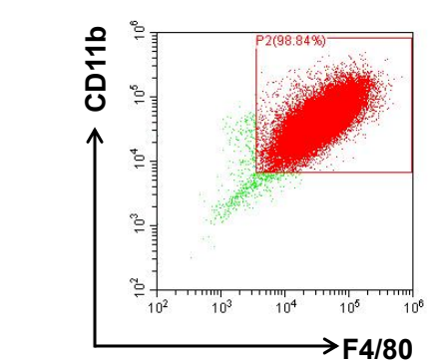
Fig. S1 The purity of macrophages differentiated from bone marrow cells.
Flow cytometry was used to analyze the percentage of BMDMs (shown as the surface marker F4/80⁺CD11b⁺ population) differentiated from C57BL/6 mice.

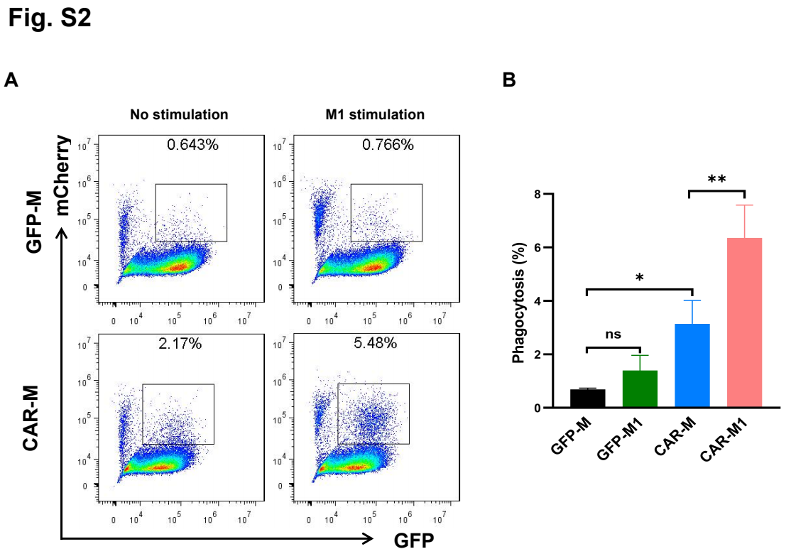
Fig. S2 CAR-mediated phagocytosis in J774A.1 macrophages.
A Representative flow cytometry assay showing phagocytosis of mCherry+MC38-HER2 cells by J774A.1 cells expressing GFP or CAR at an E:T=5:1 ratio. B Quantitative analysis of the percentage of phagocytosis by flow cytometry. Three independent experiments were performed. Data are shown as the mean ± SEM *, p < 0.05; **, p < 0.01; ***, p < 0.001.
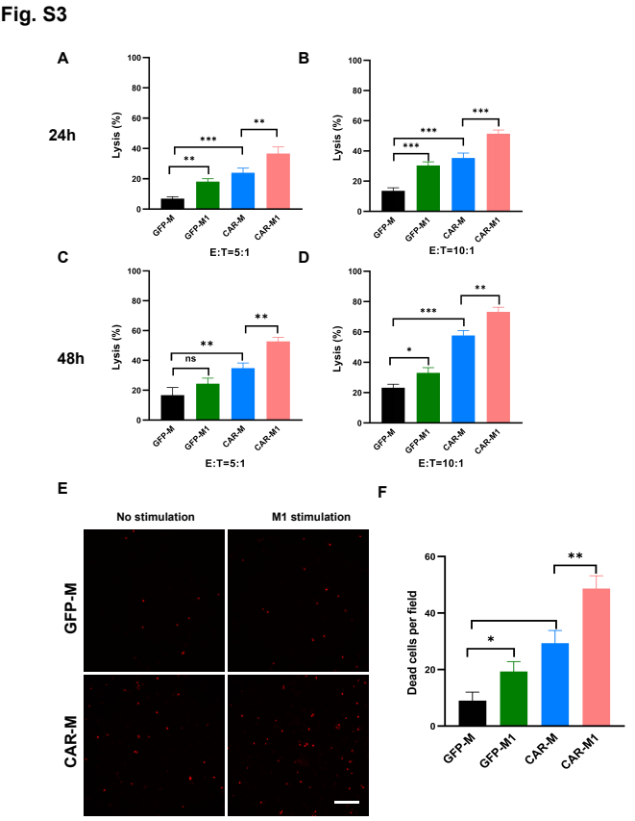
Fig. S3 M1-polarized CAR-Ms induce killing effects in vitro.
A-D Killing potential was evaluated by a luciferase-based killing assay of Luc⁺MC38-HER2 cells by J774A.1 cells after 24 hours and 48 hours of coculture at different E:T ratios in vitro. Data represent the mean±s.d. of three independent replicates. E Representative fluorescence microscopic imaging showing the CAR-M-mediated killing effect assessed with the YoYo-3 far-red fluorescent dye in vitro, scale bar: 100 µm. F Statistical analysis of the data from E. Data are shown as the mean ± SEM. *, p < 0.05; **, p < 0.01; ***, p < 0.001.

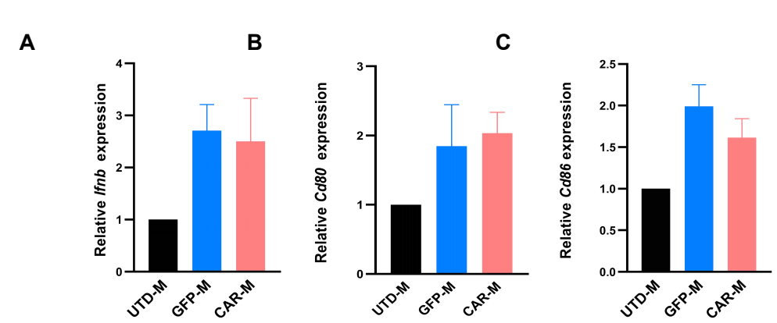 Fig. S4 Lentiviral transduction does not induce a proinflammatory phenotype in macrophages.
A-C Relative mRNA expression levels of Ifnb (A), Cd80 (B), and Cd86 (C) in UTD-Ms, GFP-Ms, and CAR-Ms by qRT‒PCR.

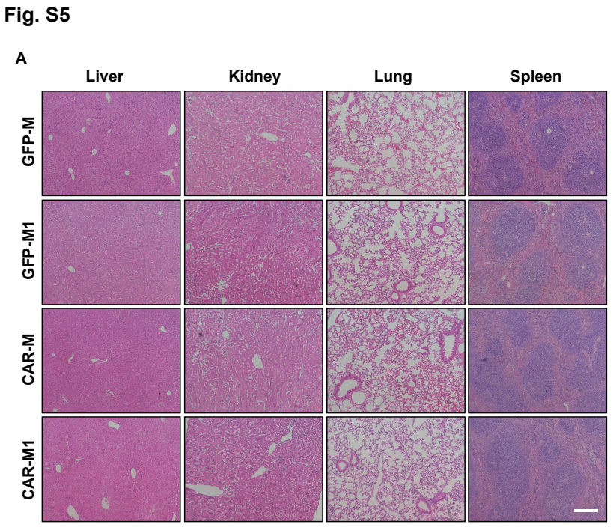
Fig. S5 Evaluation of the side effects of M1-polarized CAR-M treatment.
Representative hematoxylin and eosin (HE) staining of major organs, including the liver, lung, kidney, and spleen, from C57 mice bearing subcutaneous B16F10-HER2 melanoma tumors in the GFP-M, GFP-M1, CAR-M, and CAR-M1 treatment groups. Scale bar: 200 µm.

Table S1
Antibody | Cat# | Source
APC anti-human CD340 (erbB2/HER2) | 324407 | BioLegend
PerCP/Cyanine5.5 anti-mouse CD80 | 104721 | BioLegend
APC/Cyanine 7 anti-mouse CD86 | 105029 | BioLegend
PE anti-mouse CD11b | 101208 | BioLegend
APC anti-mouse F4/80 | 123116 | BioLegend
APC anti-His Tag | 362605 | BioLegend

