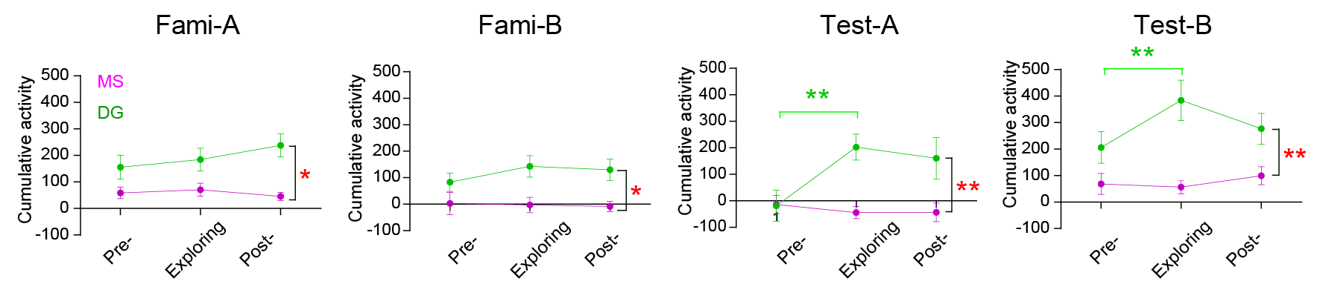
Fig. S1 Calcium activity of MS and DG GABAergic neurons in NPR test.
Calcium activity of DG, but not MS, GABAergic neurons was increased in the memory recall in NPR test. n = 4 mice, paired t-test, * p < 0.05.

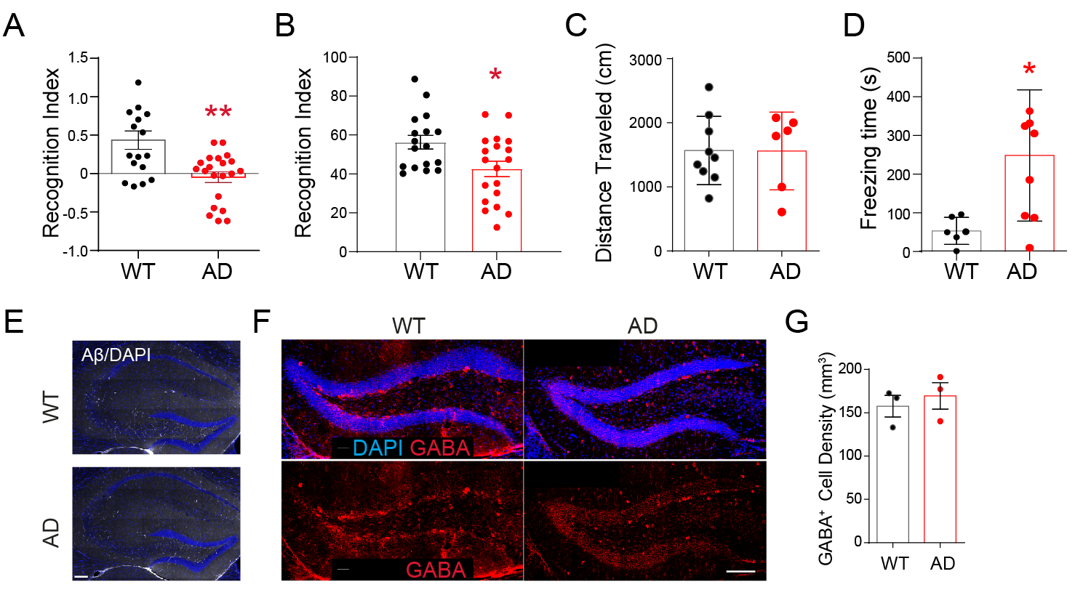
Fig. S2 Spatial memory is impaired during early-stage AD without obvious AD pathological hallmarks in DG and MS.
A) Quantification of 6 month Vgat-WT and Vgat-AD discriminative score (A-B/A+B) during the novel place recognition test, p = 0.0009, n = 17, 21 mice.
B) Recognition (B/A+B) of 6 month Vgat-WT and Vgat-AD in the NPR test. p = 0.0150, n = 17, 21 mice.
C) Traveled distance in the NPR test. n = 6-9 mice, P > 0.05.
D) Pre-NPR testing corner freezing time in a cohort of Vgat-WT and Vgat-AD mice, measured in seconds (s), p = 0.0319, n = 6, 8 mice
E) Representative confocal images of anti-amyloid (Aβ) in the hippocampus of 6 month WT and AD mice. Scale bar = 100 µm.
F) Representative confocal GABA immunofluorescence images in the DG of WT and AD mice at 6 months of age. Scale bar = 50 µm.
G) Quantification of DG GABA⁺ cell density. n = 3 mice, p = 0.278.

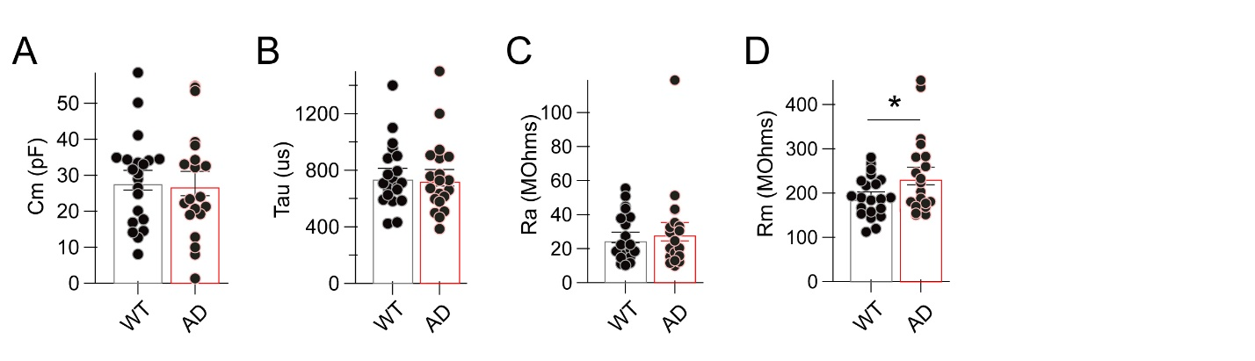 Fig. S3 Electrophysiological characteristics of granule cells in early stage AD.
A) Quantification of granule cell membrane capacitance in WT and AD mice, n = 21, 20 cells, p = 0.84.
B) Quantification of granule cell time constant in WT and AD mice, n = 21, 20 cells, p = 0.86.
C) Quantification of granule cell access resistance in WT and AD mice, n = 21, 20 cells, p = 0.58.
D) Quantification of granule cell membrane resistance in WT and AD mice, n = 21, 20 cells, p = 0.048.

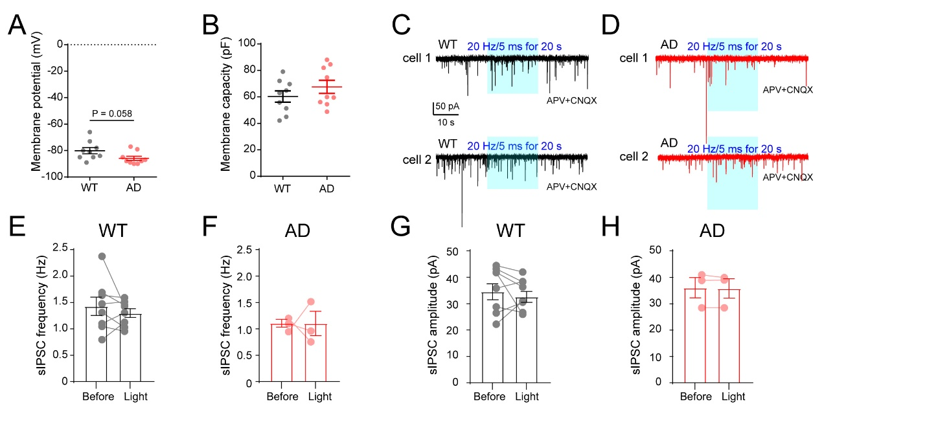
Fig. S4 Optogenetic stimulation of MS-DG circuit did not change sIPSCs of GCs during late-stage AD.
A) Quantification of GC membrane potential in 14 month WT and AD mice. n = 9, 9 cells, p = 0.058.
B) Quantification of GC membrane capacitance in 14 month WT and AD mice. n = 9, 9 cells, p = 0.278.
C) Representative 14 month WT GC traces during blue light stimulation (20 Hz/5 ms for 20 s) of MS GABA hilar projections in the presence of APV and CNQX.
D) Representative 14 month AD GC traces during blue light stimulation (20 Hz/5 ms for 20 s) of MS GABA hilar projections in the presence of APV and CNQX.
E) Quantification of GC sIPSC frequency before and during light stimulation in 14 month Vgat-WT mice, n = 8 cells.
F) Quantification of GC sIPSC frequency before and during light stimulation in 14 month Vgat-AD mice, n = 3 cells.

G) Quantification of GC sIPSC amplitude before and during light stimulation in 14 month Vgat-WT mice, n = 8 cells.
H) Quantification of GC sIPSC amplitude before and during light stimulation in 14 month Vgat-AD mice, n = 3 cells.

