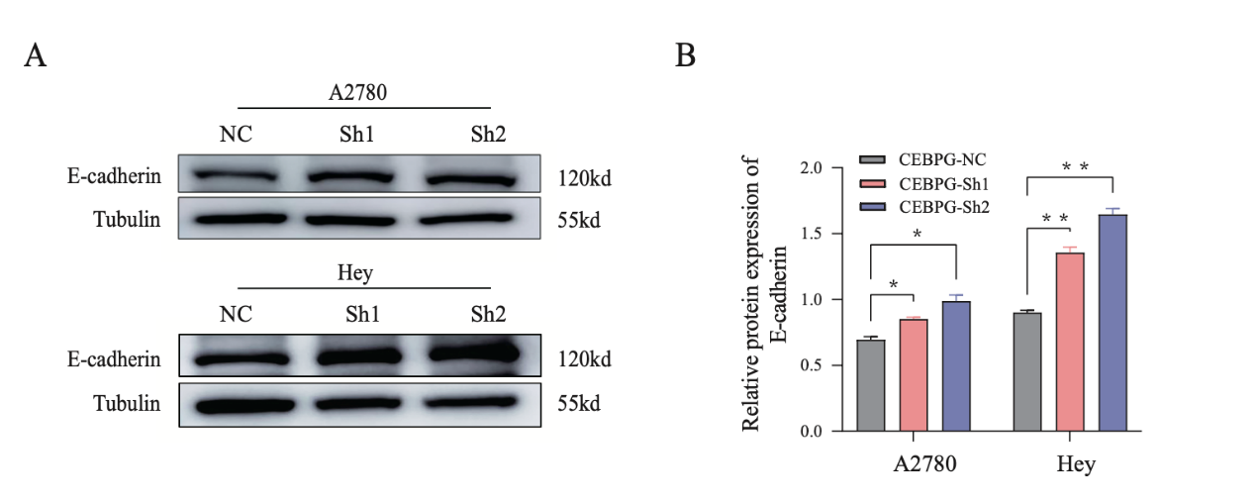
Fig.S1 Knockdown of CEBPG inhibited OC migration.
A and B The protein expression levels of E-cadherin analyzed by Western blotting in CEBPG-knockdown and control A2780 and Hey OC cells. *P < 0.05, **P < 0.01.
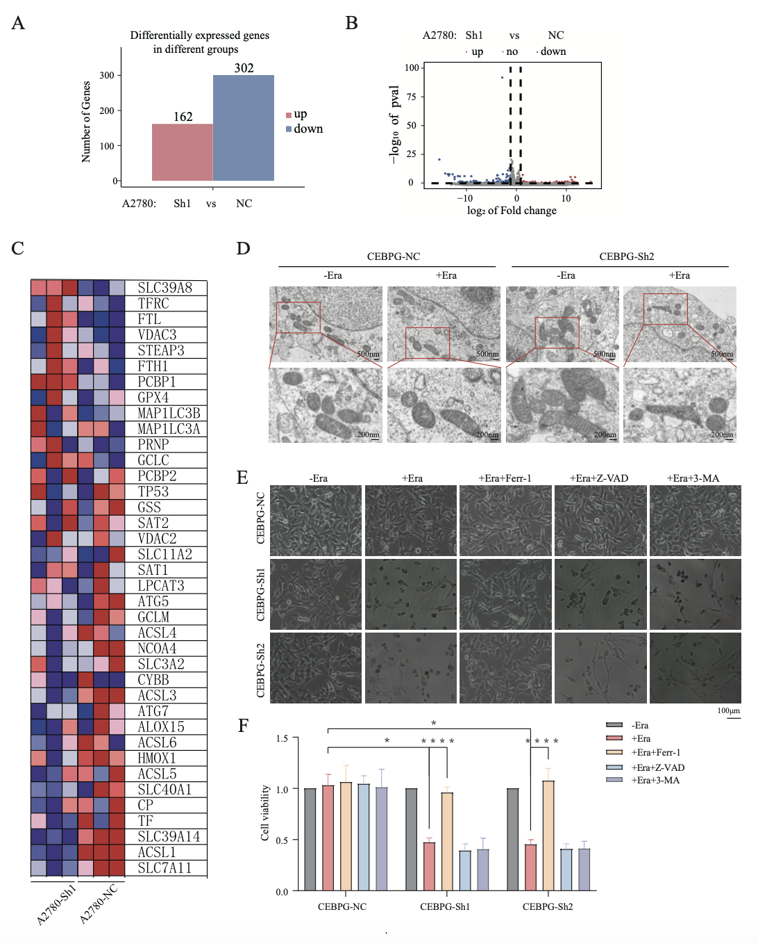
Fig. S2 CEBPG plays a crucial role in regulating ferroptosis in OC.
A and B The differential expressed genes between A2780-CEBPG-Sh1 and A2780-CEBPG-NC cells analyzed by RNA-seq. C The heatmap of differential expressed genes related to ferroptosis between A2780-CEBPG-Sh1 and A2780-CEBPG-NC cells. D TEM analysis of CEBPG-Sh2 and control A2780 cells with or without Era treatment, related to Fig.3B. Scale bars: 500nm and 200nm. E Representative phase contrast images of CEBPG-knockdown and control Hey cells treated with Era alone, Era plus Ferr-1, Era plus Z-VAD or Era plus 3-MA. Scale bar: 100μm. F Cell viability was measured after treatment with Era alone, Era plus Ferr-1, Era plus Z-VAD or Era plus 3-MA in CEBPG-knockdown and CEBPG-NC Hey cells. *P < 0.05, ****P < 0.0001.
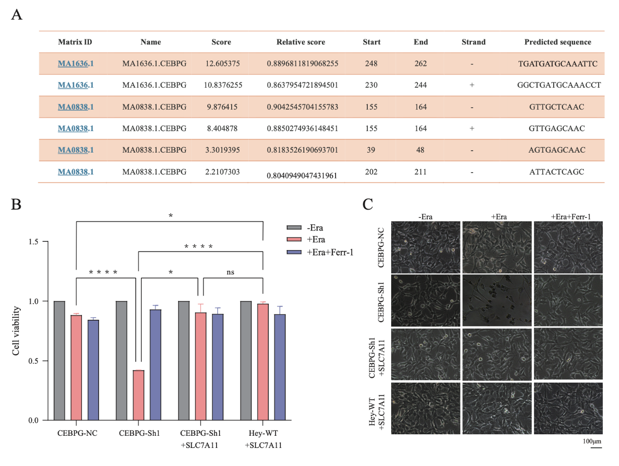
Fig. S3 The knockdown of CEBPG inhibited OC progression partially by reducing SLC7A11 expression and activating ferroptosis.
A The top 6 putative binding sites in the SLC7A11 promoter predicted in JASPAR. B The viability of CEBPG-knockdown Hey cells with or without SLC7A11 reexpression was assessed after treatment with Era alone or with Era and Ferr-1. C Representative phase contrast images of CEBPG-knockdown Hey cells treated with Era alone or combined with Ferr-1 when SLC7A11 was reexpressed. Scale bar: 100μm. *P < 0.05, ****P < 0.0001, ns: no significance.
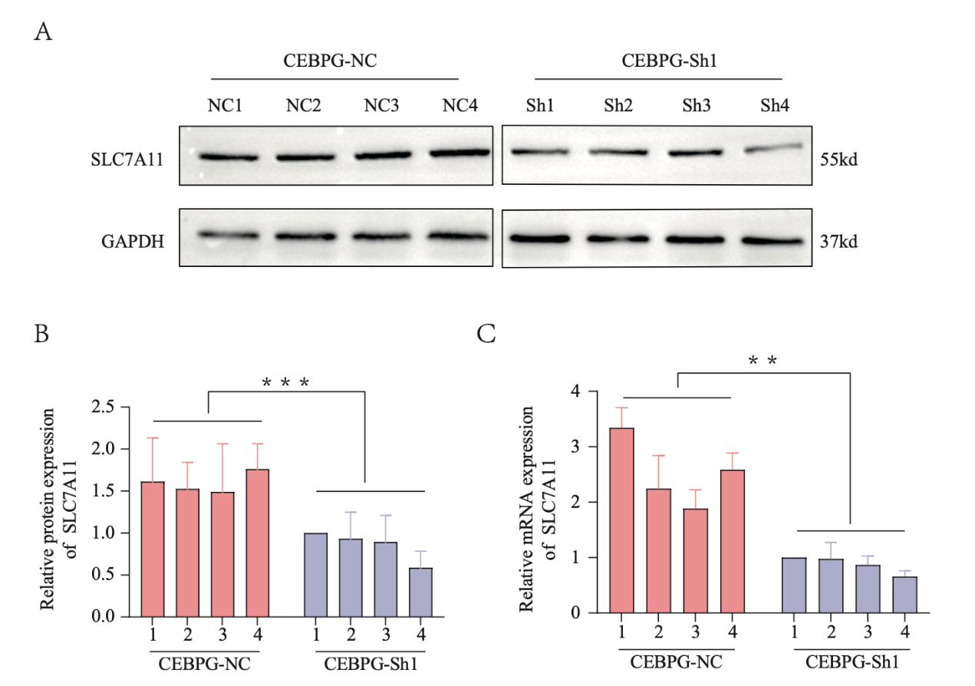

Fig. S4 CEBPG promoted the progression of OC in vivo.
A and B The protein expression levels of SLC7A11 analyzed by Western blotting in tumor tissues of mice seeded with CEBPG-knockdown or control A2780 cell. C The relative mRNA expression levels of SLC7A11 analyzed by qRT-PCR in tumor tissues of mice seeded with CEBPG-knockdown or control A2780 cells. **P < 0.01, ***P < 0.001.

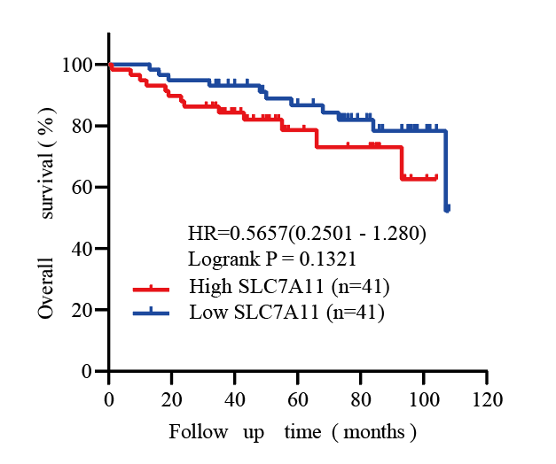
Fig. R1 The OS of patients with low/high SLC7A11 expression based on IHC analysis.

Supplementary Table 1.
The shRNA sequences targeting CEBPG
NO. | Primer sequence
ShA | GCCCATGGATCGAAACAGT
ShB | GACAGCAGATGGCGACAAT
ShC | GAGTCAATCAGCTCAAAGA

Supplementary Table 2.
Primer sequence

Gene | Primer sequence | Application
CEBPG | Forward Primer: ACTCCAGGGGTGAACGGAAT | qRT-PCR
 | Reverse Primer: CATGGGCGAACTCTTTTTGCT
SLC7A11 | Forward Primer: TCTCCAAAGGAGGTTACCTGC | qRT-PCR
 | Reverse Primer: AGACTCCCCTCAGTAAAGTGAC
GAPDH | Forward Primer: GGAGCGAGATCCCTCCAAAAT | qRT-PCR
 | Reverse Primer: GGCTGTTGTCATACTTCTCATGG
GPX4 | Forward Primer: GAGGCAAGACCGAAGTAAACTAC | qRT-PCR
 | Reverse Primer: CCGAACTGGTTACACGGGAA
VDAC3 | Forward Primer：TTGTACCGAACACAGGAAAGAAG | qRT-PCR
 | Reverse Primer：CCCAGCCATAGATGGTTGGTC

