Additional file-1

Functional status and spatial architecture of tumor-infiltrating CD8+ T cells are associated with lymph node metastases in non-small cell lung cancer
Guanqun Yang#, Siqi Cai#, Mengyu Hu, Chaozhuo Li, Liying Yang, Wei Zhang, Jujie Sun, Fenghao Sun, Ligang Xing, Xiaorong Sun*

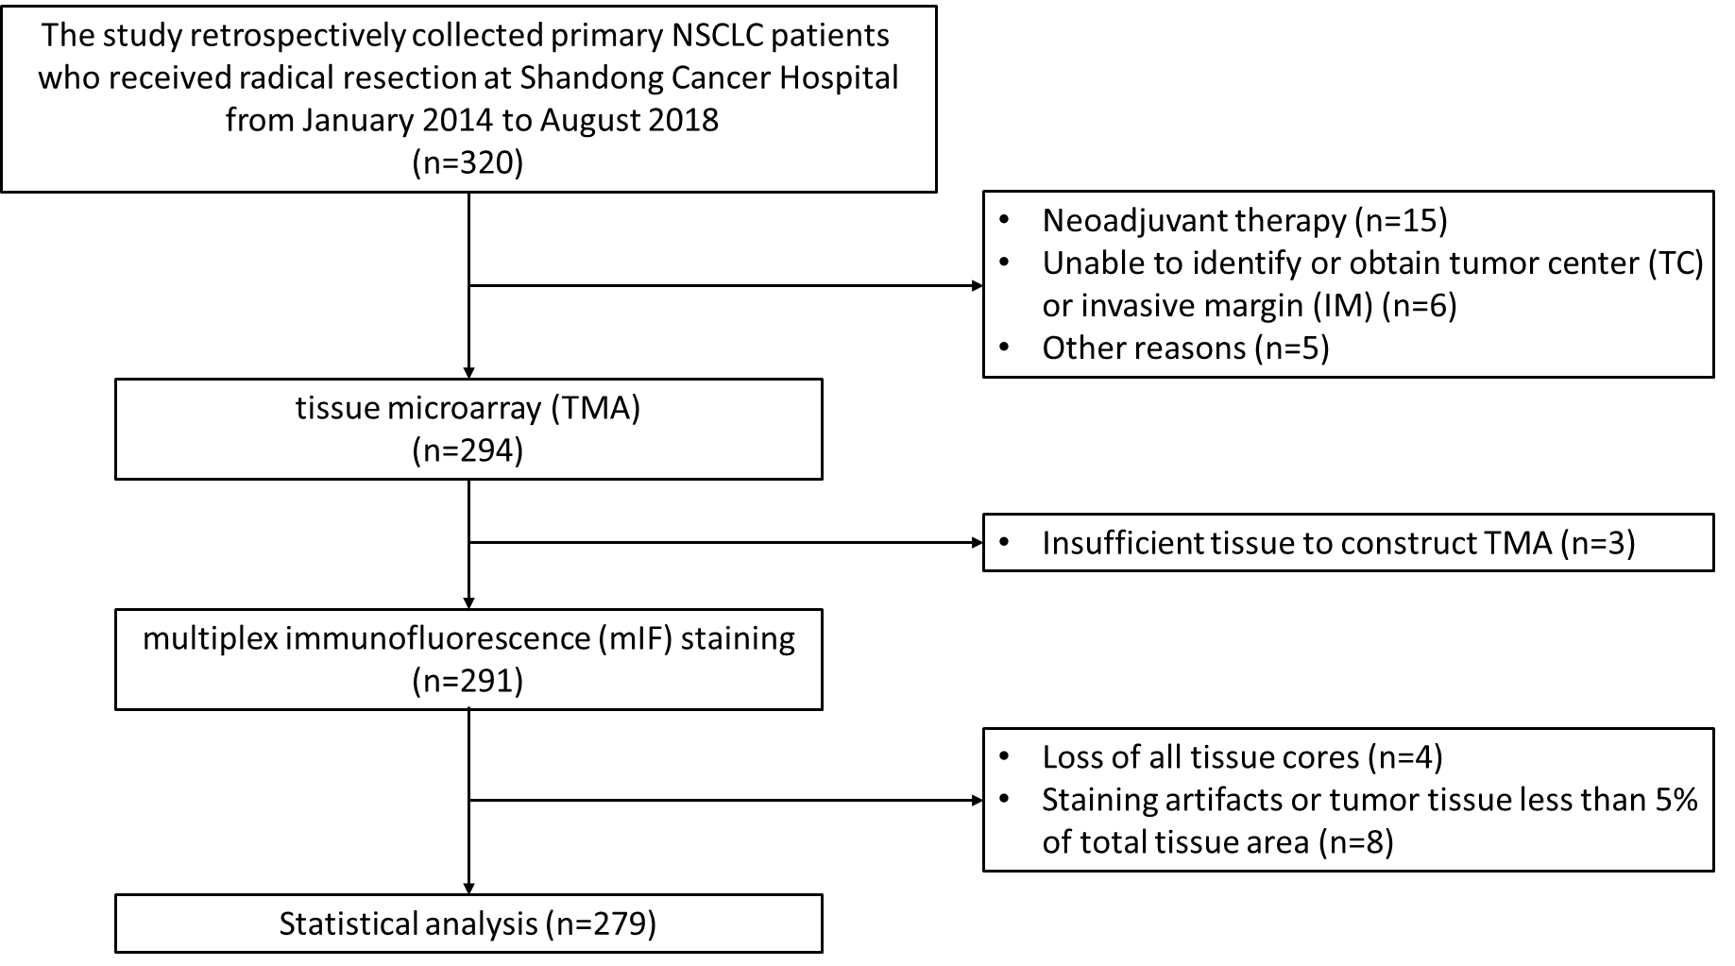
Additional Figure S1. Flowchart of the patient population in this study.

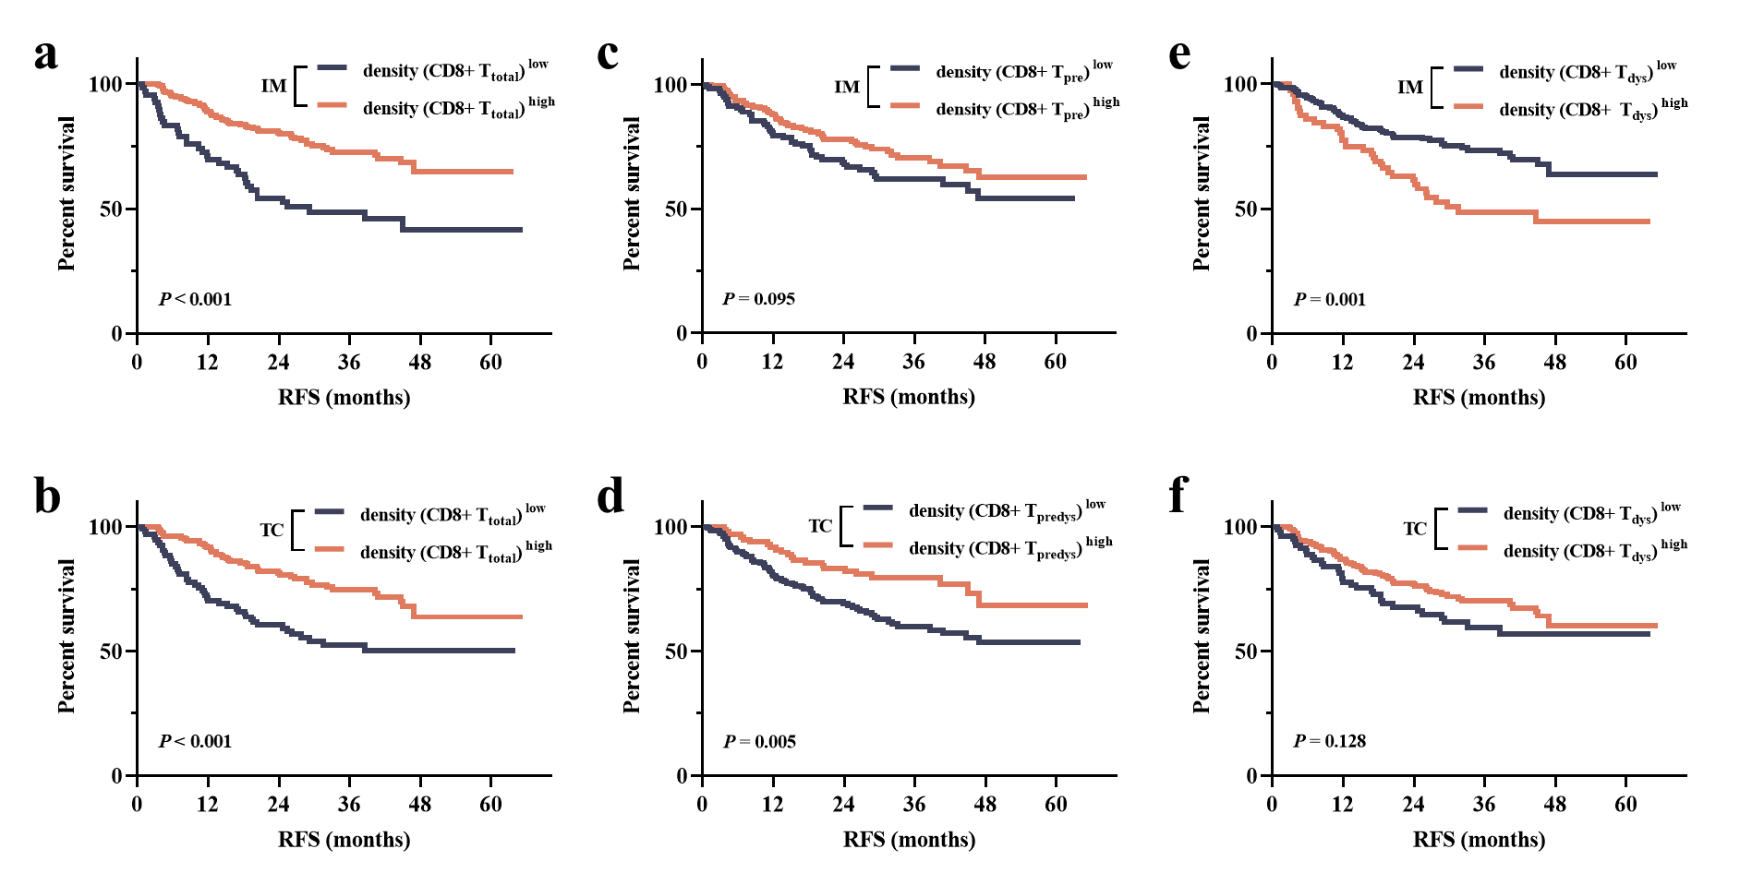
Additional Figure S2. Survival analysis of the cell densities of intratumoral-infiltrating CD8+ T-cell subsets in patients with NSCLC. (a-f) Kaplan-Meier survival analysis of intratumoral CD8+ T-cell subsets’ density-related parameters in patients with NSCLC, including CD8+T_{total} in IM (a) and in TC (b), CD8+T_{predys} in IM (c) and in TC (d), CD8+T_{dys} in IM (e) and in TC (f). Significance (P value) was determined using Log-rank test. IM, invasive margin; TC, tumor center; RFS, recurrence-free survival.

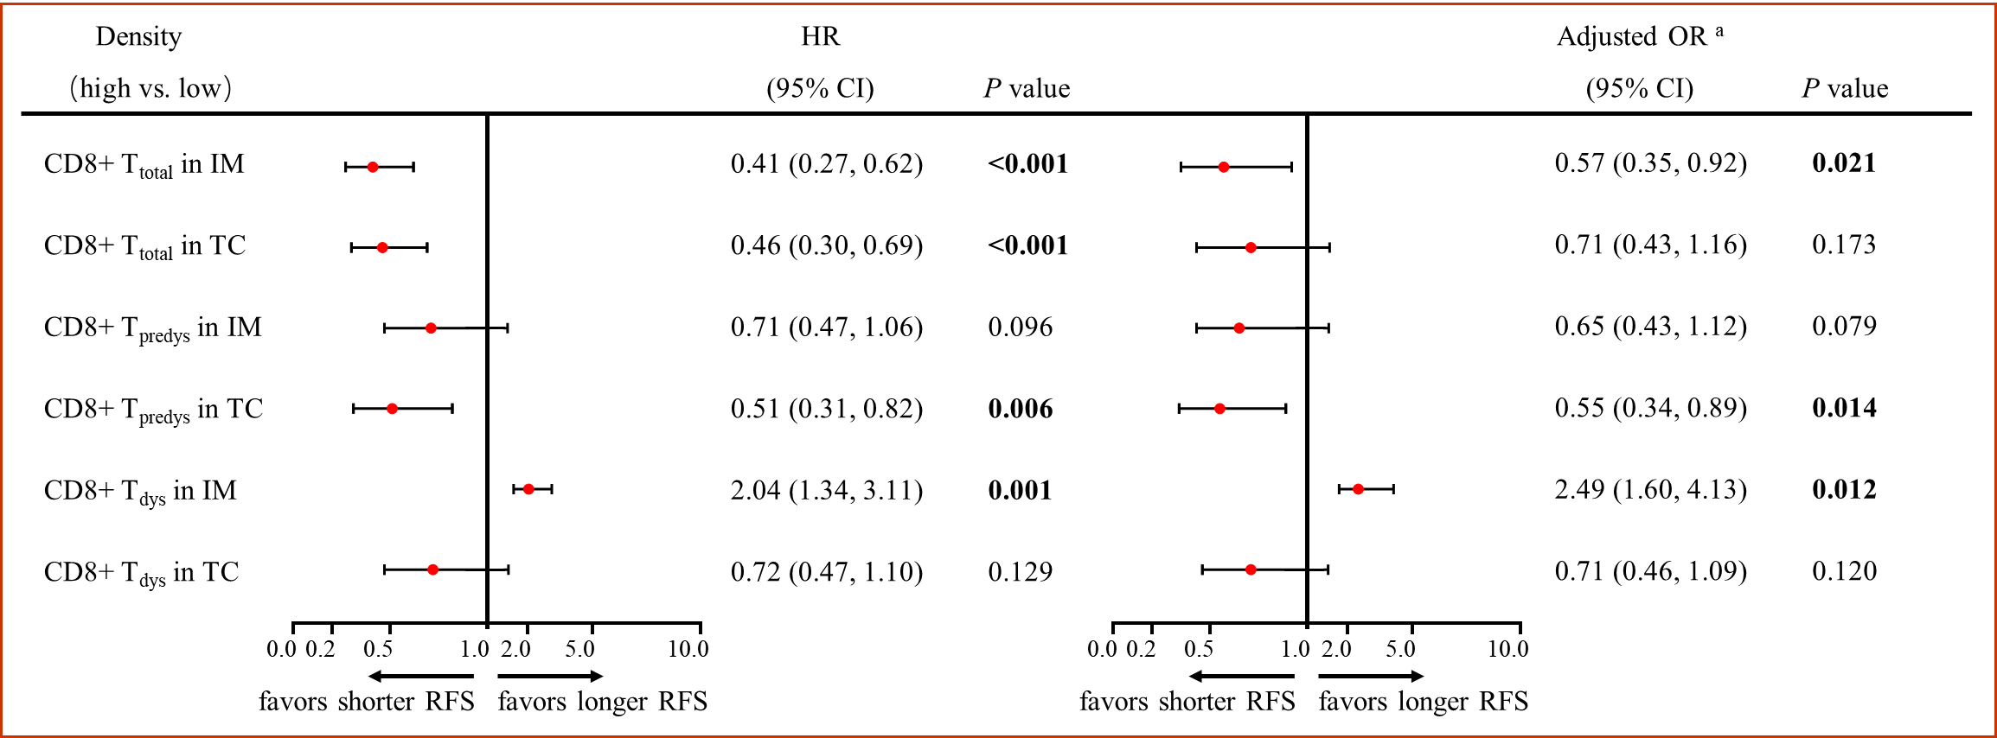
Additional Figure S3. The risk-correlation analysis of recurrence-free survival based on the density of CD8+ T-cell subsets in NSCLC. ª The multivariate Cox regression model adjusted age (≤ 60 years vs. ˃60 years), gender (male vs. female), histological subtype (squamous cell carcinoma vs. adenocarcinoma), tumor diameter (≤ 3 cm vs. ˃3 cm) and status of lymph node (positive vs. negative). A backward elimination with a threshold of P = 0.05 was used to select variables in the final models. Abbreviations: CI, confidence interval; HR, hazard ratio; IM, invasive margin; TC, tumor center; T_{predys}, pre-dysfunctional CD8+ T cell; T_{dys}, dysfunctional CD8+ T cell.

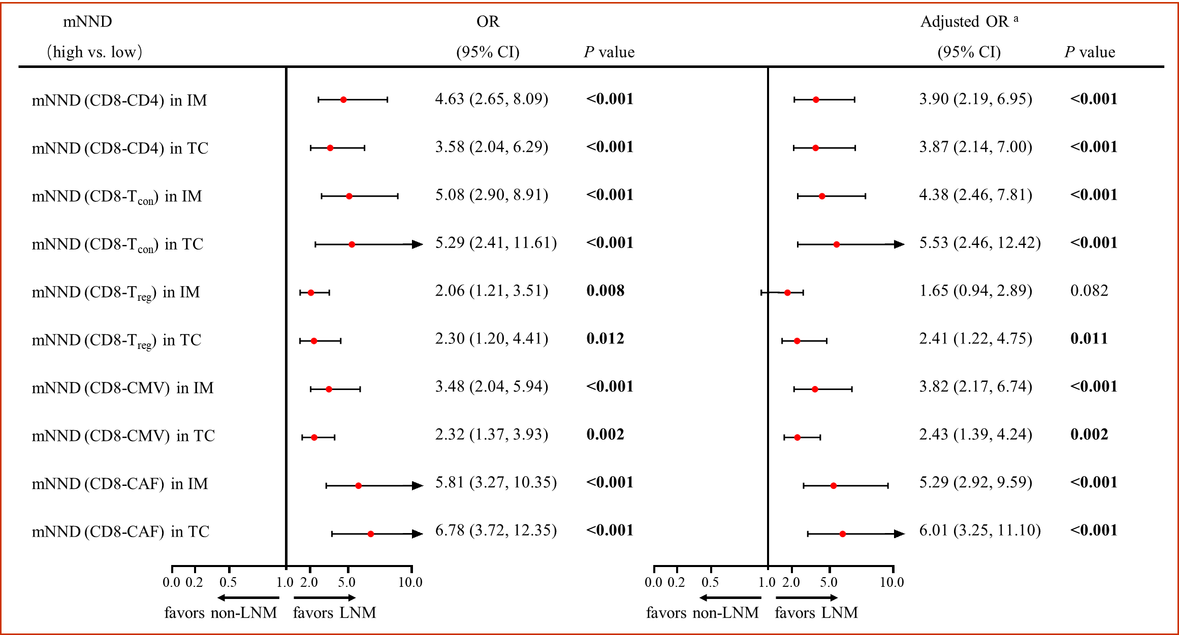
Additional Figure S4. The risk-correlation analysis of lymph node metastasis based on the mean nearest neighbor distance between CD8+ T cells and neighboring cells concerned in NSCLC. ª The multivariate Cox regression model adjusted age (≤ 60 years vs. ˃60 years), gender (male vs. female), histological subtype (squamous cell carcinoma vs. adenocarcinoma) and tumor diameter (≤ 3 cm vs. ˃3 cm). A backward elimination with a threshold of P = 0.05 was used to select variables in the final models. Abbreviations: CI, confidence interval; OR, odds ratio; IM, invasive margin; TC, tumor center; T_{con}, conventional CD4+ T cell; T_{reg}, regulatory CD4+ T cell; CMV, cancer microvessel; CAF, cancer-associated fibroblast.
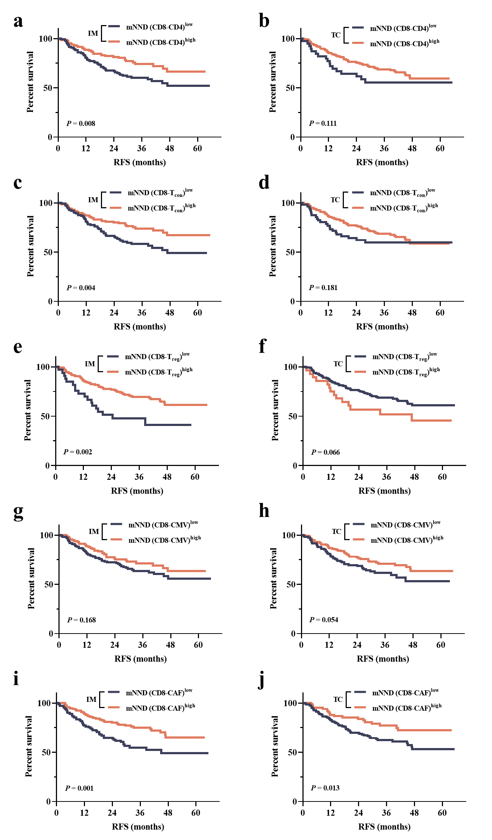
Additional Figure S5. Survival analysis of the mean nearest neighbor distances between intratumoral CD8+ T cells and neighboring cells in patients with NSCLC. (a-j) Kaplan-Meier survival analysis of intratumoral CD8+ T cells’ mNND-related parameters in patients with NSCLC, including mNND (CD8-CD4) in IM (a) and in TC (b), mNND (CD8-T_{con}) in IM (c) and in TC (d), mNND (CD8-T_{reg}) in IM (e) and in TC (f), mNND (CD8-CMV) in IM (g) and in TC (h), mNND (CD8-CAF) in IM (i) and in TC (j). Significance (P value) was determined using Log-rank test. mNND, mean nearest neighbor distance; IM, invasive margin; TC, tumor center; T_{con}, conventional CD4+ T cell; T_{reg}, regulatory CD4+ T cell; CMV, cancer microvessel; CAF, cancer-associated fibroblast; RFS, recurrence-free survival.

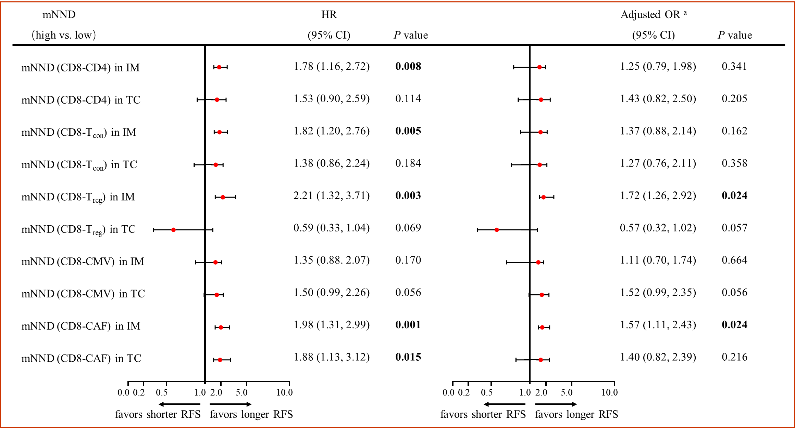
Additional Figure S6. The risk-correlation analysis of recurrence-free survival based on the mean nearest neighbor distance between CD8+ T cells and neighboring cells concerned in NSCLC. ª The multivariate Cox regression model adjusted age (≤ 60 years vs. ˃60 years), gender (male vs. female), histological subtype (squamous cell carcinoma vs. adenocarcinoma), tumor diameter (≤ 3 cm vs. ˃3 cm) and status of lymph node (positive vs. negative). A backward elimination with a threshold of P = 0.05 was used to select variables in the final models. Abbreviations: CI, confidence interval; HR, hazard ratio; IM, invasive margin; TC, tumor center; T_{con}, conventional CD4+ T cell; T_{reg}, regulatory CD4+ T cell; CMV, cancer microvessel; CAF, cancer-associated fibroblast.

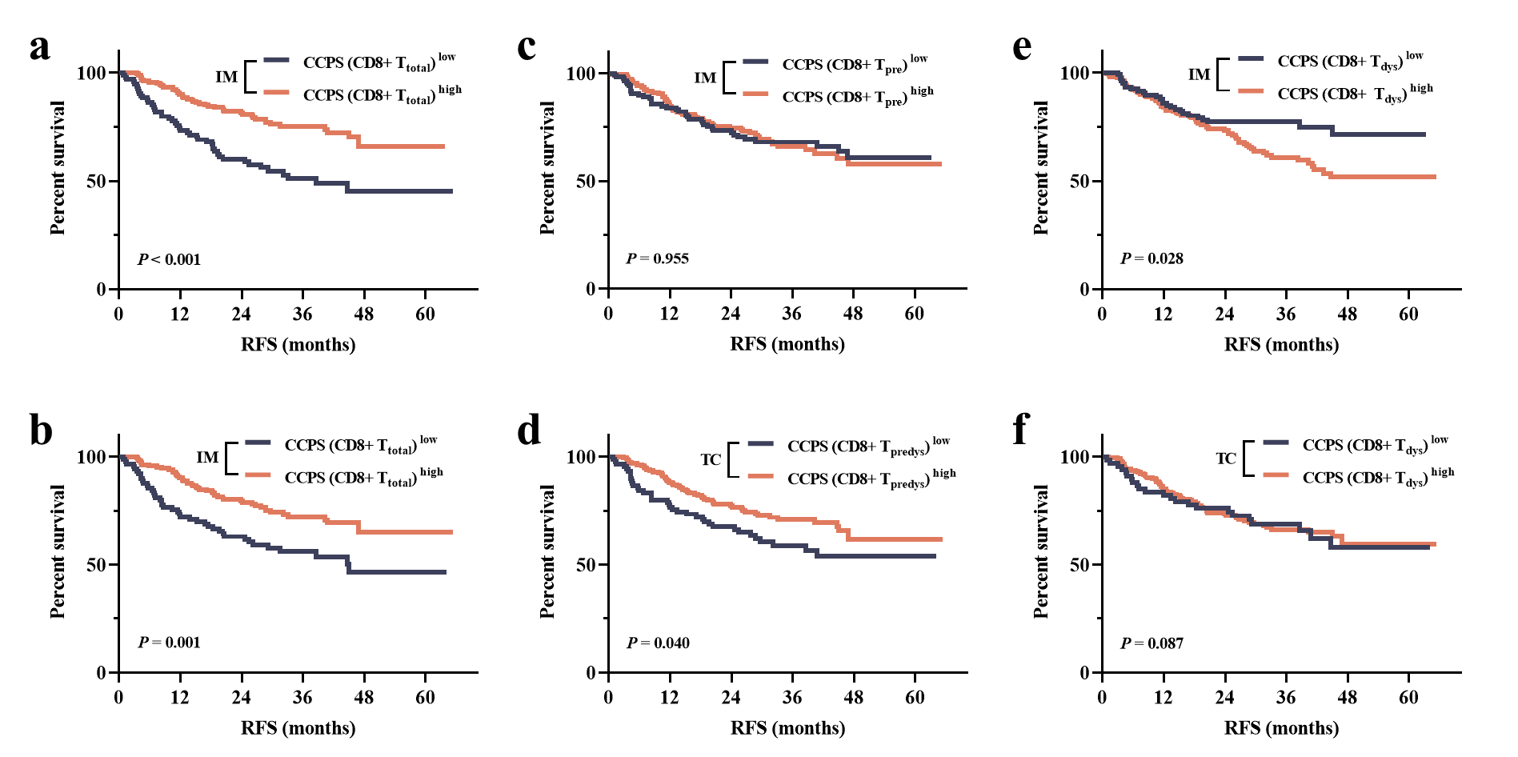
Additional Figure S7. Survival analysis of the cancer-cell proximity scores between intratumoral CD8+ T cells and neighboring cells in patients with NSCLC. (a-f) Kaplan-Meier survival analysis of intratumoral CD8+ T cells’ CCPS-related parameters in patients with NSCLC, including CD8+T_{total} in IM (a) and in TC (b), CD8+T_{predys} in IM (c) and in TC (d), CD8+T_{dys} in IM (e) and in TC (f). Significance (P value) was determined using Log-rank test. IM, invasive margin; TC, tumor center; RFS, recurrence-free survival.

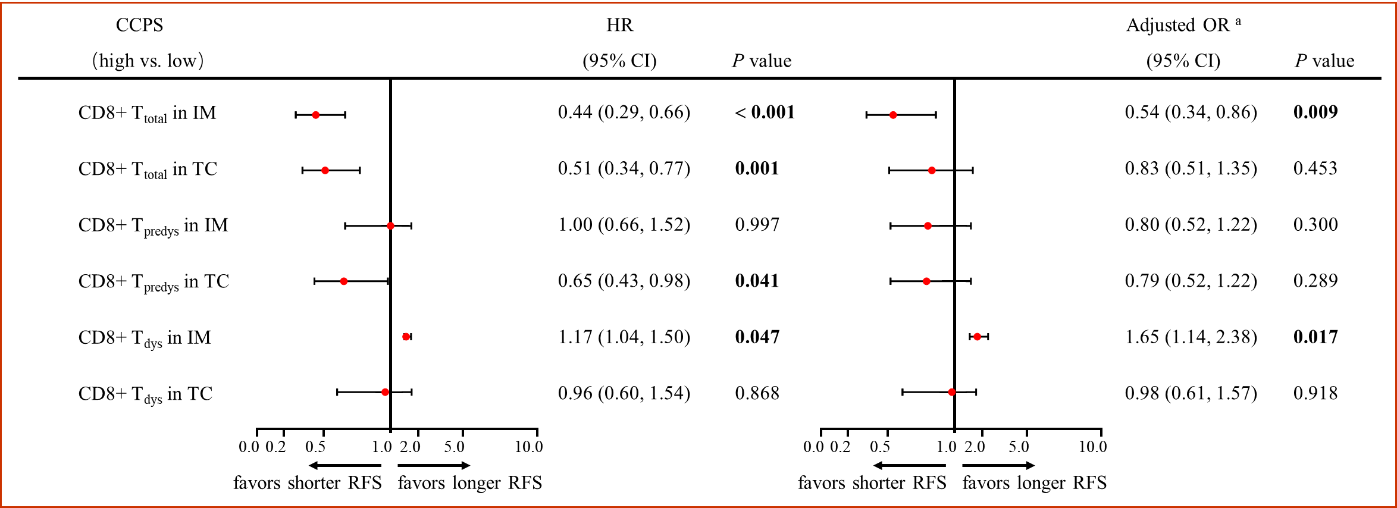
Additional Figure S8. The risk-correlation analysis of recurrence-free survival based on the cancer-cell proximity score of CD8+ T-cell functional subsets in NSCLC. ª The multivariate Cox regression model adjusted age (≤ 60 years vs. ˃60 years), gender (male vs. female), histological subtype (squamous cell carcinoma vs. adenocarcinoma), tumor diameter (≤ 3 cm vs. ˃3 cm) and status of lymph node (positive vs. negative). A backward elimination with a threshold of P = 0.05 was used to select variables in the final models. Abbreviations: CI, confidence interval; HR, hazard ratio; IM, invasive margin; TC, tumor center; T_{predys}, pre-dysfunctional CD8+ T cell; T_{dys}, dysfunctional CD8+ T cell.

Additional Table S1. Information of primary antibodies used in the multiplex immunofluorescence test
Reagent | Provider | Identifier | Concentration
pan-CK | ZSGB-BIO | ZM-0069 | 1:200
CD4 | ZSGB-BIO | ZM-0418 | 1:1
CD8 | Abcam | ab199016 | 1:500
Foxp3 | Abcam | ab20034 | 1:100
CD31 | Abcam | ab76533 | 1:100
ɑSMA | Abcam | ab7817 | 1:200
Hif-1ɑ | Abcam | ab51608 | 1:100
CD103 | Abcam | ab224202 | 1:200
GZMB | Abcam | ab255598 | 1:2000
Tim3 | Cell Signaling Technology | 45208S | 1:100
PD-1 | ZSGB-BIO | ZM-0381 | 1:1

Additional Table S2. Scheme of cell phenotypes in multiplex immunofluorescence detection.
Cell set | Cell subset | Markers
Cancer cell | N/A | pan-CK+
CD8+ T cell | Total CD8+ T cell (CD8+ T_{total}) | CD8+
CD8+ T cell | Cytotoxic CD8+ T cell (CD8+ T_{cyto}) | CD8+/PD1-/CD103-/Tim3-/GZMB+
CD8+ T cell | Predysfunctional CD8+ T cell (CD8+ T_{predys}) | CD8+/PD1+/CD103+/Tim3-/GZMB-
CD8+ T cell | Predysfunctional CD8+ T cell (CD8+ T_{predys}) | CD8+/PD1+/CD103-/Tim3-/GZMB-
CD8+ T cell | Predysfunctional CD8+ T cell (CD8+ T_{predys}) | CD8+/PD1-/CD103+/Tim3-/GZMB-
CD8+ T cell | Dysfunctional CD8+ T cell (CD8+ T_{dys}) | CD8+/Tim3+
CD4+ T cell | Total CD4+ T cell (CD4+ T_{total}) | CD4+
CD4+ T cell | Conventional CD4+ T cell (CD4+ T_{con}) | CD4+/Foxp3-
CD4+ T cell | Regulatory CD4+ T cell (CD4+ T_{reg}) | CD4+/Foxp3+
Stromal component | Cancer microvessel (CMV) | CD31+
Stromal component | Cancer-associated fibroblast (CAF) | αSMA+
Hypoxia indicator | Hypoxic cancer cell | pan-CK+/Hif-1α+
N/A, not available

Additional Table S3. The discrepancy of the density of CD8+ T-cell functional subsets among NSCLC patients grouped by clinicopathological factors
Cell density | Age  (≤ 60y vs. >60y) | Gender  (female vs. male) | Smoking index  (<400 vs. ≥400) | ECOG PS  (>1 vs. ≤1) | Histological subtype  (LUAD vs. LUSC) | T Stage  (T1 vs T2 vs. T3 + T4)
CD8+ T_{total} in IM | P = 0.012  (103.04 vs. 121.21) | P = 0.099  (98.63 vs. 116.53) | P = 0.165  (107.52 vs. 117.04) | P = 0.002  (88.65 vs. 120.45) | P = 0.668  (116.85 vs. 104.78) | P ˂ 0.001  (135.67 vs. 107.08 vs. 74.65)
CD8+ T_{total} in TC | P = 0.030  (77.36 vs. 108.47) | P = 0.556  (103.52 vs. 97.12) | P = 0.781  (106.13 vs. 88.45) | P = 0.025  (72.89 vs. 106.48) | P = 0.053  (108.81 vs. 73.35) | P ˂ 0.001  (122.14 vs. 85.50 vs. 34.86)
CD8+ T_{predys} in IM | P = 0.680  (15.70 vs. 19.87) | P = 0.143  (17.73 vs. 19.02) | P = 0.002  (15.01 vs.23.34) | P = 0.159  (15.97 vs. 19.84) | P = 0.007  (15.93 vs. 22.90) | P = 0.465  (17.59 vs. 18.59 vs. 24.35)
CD8+ T_{predys} in TC | P = 0.212  (8.13 vs. 10.46) | P = 0.003  (11.01 vs. 7.78) | P = 0.030  (10.32 vs. 7.74) | P = 0.306  (8.42 vs. 9.62) | P = 0.001  (11.17 vs. 6.05) | P = 0.010  (10.55 vs. 9.53 vs. 3.79)
CD8+ T_{dys} in IM | P = 0.886  (44.62 vs. 43.55) | P = 0.149  (34.78 vs. 50.69) | P = 0.249  (40.09 vs.51.03) | P = 0.079  (54.06 vs. 40.94) | P ˂ 0.001  (34.69 vs. 74.44) | P ˂ 0.001  (34.69 vs. 41.36 vs. 102.74)
CD8+ T_{dys} in TC | P = 0.959  (21.91 vs. 21.43) | P = 0.415  (25.85 vs. 20.37) | P = 0.474  (23.40 vs. 20.69) | P = 0.856  (20.54 vs. 21.88) | P = 0.130  (25.53 vs. 19.29) | P = 0.226  (25.30 vs.20.38 vs. 17.31)

Additional Table S4. The discrepancy of the density of compartment-special CD8+ T-cell functional subsets among NSCLC patients grouped by clinicopathological factors
Compartment | Cell density | Age  (≤ 60y vs. >60y) | Gender  (female vs. male) | Smoking index  (<400 vs. ≥400) | ECOG PS  (>1 vs. ≤1) | Histological subtype  (LUAD vs. LUSC) | T Stage  (T1 vs T2 vs. T3 + T4)
Epithelial | CD8+ T_{total} | P = 0.047  (75.96 vs. 105.76) | P = 0.483  (104.38 vs. 77.46) | P = 0.784  (96.94 vs. 75.57) | P = 0.027  (60.52 vs. 97.93) | P = 0.194  (94.14 vs. 75.37) | P ˂ 0.001  (123.61 vs. 80.73 vs. 33.25)
Epithelial | CD8+ T_{predys} | P = 0.877  (1.54 vs. 1.80) | P = 0.237  (2.07 vs. 1.56) | P = 0.160  (1.94 vs. 1.53) | P = 0.760  (1.64 vs. 1.74) | P = 0.096  (1.92 vs. 1.50) | P = 0.100  (2.21 vs. 1.64 vs. 1.11)
Epithelial | CD8+ T_{dys} | P = 0.875  (6.65 vs. 7.08) | P = 0.367  (6.40 vs. 7.01) | P = 0.707  (6.70 vs. 7.08) | P = 0.876  (6.81 vs. 6.81) | P = 0.933  (6.88 vs. 6.79) | P = 0.268  (8.71 vs. 5.67 vs. 7.22)
Stromal | CD8+ T_{total} | P = 0.034  (77.02 vs 101.09) | P = 0.990  (90.67 vs. 92.45) | P = 0.521  (101.09 vs. 85.05) | P = 0.027  (69.51 vs. 96.79) | P = 0.099  (99.88 vs. 77.73) | P ˂ 0.001  (114.97 vs. 83.85 vs. 43.96)
 | CD8+ T_{predys} | P = 0.614  (18.45 vs. 18.49) | P = 0.023  (19.57 vs. 17.11) | P = 0.067  (19.86 vs. 16.29) | P = 0.270  (15.21 vs. 20.46) | P = 0.011  (21.40 vs. 14.32) | P = 0.008  (24.12 vs. 17.80 vs. 6.90)
 | CD8+ T_{dys} | P = 0.593  (42.14 vs. 41.39) | P = 0.913  (49.59 vs. 38.72) | P = 0.899  (45.07 vs. 39.52) | P = 0.501  (40.70 vs. 43.72) | P = 0.984  (45.07 vs. 37.33) | P = 0.233  (53.28 vs. 37.89 vs. 51.49)

Additional Table S5. The discrepancy of the mean nearest distance between CD8+ T cells and neighboring cells among NSCLC patients grouped by clinicopathological factors
mNND | Age  (≤ 60y vs. >60y) | Gender  (female vs. male) | Smoking index  (<400 vs. ≥400) | ECOG PS  (>1 vs. ≤1) | Histological subtype  (LUAD vs. LUSC) | T Stage  (T1 vs T2 vs. T3 + T4)
CD8-CD4 in IM | P = 0.694  (42.99 vs. 47.49) | P = 0.034  (53.82 vs. 43.79) | P = 0.006  (47.67 vs. 40.78) | P = 0.554  (43.79 vs. 45.94) | P ˂ 0.001  (52.72 vs. 38.59) | P ˂ 0.001  (55.01 vs. 43.85 vs. 29.87)
CD8-CD4 in TC | P = 0.251  (32.02 vs. 39.75) | P ˂ 0.001  (26.96 vs. 41.94) | P = 0.007  (31.05 vs. 43.38) | P = 0.461  (34.68 vs. 34.40) | P = 0.008  (30.77 vs. 43.89) | P = 0.479  (32.86 vs. 35.65 vs. 29.25)
CD8-T_{con} in IM | P = 0.588  (46.78 vs. 52.57) | P = 0.069  (57.13 vs. 47.49) | P = 0.010  (56.26 vs. 45.54) | P = 0.603  (46.97 vs. 51.39) | P ˂ 0.001  (57.18 vs. 41.42) | P ˂ 0.001  (61.10 vs. 47.62 vs. 32.32)
CD8-T_{con} in TC | P = 0.311  (38.34 vs. 45.20) | P ˂ 0.001  (31.00 vs. 48.15) | P = 0.006  (35.59 vs. 48.84) | P = 0.555  (43.26 vs. 41.83) | P = 0.003  (35.57 vs. 52.40) | P = 0.502  (39.74 vs. 44.48 vs. 33.38)
CD8-T_{reg} in IM | P = 0.853  (111.11 vs. 109.51) | P = 0.004  (122.41 vs. 101.68) | P = 0.001  (119.24 vs. 95.56) | P = 0.533  (111.84 vs. 110.20) | P ˂ 0.001  (119.91 vs. 85.40) | P = 0.011  (121.92 vs. 107.76 vs. 77.65)
CD8-T_{reg} in TC | P = 0.089  (73.71 vs. 82.08) | P = 0.116  (72.54 vs. 82.56) | P = 0.437  (77.14 vs. 83.17) | P = 0.472  (74.98 vs. 80.99) | P = 0.399  (74.61 vs. 85.12) | P = 0.246  (71.89 vs. 82.74 vs. 82.39)
CD8-CD31 in IM | P = 0.854  (22.02 vs. 22.94) | P = 0.115  (20.83 vs. 23.51) | P = 0.174  (21.91 vs. 23.47) | P = 0.105  (21.17 vs. 23.47) | P = 0.915  (22.60 vs. 22.63) | P = 0.227  (24.96 vs. 22.39 vs. 21.11)
CD8-CD31 in TC | P = 0.277  (32.37 vs. 35.27) | P ˂ 0.001  (25.69 vs. 36.65) | P ˂ 0.001  (30.51 vs. 38.81) | P = 0.385  (33.86 vs. 34.46) | P ˂ 0.001  (30.75 vs. 40.95) | P = 0.925  (35.15 vs. 32.90 vs. 34.54)
CD8-αSMA in IM | P = 0.060  (55.22 vs. 88.89) | P = 0.885  (85.13 vs. 72.63) | P = 0.295  (85.02 vs. 62.22) | P = 0.003  (50.37 vs. 88.00) | P = 0.424  (71.96 vs. 75.81) | P = 0.130  (96.12 vs. 76.67 vs. 49.43)
CD8-αSMA in TC | P = 0.099  (31.12 vs. 43.52) | P = 0.559  (39.53 vs. 40.35) | P = 0.619  (41.13 vs. 40.28) | P = 0.158  (32.67 vs. 46.81) | P = 0.498  (39.70 vs. 43.02) | P = 0.151  (49.75 vs. 40.28 vs. 29.65)

Additional Table S6. The discrepancy of the cancer-cell proximity score of CD8+ T-cell functional subsets among NSCLC patients grouped by clinicopathological factors
CCPS | Age  (≤ 60y vs. >60y) | Gender  (female vs. male) | Smoking index  (<400 vs. ≥400) | ECOG PS  (>1 vs. ≤1) | Histological subtype  (LUAD vs. LUSC) | Stage  (I vs II vs III)
CD8+T_{total} in IM | P = 0.006  (2.53 vs. 3.45) | P = 0.205  (2.84 vs. 3.02) | P = 0.250  (2.84 vs. 3.09) | P ˂ 0.001  (2.10 vs. 3.17) | P = 0.650  (2.86 vs. 3.03) | P = 0.002  (3.59 vs. 2.69 vs.1.63)
CD8+T_{total} in TC | P = 0.209  (2.33 vs. 2.82) | P = 0.044  (3.26 vs. 2.29) | P = 0.392  (2.79 vs. 2.15) | P = 0.081  (2.19 vs. 2.68) | P = 0.018  (2.82 vs. 1.79) | P ˂ 0.001  (3.60 vs. 2.33 vs. 0.85)
CD8+ T_{predys} in IM | P = 0.630  (0.36 vs. 0.35) | P = 0.425  (0.34 vs. 0.35) | P = 0.030  (0.30 vs. 0.39) | P = 0.202  (0.30 vs. 0.36) | P = 0.021  (0.29 vs. 0.41) | P = 0.440  (0.29 vs. 0.35 vs. 0.36)
CD8+ T_{predys} in TC | P = 0.248  (0.13 vs. 0.14) | P = 0.023  (0.17 vs. 0.14) | P = 0.114  (0.15 vs. 0.13) | P = 0.231  (0.11 vs. 0.15) | P = 0.011  (0.15 vs. 0.12) | P = 0.016  (0.15 vs. 0.14 vs. 0.07)
CD8+ T_{dys} in IM | P = 0.647  (0.62 vs. 0.63) | P = 0.359  (0.58 vs. 0.67) | P = 0.241  (0.58 vs. 0.67) | P = 0.093  (0.82 vs. 0.61) | P = 0.002  (0.53 vs. 0.94) | P = 0.018  (0.57 vs. 0.61 vs. 1.19)
CD8+ T_{dys} in TC | P = 0.739  (0.42 vs. 0.40) | P = 0.807  (0.42 vs. 0.41) | P = 0.863  (0.41 vs. 0.41) | P = 0.755  (0.41 vs. 0.41) | P = 0.744  (0.42 vs. 0.39) | P = 0.281  (0.50 vs. 0.39 vs. 0.28)

