Additional file 1: Materials

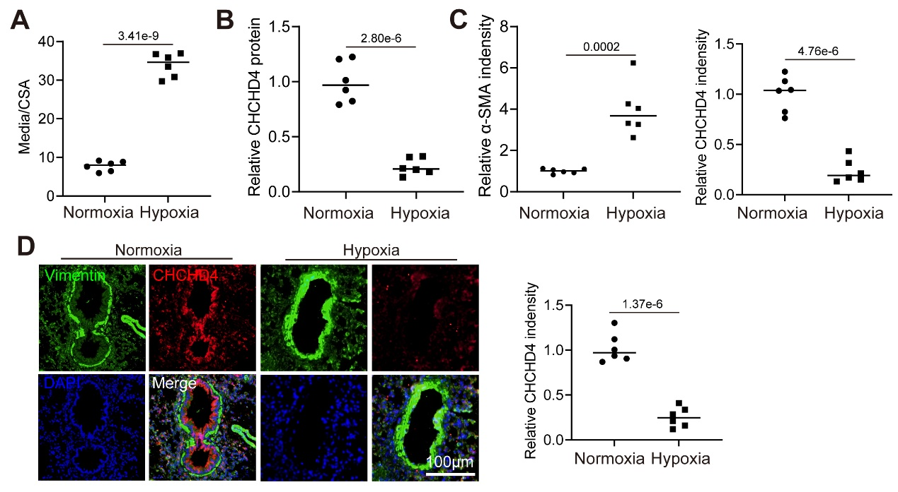
Figure S1. CHCHD4 is identified as a regulator of PAH.
Related to figure 1.
A. Quantification of ratio of pulmonary arterial medial thickness to total vessel size (media/CSA) in indicated group (n=6). Related to figure 1D.
B. Quantification of immunoblotting of CHCHD4 (n=6). Related to figure 1C.
C. Quantitative analysis of α-SMA and CHCHD4 fluorescence intensity by Image J software (n=6). Related to figure 1E.
D. Representative immunofluorescence of Vimentin (green), CHCHD4 (red) and DAPI (blue) in lung tissues from indicated group. And quantitative analysis of CHCHD4 fluorescence intensity by Image J software (n=6).
Data are shown as the mean±SEM. P value is showed in each figure.

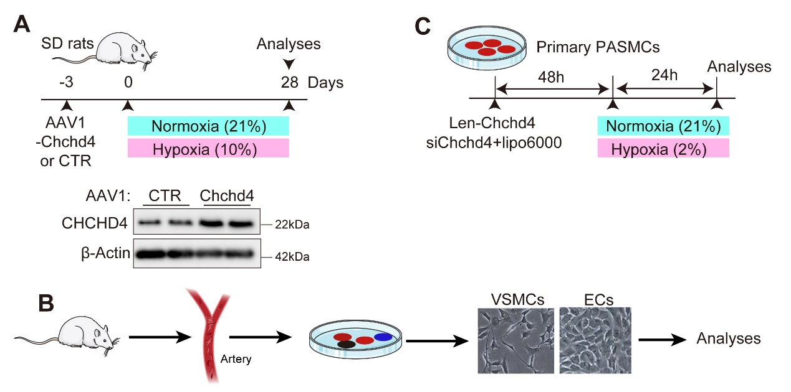
Figure S2. Protocols.
A. Experimental schedule of SD rats received AAV1-Chchd4 or CTR injection. Representative immunoblotting of CHCHD4 in lung tissues from animals with AAV1-CTR or Chchd4. Related to figure 3.
B. VSMCs, ECs and other cells were isolated from SD rats. Related to Figure 1.
C. Experimental schedule of primary PASMCs received Chchd4 overexpression or knockdown in vitro. Related to figure 4.

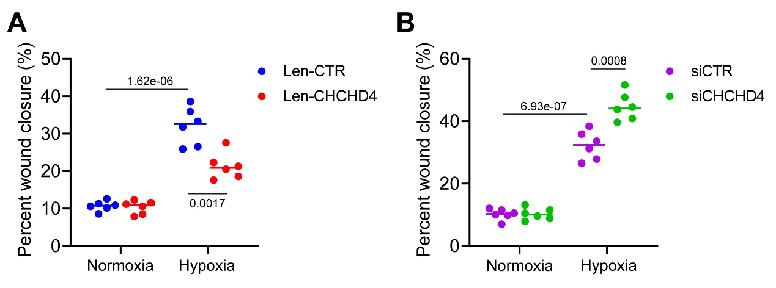
Figure S3. CHCHD4 affects hypoxia-induced migration in PASMCs.
A. The percent of wound closure of PASMCs received len-CTR or len-CHCHD4 transduction was counted (n=6 fields from 3 independent experiments). Related to figure 4B.
B. The percent of wound closure of PASMCs received siCTR or siCHCHD4 transduction was counted (n=6 fields from 3 independent experiments). Related to figure 4G.
Data are shown as the mean±SEM. P value is showed in each figure.

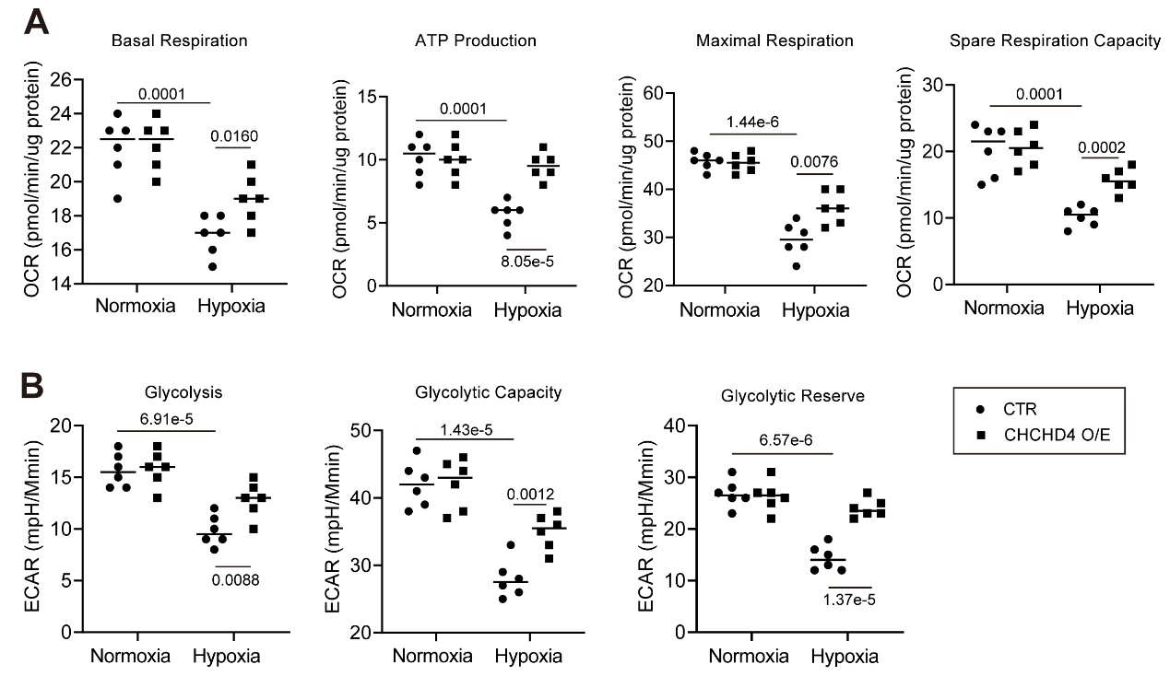
Figure S4. Overexpression of CHCHD4 improves hypoxia-induced mitochondrial dysfunction. Related to figure 5.
A. Quantification of basal respiration, ATP production–coupled respiration, maximal respiration, and spare respiratory capacity from oxygen consumption rate (OCR) in PASMCs. Related to figure 5G.
B. Quantification of glycolysis, glycolytic capacity and glycolytic reserve from extracellular acidification rate (ECAR) in PASMCs. Related to figure 5H.
Data are shown as the mean±SEM. P value is showed in each figure.

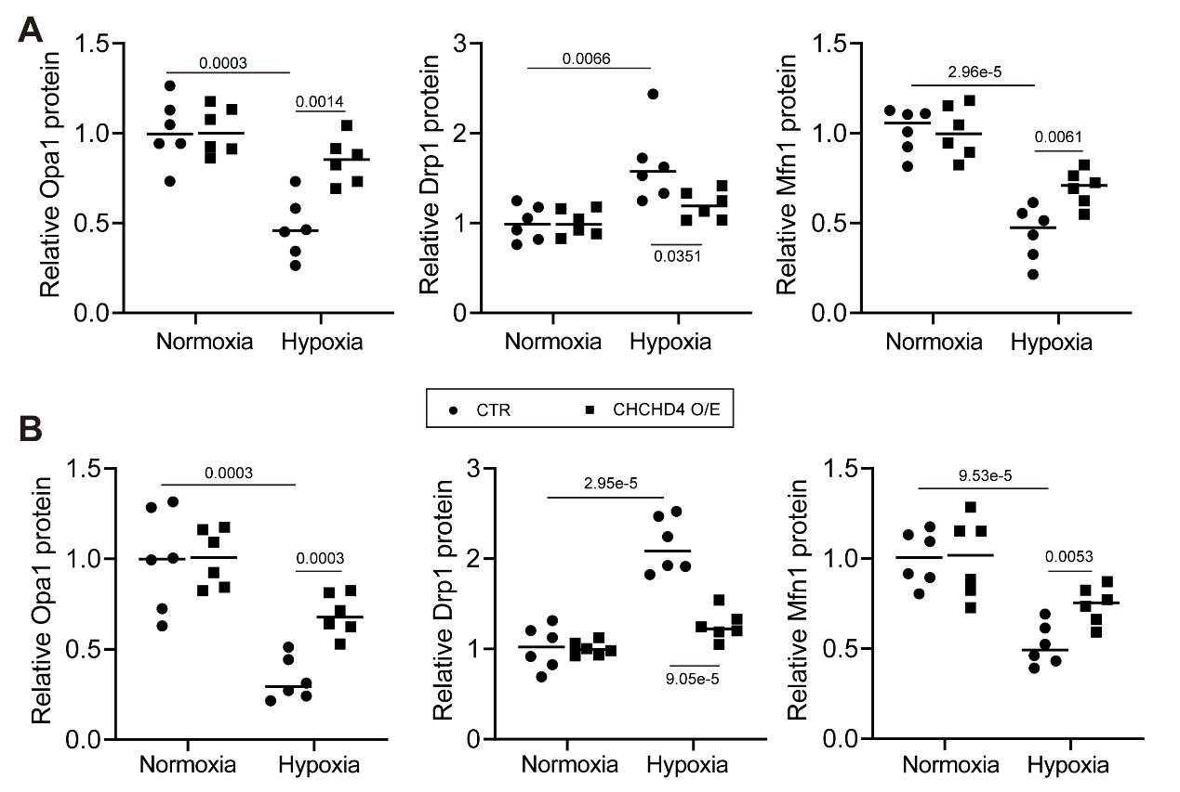
Figure S5. CHCHD4 modulates mitochondrial dynamics. Related to figure 6.
A. Quantification of immunoblotting of Opa1, Drp1 and Mfn1 in lung PA tissues from indicated groups (n=6). Related to figure 6C.
B. Quantification of immunoblotting of Opa1, Drp1 and Mfn1 in isolated PASMCs from indicated groups (n=6). Related to figure 6D.
Data are shown as the mean±SEM. P value is showed in each figure.

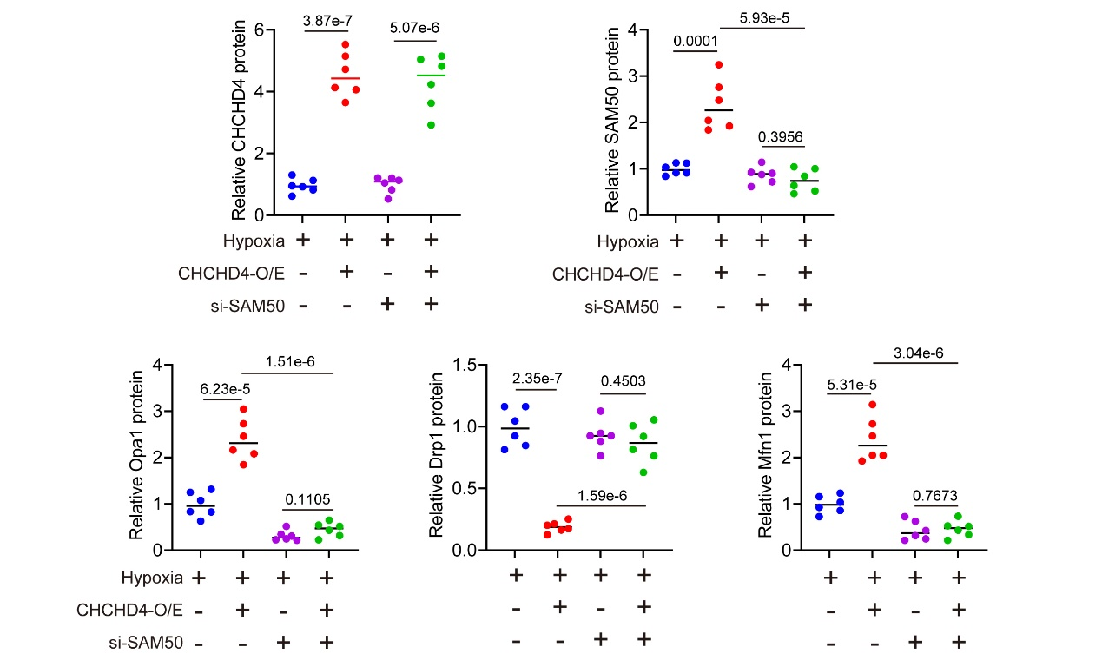
Figure S6. SAM50 knockdown abolishes the protective effects of CHHCD4 during hypoxia. Related to figure 7.
Quantification of immunoblotting of CHCHD4, SAM50, Opa1, Drp1 and Mfn1 in isolated PASMCs from indicated groups (n=6). Related to figure 7C.

