Arterial hypertension – Finngen

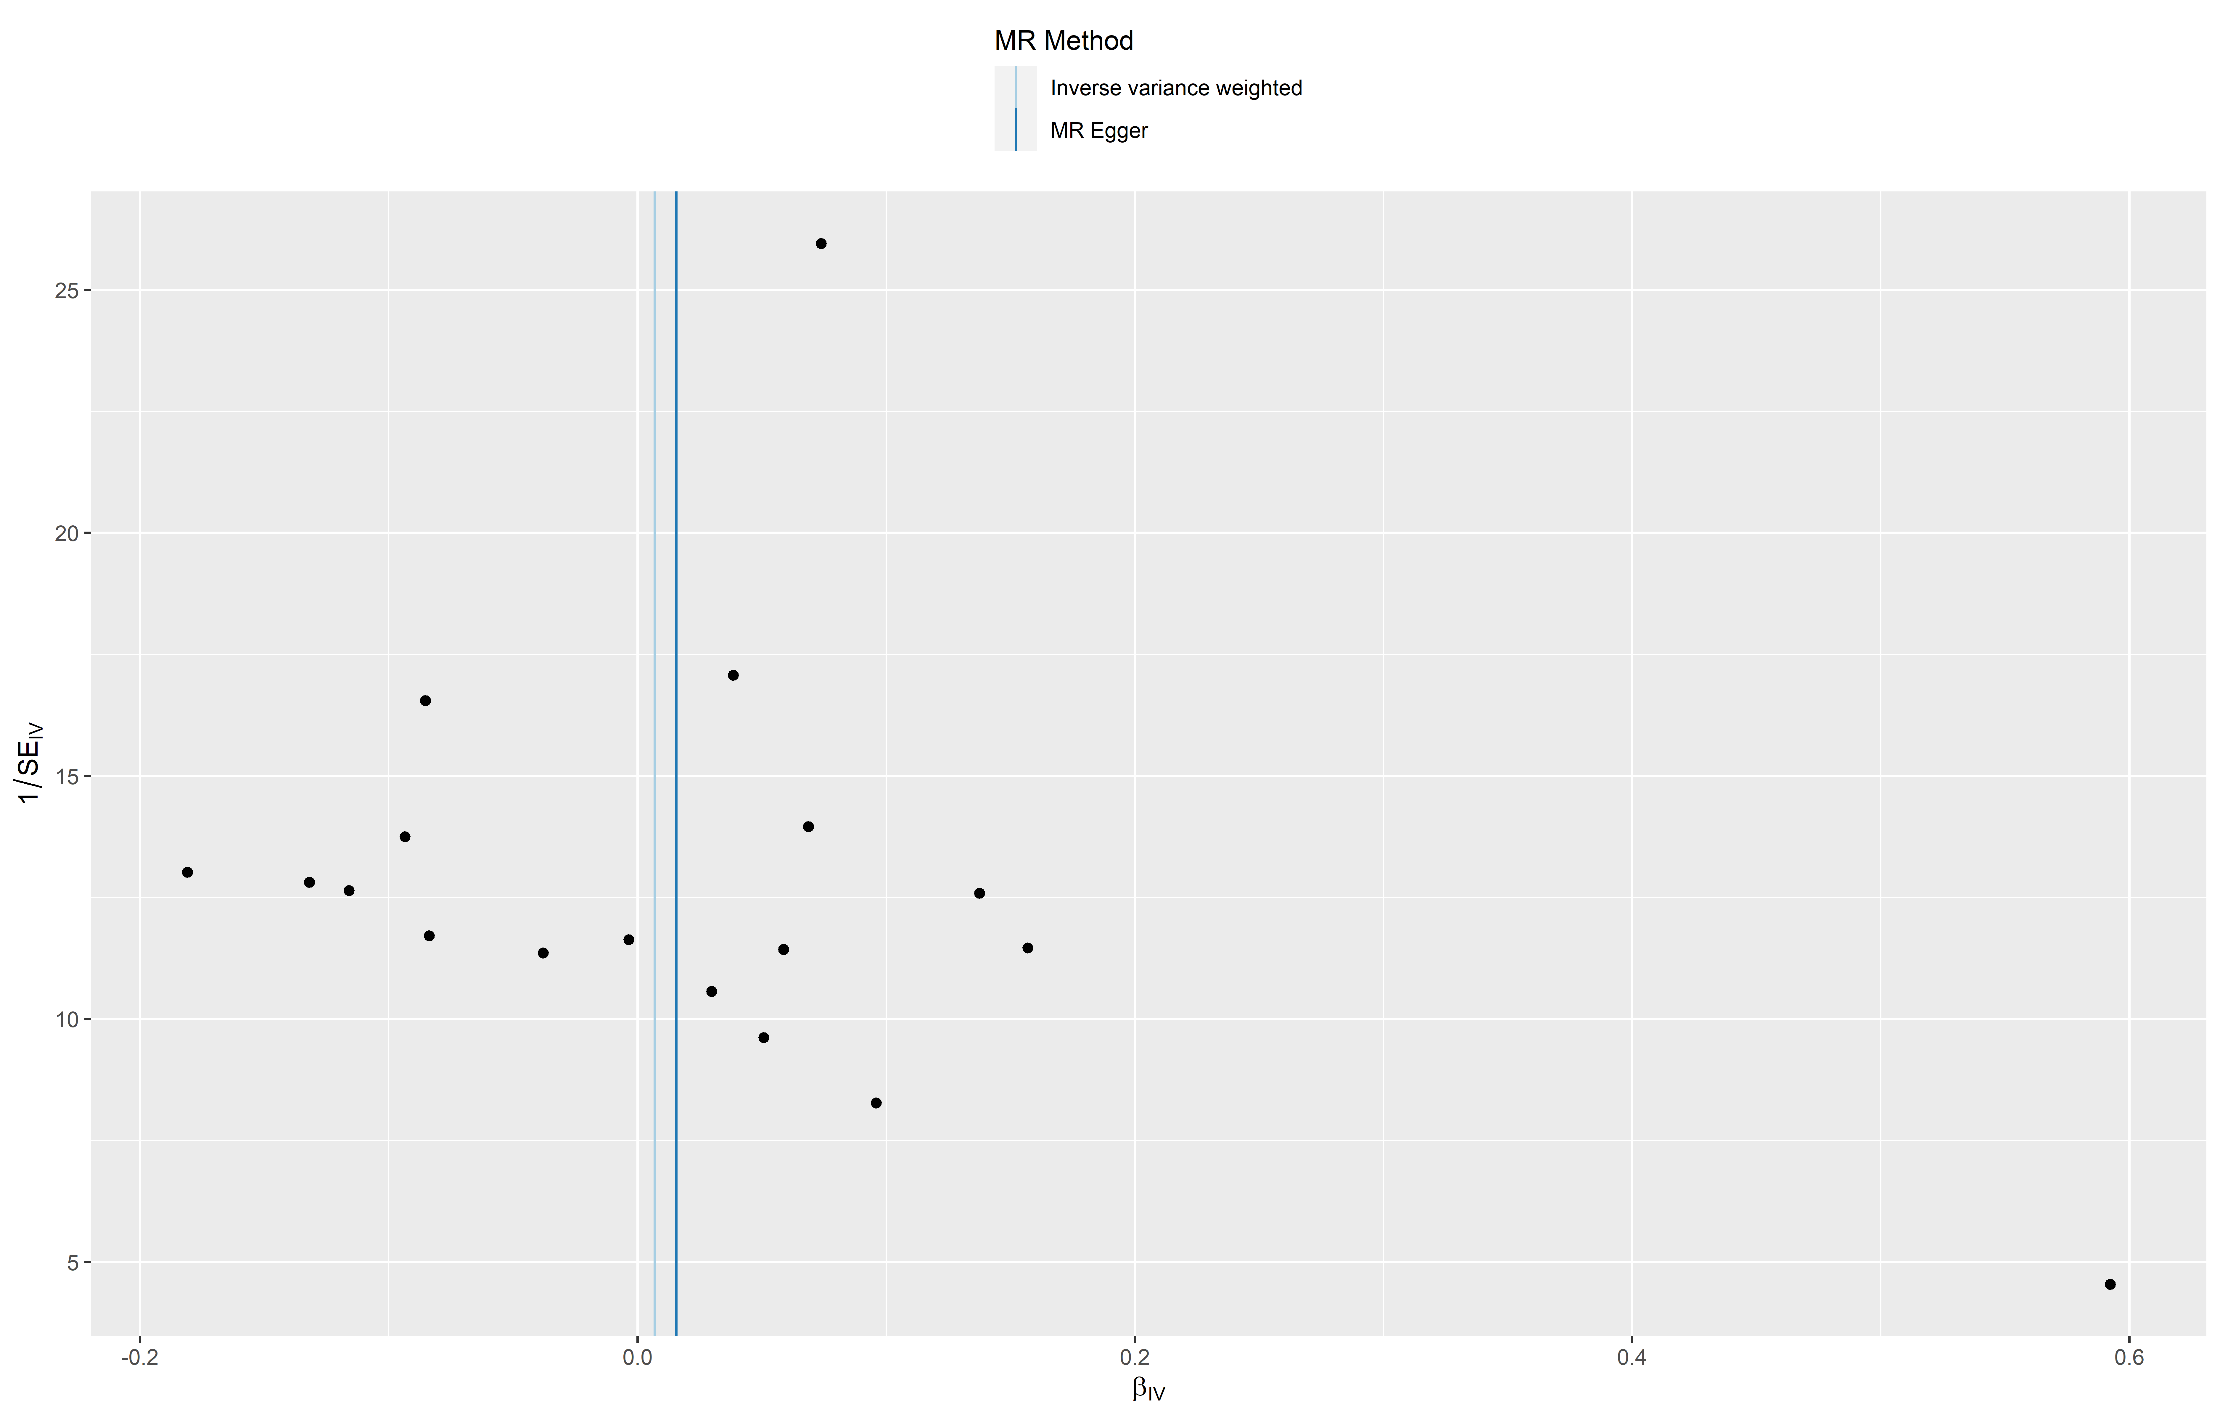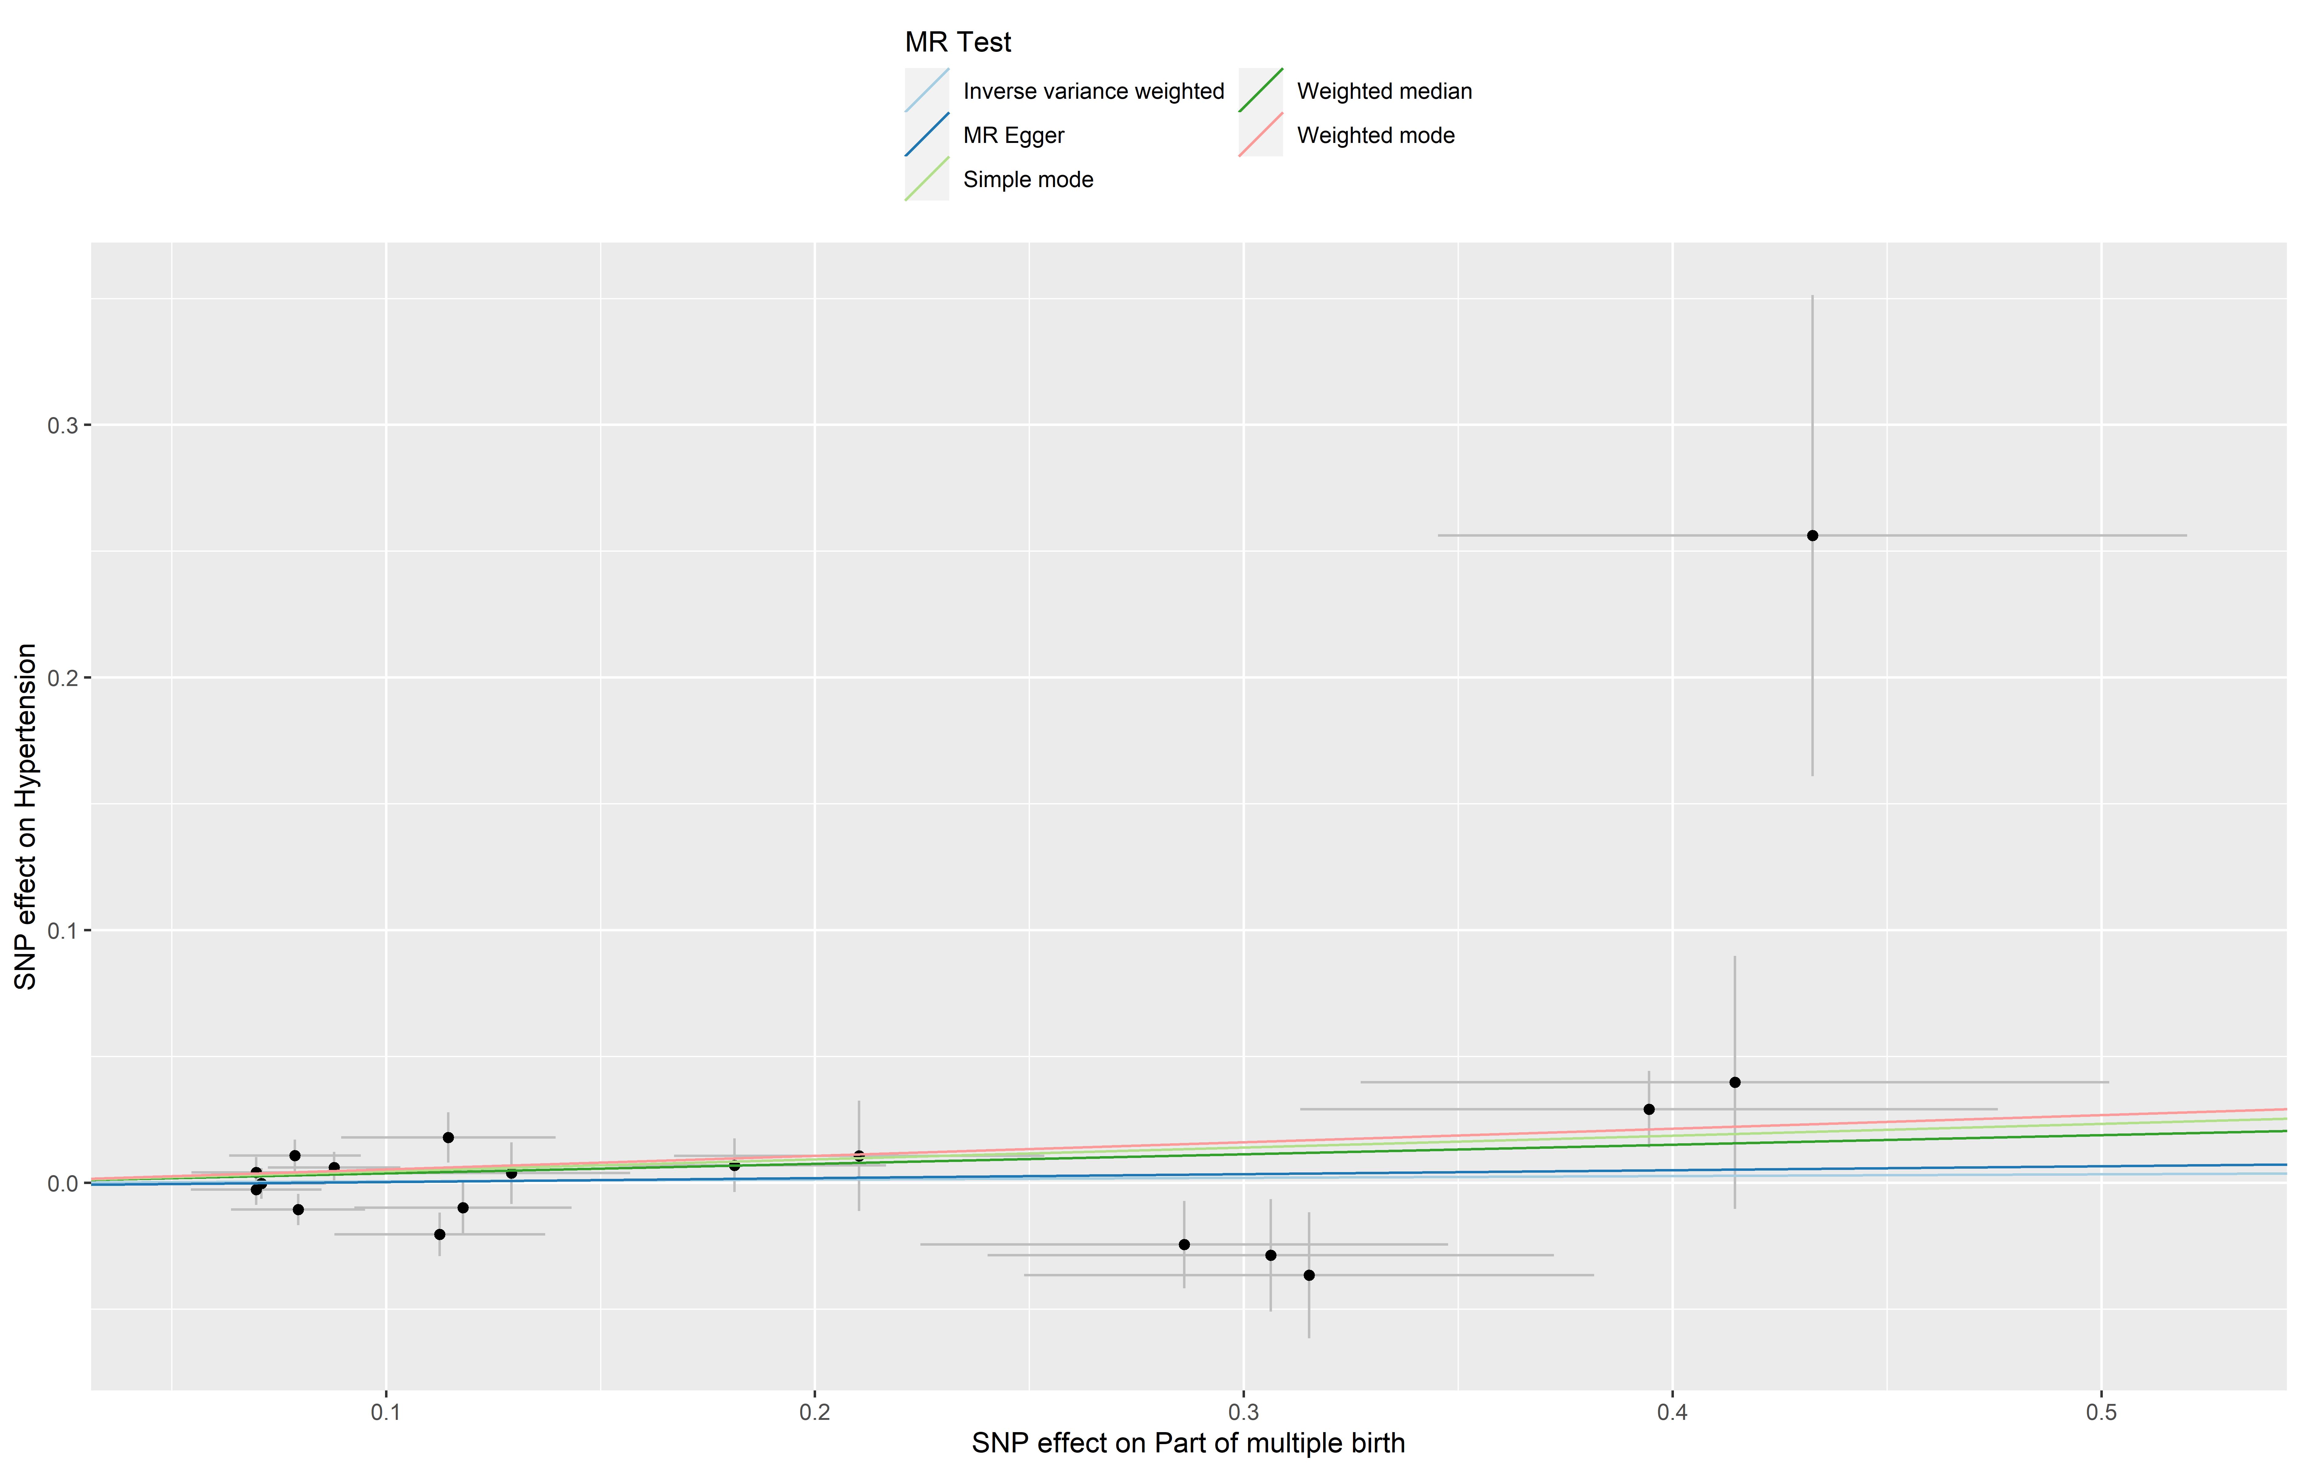
Arterial hypertension – UK Biobank

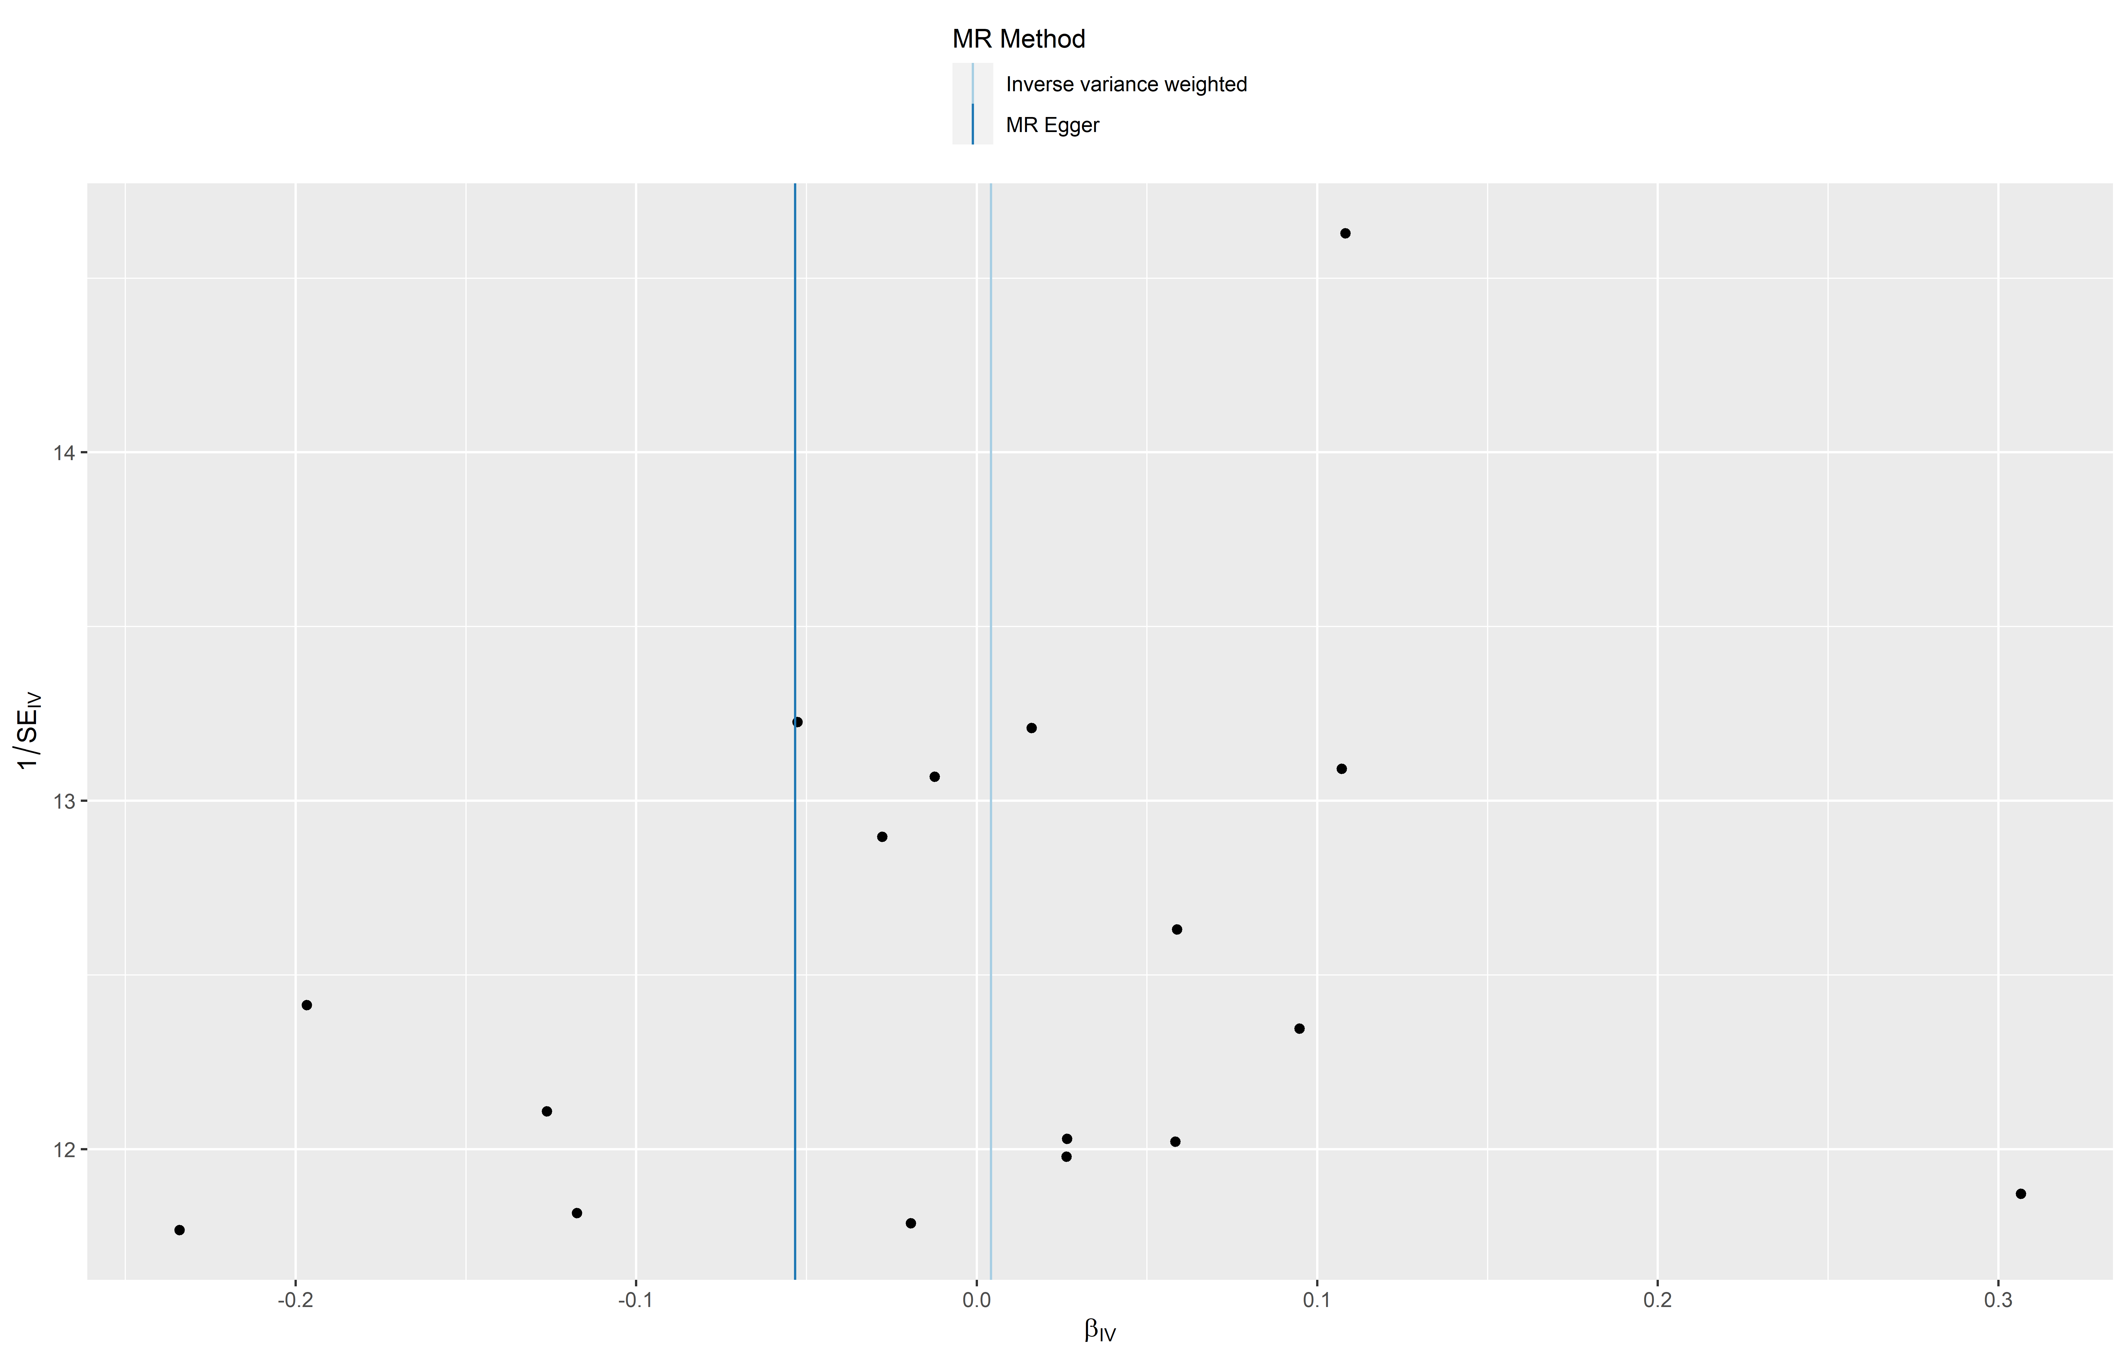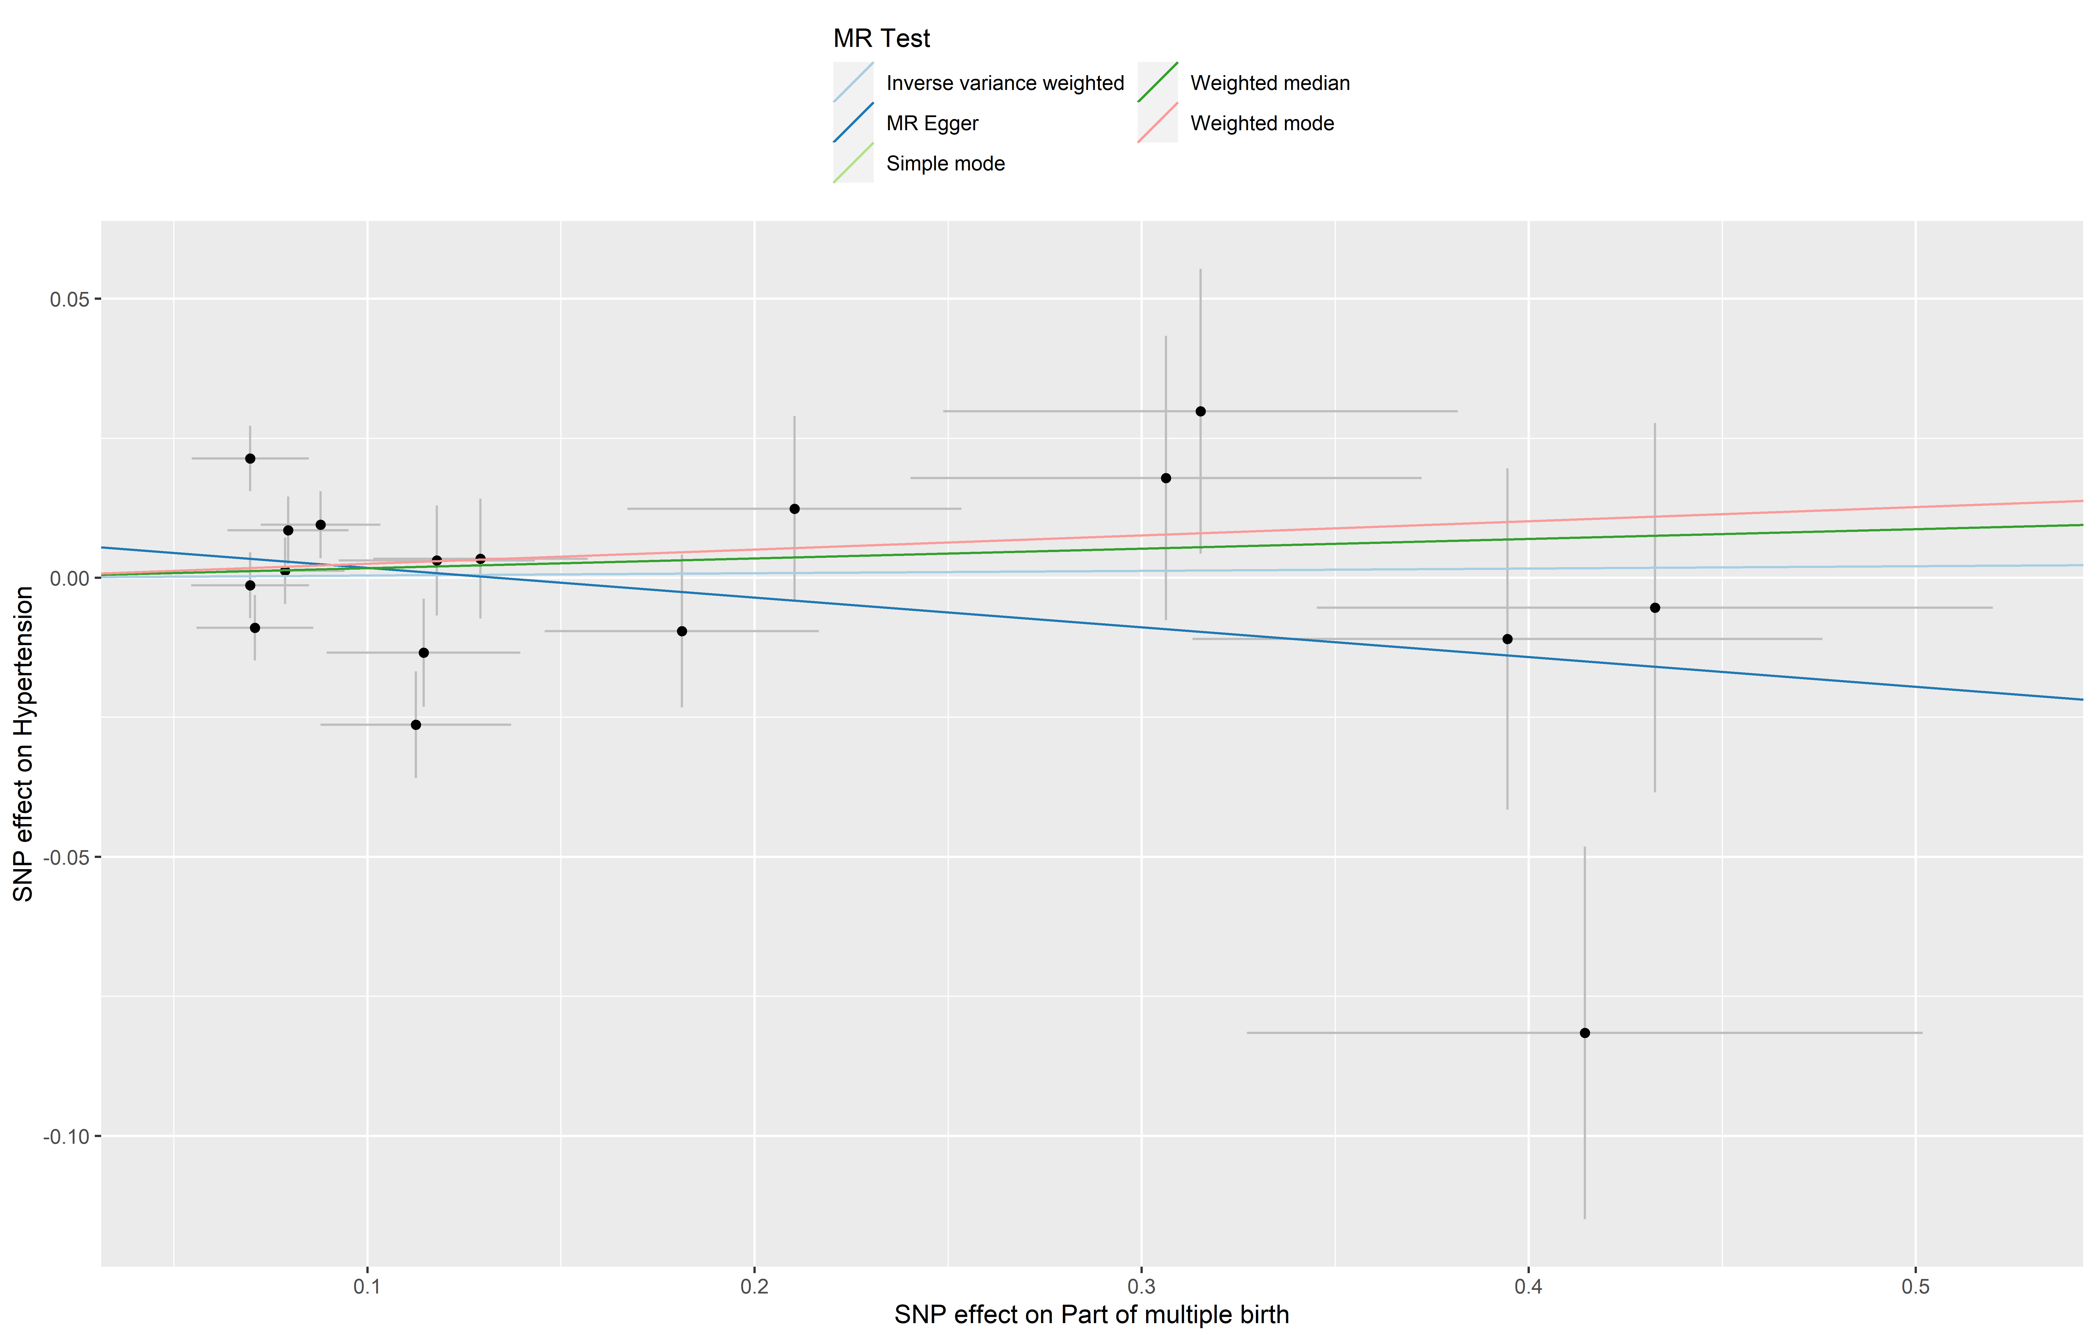
Atrial fibrillation and flutter – Finngen

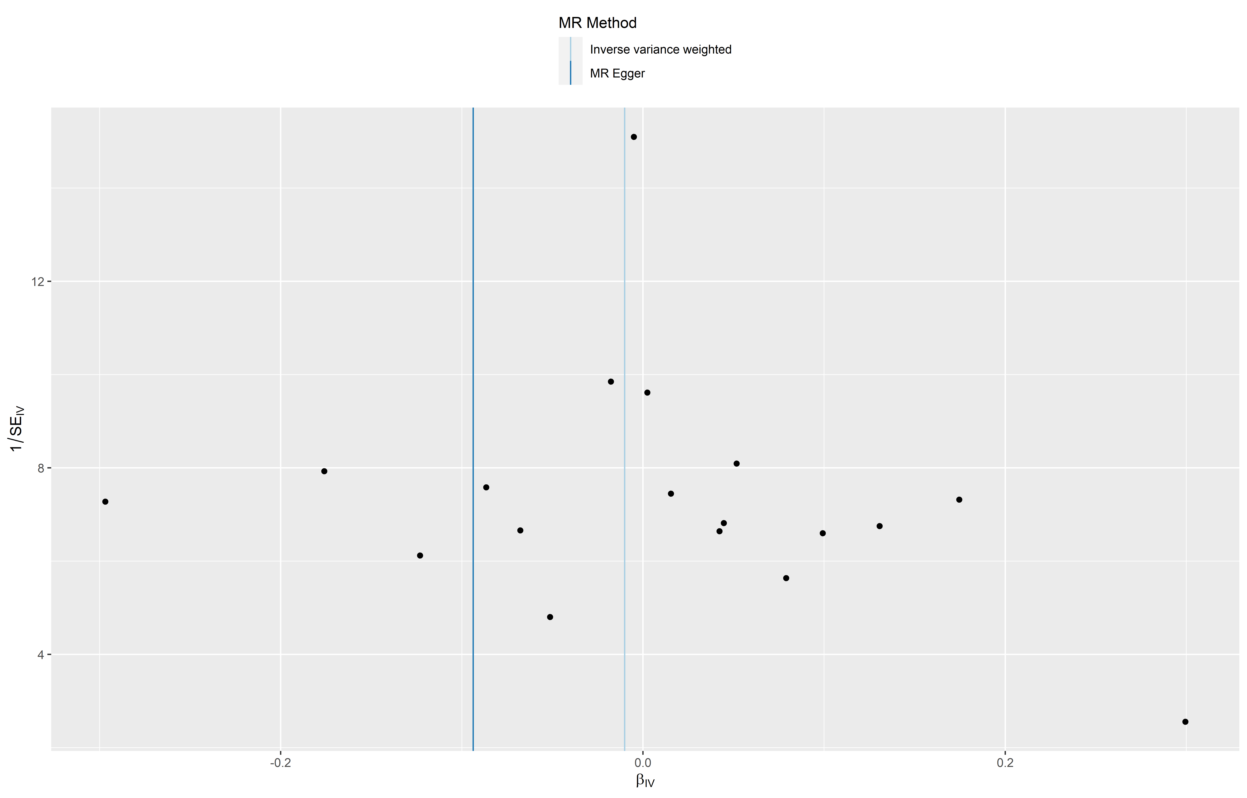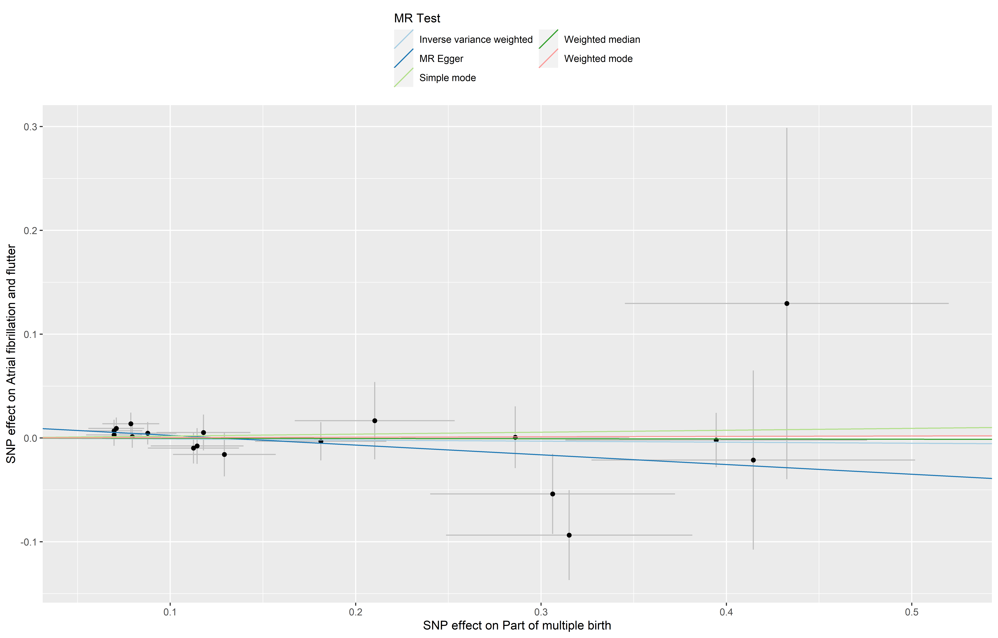
Atrial fibrillation and flutter – UK Biobank

Ischaemic heart disease – Finngen

Ischaemic heart disease – UK Biobank

Coronary heart disease – Finngen

Coronary heart disease – UK Biobank

Cardiomyopathy – Finngen

Cardiomyopathy – UK Biobank

Myocardial infarction – Finngen

Myocardial infarction – UK Biobank

Pulmonary embolism – Finngen

Pulmonary embolism – UK Biobank

Deep vein thrombosis – Finngen

Deep vein thrombosis – UK Biobank

