Additional file 2: Additional Figures
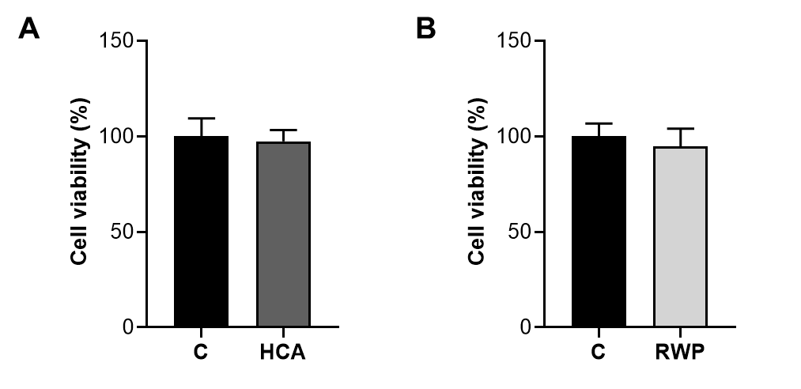
Figure S1: Effect of HCA and RWP on primary human hepatocyte cell viability. Primary human hepatocytes were treated with 500 µM HCA (A) or 200 μg/mL RWP (B), and cell viability was assessed after 72 h exposure. The mean values ± SD of three independent experiments with four replicates in each are shown. Differences were not significant according to Student's t-test.

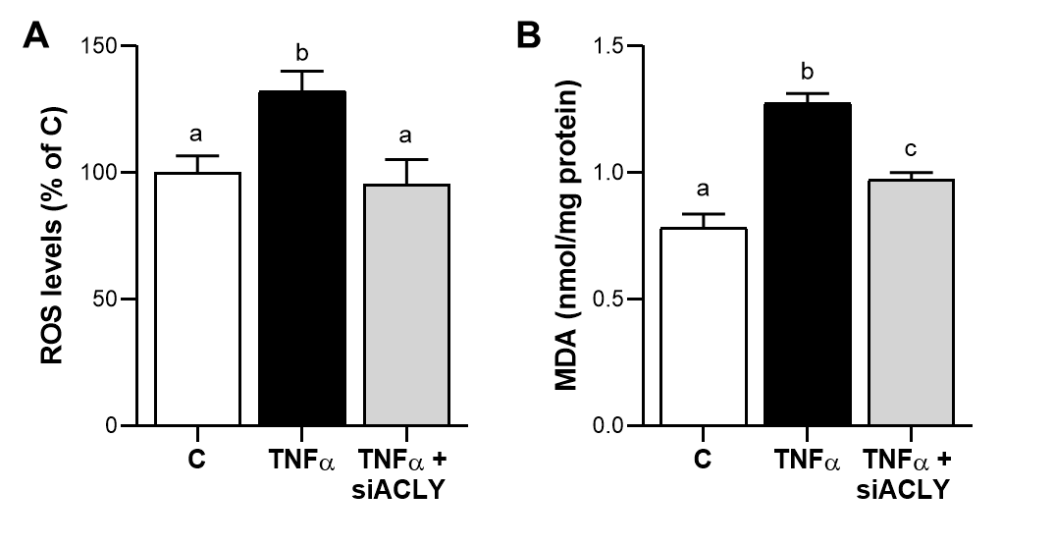
Figure S2: ACLY gene silencing reduces oxidative stress in TNFα triggered hepatocytes. Primary human hepatocytes were transfected with siRNA targeting human ACLY (siACLY) or control scramble siRNA for 48 h and then treated with 5 ng/mL TNFα. Following 24 h ROS (A) and MDA (B) levels were measured. In (A) values are expressed as the percentage of unstimulated cells (C, set at 100%). Statistical significance of differences was evaluated by using one-way ANOVA followed by Tukey’s multiple comparison test. Different letters indicate significant differences between treatments at p < 0.05.

05.
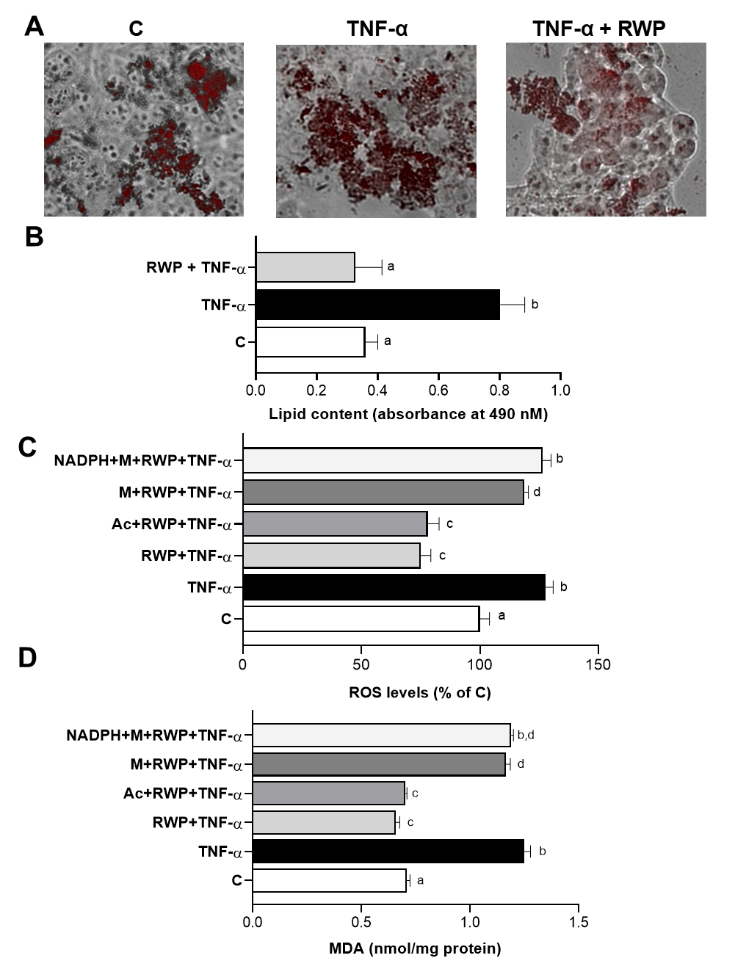
Figure S3: Effect of RWP on lipid accumulation and oxidative stress in TNFα triggered human hepatocytes. HH cells were triggered by 5 ng/mL TNFα in the absence (TNFα) or in the presence of 200 μg/mL RWP (TNFα + RWP). Unstimulated cells (C) were used as a negative control. (A) Representative photomicrographs of intracellular lipids staining from three separate experiments. (B) Quantitative assessment of Oil Red O staining. In (C-D) TNFα + RWP cells were cotreated with 5 mM sodium acetate (Ac) or 5 mM sodium malate (M) alone or in combination with 500 μM NADPH for 24 h and ROS (C) and MDA (D) levels were measured. ROS were expressed as the percentage of C, set at 100%. Data are shown as mean ± SD (error bars) and derived from 3 experiments with at least three replicates in each. Statistical significance of difference was evaluated in (B-D) by using one-way ANOVA followed by Tukey’s multiple comparison test and different letters indicate significant differences between treatments at p < 0.05.

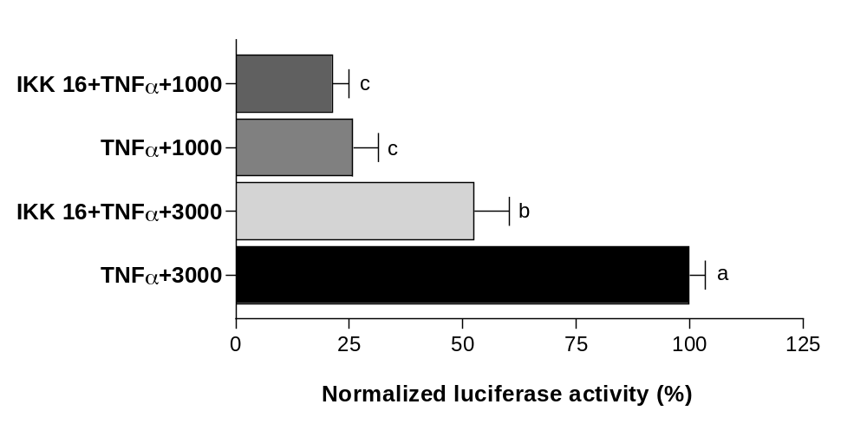
Figure S4: ACLY-dependent NF-kB binding to ACLY gene. HepG2 cells were transiently transfected for 48 h with pGL3 basic-LUC vectors containing the −3116/−20 bp full-length region of the ACLY gene promoter (3000) or a truncated version of this region (1000). Then, cells were triggered by 5 ng/mL TNFα in the absence (TNFα) or in the presence of 20 μM IKK inhibitor VII (IKK 16) (TNFα + IKK 16). The luciferase gene reporter activity was assessed after 24 hours. Data were analyzed by one-way ANOVA followed by Tukey’s multiple comparison test. Different letters indicate significant differences between treatments at p < 0.

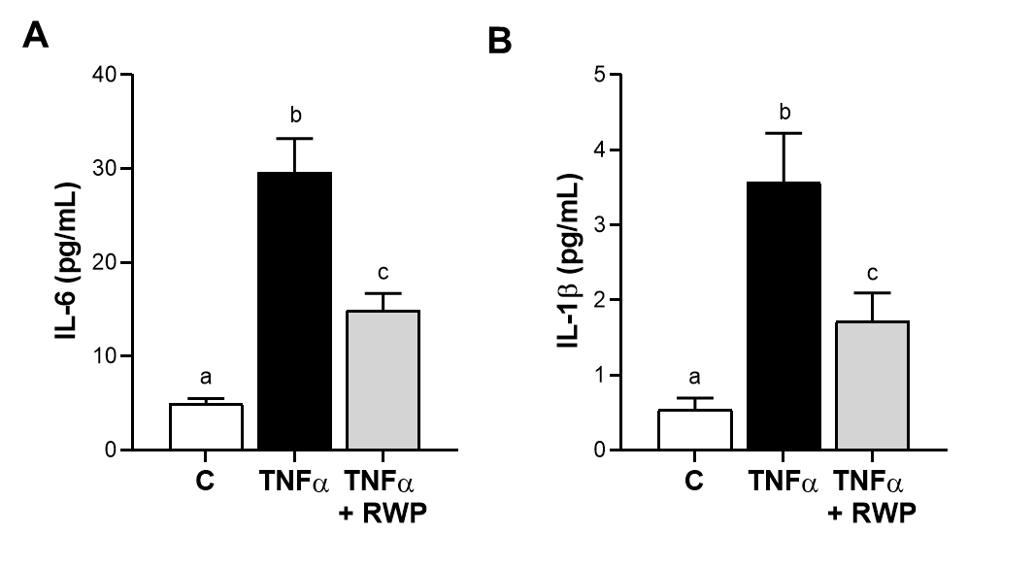

Figure S5: RWP affected IL-6 and IL-1β pro-inflammatory cytokines secretion in human hepatocytes. HH were treated with 5 ng/mL TNFα alone (TNFα) or combined with 200 μg/mL RWP (TNFα + RWP). Unstimulated cells (C) were used as negative control. The concentrations of the proinflammatory cytokines IL-6 (A) and IL-1β (B) were measured in free-cell culture supernatants following 24 h treatment with TNFα. Values represent the mean values ± SD of three independent experiments with three replicates in each. Statistical analysis was performed by one-way ANOVA followed by Tukey’s multiple comparison test. Different letters indicate significant differences between treatments at p < 0.05.

