ADDITIONAL FILE 1

Supplementary information for
Targeting FGFRs by pemigatinib induces G1 phase cell cycle arrest, cellular stress and upregulation of tumor suppressor microRNAs

Angelica Pace¹*, Fabio Scirocchi¹*, Chiara Napoletano^{1@}, Ilaria Grazia Zizzari¹, Agnese Po², Francesca Megiorni¹, Angela Asquino¹, Paola Pontecorvi¹, Hassan Rahimi¹, Cinzia Marchese¹, Elisabetta Ferretti¹, Marianna Nuti¹, Aurelia Rughetti¹

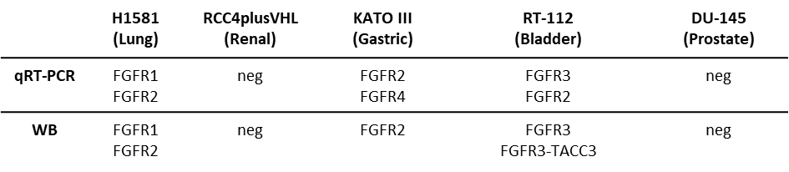
Supplementary Table 1. FGFR expression was evaluated by Western blot and q-RT‒PCR experiments in H1581, KATO III, RT-112, RCC4plusVHL and DU-145 cancer cell lines employed as cell models of lung, gastric, bladder, renal and prostate cancer, respectively.

H1581
KATO III
RT-112
A
B
24h
48h
48h
24h

Figure S1. Serial dilution of Pem and proliferation analysis. A) For selection of the optimal drug concentration, H1581, KATO III and RT-112 cells were exposed to serial dilutions of Pem (3-1000 nM) for 24 h and 48h, and MTT proliferation assay was then performed. Data are reported as the mean of three independent experiments ± SEM as variability B) H1581, KATO III and RT-112 cells were exposed to serial dilutions of Pem (25-400 nM) for 24 h and 48h, and intracellular Ki67 levels were then evaluated by flow cytometry. The histograms represent the geo-mean of Ki67-BV421 MFI found in untreated (NT) and Pem-treated H1581, KATO III and RT-112 cells and are represented as mean of three independent experiments ± SEM. *, p<0,05; **, p< 0,01; ***, p≤ 0,001 Student’s t test.

24h
48h
S phase
G2 phase

Figure S2. Effect of Pem on the S and G2 phases of cell cycle. The histograms represent the count of PI-positive cells found in S- and G2-phase in untreated (NT, white) and Pem-treated (100 nM, grey) H1581, KATO III and RT-112 cells and are represented as mean of three independent experiments ± SEM. *, p<0,05; **, p< 0,01; ***, p≤ 0,001. Student’s t test.

A
B
24h

Figure S3. Effect of pemigatinib on ATP and HMGB1 release. A) Extracellular HMGB1 release upon Pem treatment. The extracellular HMGB1 release was measured by means of an enzyme-linked immunosorbent assay (ELISA) kit (TECAN, Zürich, Switzerland), according to the manufacturer’s protocol. Histograms represent the mean values of three independent experiments ± SEM of HMGB1 released by untreated cells (NT, white) and Pem-treated cells (grey) at 24 and 48 h. ns, not significative. B) Extracellular ATP release upon Pem treatment. The ATP release was measured by ENLITEN-Promega KIT as luminescence signals. The histograms represent the mean value of ATP moles of three independent experiments ± SEM by untreated cells (NT, white) and Pem-treated cells (Pem, grey) at 24 and 48 h. ns, not significative.

RT-112
H1581
KATO III

A

B

C

Figure S4. Effect of pemigatinib on miRNA target transcripts. mRNA expression of miRNAs targets in untreated (NT) and Pem-treated (100 nM) cancer cell lines. Histograms represent the mean values of three independent experiments ± SEM.
C

