Additional Tables and Figures
Table S1. Patients and tumors characteristics: Sp: sporadic, Mutation investigated: RET: Rearranged after transfection (Multiple Endocrine Neoplasia type 2 syndrome), SDH: succinate dehydrogenase subunits A, B, C and D, SDHAF2: succinate dehydrogenase complex assembly factor 2, VHL: von Hippel-Lindau, MAX: MYC-associated factor X.
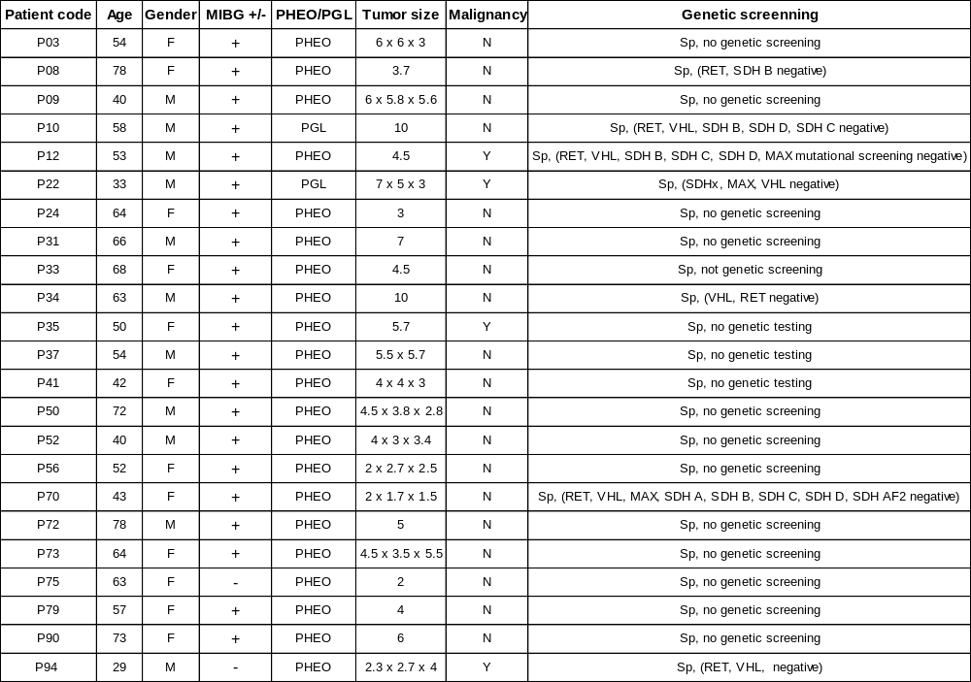

Table S2. List of the different inhibitors used and respective references.
Inhibitors | Reference
ACY-1215 | MedChem Express (HY-16026)
CUDC-101 | Selleckchem (S1194)
CUDC-907 | MedChem Express (HY-13522)
Entinostat | MedChem Express (HY-12163)
LMK-235 | MedChem Express (HY-18998 )
Mocetinostat | MedChem Express (HY-12164)
PCI-24781 | MedChem Express (HY-10990)
Quisinostat | Selleckchem (S1096)
Romidepsin | MedChem Express (HY-15149)
Sodium-4-Phenylbutyrate | Sigma-Aldrich (567616)
Tacedinaline | Selleckchem (S2818)
Trichostatin A | Reagents Direct (62-K44)
Tubacin | MedChem Express ( HY-13428)
Tucidinostat | MedChem Express ( HY-109015)
Valproic acid | Sigma-Aldrich (676380)
Vorinostat | Sigma-Aldrich (SML0061)
BGT226 | MedChem Express ( HY-13334)
VS-5584 | MedChem Express ( HY-16585)
MK2206 | MedChem Express ( HY-108232)
Desipramine | Sigma-Aldrich (D3900)
GBR12935 | Sigma-Aldrich (G9659)
Rapamycin | Sigma-Aldrich (37094)

Table S3. Primers used for RT-qPCR.
Primers | Sequence
hNET Forward | 5’ TGA TGG GGT TCA GGC CGG GT 3’
hNET Reverse | 5’ TTG GGC CAG GGC GGG AAG AT 3’
hDAT Forward | 5’ CCA TAG ACG GCA TCA GAG CA 3’
hDAT Reverse | 5’ CCG CGT CAA TCC AAA CAG A 3’
hOCT1 Forward | 5’ TTT GGC CGT AAG CTG TGT CT 3’
hOCT1 Reverse | 5’ ATG TAG TTG GGC GAG AAG GC 3’
hOCT2 Forward | 5’ TGC AGC TGG AGT TCT CAT GG 3’
hOCT2 Reverse | 5’ TGC TTT GCT GAC CAG TCC TT 3’
hOCT3 Forward | 5’ CCC CAA ATG AGG AAA TGC ACA 3’
hOCT3 Reverse | 5’ CAC CAC TGC GCT TGT GAA 3’
hPMAT Forward | 5’ CGC CAT CTA CTT TGC GAT GC 3’
hPMAT Reverse | 5’ ACG TCC GTG ATG AAG CTG TT 3’
hGAPDH Forward | 5’ CAT CCA TGA CAA CTT TGG TAT CGT 3’
hGAPDH Reverse | 5’ CCA TCA CGC CAC AGT TTC C 3’
hEEIF1A1 Forward | 5’ CTG AAC CAT CCA GGC CAA AT 3’
hEEIF1A1 Reverse | 5’ GCC GTG TGG CAA TCC AAT 3’

Table S4. Chromatographic gradient used for the separation of mIBG by LC-MS/MS.
Time (min) | Flow (mL/min) | % solution A | % solution B
Initial | 0.350 | 5.0 | 95.0
4.00 | 0.350 | 30.0 | 70.0
6.00 | 0.350 | 30.0 | 70.0
6.10 | 0.350 | 5.0 | 95.0
9.00 | 0.350 | 5.0 | 95.0

Table S5. Biodistribution data and SPECT/CT images of ¹²³I-mIBG in IGR-NB8 xenografts at 4 hours and 24 hours p.i.
¹²³I-mIBG (IGR-NB8 xenografts)
 | 4h p.i. |  |  | 24h p.i.
Organs | Vehicle* (n=3) | CUDC-907 5 mg/Kg (n=5) | CUDC-907 10 mg/Kg (n=8) | Vehicle* (n=4) | CUDC-907 5 mg/Kg (n=4) | CUDC-907 10 mg/Kg (n=5)
Blood | 0.5 ± 0.2 | 0.6 ± 0.1 | 0.8 ± 0.1 | 0.1 ± 0.03 | 0.1 ± 0.04 | 0.1 ± 0.03
Heart | 4.1 ± 1.0 | 6.6 ± 0.8 | 6.3 ± 1.8 | 0.8 ± 0.3 | 1.1 ± 0.4 | 1.1 ± 0.4
Lung | 3.2 ± 0.8 | 3.1 ± 0.4 | 3.4 ± 0.5 | 0.4 ± 0.1 | 0.4 ± 0.1 | 0.4 ± 0.1
Liver | 3.4 ± 0.5 | 3.7 ± 0.5 | 4.0 ± 0.4 | 0.4 ± 0.1 | 0.6 ± 0.1 | 0.5 ± 0.2
Pancreas | 2.1 ± 0.4 | 2.4 ± 0.2 | 2.8 ± 0.5 | 0.4 ± 0.1 | 0.4 ± 0.04 | 0.4 ± 0.1
Spleen | 2.6 ± 0.9 | 2.1 ± 0.6 | 2.8 ± 0.4 | 0.7 ± 0.3 | 0.6 ± 0.2 | 0.7 ± 0.2
Stomach | 4.6 ± 2.0 | 2.9 ± 0.2 | 3.3 ± 0.4 | 1.3 ± 0.4 | 1.6 ± 0.3 | 1.6 ± 0.2
Intestine | 3.6 ± 0.4 | 4.5 ± 0.4 | 5.5 ± 1.0 | 0.9± 0.5 | 1.2 ± 0.4 | 1.4 ± 0.4
Adrenal | 7.0 ± 0.9 | 7.4 ± 0.8 | 7.5 ± 1.3 | 6.9 ± 2.2 | 6.6 ± 1.2 | 5.7 ± 0.8
Kidney | 1.5 ± 0.2 | 1.8 ± 0.3 | 2.2 ± 0.5 | 0.3 ± 0.03 | 0.4 ± 0.1 | 0.4 ± 0.1
Muscle | 1.3 ± 0.3 | 1.1 ± 0.1 | 1.2 ± 0.3 | 0.2 ± 0.03 | 0.2 ± 0.02 | 0.2 ± 0.05
Bone | 0.9 ± 0.1 | 1.0 ± 0.2 | 1.0 ± 0.2 | 0.2 ± 0.03 | 0.2 ± 0.03 | 0.2 ± 0.1
IGR-NB8 tumor | 1.0 ± 0.3 (p<0.05) | 2.2 ± 0.4 | 3.2 ± 1.2 (p=0.1) | 1.4 ± 0.4  (p<0.05) | 2.7 ± 0.6 | 3.1 ± 0.6 (p=0.4)
Salivary gland | 7.3 ± 1.2 | 8.5 ± 0.6 | 9.3± 1.7 | 1.2 ± 0.5 | 1.7 ± 0.4 | 1.5 ± 0.6

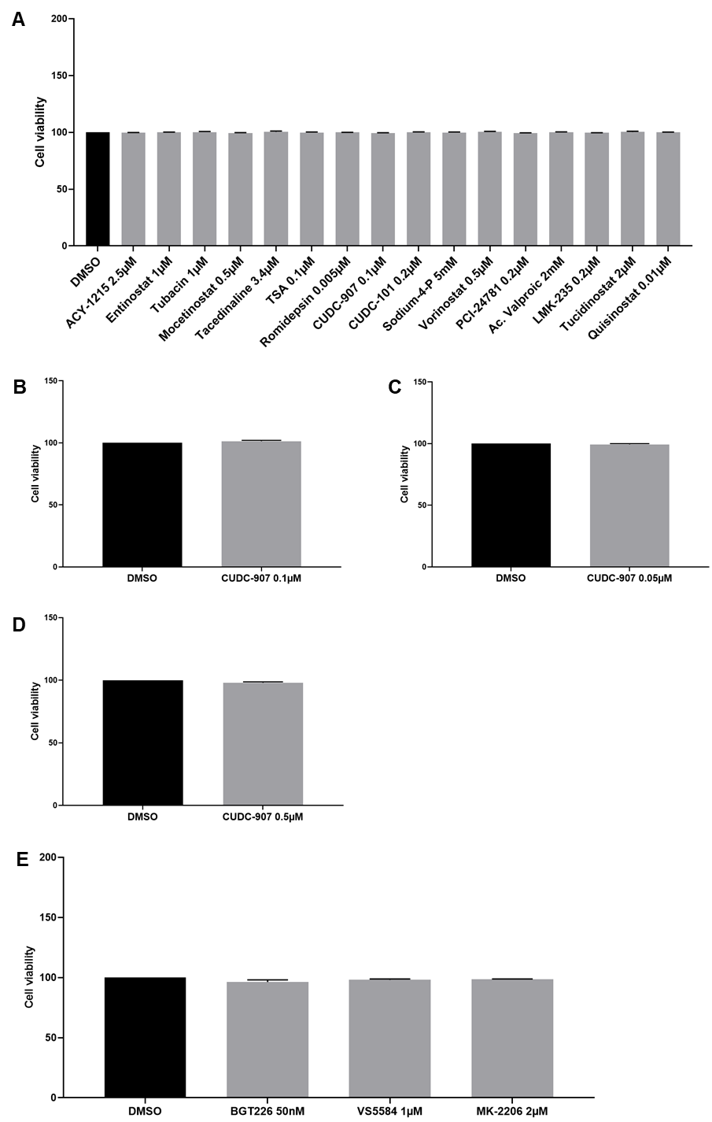
Figure S1. Effect of the treatment with different inhibitors on cell viability in IGR-NB8, SK-N-Be2C, LAN-1 and PC-12 cells.
A) IGR-NB8 cells were incubated with different HDACi for 48 hours. B) SK-N-Be2C cells were incubated with CUDC-907 0.1 µM for 48 hours. C) LAN-1 cells were incubated with CUDC-907 0.05 µM for 48 hours. D) PC-12 cells were incubated with CUDC-907 0.5 µM for 48 hours. E) IGR-NB8 cells were incubated with PI3K, Akt and mTOR inhibitors for 48 hours. For all the experiments, after CUDC-907 incubation, a trypan blue assay was performed. All the experiments were performed once in triplicate.

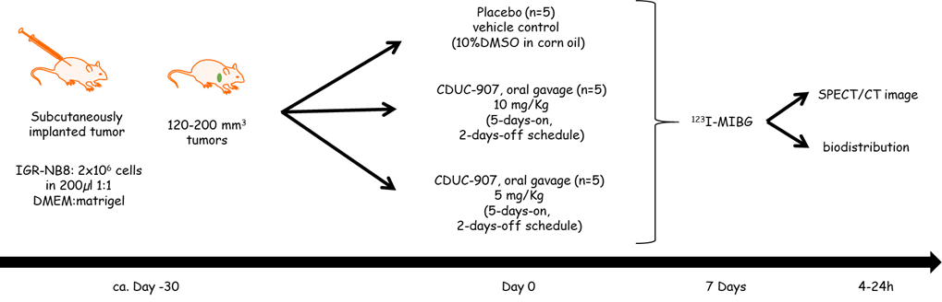

Figure S2. Experimental design of the in vivo studies.
IGR-NB8 xenografted mice were randomly divided into three groups (placebo; CUDC-907 10 mg/kg; CUDC-907 5 mg/kg). CUDC-907 was given orally to the mice for 5 days and 2 days drug free.

