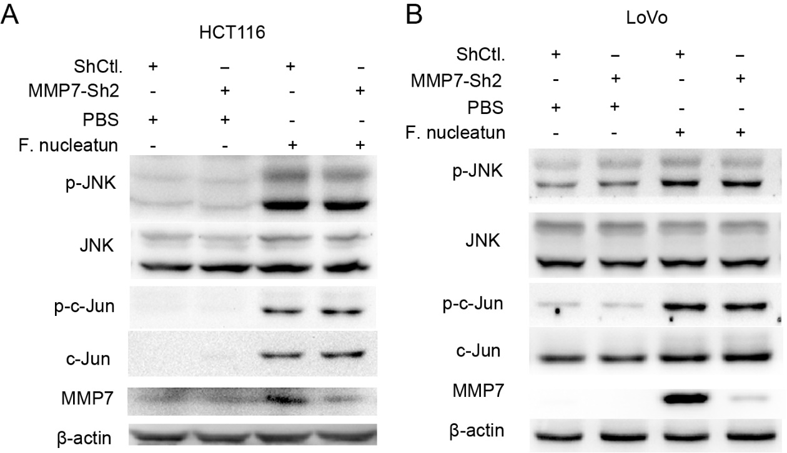
Figure S2. (A, B) CRC cells were transfected with MMP7 shRNA lentivirus or control lentivirus, and then incubated with F. nucleatum or PBS. The protein expression were measured by western blot (repeated three times).

