Supporting information for

Genetic evidence strengthens the bidirectional connection between gut microbiota and periodontitis: insights from a two-sample Mendelian randomization study

Xinjian Ye, Bin Liu, Yijing Bai, Yue Cao, Sirui Lin, Linshuoshuo Lyu, Haohao Meng, Yuwei Dai, Ding Ye, Weiyi Pan, Zhiyong Wang, Yingying Mao & Qianming Chen

Additional file 2: Supplementary Figures
Figure of Contents

Fig. S1. Forest plot of the results after removing potential pleiotropic SNPs. 2
Fig. S2. Results of leave-one-out sensitivity analysis. 3
Fig. S3. Forest plot of the results in reverse MR for the causal effects of periodontitis on genetically predicted gut microbiota composition. 4

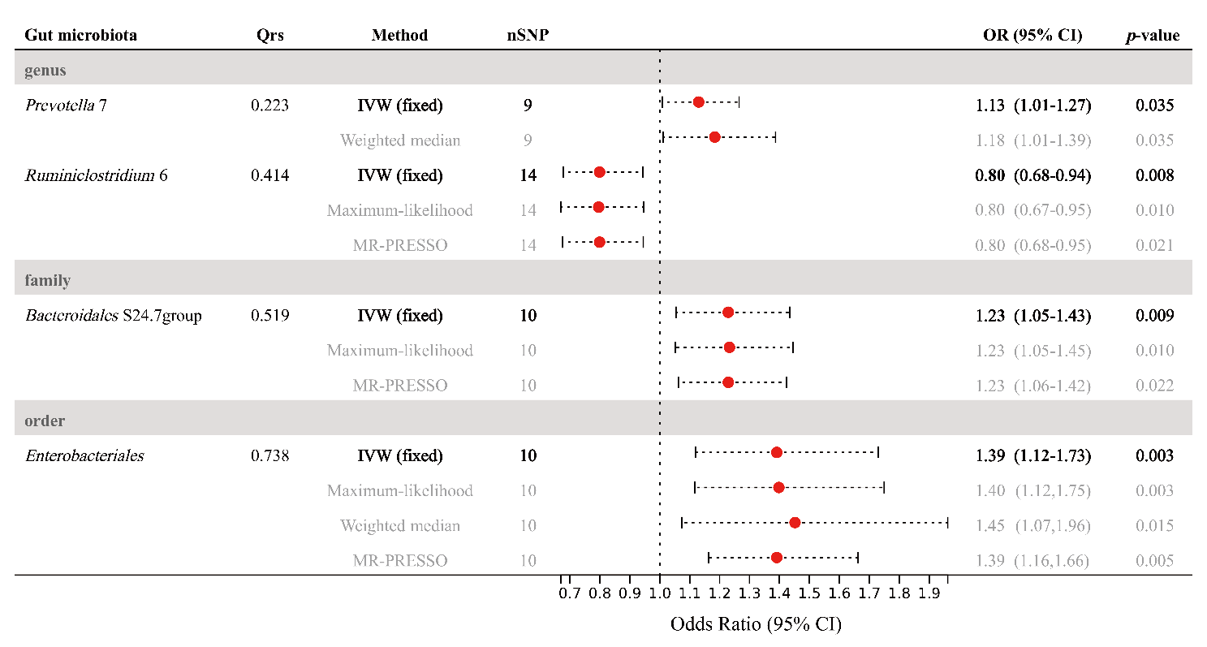
Fig. S1 Forest plot of the results after removing potential pleiotropic SNPs. Abbreviations: CI, confidence interval; IVW, inverse-variance weighted; MR, Mendelian randomization; MR-PRESSO, Mendelian Randomization Pleiotropy RESidual Sum and Outlier; OR, odds ratio; SNP, single nucleotide polymorphism.

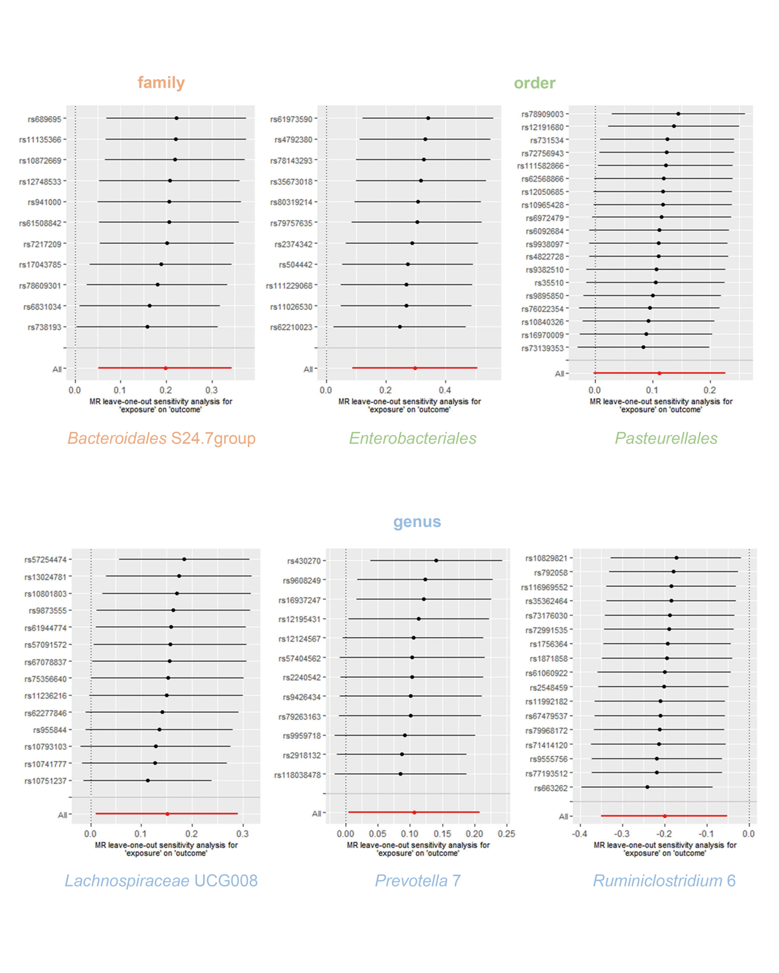
Fig. S2 Results of leave-one-out sensitivity analysis. The effect estimates are re-calculated after removal of each SNP to identify if a single SNP is driving the association. Abbreviations: MR, Mendelian randomization; SNP, single nucleotide polymorphism.

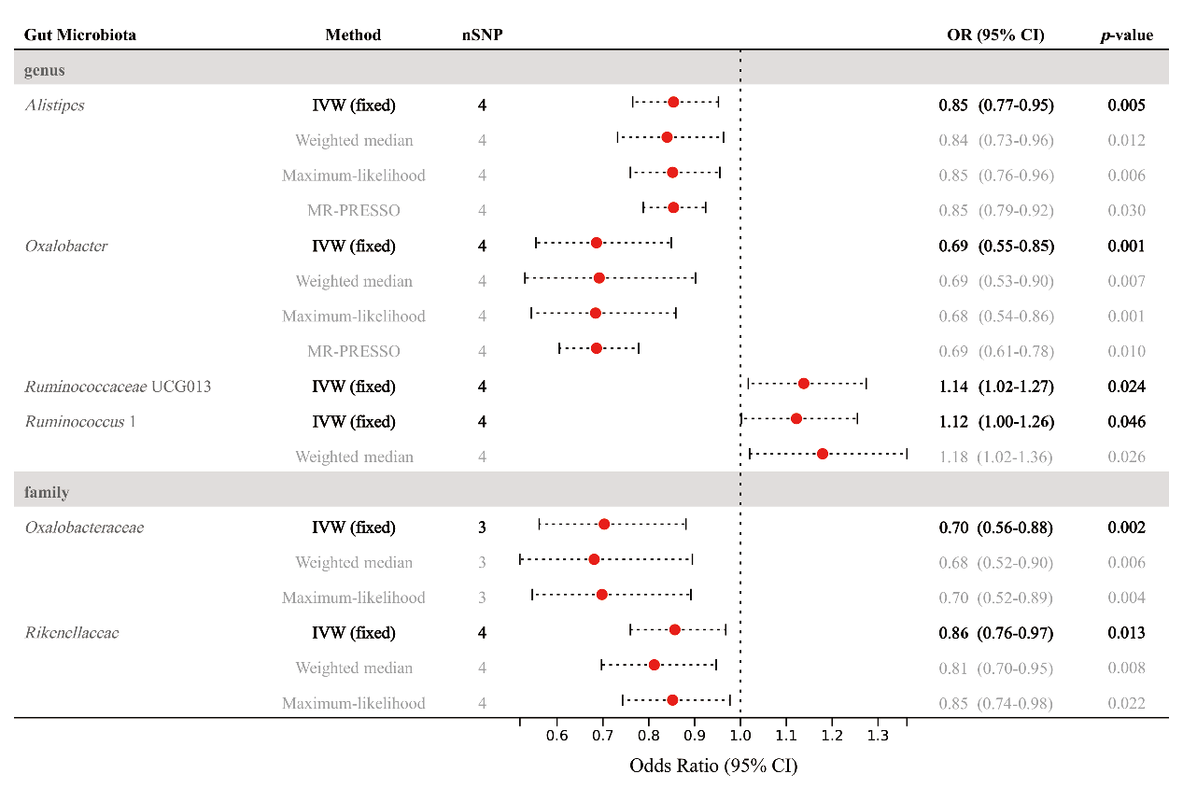
Fig. S3 Forest plot of the results in reverse MR for the causal effects of periodontitis on genetically predicted gut microbiota composition. Abbreviations: CI, confidence interval; IVW, inverse-variance weighted; MR, Mendelian randomization; MR-PRESSO, Mendelian Randomization Pleiotropy RESidual Sum and Outlier; OR, odds ratio; SNP, single nucleotide polymorphism.

