Additional file

KRAS^{G12C} inhibition using MRTX1257: a novel radio-sensitizing partner.
Pierre-Antoine Laurent^{1,2,3*}, Marina Milic^{2,3*}, Clément Quevrin^{2,3}, Lydia Meziani^{2,3}, Winchygn Liu^{2,3}, Daphné Morel⁴, Nicolas Signolle⁵, Céline Clémenson^{2,3}, Antonin Levy^{1,2,3}, Michele Mondini^{2,3}, Eric Deutsch^{1,2,3}
* Equal contributors

Corresponding author: Eric Deutsch, INSERM U1030, 114 rue Edouard Vaillant; 94805 Villejuif, France; eric.deutsch@gustaveroussy.fr

Supplementary material and methods

Dose-response curves on WT cells:
Two hundred thousand CTT26 WT or LL2 WT cells were seeded in 6-well plates with 2 mL of their respective culture media containing MRTX1257 at various concentrations ranging from 0 nM to 50 µM. At 48 hours of culturing, the medium containing MRTX1257 was changed and washed for a drug-free one. The day after, i.e. at 72h of culturing, cells were harvested separately in each well by using tryspin-EDTA 0.05% (Gicbo) and counted using an automated cell counter Cellometer K2 (Nexcellom Bioscience, MA) after trypan blue staining. The viable cells were thus counted and plotted in dose-response curves.

Two-tumors experiment
Immunocompetent female BALB/c mice were subcutaneously inoculated with 1.2 10⁶ CT26 KRAS^{G12C+/+} in their right flank and 8.10⁵ CT26 KRAS^{G12C+/+}cells in their left flank, in 50µL of pH 7.2 phosphate-buffer saline (PBS) solution (Gibco).
Once the tumors reached an average of 100-110 mm³ for right tumors (primary tumors) and 60-70 mm³ for the corresponding left tumors (secondary tumors), estimated using the formula exposed in the methods section, mice were randomized into the different treatment groups.
On the day of randomization (= D-1 before RT), as well as on D1 and D3 after RT, mice received an oral administration of MRTX1257 at the dose of 50 mg/kg reconstituted in 5 ml/kg of Captisol vehicle or the same volume of Captisol vehicle alone, according to the treatment group. At D0, mice randomized into RT only and combination groups received a single fraction of 6 Gy to the primary tumor volume using a Varian Tube NDI 226 (X-ray machine; 200 kV; tube current 15mA; beam filter: 0.2 mmCu, dose-rate 1.15 Gy/minute). Radiation was only delivered to the primary tumor by using a custom shielding and an appropriate device to immobilize the mouse.
Tumor volumes were measured 3 times a week using a digital caliper and the formula described in the methods section. When any of the tumors reached 1200 mm³ or when any of critical points including weight loss > 20%, tumor necrosis or suffering appeared, mice were sacrificed.

Additional file 1: Table: List of the antibodies used and their respective dilutions in flow cytometry experiments.

Additional file 1: Figure 1 (complementary to Figure 1): MRTX1257 at the concentration of 5 nM or 10 nM for 24 hours does not sensitize CT26 KRAS^{G12C+/+} or LL2 NRAS^{-/-} tumor cells to radiation. Clonogenic survival assays were performed in CT26 KRAS^{G12C+/+} or LL2 NRAS^{-/-} tumor cells exposed to various concentrations of MRTX1257 for 24 hours. Normalized survival fractions are represented in mean +/- standard-error to mean (SEM), with n=3 to 6 replicates per condition. Survival curves are extrapolations according to the linear quadratic model. Survival curves for (A) CT26 KRAS^{G12C+/+} cell line and (B) LL2 NRAS^{-/-} cell line.

Additional file 1: Figure 2: A single-fraction irradiation of 6 Gy does not increase the efficacy of MRTX1257 in a distant unirradiated tumor. The combination of RT delivered to a single-tumor and oral administration of MRTX1257 was experimented in BALB/c mice bearing bilateral s.c. CT26 KRAS^{G12C+/+} tumors according to the supplementary material and methods. (A) Schematic view of the experimental setting. A single fraction of 6 Gy was delivered to the right (primary) tumor (primary) whereas the left (secondary) tumor remained unirradiated. (B) Primary tumor volumes in each condition at the different timepoints (left), and specifically at D6 and D13 after RT (right). All the volumes are represented in mean +/- standard-error to mean (SEM) (mm³). *: p<0.05; **: p<0.01; ****: p<0.0001 (one-way ANOVA). (C) Secondary tumor volumes in each condition at the different timepoints (left), and specifically at D6 and D13 after RT (right). All the volumes are represented in mean +/- standard-error to mean (SEM) (mm³). *: p<0.05; **: p<0.01; ****: p<0.0001 (one-way ANOVA). (D) Survival Kaplan-Meier curves were compared between each group using the log-rank test. The sacrifice of mice was determined by the conditions described in the supplementary material and methods. ns: non-significant; **: p<0.01.

Additional file 1: TABLE

Antibody (fluorochrome) | Clone | Manufacturer | Dilution
CD 16/32 Fc Block | 93 | BioLegend | 1:50
CD45 (APC Vio770) | REA 737 | Miltenyi Biotec | 1:50
CD11b (BUV395) | M1/70 | BD Biosciences | 1:100
CD11b (BV605) | M1/70 | BioLegend | 1:100
PD1 (PerCp Vio700) | REA 802 | Miltenyi Biotec | 1:50
PD-L1 (BV650) | MIH5 | BD Biosciences | 1:100
CD4 (BV510) | RM 4-5 | BioLegend | 1:400
CD8 (BUV737) | 53-6.7 | BD Horizon | 1:400
NKp46 (BV421) | 29A 1.4 | BioLegend | 1:100
CD64 (BV605) | X 54-5/7.1 | BioLegend | 1:50
Ly6G (PerCp Vio700) | REA 526 | Miltenyi Biotec | 1:50
CD11c (PE Vio770) | REA 754 | Miltenyi Biotec | 1:50
H-2Ld/H-2Db (BV650) | 28-14-8 | BD Optibuild | 1:100
Ly6c (AlexaFluor700) | HK1.4 | BioLegend | 1:50
MHC II (VioGreen) | REA 813 | Miltenyi Biotec | 1:50
FoxP3 (PE) | REA 788 | Miltenyi Biotec | 1:50
CD80 (PE Vio615) | REA 983 | Miltenyi | 1:50

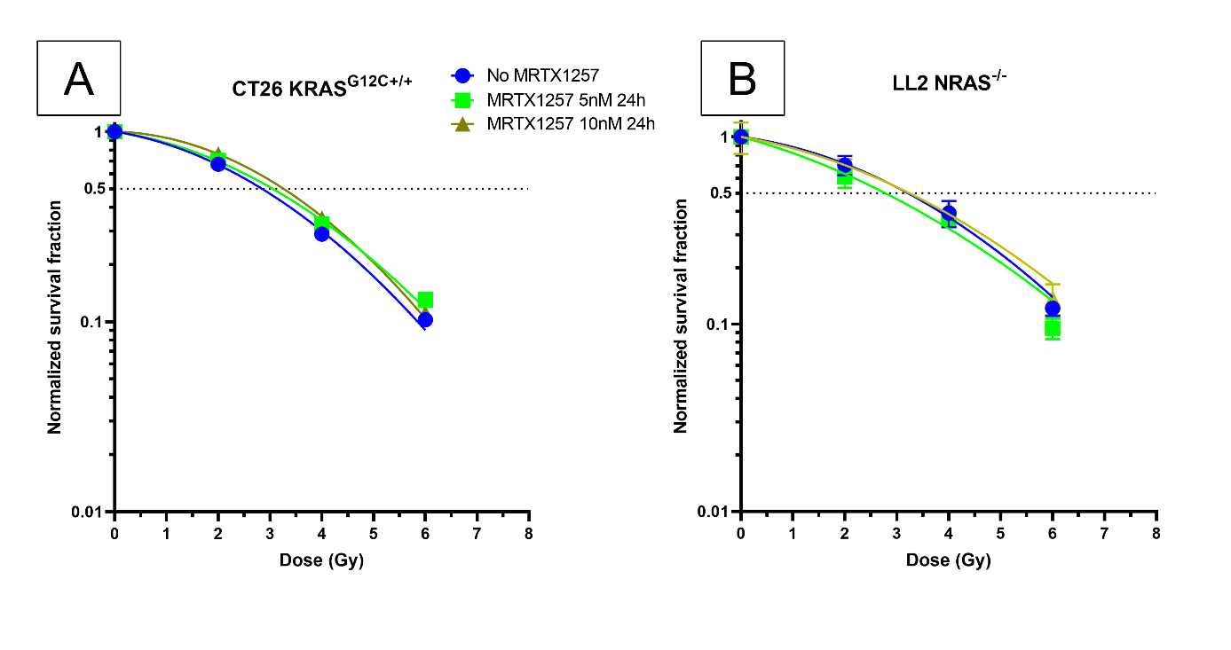
Additional file 1: FIGURE 1

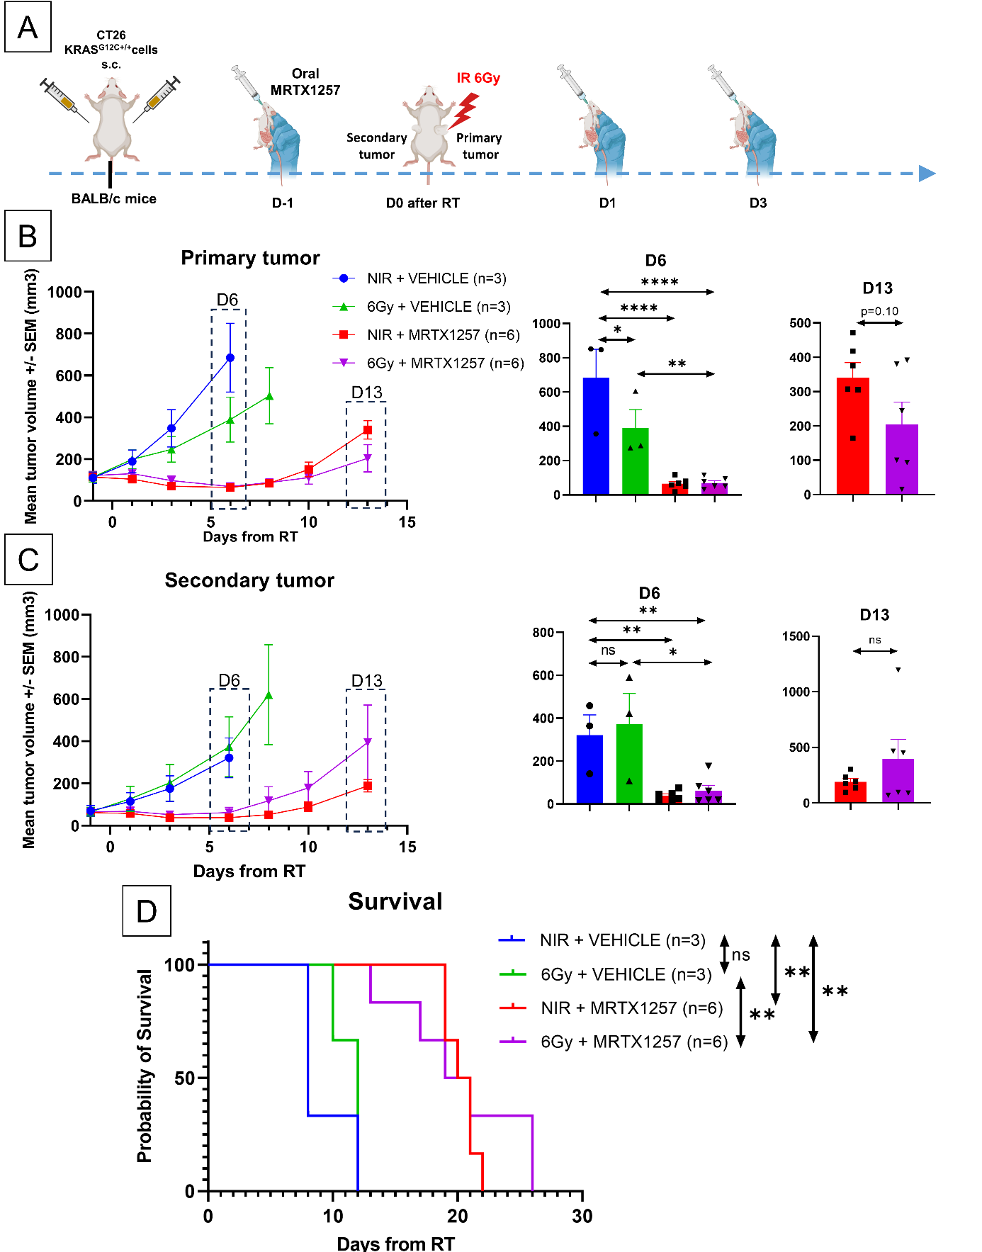
Additional file 1: FIGURE 2

s

