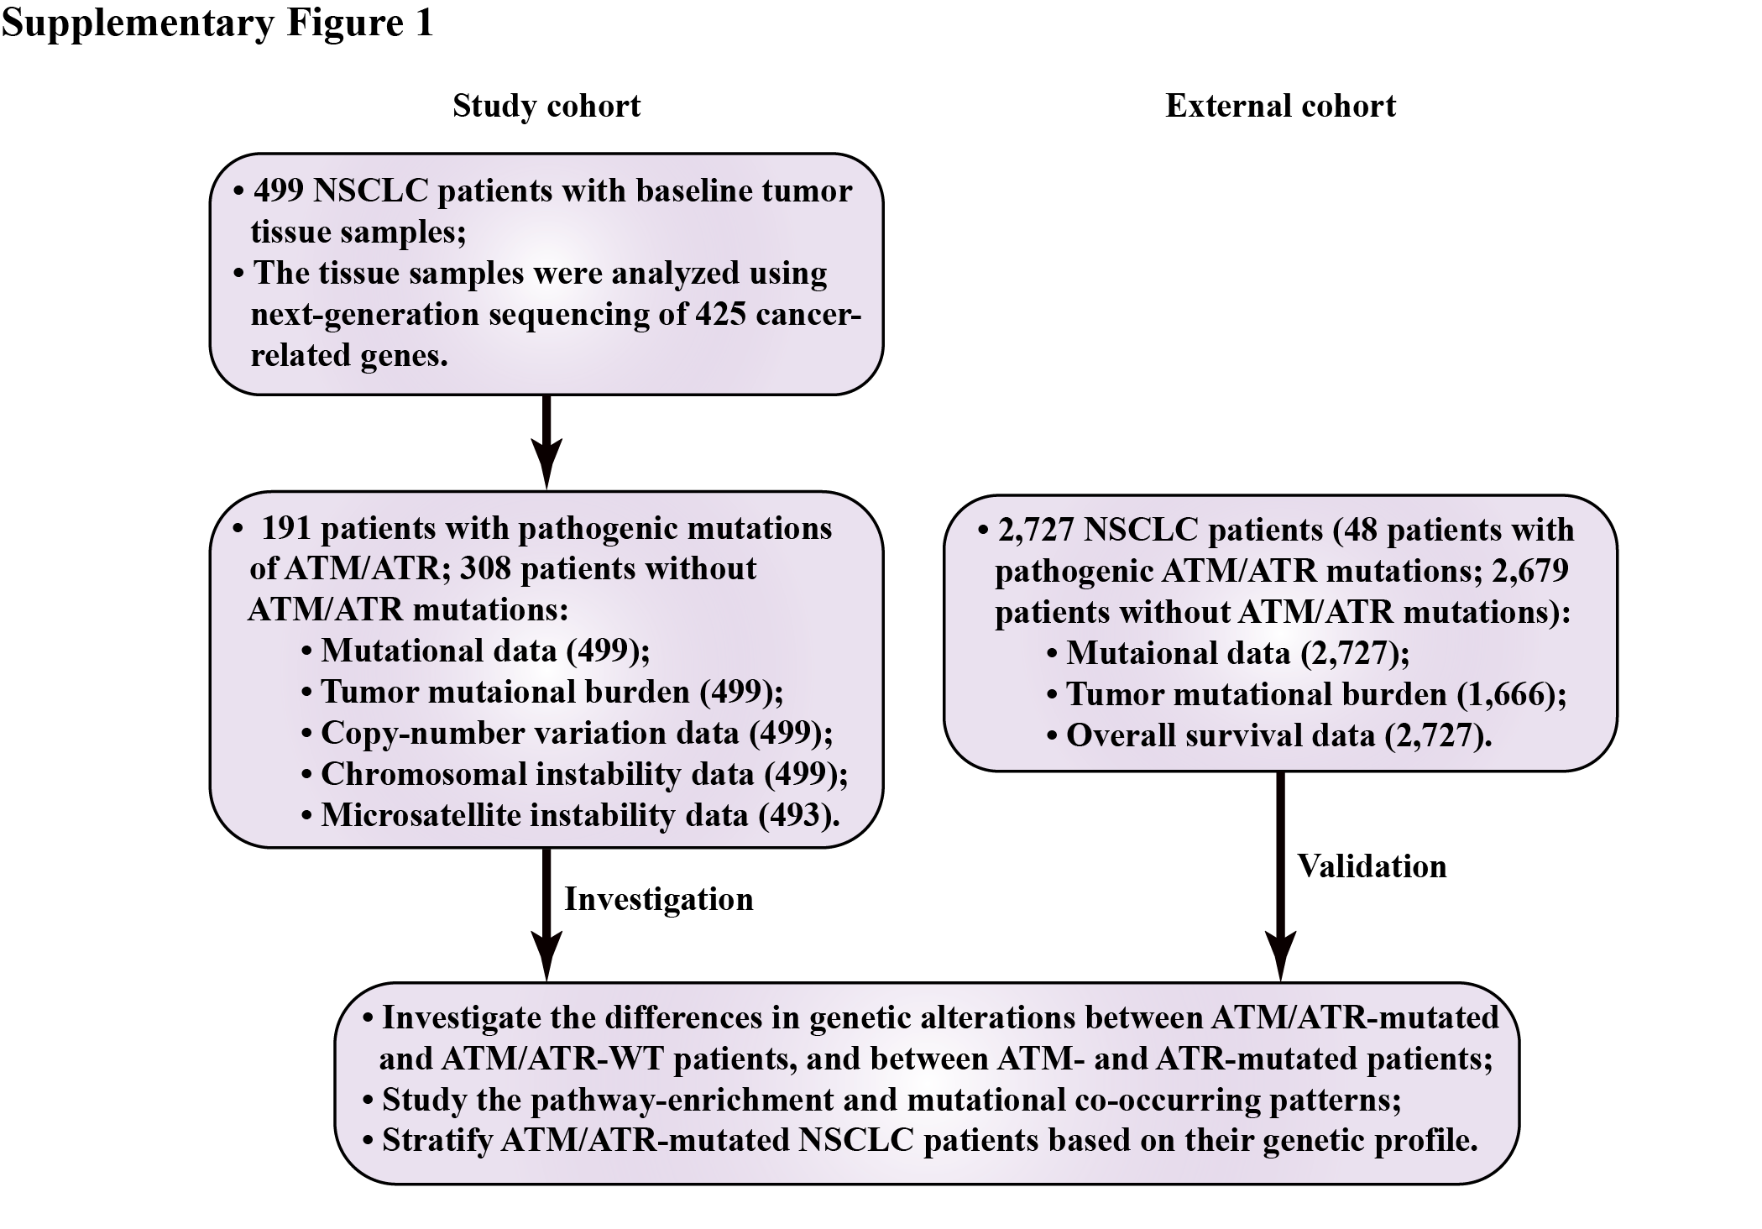
Figure S1 The workflow of the study cohort and external cohort.
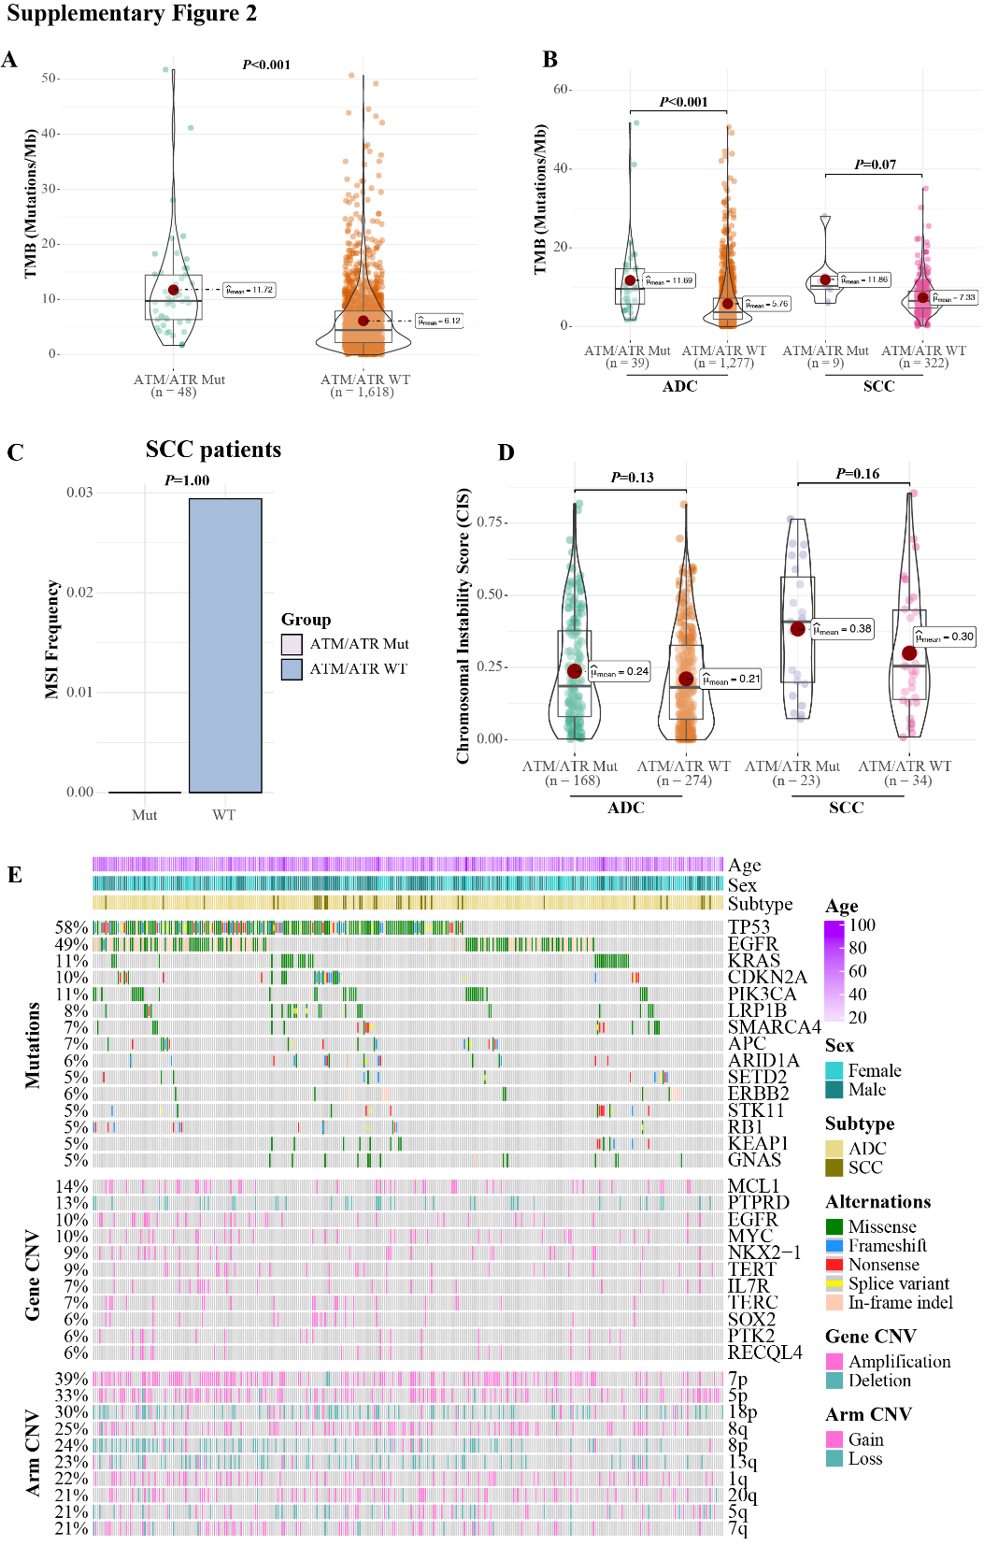
Figure S2 PIKK pathogenic mutations were associated with higher mutational loads in NSCLC. (A) The TMB in PIKK-Mut and PIKK-WT NSCLC patients from the external cohort. (B) The comparison of TMB between different PIKK mutational status and histological subtypes in the external cohort. (C) The MSI in PIKK-Mut and PIKK-WT SCC patients from the study cohort. (D) The comparison of CIS stratified by both the PIKK mutational status and histological subtypes in the study cohort. (E) The oncoprint plot of NSCLC patients without any PIKK mutations from the study cohort. CNV, copy-number variation.
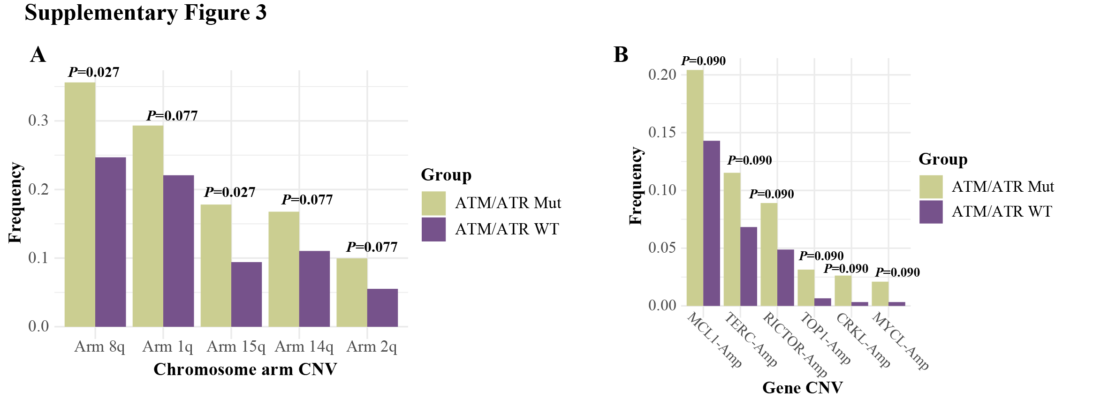
Figure S3 The CNV enriched in PIKK-mutated patients. (A, B) The comparison of chromosome arm CNV (A) and gene-level CNV (B) between PIKK-mutated and PIKK-WT patients from the study cohort. The analyses were done using Fisher’s exact test, and all multiple comparisons were corrected by the Benjamini & Hochberg approach.

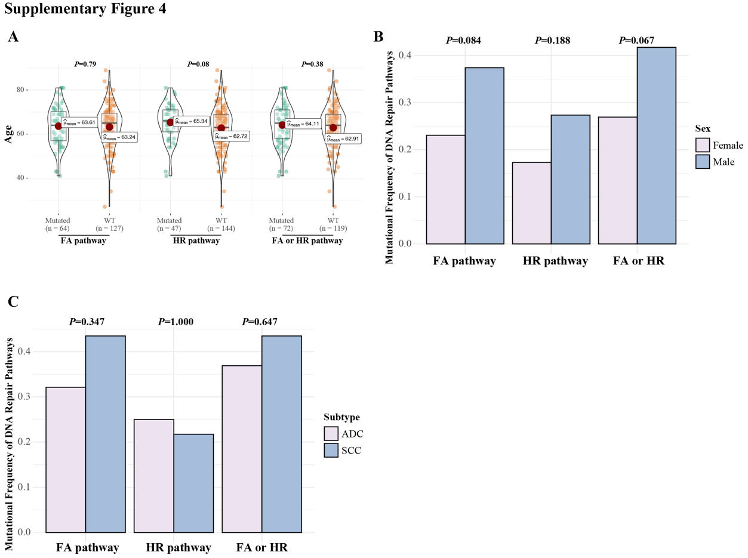
Figure S4 The relationship between FA/HR mutations and demographic/clinical characteristics in the study cohort. (A-C) The age (A), sex (B), and histological subtype (C) differences in PIKK-mutated patients with different FA/HR mutational statuses.

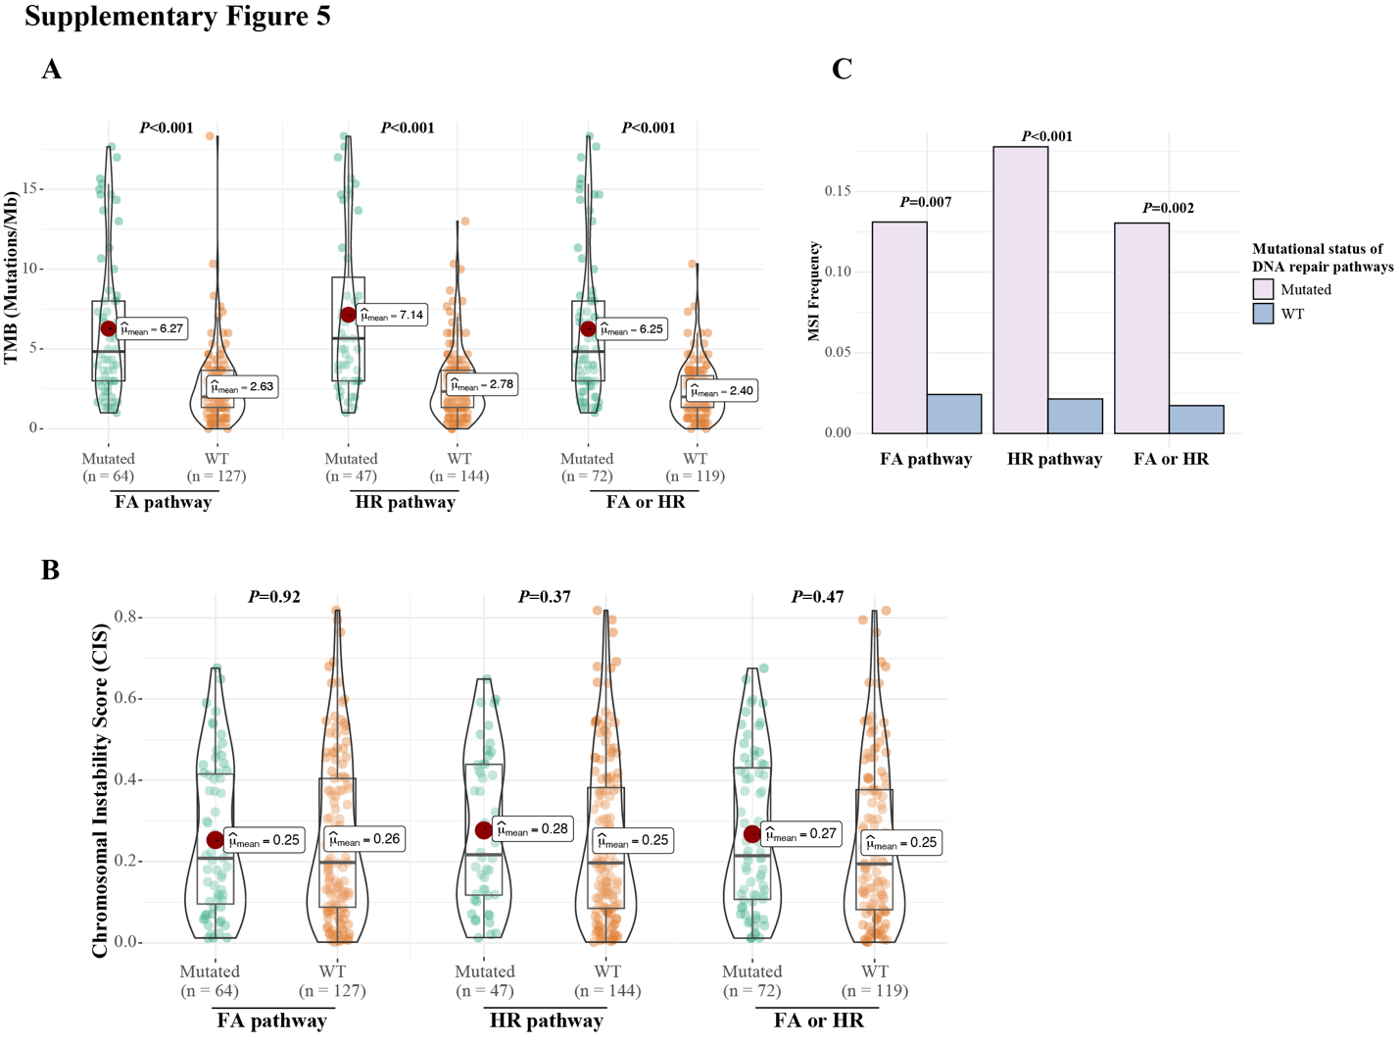
Figure S5 Patients with both PIKK and FA/HR mutations were associated with more nucleotide-level alterations. (A-C) The comparison of TMB (A), CIS (B), and MSI (C) in PIKK-mutated NSCLC patients with different FA/HR mutational statuses.

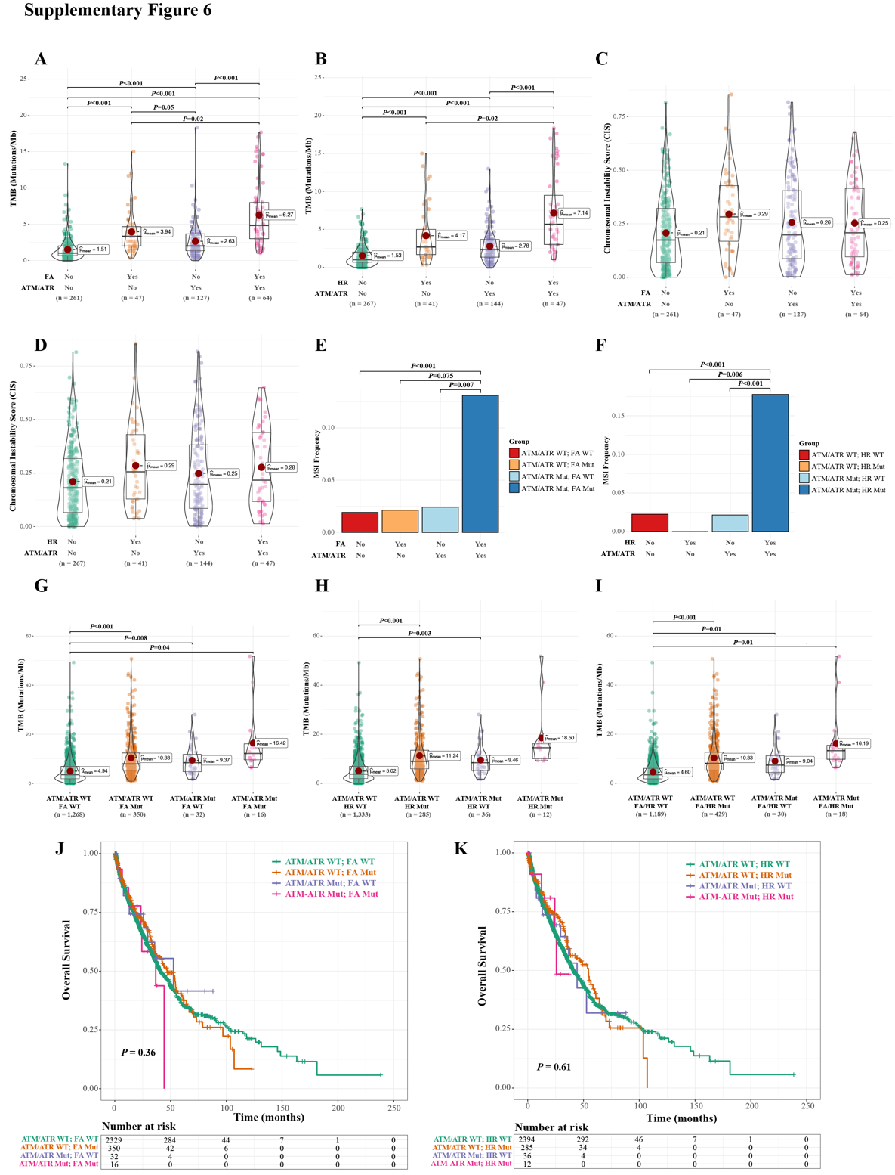
Figure S6 PIKK and FA/HR co-mutations were associated with higher nucleotide-level changes and worse prognosis. (A, B) The comparison of TMB in NSCLC patients with different PIKK and FA (A) or HR (B) mutational statuses in the study cohort. (C, D) The comparison of CIS in NSCLC patients with different PIKK and FA (C) or HR (D) mutational statuses in the study cohort. (E, F) The comparison of MSI frequency in NSCLC patients with different PIKK and FA (E) or HR (F) mutational statuses in the study cohort. (G-I) The comparison of TMB in NSCLC patients with different PIKK and FA/HR mutational statuses in the external cohort. (J, K) Kaplan-Meier curve of overall survival in NSCLC patients from the external cohort in strata of different PIKK and FA (J) or HR (K) mutational statuses.
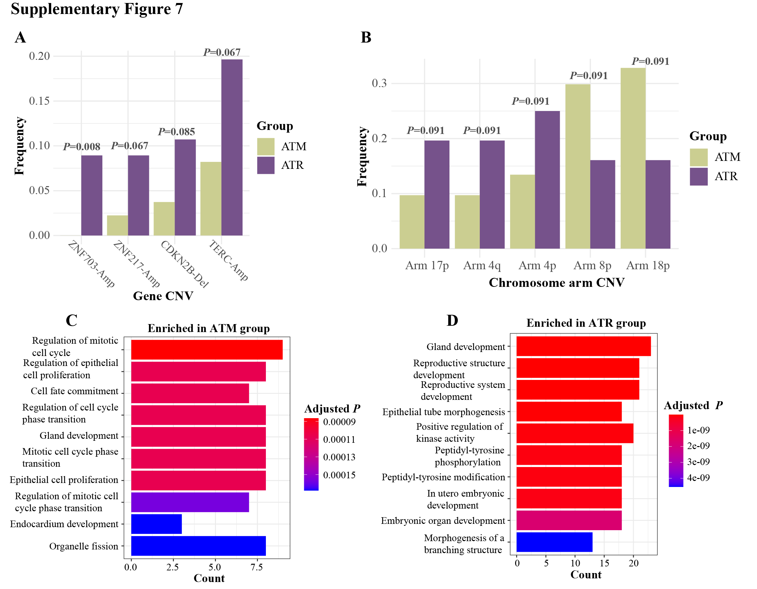
Figure S7 CNV and pathways enriched in ATM-mutated versus ATR-mutated patients. (A, B) The gene-level CNV (A) and chromosome arm-level CNV (B) that were enriched in ATM-mutated or ATR-mutated patients. The analyses were done using Fisher’s exact test, and all multiple comparisons were corrected by the Benjamini & Hochberg approach. (C, D) The gene ontology analysis of mutated genes enriched in ATM-mutated patients (C) or ATR-mutated patients (D).

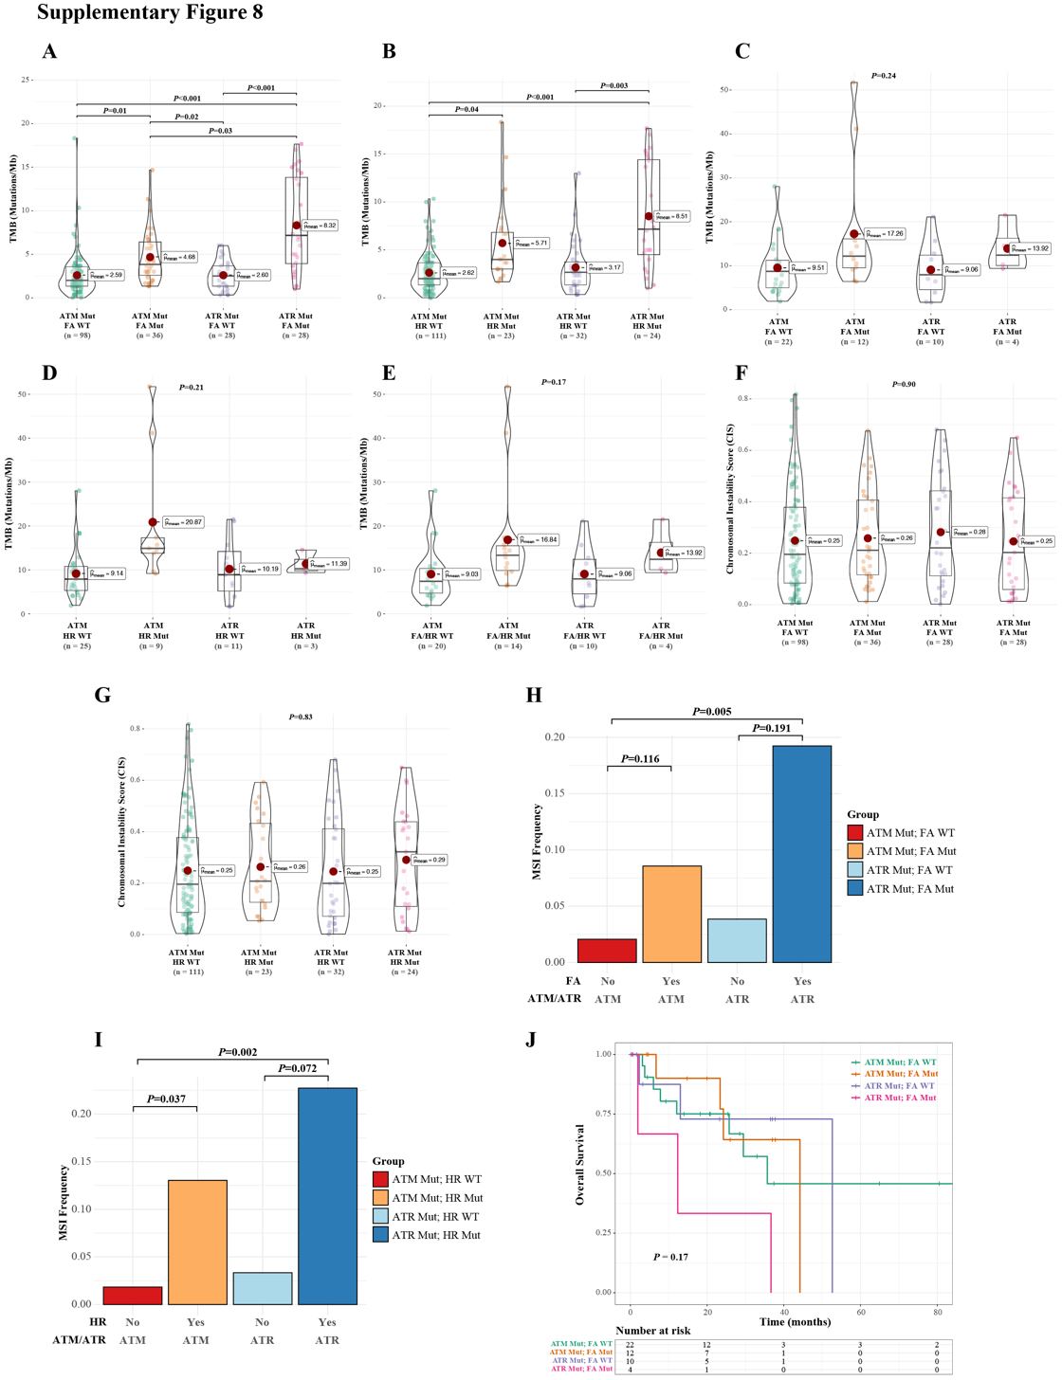
Figure S8 The association of ATM/ATR and FA/HR co-mutations and various molecular and clinical characteristics. (A, B) The comparison of TMB in NSCLC patients from the study cohort who were stratified by different ATM/ATR and FA (A) or HR (B) mutational statuses. (C-E) The comparison of TMB in NSCLC patients from the external cohort who were stratified by different ATM/ATR and FA/HR mutational statuses. (F, G) The comparison of CIS in NSCLC patients from the study cohort who were stratified by different ATM/ATR and FA (F) or HR (G) mutational statuses. (H, I) The comparison of MSI frequency in NSCLC patients from the study cohort who were stratified by different ATM/ATR and FA (H) or HR (I) mutational statuses. (J) Kaplan-Meier curve of overall survival in NSCLC patients from the external cohort in strata of different ATM/ATR and FA mutational statuses.

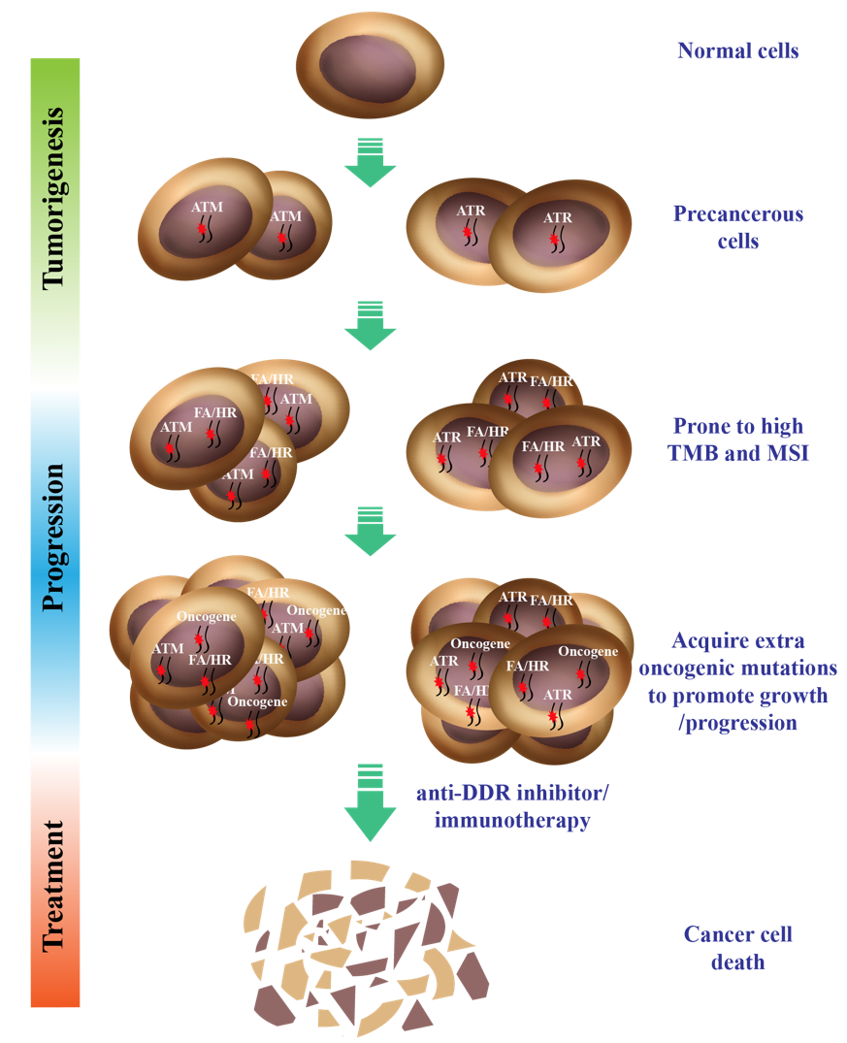
Figure S9 The proposed tumorigenesis model in DDR-mutation driven NSCLC tumors.

Table S1 The ATM/ATR pathological mutations detected in the study cohort.
Patient ID | Gene | Mutation | Variant  classification | ClinVar  classification
P1 | ATM | c.6399_6412delATCTCTAAGAGACA(p.S2134Rfs*7) | Frameshift
P2 | ATR | c.4387A>T(p.K1463*) | Nonsense
P3 | ATM | c.5692C>T(p.R1898*) | Nonsense
P4 | ATR | c.178_181delGACT(p.D60Lfs*6) | Frameshift
P5 | ATM | c.1039G>T(p.E347*) | Nonsense
P6 | ATR | c.2690_2691ins(149)(p.L897Ffs*92) | Frameshift
P7 | ATR | c.5173del(p.A1725Lfs*4) | Frameshift
P8 | ATR | c.1240C>T(p.Q414*) | Nonsense
P9 | ATM | c.8592C>G(p.Y2864*) | Nonsense
P10 | ATM | c.9139C>T(p.R3047*) | Nonsense | Pathogenic
P11 | ATR | c.6356T>A(p.L2119*) | Nonsense
P12 | ATM | c.4776+2T>C | Splice | Pathogenic
P13 | ATM | c.6214_6259delGGACTCTGCCATATTCTTTCCGTCTATTTAAAAGGATTGGATTATG(p.G2072Kfs*9) | Frameshift
P14 | ATM | c.8300delTinsCC(p.L2767Pfs*2) | Frameshift
P15 | ATM | c.1756G>T(p.E586*) | Nonsense
P16 | ATR | c.4097delC(p.P1366Qfs*4) | Frameshift
P17 | ATR | c.4888delA(p.T1630Pfs*4) | Frameshift
P18 | ATM | c.742C>T(p.R248*) | Nonsense | Pathogenic/Likely_pathogenic
P19 | ATM | c.521_530delTCTATCTGAA(p.L174Hfs*10) | Frameshift
P20 | ATR | c.2599delG(p.D867Ifs*3) | Frameshift
P21 | ATR | c.7789C>T(p.Q2597*) | Nonsense
P22 | ATR | c.3175G>T(p.E1059*) | Nonsense
P23 | ATM | c.1380_1381delGGinsTT(p.E461*) | Nonsense
P24 | ATM | c.3007C>T(p.Q1003*) | Nonsense
P25 | ATM | c.4772T>A(p.L1591*) | Nonsense
P26 | ATM | c.1464G>A(p.W488*) | Nonsense
P27 | ATR | c.1903C>T(p.R635*) | Nonsense
P28 | ATM | c.2089_2123delTTATCAGAACAGCTTCTGAATAATTACTCATCTGAinsATGAAAGTTCTTCTTTATCTTTTTGGT(p.L697Mfs*38) | Frameshift
P29 | ATR | c.3788dupA(p.I1264Dfs*14) | Frameshift
P30 | ATR | c.6409C>T(p.Q2137*) | Nonsense
P31 | ATR | c.2320dupA(p.I774Nfs*3) | Frameshift
P32 | ATM | c.8264_8268delATAAG(p.Y2755Cfs*12) | Frameshift | Pathogenic
P33 | ATR | c.684_687delACTT(p.L228Ffs*4) | Frameshift
P34 | ATR | c.3432delC(p.I1145Lfs*8) | Frameshift
P35 | ATM | c.1939G>T(p.E647*) | Nonsense | Pathogenic
P36 | ATR | c.4396C>T(p.Q1466*) | Nonsense
P37 | ATM | c.1236-2A>T | Splice | Pathogenic
P38 | ATR | c.4996A>T(p.K1666*) | Nonsense
P39 | ATM | c.67C>T(p.R23*) | Nonsense | Pathogenic
P40 | ATM | c.8645C>A(p.S2882*) | Nonsense
P41 | ATM | c.1027delG(p.E343Kfs*3) | Frameshift
P42 | ATM | c.4732C>T(p.Q1578*) | Nonsense | Likely_pathogenic
P43 | ATM | c.5216dupA(p.N1739Kfs*10) | Frameshift
P44 | ATR | c.2320dupA(p.I774Nfs*3) | Frameshift
P45 | ATR | c.3341dupT(p.S1115Ifs*3) | Frameshift
P46 | ATM | c.4145delC(p.P1382Hfs*4) | Frameshift
P47 | ATM | c.5121_5122insGGTAAATAATTATGTGAATTAATAAAAATATAAGAATTTTCATAAAGAA(p.L1708Gfs*3) | Nonsense
P48 | ATM | c.2854A>T(p.K952*) | Nonsense
P49 | ATM | c.1236-2A>T | Splice | Pathogenic
P50 | ATM | c.5200delG(p.V1734Lfs*4) | Frameshift
P51 | ATR | c.4826C>G(p.S1609*) | Nonsense
P52 | ATM | c.6615G>A(p.W2205*) | Nonsense
P53 | ATM | c.943_944delTT(p.L315Ifs*2) | Frameshift
P54 | ATM | c.1208C>G(p.S403*) | Nonsense
P55 | ATR | c.6815C>A(p.S2272*) | Nonsense
P56 | ATR | c.3386delG(p.G1129Afs*11) | Frameshift
P57 | ATM | c.6451A>T(p.R2151*) | Nonsense
P58 | ATM | c.642delC(p.K215Rfs*15) | Frameshift | Pathogenic
P59 | ATM | c.6757A>T(p.K2253*) | Nonsense
P60 | ATM | c.5492delG(p.C1831Lfs*3) | Frameshift
P61 | ATM | c.1234dupT(p.W412Lfs*18) | Frameshift
P62 | ATM | c.8720delC(p.P2907Lfs*31) | Frameshift
P62 | ATM | c.2461delA(p.S821Vfs*2) | Frameshift
P63 | ATR | c.5440dupA(p.R1814Kfs*8) | Frameshift
P64 | ATM | c.1236_1237insA(p.L413Tfs*17) | Frameshift
P65 | ATM | c.8122G>A(p.D2708N) | Missense | Likely_pathogenic
P66 | ATM | c.802C>T(p.Q268*) | Nonsense | Pathogenic/Likely_pathogenic
P67 | ATM | c.757G>T(p.E253*) | Nonsense
P68 | ATM | c.9019delG(p.E3007Nfs*4) | Frameshift
P69 | ATR | c.7792C>T(p.R2598*) | Nonsense
P70 | ATM | c.7777C>T(p.Q2593*) | Nonsense
P71 | ATM | c.4765delT(p.S1589Hfs*12) | Frameshift
P72 | ATR | c.3043delC(p.R1015Efs*3) | Frameshift
P73 | ATM | c.4282G>T(p.E1428*) | Nonsense
P74 | ATM | c.3077+1delG | Frameshift
P75 | ATM | c.7886dupT(p.L2630Ifs*26) | Frameshift
P76 | ATM | c.1898+1delG | Frameshift
P77 | ATM | c.4169_4178delTTGCCTATAT(p.F1390Sfs*9) | Frameshift
P78 | ATM | c.6268_6280delGACTGGTGTCCTG(p.D2090Nfs*2) | Frameshift
P79 | ATM | c.465C>G(p.Y155*) | Nonsense
P80 | ATR | c.1038delG(p.L346Ffs*27) | Frameshift
P81 | ATM | c.7542T>A(p.Y2514*) | Nonsense
P81 | ATM | c.5823dupT(p.A1942Cfs*23) | Frameshift
P82 | ATM | c.6661G>T(p.E2221*) | Nonsense
P83 | ATM | c.8287C>T(p.R2763*) | Nonsense | Pathogenic
P84 | ATR | c.5440dupA(p.R1814Kfs*8) | Frameshift
P85 | ATM | c.7886_7890delTATTA(p.I2629Sfs*25) | Frameshift | Pathogenic
P86 | ATM | c.2866G>T(p.G956*) | Nonsense
P87 | ATM | c.1236-2A>T | Splice | Pathogenic
P88 | ATM | c.6572+46_6572+47ins(147) | Nonsense
P89 | ATR | c.244dupA(p.M82Nfs*10) | Frameshift
P90 | ATM | c.1311delG(p.M437Ifs*36) | Frameshift
P91 | ATM | c.1102C>T(p.Q368*) | Nonsense
P92 | ATR | c.4417G>T(p.G1473*) | Nonsense
P93 | ATM | c.8494C>T(p.R2832C) | Missense | Pathogenic/Likely_pathogenic
P94 | ATM | c.8230G>T(p.E2744*) | Nonsense
P95 | ATM | c.5697C>A(p.C1899*) | Nonsense | Pathogenic
P96 | ATR | c.7138delG(p.V2380*) | Frameshift
P97 | ATM | c.7533_7542delTCCAACATAT(p.P2512Nfs*17) | Frameshift
P98 | ATM | c.8293G>A(p.G2765S) | Missense | Pathogenic/Likely_pathogenic
P99 | ATM | c.1071delT(p.F357Lfs*33) | Frameshift
P100 | ATM | c.1236-2A>T | Splice | Pathogenic
P101 | ATR | c.3220G>T(p.G1074*) | Nonsense
P102 | ATR | c.2188G>T(p.E730*) | Nonsense
P103 | ATR | c.5383G>T(p.G1795*) | Nonsense
P104 | ATR | c.5293G>T(p.E1765*) | Nonsense
P105 | ATR | c.2320dupA(p.I774Nfs*3) | Frameshift
P106 | ATM | c.601C>T(p.Q201*) | Nonsense | Likely_pathogenic
P107 | ATM | c.8545C>T(p.R2849*) | Nonsense | Pathogenic
P108 | ATM | c.7149_7150delinsG(p.M2384*) | Frameshift
P109 | ATM | c.447delT(p.L150Ffs*3) | Frameshift
P109 | ATM | c.5044G>C(p.D1682H) | Missense | Pathogenic
P110 | ATM | c.709dupA(p.T237Nfs*17) | Frameshift
P111 | ATM | c.583_584delACinsT(p.T195Sfs*11) | Frameshift
P112 | ATM | c.5395_5405delAGTGAAAATCA(p.S1799*) | Frameshift
P113 | ATM | c.2209G>T(p.E737*) | Nonsense
P114 | ATR | c.4154delC(p.T1385Mfs*3) | Frameshift
P115 | ATR | c.4082T>A(p.L1361*) | Nonsense
P116 | ATR | c.2320dupA(p.I774Nfs*3) | Frameshift
P117 | ATM | c.6049_6052delAGTT(p.S2017Cfs*29) | Frameshift
P118 | ATM | c.8325delC(p.I2776Lfs*30) | Frameshift | Pathogenic/Likely_pathogenic
P119 | ATR | c.2320dupA(p.I774Nfs*3) | Frameshift
P120 | ATM | c.8293G>A(p.G2765S) | Missense | Pathogenic/Likely_pathogenic
P121 | ATM | c.700delG(p.A234Qfs*21) | Frameshift
P122 | ATM | c.2548G>T(p.E850*) | Nonsense | Pathogenic
P123 | ATM | c.2212G>T(p.E738*) | Nonsense
P124 | ATM | c.1597A>T(p.R533*) | Nonsense
P125 | ATM | c.1093G>T(p.E365*) | Nonsense | Pathogenic
P126 | ATM | c.8398C>T(p.Q2800*) | Nonsense
P127 | ATM | c.3154-1G>T | Splice | Likely_pathogenic
P128 | ATM | c.7189C>T(p.Q2397*) | Nonsense | Pathogenic
P129 | ATM | c.3231delT(p.A1079Lfs*30) | Frameshift
P130 | ATM | c.3176_3194delCCATTCTTAATGTAATGGG(p.A1059Efs*6) | Frameshift
P131 | ATR | c.4264C>T(p.Q1422*) | Nonsense
P132 | ATR | c.3883G>T(p.E1295*) | Nonsense
P133 | ATM | c.5697C>A(p.C1899*) | Nonsense | Pathogenic
P134 | ATM | c.1249_1265delACCCAATTAATATCAAA(p.T417Vfs*7) | Frameshift
P135 | ATM | c.1750C>T(p.Q584*) | Nonsense
P136 | ATM | c.2548G>T(p.E850*) | Nonsense | Pathogenic
P137 | ATM | c.7267G>T(p.E2423*) | Nonsense
P138 | ATM | c.6725C>G(p.S2242*) | Nonsense
P139 | ATM | c.5908C>T(p.Q1970*) | Nonsense | Pathogenic
P140 | ATR | c.361A>T(p.K121*) | Nonsense
P141 | ATM | c.3145_3146insC(p.L1049Sfs*3) | Frameshift
P142 | ATM | c.6825_6826del(p.F2276Sfs*3) | Frameshift
P143 | ATM | c.7708G>T(p.E2570*) | Nonsense | Pathogenic/Likely_pathogenic
P144 | ATM | c.635_636insG(p.F212Lfs*42) | Frameshift
P145 | ATR | c.2770del(p.S924Vfs*15) | Frameshift
P145 | ATM | c.7476_7477insA(p.E2493Rfs*7) | Frameshift
P145 | ATM | c.7477delinsAA(p.E2493Kfs*7) | Frameshift
P146 | ATM | c.3089dup(p.E1031Gfs*17) | Frameshift
P147 | ATR | c.512G>A(p.W171*) | Nonsense
P148 | ATM | c.3402+2T>C | Splice | Likely_pathogenic
P149 | ATM | c.3424G>T(p.E1142*) | Nonsense
P150 | ATM | c.6272G>A(p.W2091*) | Nonsense | Pathogenic
P151 | ATM | c.1077del(p.D360Ifs*30) | Frameshift
P152 | ATM | c.1102C>T(p.Q368*) | Nonsense
P153 | ATM | c.1236-1G>A | Splice | Likely_pathogenic
P154 | ATM | c.2638+1G>T | Splice | Likely_pathogenic
P155 | ATR | c.1602G>A(p.W534*) | Nonsense
P156 | ATM | c.8157_8166del(p.D2721Kfs*27) | Frameshift
P157 | ATR | c.6313delinsAA(p.E2105Kfs*14) | Frameshift
P158 | ATM | c.8283_8284del(p.Q2762Afs*6) | Frameshift | Pathogenic
P159 | ATM | c.4292_4296del(p.N1431Ifs*2) | Frameshift
P160 | ATR | c.6373_6382del(p.V2125Sfs*6) | Frameshift
P161 | ATM | c.7261A>T(p.K2421*) | Nonsense
P162 | ATM | c.7413_7428del(p.I2471Mfs*28) | Frameshift
P163 | ATM | c.8929G>T(p.E2977*) | Nonsense
P164 | ATR | c.6265C>T(p.R2089*) | Nonsense
P165 | ATM | c.8293G>A(p.G2765S) | Missense | Pathogenic/Likely_pathogenic
P166 | ATM | c.2340del(p.M780Ifs*8) | Frameshift
P167 | ATM | c.5971G>T(p.E1991*) | Nonsense | Pathogenic
P168 | ATM | c.6715del(p.M2239Wfs*18) | Frameshift
P169 | ATM | c.5623C>T(p.R1875*) | Nonsense | Pathogenic
P170 | ATR | c.5020G>T(p.G1674*) | Nonsense
P171 | ATM | c.901+1G>T | Splice | Pathogenic/Likely_pathogenic
P172 | ATM | c.9139C>T(p.R3047*) | Nonsense | Pathogenic
P173 | ATM | c.1426C>T(p.Q476*) | Nonsense
P174 | ATM | c.2193C>A(p.Y731*) | Nonsense | Pathogenic
P175 | ATM | c.967A>G(p.I323V) | Missense | Pathogenic/Likely_pathogenic
P176 | ATM | c.7191del(p.Q2397Hfs*9) | Frameshift
P177 | ATR | c.5485G>T(p.E1829*) | Nonsense
P178 | ATM | c.7181C>T(p.S2394L) | Missense | Likely_pathogenic
P179 | ATR | c.1227_1236del(p.E409Dfs*27) | Frameshift
P180 | ATR | c.6265C>T(p.R2089*) | Nonsense
P181 | ATM | c.1750C>T(p.Q584*) | Nonsense | Pathogenic
P182 | ATM | c.4177_4181del(p.I1393Qfs*4) | Frameshift
P183 | ATM | c.3993+1G>T | Splice | Likely_pathogenic
P184 | ATM | c.2921+1G>T | Splice | Pathogenic/Likely_pathogenic
P185 | ATR | c.1303_1312del(p.S435*) | Frameshift
P186 | ATM | c.6998_6999del(p.T2333Ifs*39) | Frameshift
P187 | ATR | c.5656C>T(p.R1886*) | Nonsense
P188 | ATM | c.1021_1022del(p.V341Qfs*6) | Frameshift
P189 | ATM | c.4741del(p.I1581Sfs*20) | Frameshift
P189 | ATM | c.4741_4742delinsG(p.I1581Afs*20) | Frameshift
P190 | ATM | c.4043_4046del(p.L1348*) | Frameshift
P191 | ATR | c.5413G>T(p.G1805*) | Nonsense

Table S2 Demographic characteristics of the 499 NSCLC patients in the study cohort.
Characteristics | With ATM/ATR pathological mutations (n=191) | Without ATM/ATR mutations (n=308) | P values
Age (median, range) | 64 (27-89) | 60 (28-89) | <0.001
Sex |  |  | <0.001
Male | 139 (72.8%) | 172 (55.8%)
Female | 52 (27.2%) | 136 (44.2%)
Histologic subtype |  |  | 0.773
ADC | 168 (88.0%) | 274 (89.0%)
SCC | 23 (12.0%) | 34 (11.0%)

Table S3 The ATM/ATR pathological mutations in the external cohort.
Patient ID | Gene | Mutation | Variant classification
E1 | ATR | p.E7Dfs*21 | Frameshift
E2 | ATR | p.E1329* | Nonsense
E3 | ATM | p.E1822* | Nonsense
E4 | ATR | p.W102* | Nonsense
E5 | ATM | p.G2369* | Nonsense
E6 | ATM | p.E1313Gfs*36 | Frameshift
E7 | ATM | p.G956* | Nonsense
E7 | ATM | p.G956* | Nonsense
E8 | ATM | p.Q1084* | Nonsense
E9 | ATM | p.G2536Efs*6 | Frameshift
E10 | ATR | p.R1814Kfs*8 | Frameshift
E11 | ATM | p.Q445Lfs*42 | Frameshift
E12 | ATM | p.Q2615* | Nonsense
E13 | ATR | p.S1372* | Nonsense
E14 | ATM | p.G873* | Nonsense
E15 | ATR | p.L537* | Nonsense
E16 | ATM | p.D2569* | Frameshift
E17 | ATM | p.I1581Nfs*5 | Frameshift
E18 | ATM | p.Q1636Rfs*10 | Frameshift
E19 | ATM | p.Y889Ifs*10 | Frameshift
E20 | ATM | p.E871* | Nonsense
E21 | ATM | p.E1940* | Nonsense
E22 | ATM | p.Q1225* | Nonsense
E23 | ATM | p.E1979* | Nonsense
E24 | ATM | p.S2882* | Nonsense
E25 | ATR | p.S2207Ifs*15 | Frameshift
E26 | ATM | p.E3015* | Nonsense
E27 | ATR | p.K343* | Nonsense
E28 | ATM | p.S751Ffs*14 | Frameshift
E28 | ATM | p.S1487* | Nonsense
E29 | ATM | p.Q628* | Nonsense
E30 | ATM | p.E770* | Nonsense
E31 | ATR | p.E833* | Nonsense
E32 | ATR | p.S1616* | Nonsense
E33 | ATR | p.G736* | Nonsense
E34 | ATM | p.I1525Nfs*6 | Frameshift
E35 | ATM | p.K1196* | Nonsense
E36 | ATM | p.R248* | Nonsense
E37 | ATM | p.C819Lfs*4 | Frameshift
E38 | ATM | p.R1437* | Nonsense
E39 | ATR | p.S508Lfs*5 | Frameshift
E40 | ATM | p.R250Sfs*3 | Frameshift
E40 | ATM | p.L2006* | Frameshift
E41 | ATM | p.T1029Qfs*10 | Frameshift
E42 | ATM | p.Q65* | Nonsense
E43 | ATR | p.I97* | Frameshift
E44 | ATM | p.L427* | Nonsense
E45 | ATM | p.L210Wfs*20 | Frameshift
E46 | ATM | p.Q1116Sfs*10 | Frameshift
E47 | ATR | p.Q2085* | Nonsense
E48 | ATM | p.Q2277* | Nonsense

Table S4 Demographic characteristics of the 2,727 NSCLC patients in the external cohort.
Characteristics | With ATM/ATR pathological mutations (n=48) | Without ATM/ATR mutations (n=2,679) | P values
Age (mean, range) | 65 (44-84) | 67 (25-93) | 0.303
Sex |  |  | 0.306
Male | 18 (37.5%) | 1,223 (45.6%)
Female | 30 (62.5%) | 1,446 (54.0%)
NA | 0 (0.0%) | 10 (0.4%)
Histologic subtype |  |  | 0.543
ADC | 39 (81.3%) | 2,176 (81.2%)
SCC | 9 (18.7%) | 394 (14.7%)
NA | 0 (0.0%) | 109 (4.1%)

Table S5 The list of mutated genes that were enriched in PIKK-mutated patients by at least 2 fold.
ABCB1 | LZTR1 | EPHA2 | PKHD1 | CDC73 | NRAS | GNAQ | SMO
ADGRB3 | MAP2K4 | EPHA5 | POLD1 | CDH1 | NSD1 | GRIN2A | SOX2
ALK | MAP3K4 | ERCC2 | POT1 | CDK12 | NTRK1 | GRM8 | SPRY4
ASCL4 | MCL1 | ERCC5 | PRF1 | CDK8 | NTRK3 | GSTM5 | SRC
AURKB | MDM2 | EXT1 | PRKCI | CDKN1B | PALB2 | HDAC2 | STAG2
AXIN2 | MECOM | FANCA | PRSS1 | CEBPA | PALLD | HNF1A | STK11
B2M | MEN1 | FANCC | PTCH1 | CEP57 | PARK2 | IDH1 | TERT
BAP1 | MITF | FANCE | PTPN11 | CHD4 | PARP1 | IDH2 | TGFBR2
BARD1 | MLH1 | FANCF | RAD54L | CHD8 | PAX5 | IGF1R | TNFRSF11A
BLM | MLH3 | FANCG | RET | CHEK1 | PBRM1 | IGF2 | TOP2A
BMPR1A | MPL | FANCL | ROS1 | CHEK2 | PDCD1 | INPP4B | TSC1
BRCA1 | MSH2 | FBXW7 | RPTOR | CRKL | PDE11A | KDM5A | TTF1
BRCA2 | MSH6 | FGFR2 | RRM1 | CSF1R | PDGFRA | KDR | WAS
BRD4 | MYC | FGFR4 | RUNX1 | CYLD | PDGFRB | KLLN | WISP3
BRIP1 | NBN | FH | RUNX1T1 | CYP2C19 | PDK1 | KMT2C | WRN
BTK | NF1 | FLT1 | SETBP1 | DDR2 | PIK3R2 | KRAS | WT1
C11orf30 | NOTCH1 | GATA3 | SGK1 | DENND1A | PKD1 | LHCGR | XPC
CCNE1 | NPM1 | GATA4 | SMAD3 | EPAS1 | PKD2 | ZNF703

Table S6 The list of mutated genes that were enriched in ATM or ATR by at least two folds.
Category | Gene list
Enriched in ATM than ATR group | AURKB B2M BUB1B CDC73 CDKN1C CHEK2 CYP2C19 DENND1A DLL3 EPHA5 ERBB4 FANCD2 HDAC9 JAK3 KDR KMT2C KRAS MCL1 MECOM MET MLH3 MYC NRG1 PTPN13 RAD54L RPTOR RRM1 SMAD4 STAT3 STK11 UGT1A1
Enriched in ATR than ATM group | AMER1 AXIN2 BRAF BRCA1 BRCA2 BRIP1 BTK C11orf30 CBL CBLB CDH1 CDK8 CEP57 CHD4 CHD8 CREBBP CSF1R CYLD DAXX DDR2 DICER1 DNMT3A ERBB2 ERCC2 FANCG FBXW7 FGFR1 FGFR2 FLT3 GATA6 GNAQ GNAS HGF IGF2 JAK1 KDM5A KMT2B MED12 MLH1 MSH2 MTOR NFE2L2 NKX2-1 NOTCH1 NOTCH2 NPM1 NRAS NSD1 NTRK1 PALB2 PALLD PAX5 PDCD1 PDK1 PGR PKD1 PKD2 PLCB4 PMS1 POLD1 POLE POLH PRKCI PRSS1 PTCH1 RET SETD2 SMAD3 SMARCA4 SPRY4 SRC TEK TET2 TGFBR2 WISP3 WT1 AKT1 BLM BMPR1A CTCF DPYD ERCC3 FANCE FOXA1 IDH2 KLLN PARP1 RAD51D RARA RUNX1 STAG2 TAP2

