Fig.S1 Composition of Lycium barbarum glycopeptide. (A)Composition of Lycium barbarum glycopeptide;

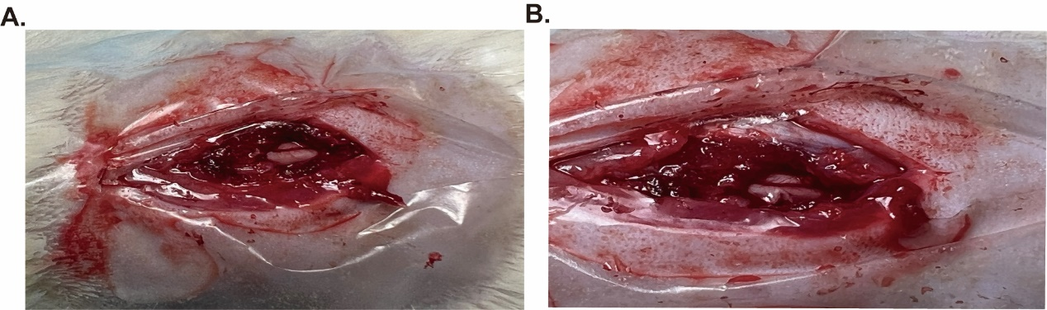

Fig. S2 Rat spinal cord hemisection model. (A). Establishment of rat spinal cord hemisection model(before)；（B）.Establishment of rat spinal cord hemisection model(after)
Fig. S3 Effect of Lycium barbarum glycopeptide treatment on the spinal cord injury. (A-B). detected the expression level of BDNF and GDNF in spinal cord tissue by western blotting. (C). Spinal cord injury treatment with different doses(10mg/kg-100mg/kg) of LbGp of reduces pro-IL-18 protein expression levels. （D-E）On day 7, the expression level of each group of NLRP3, ASC, caspase-1, P-p65, P65, GSDMD, GSDMD-N, IL-18, IL-1β protein in spinal cord tissue was detected by western blotting.

Fig. S4 Cell viability of microglia treated with different concentration of Lycium barbarum glycopeptide. (A)Cell viability of microglia treated with different concentration of LbGp

Fig. S5 Heatmap of differential metabolic substances between three groups in vivo and vitro. (A)Heatmap of differential metabolic substances between the Sham and LbGp groups in spinal cord tissue. (B)Heatmap of differential metabolic substances between the SCI and LbGp groups in spinal cord tissue. (C)Heatmap of differential metabolic substances between Control and ATP+LPS treatment groups in microglia supernatants. (D-E) Heatmap of differential metabolic substances between ATP+LPS and LbGp treatment groups in microglia supernatants.

