Table S1 Genetic variants used in the analyses investigating a causal impact of genetically predicted GERD and respiratory diseases
SNP | EA | OA | EAF | $β$_{expsr} | SE_{expsr} | $P$_{expsr} | $β$_{otcm} | SE_{otcm} | $P$_{otcm} | R2 | F
COPD on GERD
rs10010963 | T | C | 0.616433 | -0.02698 | 0.004947 | 4.92E-08 | -0.0266 | 0.0195 | 0.1738 | 0.000344 | 75.34104
rs1011407 | G | A | 0.121628 | -0.04206 | 0.007359 | 1.09E-08 | -0.0159 | 0.0333 | 0.633501 | 0.000378 | 82.7396
rs10133111 | A | G | 0.162996 | 0.041788 | 0.006508 | 1.35E-10 | -0.0201 | 0.0222 | 0.365 | 0.000476 | 104.2955
rs1021363 | G | A | 0.641992 | -0.03122 | 0.005022 | 5.10E-10 | -0.0034 | 0.0207 | 0.8673 | 0.000448 | 98.05296
rs10837002 | G | C | 0.35122 | 0.027649 | 0.005037 | 4.03E-08 | 0.033 | 0.0197 | 0.09307 | 0.000348 | 76.25204
rs11762636 | A | C | 0.180282 | -0.05148 | 0.006256 | 1.88E-16 | 0.0045 | 0.0206 | 0.8291 | 0.000783 | 171.5305
rs11953061 | T | C | 0.338908 | 0.02816 | 0.005087 | 3.10E-08 | 0.0256 | 0.0189 | 0.1756 | 0.000355 | 77.77172
rs12204714 | T | C | 0.632223 | -0.02882 | 0.004994 | 7.92E-09 | 0.0153 | 0.0191 | 0.4229 | 0.000386 | 84.5243
rs12357321 | A | G | 0.311087 | 0.031716 | 0.005231 | 1.33E-09 | 0.0568 | 0.0202 | 0.004843 | 0.000431 | 94.37328
rs12453010 | T | C | 0.394803 | 0.029697 | 0.004933 | 1.75E-09 | 0.0486 | 0.019 | 0.0106 | 0.000421 | 92.24399
rs12598916 | G | C | 0.274798 | -0.03326 | 0.005392 | 6.87E-10 | -0.0504 | 0.021 | 0.01663 | 0.000441 | 96.51762
rs12967855 | G | A | 0.670435 | -0.03655 | 0.005134 | 1.09E-12 | -0.0118 | 0.0208 | 0.5697 | 0.00059 | 129.2034
rs12997558 | A | G | 0.358751 | 0.027818 | 0.005022 | 3.04E-08 | -0.0276 | 0.0192 | 0.1498 | 0.000356 | 77.9292
rs13107325 | T | C | 0.074445 | 0.070144 | 0.009183 | 2.20E-14 | 0.0116 | 0.0779 | 0.8816 | 0.000678 | 148.4494
rs1334297 | A | G | 0.734249 | -0.0388 | 0.005455 | 1.14E-12 | -0.0231 | 0.0208 | 0.2653 | 0.000587 | 128.6064
rs13409451 | G | A | 0.392403 | -0.02771 | 0.004932 | 1.93E-08 | -0.0189 | 0.0194 | 0.3313 | 0.000366 | 80.12755
rs1431196 | G | A | 0.428432 | 0.03242 | 0.004864 | 2.65E-11 | -0.0064 | 0.0187 | 0.7327 | 0.000515 | 112.6816
rs1479405 | T | C | 0.3217 | 0.031484 | 0.005151 | 9.85E-10 | 0.04 | 0.0201 | 0.04627 | 0.000433 | 94.69135
rs1510719 | C | T | 0.383439 | -0.03888 | 0.004947 | 3.84E-15 | -0.0505 | 0.0191 | 0.008321 | 0.000715 | 156.5291
rs1592757 | C | G | 0.355772 | 0.031105 | 0.005025 | 6.00E-10 | 0.0241 | 0.0193 | 0.2121 | 0.000444 | 97.07975
rs1596747 | G | A | 0.494136 | 0.031087 | 0.004807 | 1.00E-10 | 0.0224 | 0.0184 | 0.2242 | 0.000483 | 105.7563
rs1716171 | T | C | 0.790024 | 0.038398 | 0.005904 | 7.83E-11 | -0.0242 | 0.0225 | 0.2823 | 0.000489 | 107.0788
rs17379561 | T | A | 0.144391 | 0.053071 | 0.006866 | 1.08E-14 | 0.0312 | 0.022 | 0.1554 | 0.000696 | 152.3703
rs1883842 | G | T | 0.279255 | 0.030833 | 0.005368 | 9.27E-09 | 0.0125 | 0.0236 | 0.5975 | 0.000383 | 83.76208
rs1937450 | G | T | 0.537739 | 0.031585 | 0.004845 | 7.07E-11 | 0.0301 | 0.0186 | 0.106 | 0.000496 | 108.5635
rs2016933 | G | C | 0.730053 | -0.03103 | 0.005421 | 1.04E-08 | -0.0299 | 0.0216 | 0.1663 | 0.000379 | 83.04072
rs2023878 | T | C | 0.192377 | -0.03628 | 0.006119 | 3.04E-09 | -0.036 | 0.021 | 0.08626 | 0.000409 | 89.54589
rs2043539 | A | G | 0.41866 | 0.027206 | 0.004865 | 2.24E-08 | -0.0055 | 0.0191 | 0.7727 | 0.00036 | 78.85561
rs215614 | A | G | 0.629725 | -0.03285 | 0.004977 | 4.08E-11 | -0.0346 | 0.0205 | 0.092321 | 0.000503 | 110.1881
rs2164300 | T | C | 0.523279 | -0.02648 | 0.004827 | 4.13E-08 | -0.0212 | 0.0184 | 0.2489 | 0.00035 | 76.53959
rs2240326 | A | G | 0.473775 | -0.04717 | 0.004813 | 1.13E-22 | -0.0086 | 0.0184 | 0.6428 | 0.001109 | 242.9875
rs2396133 | G | A | 0.475329 | 0.029355 | 0.004818 | 1.11E-09 | 0.0133 | 0.0185 | 0.4713 | 0.00043 | 94.07729
rs2396766 | A | G | 0.47308 | 0.032206 | 0.004819 | 2.34E-11 | 0.0134 | 0.0184 | 0.4666 | 0.000517 | 113.1959
rs2734839 | T | C | 0.606693 | -0.02835 | 0.004928 | 8.79E-09 | -0.0143 | 0.0184 | 0.4374 | 0.000384 | 83.9397
rs2744961 | T | C | 0.358437 | 0.029201 | 0.005015 | 5.81E-09 | 0.0228 | 0.0195 | 0.2424 | 0.000392 | 85.83619
rs2782641 | A | G | 0.612669 | 0.027088 | 0.004946 | 4.33E-08 | 0.0124 | 0.0189 | 0.511601 | 0.000348 | 76.22214
rs2815749 | G | A | 0.800974 | 0.038877 | 0.006022 | 1.07E-10 | -0.0049 | 0.0265 | 0.8542 | 0.000482 | 105.4819
rs2834005 | C | T | 0.315 | 0.0297 | 0.005173 | 9.42E-09 | 0.0212 | 0.0206 | 0.3038 | 0.000381 | 83.31669
rs2838771 | C | G | 0.646721 | -0.0281 | 0.005066 | 2.91E-08 | -0.0376 | 0.0203 | 0.06354 | 0.000361 | 78.96163
rs324769 | T | C | 0.449179 | -0.02677 | 0.004833 | 3.05E-08 | -0.0313 | 0.0188 | 0.09689 | 0.000355 | 77.61379
rs329122 | A | G | 0.419631 | -0.02895 | 0.004884 | 3.05E-09 | -0.0305 | 0.0186 | 0.101 | 0.000408 | 89.37061
rs3766823 | A | G | 0.171467 | 0.03936 | 0.006385 | 7.09E-10 | -0.0159 | 0.0223 | 0.4745 | 0.00044 | 96.34984
rs3793577 | G | A | 0.538279 | 0.027031 | 0.00485 | 2.49E-08 | 0.0259 | 0.0185 | 0.1606 | 0.000363 | 79.4927
rs3828917 | T | G | 0.041826 | 0.067111 | 0.012005 | 2.27E-08 | 0.0098 | 0.075 | 0.8955 | 0.000361 | 79.01331
rs3863241 | T | C | 0.52696 | 0.032498 | 0.004815 | 1.49E-11 | 0.0146 | 0.0187 | 0.4348 | 0.000527 | 115.2615
rs4300861 | T | C | 0.38208 | 0.030713 | 0.004949 | 5.43E-10 | 0.0255 | 0.0186 | 0.1705 | 0.000445 | 97.49708
rs4382592 | G | T | 0.699524 | -0.03027 | 0.005251 | 8.20E-09 | -0.0296 | 0.0206 | 0.15 | 0.000385 | 84.29576
rs4713692 | T | C | 0.367808 | -0.02761 | 0.004986 | 3.07E-08 | 0.0077 | 0.0194 | 0.691301 | 0.000355 | 77.608
rs569356 | G | A | 0.140835 | -0.03792 | 0.00691 | 4.07E-08 | -0.0674 | 0.0274 | 0.01409 | 0.000348 | 76.15764
rs6711584 | A | G | 0.452019 | 0.032255 | 0.00484 | 2.66E-11 | 0.0234 | 0.0185 | 0.2056 | 0.000515 | 112.8205
rs6722661 | A | G | 0.364669 | -0.03225 | 0.005004 | 1.15E-10 | -0.0238 | 0.0193 | 0.2182 | 0.000482 | 105.5225
rs6780459 | T | A | 0.746622 | 0.030551 | 0.005521 | 3.14E-08 | 0.0065 | 0.0225 | 0.772999 | 0.000353 | 77.29063
rs7032155 | A | C | 0.59185 | 0.02775 | 0.004914 | 1.63E-08 | 0.0227 | 0.019 | 0.2334 | 0.000372 | 81.42926
rs7206608 | G | C | 0.322927 | 0.029154 | 0.005145 | 1.46E-08 | -0.0035 | 0.0192 | 0.8549 | 0.000372 | 81.35083
rs7241572 | A | G | 0.209101 | 0.036551 | 0.005975 | 9.49E-10 | 0.0273 | 0.0224 | 0.2236 | 0.000442 | 96.72337
rs7527682 | G | A | 0.53725 | -0.02668 | 0.004822 | 3.13E-08 | 6.00E-04 | 0.0189 | 0.9734 | 0.000354 | 77.48898
rs7541875 | G | A | 0.426069 | 0.027397 | 0.00485 | 1.61E-08 | 0.0278 | 0.0188 | 0.1392 | 0.000367 | 80.34759
rs7600261 | T | C | 0.306391 | 0.033803 | 0.005221 | 9.47E-11 | 8.00E-04 | 0.02 | 0.9671 | 0.000486 | 106.3124
rs7612999 | A | G | 0.245338 | 0.030523 | 0.005595 | 4.90E-08 | 0.0225 | 0.0218 | 0.3022 | 0.000345 | 75.50677
rs761777 | G | A | 0.254034 | 0.034534 | 0.005545 | 4.71E-10 | -0.0047 | 0.0207 | 0.8208 | 0.000452 | 98.93841
rs7675588 | A | C | 0.794635 | -0.03352 | 0.005954 | 1.80E-08 | -0.0094 | 0.0247 | 0.7052 | 0.000367 | 80.2778
rs7685686 | G | A | 0.422353 | -0.02792 | 0.004892 | 1.14E-08 | -0.0412 | 0.0185 | 0.02571 | 0.00038 | 83.2653
rs773109 | A | G | 0.335269 | -0.03806 | 0.005102 | 8.71E-14 | -0.0102 | 0.02 | 0.611799 | 0.000646 | 141.3367
rs7942368 | T | C | 0.214659 | -0.03397 | 0.005919 | 9.54E-09 | 0.012 | 0.0227 | 0.5956 | 0.000389 | 85.15015
rs903678 | A | G | 0.339412 | 0.027738 | 0.005085 | 4.89E-08 | 0.0247 | 0.0202 | 0.2199 | 0.000345 | 75.51152
rs903959 | A | T | 0.399262 | 0.029163 | 0.004916 | 2.99E-09 | -0.0159 | 0.0189 | 0.3997 | 0.000408 | 89.29952
rs9372625 | A | G | 0.383042 | -0.03773 | 0.004954 | 2.62E-14 | -0.0195 | 0.0197 | 0.3233 | 0.000673 | 147.2856
rs9373363 | G | A | 0.253631 | -0.03268 | 0.00556 | 4.13E-09 | -0.0606 | 0.0196 | 0.001993 | 0.000404 | 88.52233
rs9396740 | A | G | 0.248794 | -0.03149 | 0.005559 | 1.47E-08 | -0.033 | 0.0229 | 0.1489 | 0.000371 | 81.14271
rs942065 | A | G | 0.634045 | 0.030738 | 0.005009 | 8.45E-10 | 0.0017 | 0.019 | 0.9306 | 0.000438 | 95.9759
rs9529055 | A | G | 0.475633 | 0.02666 | 0.004816 | 3.11E-08 | 0.028 | 0.0184 | 0.1293 | 0.000355 | 77.59899
rs9542729 | G | C | 0.20244 | -0.03632 | 0.005999 | 1.41E-09 | -0.0342 | 0.0207 | 0.098431 | 0.000426 | 93.23597
rs9615905 | T | C | 0.458193 | 0.027566 | 0.004838 | 1.21E-08 | 0.0034 | 0.0185 | 0.8551 | 0.000377 | 82.57649
rs9636202 | A | G | 0.26663 | -0.03504 | 0.005472 | 1.51E-10 | -0.0554 | 0.0221 | 0.01229 | 0.00048 | 105.1307
rs9940128 | A | G | 0.421755 | 0.033251 | 0.004863 | 8.06E-12 | 0.0108 | 0.0186 | 0.5616 | 0.000539 | 118.0552
Bronchitis on GERD
rs10010963 | T | C | 0.616433 | -0.02698 | 0.004947 | 4.92E-08 | -0.0092 | 0.0101 | 0.3629 | 0.000344 | 75.34104
rs1011407 | G | A | 0.121628 | -0.04206 | 0.007359 | 1.09E-08 | -0.0051 | 0.0173 | 0.7687 | 0.000378 | 82.7396
rs10133111 | A | G | 0.162996 | 0.041788 | 0.006508 | 1.35E-10 | 0.003 | 0.0115 | 0.7977 | 0.000476 | 104.2955
rs1021363 | G | A | 0.641992 | -0.03122 | 0.005022 | 5.10E-10 | -0.0137 | 0.0107 | 0.2002 | 0.000448 | 98.05296
rs10837002 | G | C | 0.35122 | 0.027649 | 0.005037 | 4.03E-08 | -0.0021 | 0.0102 | 0.8389 | 0.000348 | 76.25204
rs11762636 | A | C | 0.180282 | -0.05148 | 0.006256 | 1.88E-16 | 0.0019 | 0.0107 | 0.8621 | 0.000783 | 171.5305
rs11953061 | T | C | 0.338908 | 0.02816 | 0.005087 | 3.10E-08 | 0.0019 | 0.0099 | 0.8481 | 0.000355 | 77.77172
rs12204714 | T | C | 0.632223 | -0.02882 | 0.004994 | 7.92E-09 | 0.0077 | 0.0099 | 0.435 | 0.000386 | 84.5243
rs12357321 | A | G | 0.311087 | 0.031716 | 0.005231 | 1.33E-09 | -0.0053 | 0.0105 | 0.6132 | 0.000431 | 94.37328
rs12453010 | T | C | 0.394803 | 0.029697 | 0.004933 | 1.75E-09 | 0.0132 | 0.0099 | 0.1812 | 0.000421 | 92.24399
rs12598916 | G | C | 0.274798 | -0.03326 | 0.005392 | 6.87E-10 | -0.015 | 0.0109 | 0.1682 | 0.000441 | 96.51762
rs12967855 | G | A | 0.670435 | -0.03655 | 0.005134 | 1.09E-12 | -0.0075 | 0.0108 | 0.4914 | 0.00059 | 129.2034
rs12997558 | A | G | 0.358751 | 0.027818 | 0.005022 | 3.04E-08 | 0.003 | 0.01 | 0.7617 | 0.000356 | 77.9292
rs13107325 | T | C | 0.074445 | 0.070144 | 0.009183 | 2.20E-14 | 0.01 | 0.0402 | 0.8036 | 0.000678 | 148.4494
rs1334297 | A | G | 0.734249 | -0.0388 | 0.005455 | 1.14E-12 | 0.0011 | 0.0108 | 0.9215 | 0.000587 | 128.6064
rs13409451 | G | A | 0.392403 | -0.02771 | 0.004932 | 1.93E-08 | -0.0164 | 0.0101 | 0.1039 | 0.000366 | 80.12755
rs1431196 | G | A | 0.428432 | 0.03242 | 0.004864 | 2.65E-11 | 0.0209 | 0.0097 | 0.03119 | 0.000515 | 112.6816
rs1479405 | T | C | 0.3217 | 0.031484 | 0.005151 | 9.85E-10 | 0.0016 | 0.0105 | 0.8766 | 0.000433 | 94.69135
rs1510719 | C | T | 0.383439 | -0.03888 | 0.004947 | 3.84E-15 | -0.0021 | 0.0099 | 0.8303 | 0.000715 | 156.5291
rs1592757 | C | G | 0.355772 | 0.031105 | 0.005025 | 6.00E-10 | 0.0117 | 0.01 | 0.2436 | 0.000444 | 97.07975
rs1596747 | G | A | 0.494136 | 0.031087 | 0.004807 | 1.00E-10 | 0.0013 | 0.0096 | 0.8894 | 0.000483 | 105.7563
rs1716171 | T | C | 0.790024 | 0.038398 | 0.005904 | 7.83E-11 | ######## | 0.0117 | 0.9505 | 0.000489 | 107.0788
rs17379561 | T | A | 0.144391 | 0.053071 | 0.006866 | 1.08E-14 | 0.0046 | 0.0114 | 0.690601 | 0.000696 | 152.3703
rs1883842 | G | T | 0.279255 | 0.030833 | 0.005368 | 9.27E-09 | 0.0167 | 0.0123 | 0.175 | 0.000383 | 83.76208
rs1937450 | G | T | 0.537739 | 0.031585 | 0.004845 | 7.07E-11 | 0.0154 | 0.0097 | 0.1116 | 0.000496 | 108.5635
rs2016933 | G | C | 0.730053 | -0.03103 | 0.005421 | 1.04E-08 | -0.0105 | 0.0112 | 0.3507 | 0.000379 | 83.04072
rs2023878 | T | C | 0.192377 | -0.03628 | 0.006119 | 3.04E-09 | -0.0025 | 0.0109 | 0.818 | 0.000409 | 89.54589
rs2043539 | A | G | 0.41866 | 0.027206 | 0.004865 | 2.24E-08 | 0.0046 | 0.0099 | 0.6446 | 0.00036 | 78.85561
rs215614 | A | G | 0.629725 | -0.03285 | 0.004977 | 4.08E-11 | -0.0052 | 0.0107 | 0.6268 | 0.000503 | 110.1881
rs2164300 | T | C | 0.523279 | -0.02648 | 0.004827 | 4.13E-08 | 5.00E-04 | 0.0096 | 0.961 | 0.00035 | 76.53959
rs2240326 | A | G | 0.473775 | -0.04717 | 0.004813 | 1.13E-22 | -0.0183 | 0.0096 | 0.05532 | 0.001109 | 242.9875
rs2396133 | G | A | 0.475329 | 0.029355 | 0.004818 | 1.11E-09 | -0.0032 | 0.0096 | 0.7396 | 0.00043 | 94.07729
rs2396766 | A | G | 0.47308 | 0.032206 | 0.004819 | 2.34E-11 | -0.005 | 0.0096 | 0.6025 | 0.000517 | 113.1959
rs2734839 | T | C | 0.606693 | -0.02835 | 0.004928 | 8.79E-09 | -0.0047 | 0.0096 | 0.6206 | 0.000384 | 83.9397
rs2744961 | T | C | 0.358437 | 0.029201 | 0.005015 | 5.81E-09 | 0.0044 | 0.0101 | 0.6612 | 0.000392 | 85.83619
rs2782641 | A | G | 0.612669 | 0.027088 | 0.004946 | 4.33E-08 | 0.0025 | 0.0098 | 0.7968 | 0.000348 | 76.22214
rs2815749 | G | A | 0.800974 | 0.038877 | 0.006022 | 1.07E-10 | 0.0022 | 0.0138 | 0.8741 | 0.000482 | 105.4819
rs2834005 | C | T | 0.315 | 0.0297 | 0.005173 | 9.42E-09 | 0.0225 | 0.0107 | 0.03559 | 0.000381 | 83.31669
rs2838771 | C | G | 0.646721 | -0.0281 | 0.005066 | 2.91E-08 | -0.0074 | 0.0105 | 0.4821 | 0.000361 | 78.96163
rs324769 | T | C | 0.449179 | -0.02677 | 0.004833 | 3.05E-08 | -0.0144 | 0.0098 | 0.1416 | 0.000355 | 77.61379
rs329122 | A | G | 0.419631 | -0.02895 | 0.004884 | 3.05E-09 | -0.0252 | 0.0097 | 0.009226 | 0.000408 | 89.37061
rs3766823 | A | G | 0.171467 | 0.03936 | 0.006385 | 7.09E-10 | 0.006 | 0.0116 | 0.6036 | 0.00044 | 96.34984
rs3793577 | G | A | 0.538279 | 0.027031 | 0.00485 | 2.49E-08 | 0.0053 | 0.0096 | 0.5807 | 0.000363 | 79.4927
rs3828917 | T | G | 0.041826 | 0.067111 | 0.012005 | 2.27E-08 | 0.0483 | 0.0383 | 0.2072 | 0.000361 | 79.01331
rs3863241 | T | C | 0.52696 | 0.032498 | 0.004815 | 1.49E-11 | 0.0099 | 0.0097 | 0.309 | 0.000527 | 115.2615
rs4300861 | T | C | 0.38208 | 0.030713 | 0.004949 | 5.43E-10 | -0.0062 | 0.0096 | 0.5213 | 0.000445 | 97.49708
rs4382592 | G | T | 0.699524 | -0.03027 | 0.005251 | 8.20E-09 | 0.0018 | 0.0107 | 0.8632 | 0.000385 | 84.29576
rs4713692 | T | C | 0.367808 | -0.02761 | 0.004986 | 3.07E-08 | -0.0032 | 0.0101 | 0.7514 | 0.000355 | 77.608
rs569356 | G | A | 0.140835 | -0.03792 | 0.00691 | 4.07E-08 | -0.0093 | 0.0142 | 0.5125 | 0.000348 | 76.15764
rs6711584 | A | G | 0.452019 | 0.032255 | 0.00484 | 2.66E-11 | 0.0153 | 0.0096 | 0.1116 | 0.000515 | 112.8205
rs6722661 | A | G | 0.364669 | -0.03225 | 0.005004 | 1.15E-10 | ######## | 0.01 | 0.9406 | 0.000482 | 105.5225
rs6780459 | T | A | 0.746622 | 0.030551 | 0.005521 | 3.14E-08 | 0.0206 | 0.0117 | 0.07858 | 0.000353 | 77.29063
rs7032155 | A | C | 0.59185 | 0.02775 | 0.004914 | 1.63E-08 | -0.0033 | 0.0099 | 0.7363 | 0.000372 | 81.42926
rs7206608 | G | C | 0.322927 | 0.029154 | 0.005145 | 1.46E-08 | 0.0076 | 0.01 | 0.4479 | 0.000372 | 81.35083
rs7241572 | A | G | 0.209101 | 0.036551 | 0.005975 | 9.49E-10 | 0.0111 | 0.0117 | 0.3406 | 0.000442 | 96.72337
rs7527682 | G | A | 0.53725 | -0.02668 | 0.004822 | 3.13E-08 | 0.0056 | 0.0099 | 0.5673 | 0.000354 | 77.48898
rs7541875 | G | A | 0.426069 | 0.027397 | 0.00485 | 1.61E-08 | -0.0073 | 0.0098 | 0.456 | 0.000367 | 80.34759
rs7600261 | T | C | 0.306391 | 0.033803 | 0.005221 | 9.47E-11 | -0.0112 | 0.0104 | 0.2809 | 0.000486 | 106.3124
rs7612999 | A | G | 0.245338 | 0.030523 | 0.005595 | 4.90E-08 | 0.0125 | 0.0113 | 0.2697 | 0.000345 | 75.50677
rs761777 | G | A | 0.254034 | 0.034534 | 0.005545 | 4.71E-10 | -0.0141 | 0.0107 | 0.1906 | 0.000452 | 98.93841
rs7675588 | A | C | 0.794635 | -0.03352 | 0.005954 | 1.80E-08 | -0.0089 | 0.0128 | 0.4863 | 0.000367 | 80.2778
rs7685686 | G | A | 0.422353 | -0.02792 | 0.004892 | 1.14E-08 | -0.0131 | 0.0096 | 0.171 | 0.00038 | 83.2653
rs773109 | A | G | 0.335269 | -0.03806 | 0.005102 | 8.71E-14 | 0.0017 | 0.0104 | 0.8714 | 0.000646 | 141.3367
rs7942368 | T | C | 0.214659 | -0.03397 | 0.005919 | 9.54E-09 | 0.0103 | 0.0118 | 0.3814 | 0.000389 | 85.15015
rs903678 | A | G | 0.339412 | 0.027738 | 0.005085 | 4.89E-08 | 0.0036 | 0.0105 | 0.7326 | 0.000345 | 75.51152
rs903959 | A | T | 0.399262 | 0.029163 | 0.004916 | 2.99E-09 | 0.0127 | 0.0098 | 0.195 | 0.000408 | 89.29952
rs9372625 | A | G | 0.383042 | -0.03773 | 0.004954 | 2.62E-14 | -0.0043 | 0.0103 | 0.6772 | 0.000673 | 147.2856
rs9373363 | G | A | 0.253631 | -0.03268 | 0.00556 | 4.13E-09 | -0.0184 | 0.0102 | 0.069539 | 0.000404 | 88.52233
rs9396740 | A | G | 0.248794 | -0.03149 | 0.005559 | 1.47E-08 | -0.0024 | 0.0119 | 0.8376 | 0.000371 | 81.14271
rs942065 | A | G | 0.634045 | 0.030738 | 0.005009 | 8.45E-10 | 0.0189 | 0.0099 | 0.05663 | 0.000438 | 95.9759
rs9529055 | A | G | 0.475633 | 0.02666 | 0.004816 | 3.11E-08 | 0.0124 | 0.0096 | 0.1939 | 0.000355 | 77.59899
rs9542729 | G | C | 0.20244 | -0.03632 | 0.005999 | 1.41E-09 | 0.0083 | 0.0107 | 0.4375 | 0.000426 | 93.23597
rs9615905 | T | C | 0.458193 | 0.027566 | 0.004838 | 1.21E-08 | 0.0197 | 0.0096 | 0.04005 | 0.000377 | 82.57649
rs9636202 | A | G | 0.26663 | -0.03504 | 0.005472 | 1.51E-10 | 0.0041 | 0.0115 | 0.7229 | 0.00048 | 105.1307
rs9940128 | A | G | 0.421755 | 0.033251 | 0.004863 | 8.06E-12 | 0.0118 | 0.0096 | 0.2208 | 0.000539 | 118.0552
Pneumonia on GERD
rs10010963 | T | C | 0.616433 | -0.02698 | 0.004947 | 4.92E-08 | -0.0062 | 0.0109 | 0.568499 | 0.000172 | 36.53924
rs1011407 | G | A | 0.121628 | -0.04206 | 0.007359 | 1.09E-08 | -0.0452 | 0.0186 | 0.01484 | 0.000189 | 40.12674
rs10133111 | A | G | 0.162996 | 0.041788 | 0.006508 | 1.35E-10 | 0.0175 | 0.0124 | 0.1576 | 0.000238 | 50.57837
rs1021363 | G | A | 0.641992 | -0.03122 | 0.005022 | 5.10E-10 | -0.0116 | 0.0115 | 0.3105 | 0.000224 | 47.5517
rs10837002 | G | C | 0.35122 | 0.027649 | 0.005037 | 4.03E-08 | -0.0082 | 0.011 | 0.454099 | 0.000174 | 36.98098
rs11762636 | A | C | 0.180282 | -0.05148 | 0.006256 | 1.88E-16 | -0.008 | 0.0115 | 0.484299 | 0.000392 | 83.17134
rs11953061 | T | C | 0.338908 | 0.02816 | 0.005087 | 3.10E-08 | 0.0101 | 0.0105 | 0.34 | 0.000178 | 37.71787
rs12204714 | T | C | 0.632223 | -0.02882 | 0.004994 | 7.92E-09 | 0.0065 | 0.0106 | 0.5426 | 0.000193 | 40.99211
rs12357321 | A | G | 0.311087 | 0.031716 | 0.005231 | 1.33E-09 | 0.0233 | 0.0112 | 0.03811 | 0.000216 | 45.76759
rs12453010 | T | C | 0.394803 | 0.029697 | 0.004933 | 1.75E-09 | 0.0135 | 0.0106 | 0.201 | 0.000211 | 44.73518
rs12598916 | G | C | 0.274798 | -0.03326 | 0.005392 | 6.87E-10 | -0.0132 | 0.0117 | 0.2593 | 0.00022 | 46.80728
rs12967855 | G | A | 0.670435 | -0.03655 | 0.005134 | 1.09E-12 | 0.007 | 0.0116 | 0.5483 | 0.000295 | 62.65393
rs12997558 | A | G | 0.358751 | 0.027818 | 0.005022 | 3.04E-08 | -0.0048 | 0.0107 | 0.6532 | 0.000178 | 37.79423
rs13107325 | T | C | 0.074445 | 0.070144 | 0.009183 | 2.20E-14 | -0.0251 | 0.0434 | 0.562999 | 0.000339 | 71.98365
rs1334297 | A | G | 0.734249 | -0.0388 | 0.005455 | 1.14E-12 | -0.0078 | 0.0115 | 0.4984 | 0.000294 | 62.36452
rs13409451 | G | A | 0.392403 | -0.02771 | 0.004932 | 1.93E-08 | -0.0133 | 0.0108 | 0.2195 | 0.000183 | 38.8602
rs1431196 | G | A | 0.428432 | 0.03242 | 0.004864 | 2.65E-11 | 0.0284 | 0.0104 | 0.006301 | 0.000257 | 54.64415
rs1479405 | T | C | 0.3217 | 0.031484 | 0.005151 | 9.85E-10 | 0.0017 | 0.0112 | 0.8801 | 0.000216 | 45.92181
rs1510719 | C | T | 0.383439 | -0.03888 | 0.004947 | 3.84E-15 | -0.011 | 0.0106 | 0.3001 | 0.000357 | 75.90012
rs1592757 | C | G | 0.355772 | 0.031105 | 0.005025 | 6.00E-10 | -0.0053 | 0.0107 | 0.625101 | 0.000222 | 47.07984
rs1596747 | G | A | 0.494136 | 0.031087 | 0.004807 | 1.00E-10 | ######## | 0.0102 | 0.9429 | 0.000242 | 51.28662
rs1716171 | T | C | 0.790024 | 0.038398 | 0.005904 | 7.83E-11 | 6.00E-04 | 0.0125 | 0.9645 | 0.000245 | 51.92778
rs17379561 | T | A | 0.144391 | 0.053071 | 0.006866 | 1.08E-14 | 0.0154 | 0.0122 | 0.2096 | 0.000348 | 73.88423
rs1883842 | G | T | 0.279255 | 0.030833 | 0.005368 | 9.27E-09 | 0.0161 | 0.0131 | 0.2196 | 0.000191 | 40.62253
rs1937450 | G | T | 0.537739 | 0.031585 | 0.004845 | 7.07E-11 | 0.0041 | 0.0103 | 0.6885 | 0.000248 | 52.6476
rs2016933 | G | C | 0.730053 | -0.03103 | 0.005421 | 1.04E-08 | -0.0301 | 0.012 | 0.0123 | 0.00019 | 40.27275
rs2023878 | T | C | 0.192377 | -0.03628 | 0.006119 | 3.04E-09 | 0.0029 | 0.0117 | 0.8011 | 0.000205 | 43.42696
rs2043539 | A | G | 0.41866 | 0.027206 | 0.004865 | 2.24E-08 | 0.0113 | 0.0106 | 0.2875 | 0.00018 | 38.24344
rs215614 | A | G | 0.629725 | -0.03285 | 0.004977 | 4.08E-11 | ######## | 0.0114 | 0.9393 | 0.000252 | 53.43525
rs2164300 | T | C | 0.523279 | -0.02648 | 0.004827 | 4.13E-08 | -0.0022 | 0.0102 | 0.8282 | 0.000175 | 37.12041
rs2240326 | A | G | 0.473775 | -0.04717 | 0.004813 | 1.13E-22 | -0.0056 | 0.0103 | 0.5856 | 0.000555 | 117.8
rs2396133 | G | A | 0.475329 | 0.029355 | 0.004818 | 1.11E-09 | -0.0121 | 0.0103 | 0.2412 | 0.000215 | 45.62407
rs2396766 | A | G | 0.47308 | 0.032206 | 0.004819 | 2.34E-11 | 0.0034 | 0.0102 | 0.743 | 0.000259 | 54.89353
rs2734839 | T | C | 0.606693 | -0.02835 | 0.004928 | 8.79E-09 | -0.004 | 0.0103 | 0.7 | 0.000192 | 40.70865
rs2744961 | T | C | 0.358437 | 0.029201 | 0.005015 | 5.81E-09 | 0.0115 | 0.0109 | 0.2887 | 0.000196 | 41.62823
rs2782641 | A | G | 0.612669 | 0.027088 | 0.004946 | 4.33E-08 | 0.0081 | 0.0105 | 0.4428 | 0.000174 | 36.96648
rs2815749 | G | A | 0.800974 | 0.038877 | 0.006022 | 1.07E-10 | -0.0187 | 0.0147 | 0.2052 | 0.000241 | 51.15355
rs2834005 | C | T | 0.315 | 0.0297 | 0.005173 | 9.42E-09 | 0.0114 | 0.0115 | 0.322 | 0.00019 | 40.40657
rs2838771 | C | G | 0.646721 | -0.0281 | 0.005066 | 2.91E-08 | -0.0044 | 0.0113 | 0.697999 | 0.00018 | 38.29485
rs324769 | T | C | 0.449179 | -0.02677 | 0.004833 | 3.05E-08 | -0.0183 | 0.0105 | 0.08012 | 0.000177 | 37.64129
rs329122 | A | G | 0.419631 | -0.02895 | 0.004884 | 3.05E-09 | 0.0022 | 0.0104 | 0.8341 | 0.000204 | 43.34197
rs3766823 | A | G | 0.171467 | 0.03936 | 0.006385 | 7.09E-10 | 0.0095 | 0.0124 | 0.4439 | 0.00022 | 46.72593
rs3793577 | G | A | 0.538279 | 0.027031 | 0.00485 | 2.49E-08 | -0.008 | 0.0103 | 0.4365 | 0.000182 | 38.55236
rs3828917 | T | G | 0.041826 | 0.067111 | 0.012005 | 2.27E-08 | -0.0255 | 0.0413 | 0.536701 | 0.000181 | 38.31991
rs3863241 | T | C | 0.52696 | 0.032498 | 0.004815 | 1.49E-11 | ######## | 0.0104 | 0.946 | 0.000263 | 55.89495
rs4300861 | T | C | 0.38208 | 0.030713 | 0.004949 | 5.43E-10 | -0.0055 | 0.0103 | 0.5942 | 0.000223 | 47.28218
rs4382592 | G | T | 0.699524 | -0.03027 | 0.005251 | 8.20E-09 | 0.0073 | 0.0114 | 0.5221 | 0.000193 | 40.8813
rs4713692 | T | C | 0.367808 | -0.02761 | 0.004986 | 3.07E-08 | 0.0068 | 0.0108 | 0.5302 | 0.000177 | 37.63848
rs569356 | G | A | 0.140835 | -0.03792 | 0.00691 | 4.07E-08 | -0.004 | 0.0152 | 0.7944 | 0.000174 | 36.93521
rs6711584 | A | G | 0.452019 | 0.032255 | 0.00484 | 2.66E-11 | 0.0094 | 0.0103 | 0.3578 | 0.000258 | 54.71152
rs6722661 | A | G | 0.364669 | -0.03225 | 0.005004 | 1.15E-10 | 0.0129 | 0.0107 | 0.2289 | 0.000241 | 51.17324
rs6780459 | T | A | 0.746622 | 0.030551 | 0.005521 | 3.14E-08 | -0.002 | 0.0125 | 0.8722 | 0.000177 | 37.48459
rs7032155 | A | C | 0.59185 | 0.02775 | 0.004914 | 1.63E-08 | 0.005 | 0.0106 | 0.6373 | 0.000186 | 39.49138
rs7206608 | G | C | 0.322927 | 0.029154 | 0.005145 | 1.46E-08 | 0.0118 | 0.0107 | 0.2678 | 0.000186 | 39.45335
rs7241572 | A | G | 0.209101 | 0.036551 | 0.005975 | 9.49E-10 | -0.01 | 0.0125 | 0.4215 | 0.000221 | 46.90704
rs7527682 | G | A | 0.53725 | -0.02668 | 0.004822 | 3.13E-08 | -0.0036 | 0.0105 | 0.7312 | 0.000177 | 37.58077
rs7541875 | G | A | 0.426069 | 0.027397 | 0.00485 | 1.61E-08 | -0.0068 | 0.0105 | 0.5142 | 0.000184 | 38.96689
rs7600261 | T | C | 0.306391 | 0.033803 | 0.005221 | 9.47E-11 | -0.0058 | 0.0111 | 0.6025 | 0.000243 | 51.55622
rs7612999 | A | G | 0.245338 | 0.030523 | 0.005595 | 4.90E-08 | 0.0154 | 0.0121 | 0.2051 | 0.000172 | 36.6196
rs761777 | G | A | 0.254034 | 0.034534 | 0.005545 | 4.71E-10 | 0.0114 | 0.0115 | 0.3208 | 0.000226 | 47.98101
rs7675588 | A | C | 0.794635 | -0.03352 | 0.005954 | 1.80E-08 | -0.0086 | 0.0138 | 0.5337 | 0.000183 | 38.93305
rs7685686 | G | A | 0.422353 | -0.02792 | 0.004892 | 1.14E-08 | -0.005 | 0.0103 | 0.6297 | 0.00019 | 40.38165
rs773109 | A | G | 0.335269 | -0.03806 | 0.005102 | 8.71E-14 | 0.0057 | 0.0111 | 0.611899 | 0.000323 | 68.53577
rs7942368 | T | C | 0.214659 | -0.03397 | 0.005919 | 9.54E-09 | -0.005 | 0.0126 | 0.690799 | 0.000195 | 41.29558
rs903678 | A | G | 0.339412 | 0.027738 | 0.005085 | 4.89E-08 | 0.009 | 0.0112 | 0.425 | 0.000173 | 36.6219
rs903959 | A | T | 0.399262 | 0.029163 | 0.004916 | 2.99E-09 | 0.009 | 0.0105 | 0.3913 | 0.000204 | 43.3075
rs9372625 | A | G | 0.383042 | -0.03773 | 0.004954 | 2.62E-14 | -0.0248 | 0.011 | 0.02395 | 0.000336 | 71.41948
rs9373363 | G | A | 0.253631 | -0.03268 | 0.00556 | 4.13E-09 | 0.0049 | 0.0109 | 0.6519 | 0.000202 | 42.93066
rs9396740 | A | G | 0.248794 | -0.03149 | 0.005559 | 1.47E-08 | -0.0109 | 0.0127 | 0.3921 | 0.000185 | 39.35243
rs942065 | A | G | 0.634045 | 0.030738 | 0.005009 | 8.45E-10 | 0 | 0.0106 | 1 | 0.000219 | 46.54463
rs9529055 | A | G | 0.475633 | 0.02666 | 0.004816 | 3.11E-08 | 0.0027 | 0.0103 | 0.7939 | 0.000177 | 37.63412
rs9542729 | G | C | 0.20244 | -0.03632 | 0.005999 | 1.41E-09 | -0.0176 | 0.0115 | 0.125 | 0.000213 | 45.21615
rs9615905 | T | C | 0.458193 | 0.027566 | 0.004838 | 1.21E-08 | ######## | 0.0103 | 0.9956 | 0.000189 | 40.04766
rs9636202 | A | G | 0.26663 | -0.03504 | 0.005472 | 1.51E-10 | -0.0019 | 0.0123 | 0.8753 | 0.00024 | 50.98329
rs9940128 | A | G | 0.421755 | 0.033251 | 0.004863 | 8.06E-12 | 0.0068 | 0.0103 | 0.5125 | 0.00027 | 57.24935
Lung cancer on GERD
rs1011407 | G | A | 0.121628 | -0.042062 | 0.0073592 | 1.09E-08 | 5.85E-05 | 0.121004 | 0.0002982 | 0.000378 | 141.69371
rs10133111 | A | G | 0.162996 | 0.0417875 | 0.0065079 | 1.35E-10 | 1.30E-05 | 0.163557 | 0.0002624 | 0.0004765 | 178.6088
rs1021363 | G | A | 0.641992 | -0.031217 | 0.005022 | 5.10E-10 | 0.0001018 | 0.643521 | 0.0002032 | 0.000448 | 167.91824
rs10837002 | G | C | 0.35122 | 0.0276491 | 0.0050367 | 4.03E-08 | -6.64E-05 | 0.352409 | 0.0002032 | 0.0003484 | 130.5836
rs11762636 | A | C | 0.180282 | -0.051483 | 0.006256 | 1.88E-16 | -0.000379 | 0.18239 | 0.0002519 | 0.0007834 | 293.75038
rs11953061 | T | C | 0.338908 | 0.0281599 | 0.0050869 | 3.10E-08 | -0.000182 | 0.338012 | 0.0002063 | 0.0003553 | 133.1861
rs12204714 | T | C | 0.632223 | -0.028817 | 0.0049942 | 7.92E-09 | 8.05E-05 | 0.6325 | 0.0002017 | 0.0003862 | 144.75006
rs12357321 | A | G | 0.311087 | 0.0317159 | 0.0052308 | 1.33E-09 | 4.14E-05 | 0.312342 | 0.0002115 | 0.0004312 | 161.6167
rs12453010 | T | C | 0.394803 | 0.0296967 | 0.0049332 | 1.75E-09 | 0.0002347 | 0.393375 | 0.0001997 | 0.0004214 | 157.97024
rs12598916 | G | C | 0.274798 | -0.033261 | 0.0053917 | 6.87E-10 | 0.0001683 | 0.275271 | 0.000218 | 0.0004409 | 165.28893
rs12997558 | A | G | 0.358751 | 0.0278184 | 0.0050221 | 3.04E-08 | 9.98E-05 | 0.358982 | 0.0002032 | 0.0003561 | 133.45578
rs1334297 | A | G | 0.734249 | -0.038798 | 0.0054551 | 1.14E-12 | -0.000359 | 0.735623 | 0.0002208 | 0.0005875 | 220.24179
rs13409451 | G | A | 0.392403 | -0.027708 | 0.0049318 | 1.93E-08 | 6.89E-05 | 0.390247 | 0.0001996 | 0.0003661 | 137.22052
rs1431196 | G | A | 0.428432 | 0.0324197 | 0.0048645 | 2.65E-11 | -0.000246 | 0.426244 | 0.0001969 | 0.0005148 | 192.9701
rs1479405 | T | C | 0.3217 | 0.0314843 | 0.0051514 | 9.85E-10 | -0.000284 | 0.322107 | 0.0002081 | 0.0004326 | 162.16141
rs1592757 | C | G | 0.355772 | 0.0311051 | 0.0050247 | 6.00E-10 | 6.50E-05 | 0.356111 | 0.000203 | 0.0004435 | 166.2516
rs1596747 | G | A | 0.494136 | 0.0310869 | 0.0048074 | 1.00E-10 | 0.0001741 | 0.492385 | 0.0001946 | 0.0004831 | 181.11049
rs1716171 | T | C | 0.790024 | 0.0383981 | 0.0059038 | 7.83E-11 | 0.0001125 | 0.787905 | 0.0002382 | 0.0004892 | 183.37517
rs17379561 | T | A | 0.144391 | 0.0530714 | 0.0068657 | 1.08E-14 | 0.0003516 | 0.142589 | 0.000278 | 0.0006959 | 260.93812
rs1883842 | G | T | 0.279255 | 0.0308332 | 0.0053683 | 9.27E-09 | 0.0003999 | 0.277 | 0.0002175 | 0.0003827 | 143.44475
rs1937450 | G | T | 0.537739 | 0.0315845 | 0.0048448 | 7.07E-11 | 0.0001761 | 0.534791 | 0.0001966 | 0.0004959 | 185.91775
rs2016933 | G | C | 0.730053 | -0.031025 | 0.0054206 | 1.04E-08 | -0.000223 | 0.726316 | 0.0002181 | 0.0003794 | 142.2094
rs2023878 | T | C | 0.192377 | -0.036285 | 0.0061191 | 3.04E-09 | 2.60E-05 | 0.192222 | 0.0002473 | 0.0004091 | 153.34967
rs2043539 | A | G | 0.41866 | 0.0272058 | 0.0048649 | 2.24E-08 | 1.17E-05 | 0.419412 | 0.0001967 | 0.0003603 | 135.04229
rs2106353 | T | G | 0.231451 | 0.0367491 | 0.0057251 | 1.37E-10 | 0.0002032 | 0.230287 | 0.0002318 | 0.0004805 | 180.10732
rs2164300 | T | C | 0.523279 | -0.026475 | 0.0048268 | 4.13E-08 | -7.68E-06 | 0.518823 | 0.0001952 | 0.0003497 | 131.07605
rs2240326 | A | G | 0.473775 | -0.047168 | 0.0048134 | 1.13E-22 | -0.000241 | 0.476921 | 0.0001945 | 0.0011094 | 416.12236
rs2396133 | G | A | 0.475329 | 0.0293547 | 0.0048179 | 1.11E-09 | -0.000299 | 0.476802 | 0.000195 | 0.0004298 | 161.10981
rs2396766 | A | G | 0.47308 | 0.0322057 | 0.0048188 | 2.34E-11 | 0.0001428 | 0.469737 | 0.0001947 | 0.0005171 | 193.85098
rs2734839 | T | C | 0.606693 | -0.028348 | 0.0049278 | 8.79E-09 | -0.000485 | 0.607025 | 0.0001993 | 0.0003835 | 143.74892
rs2834005 | C | T | 0.315 | 0.0296997 | 0.0051734 | 9.42E-09 | -0.000155 | 0.314881 | 0.0002091 | 0.0003807 | 142.68201
rs2838771 | C | G | 0.646721 | -0.028098 | 0.0050657 | 2.91E-08 | -0.000277 | 0.646152 | 0.0002037 | 0.0003608 | 135.22385
rs324769 | T | C | 0.449179 | -0.02677 | 0.0048333 | 3.05E-08 | 0.0001725 | 0.445618 | 0.0001956 | 0.0003546 | 132.91564
rs3766823 | A | G | 0.171467 | 0.0393599 | 0.0063855 | 7.09E-10 | 0.0005978 | 0.171818 | 0.0002577 | 0.0004402 | 165.0016
rs3793577 | G | A | 0.538279 | 0.0270309 | 0.0048498 | 2.49E-08 | 4.41E-05 | 0.53675 | 0.0001969 | 0.0003632 | 136.13333
rs3828917 | T | G | 0.041826 | 0.0671113 | 0.0120054 | 2.27E-08 | 0.0009005 | 0.041611 | 0.0004861 | 0.000361 | 135.31235
rs3863241 | T | C | 0.52696 | 0.0324982 | 0.0048152 | 1.49E-11 | 0.0002762 | 0.528113 | 0.0001947 | 0.0005265 | 197.38833
rs4300861 | T | C | 0.38208 | 0.0307132 | 0.0049489 | 5.43E-10 | 0.0001496 | 0.382134 | 0.0002005 | 0.0004454 | 166.96629
rs4382592 | G | T | 0.699524 | -0.030268 | 0.0052509 | 8.20E-09 | -0.000433 | 0.69876 | 0.0002122 | 0.0003851 | 144.35868
rs4713692 | T | C | 0.367808 | -0.027613 | 0.0049863 | 3.07E-08 | -0.000168 | 0.36452 | 0.0002017 | 0.0003546 | 132.90573
rs569356 | G | A | 0.140835 | -0.037919 | 0.0069097 | 4.07E-08 | 0.0004449 | 0.140053 | 0.00028 | 0.000348 | 130.42195
rs6722661 | A | G | 0.364669 | -0.032254 | 0.0050035 | 1.15E-10 | -0.0001 | 0.362052 | 0.0002025 | 0.0004821 | 180.70999
rs6780459 | T | A | 0.746622 | 0.0305507 | 0.0055211 | 3.14E-08 | 6.69E-05 | 0.747165 | 0.0002239 | 0.0003531 | 132.36222
rs7032155 | A | C | 0.59185 | 0.02775 | 0.0049136 | 1.63E-08 | 0.0001066 | 0.591671 | 0.0001989 | 0.000372 | 139.44972
rs7206608 | G | C | 0.322927 | 0.0291541 | 0.005145 | 1.46E-08 | 0.0004194 | 0.32149 | 0.0002083 | 0.0003717 | 139.31542
rs7241572 | A | G | 0.209101 | 0.0365511 | 0.0059746 | 9.49E-10 | 0.0002068 | 0.207948 | 0.0002429 | 0.0004419 | 165.64129
rs7527682 | G | A | 0.53725 | -0.026684 | 0.0048217 | 3.13E-08 | -0.000199 | 0.537131 | 0.0001951 | 0.000354 | 132.70189
rs7541875 | G | A | 0.426069 | 0.0273972 | 0.0048498 | 1.61E-08 | 0.0001976 | 0.425246 | 0.0001963 | 0.0003671 | 137.59735
rs7600261 | T | C | 0.306391 | 0.0338034 | 0.0052205 | 9.47E-11 | 0.0002953 | 0.306342 | 0.0002113 | 0.0004857 | 182.06275
rs7612999 | A | G | 0.245338 | 0.0305231 | 0.0055955 | 4.90E-08 | 6.08E-05 | 0.244378 | 0.0002264 | 0.000345 | 129.3073
rs761777 | G | A | 0.254034 | 0.0345341 | 0.0055447 | 4.71E-10 | -5.68E-05 | 0.254707 | 0.0002228 | 0.000452 | 169.43461
rs7675588 | A | C | 0.794635 | -0.033523 | 0.0059544 | 1.80E-08 | -0.000218 | 0.793381 | 0.0002403 | 0.0003668 | 137.47782
rs7685686 | G | A | 0.422353 | -0.027922 | 0.0048919 | 1.14E-08 | -0.000257 | 0.422552 | 0.0001969 | 0.0003804 | 142.594
rs773109 | A | G | 0.335269 | -0.038057 | 0.0051021 | 8.71E-14 | -0.000403 | 0.33484 | 0.000206 | 0.0006456 | 242.04275
rs7942368 | T | C | 0.214659 | -0.033968 | 0.0059192 | 9.54E-09 | 0.0004584 | 0.217696 | 0.0002386 | 0.000389 | 145.82185
rs903959 | A | T | 0.399262 | 0.0291631 | 0.0049161 | 2.99E-09 | 4.20E-05 | 0.397636 | 0.000199 | 0.000408 | 152.92775
rs9372625 | A | G | 0.383042 | -0.037727 | 0.0049537 | 2.62E-14 | -4.25E-05 | 0.381634 | 0.0002007 | 0.0006727 | 252.23039
rs9373363 | G | A | 0.253631 | -0.032684 | 0.0055597 | 4.13E-09 | 0.0002893 | 0.252202 | 0.0002255 | 0.0004044 | 151.59679
rs9396740 | A | G | 0.248794 | -0.031493 | 0.0055587 | 1.47E-08 | -0.000147 | 0.251188 | 0.0002242 | 0.0003707 | 138.959
rs942065 | A | G | 0.634045 | 0.0307384 | 0.0050093 | 8.45E-10 | -8.63E-05 | 0.633171 | 0.0002024 | 0.0004385 | 164.36123
rs9517313 | C | G | 0.383217 | 0.0331144 | 0.0049405 | 2.05E-11 | 0.0001731 | 0.380002 | 0.0002002 | 0.0005184 | 194.32772
rs9529055 | A | G | 0.475633 | 0.0266604 | 0.0048164 | 3.11E-08 | 0.000107 | 0.476282 | 0.0001946 | 0.0003545 | 132.8903
rs9542729 | G | C | 0.20244 | -0.036319 | 0.0059991 | 1.41E-09 | 0.0002526 | 0.202156 | 0.0002426 | 0.000426 | 159.66903
rs9615905 | T | C | 0.458193 | 0.0275657 | 0.0048378 | 1.21E-08 | 1.62E-05 | 0.456685 | 0.0001951 | 0.0003773 | 141.41439
rs9636202 | A | G | 0.26663 | -0.035044 | 0.0054719 | 1.51E-10 | 0.0004912 | 0.267353 | 0.0002204 | 0.0004803 | 180.03906
Pulmonary embolism on GERD
rs10010963 | T | C | 0.616433 | -0.02698 | 0.004947 | 4.92E-08 | -0.0064 | 0.0241 | 0.7921 | 0.000344 | 75.21053
rs1011407 | G | A | 0.121628 | -0.04206 | 0.007359 | 1.09E-08 | 0.0207 | 0.0412 | 0.616 | 0.000378 | 82.59627
rs10133111 | A | G | 0.162996 | 0.041788 | 0.006508 | 1.35E-10 | -0.0044 | 0.0275 | 0.8714 | 0.000476 | 104.1149
rs1021363 | G | A | 0.641992 | -0.03122 | 0.005022 | 5.10E-10 | -0.0145 | 0.0255 | 0.568 | 0.000448 | 97.88311
rs10837002 | G | C | 0.35122 | 0.027649 | 0.005037 | 4.03E-08 | -0.0198 | 0.0243 | 0.4159 | 0.000348 | 76.11995
rs11762636 | A | C | 0.180282 | -0.05148 | 0.006256 | 1.88E-16 | -0.024 | 0.0255 | 0.3461 | 0.000783 | 171.2333
rs11953061 | T | C | 0.338908 | 0.02816 | 0.005087 | 3.10E-08 | 0.0139 | 0.0234 | 0.5538 | 0.000355 | 77.637
rs12204714 | T | C | 0.632223 | -0.02882 | 0.004994 | 7.92E-09 | 0.0292 | 0.0236 | 0.2166 | 0.000386 | 84.37788
rs12357321 | A | G | 0.311087 | 0.031716 | 0.005231 | 1.33E-09 | 0.023 | 0.025 | 0.3558 | 0.000431 | 94.2098
rs12453010 | T | C | 0.394803 | 0.029697 | 0.004933 | 1.75E-09 | -0.0294 | 0.0235 | 0.2114 | 0.000421 | 92.0842
rs12598916 | G | C | 0.274798 | -0.03326 | 0.005392 | 6.87E-10 | 0.0348 | 0.0259 | 0.1792 | 0.000441 | 96.35042
rs12967855 | G | A | 0.670435 | -0.03655 | 0.005134 | 1.09E-12 | 0.0023 | 0.0257 | 0.9289 | 0.00059 | 128.9796
rs12997558 | A | G | 0.358751 | 0.027818 | 0.005022 | 3.04E-08 | -0.017 | 0.0237 | 0.473301 | 0.000356 | 77.79421
rs13107325 | T | C | 0.074445 | 0.070144 | 0.009183 | 2.20E-14 | 0.0558 | 0.0954 | 0.5586 | 0.000678 | 148.1923
rs1334297 | A | G | 0.734249 | -0.0388 | 0.005455 | 1.14E-12 | 0.0206 | 0.0257 | 0.4235 | 0.000587 | 128.3836
rs13409451 | G | A | 0.392403 | -0.02771 | 0.004932 | 1.93E-08 | -0.0148 | 0.024 | 0.5364 | 0.000366 | 79.98875
rs1431196 | G | A | 0.428432 | 0.03242 | 0.004864 | 2.65E-11 | 0.0353 | 0.0231 | 0.126 | 0.000515 | 112.4864
rs1479405 | T | C | 0.3217 | 0.031484 | 0.005151 | 9.85E-10 | 0.0585 | 0.0248 | 0.01828 | 0.000433 | 94.52732
rs1510719 | C | T | 0.383439 | -0.03888 | 0.004947 | 3.84E-15 | 0.0029 | 0.0236 | 0.9017 | 0.000715 | 156.258
rs1592757 | C | G | 0.355772 | 0.031105 | 0.005025 | 6.00E-10 | 0.0162 | 0.0239 | 0.4975 | 0.000444 | 96.91159
rs1596747 | G | A | 0.494136 | 0.031087 | 0.004807 | 1.00E-10 | 0.0177 | 0.0228 | 0.4375 | 0.000483 | 105.5731
rs1716171 | T | C | 0.790024 | 0.038398 | 0.005904 | 7.83E-11 | 0.0326 | 0.0279 | 0.2431 | 0.000489 | 106.8933
rs17379561 | T | A | 0.144391 | 0.053071 | 0.006866 | 1.08E-14 | 0.0259 | 0.0272 | 0.3402 | 0.000696 | 152.1064
rs1883842 | G | T | 0.279255 | 0.030833 | 0.005368 | 9.27E-09 | 0.0521 | 0.0291 | 0.07367 | 0.000383 | 83.61699
rs1937450 | G | T | 0.537739 | 0.031585 | 0.004845 | 7.07E-11 | 0.05 | 0.023 | 0.02932 | 0.000496 | 108.3754
rs2016933 | G | C | 0.730053 | -0.03103 | 0.005421 | 1.04E-08 | -0.0386 | 0.0266 | 0.1472 | 0.000379 | 82.89687
rs2023878 | T | C | 0.192377 | -0.03628 | 0.006119 | 3.04E-09 | -0.0013 | 0.0259 | 0.9586 | 0.000409 | 89.39077
rs2043539 | A | G | 0.41866 | 0.027206 | 0.004865 | 2.24E-08 | 0.041 | 0.0235 | 0.08119 | 0.00036 | 78.71902
rs215614 | A | G | 0.629725 | -0.03285 | 0.004977 | 4.08E-11 | -0.0055 | 0.0253 | 0.8285 | 0.000503 | 109.9972
rs2164300 | T | C | 0.523279 | -0.02648 | 0.004827 | 4.13E-08 | 0.0156 | 0.0228 | 0.4921 | 0.00035 | 76.40701
rs2240326 | A | G | 0.473775 | -0.04717 | 0.004813 | 1.13E-22 | -0.0018 | 0.0228 | 0.9363 | 0.001109 | 242.5666
rs2396133 | G | A | 0.475329 | 0.029355 | 0.004818 | 1.11E-09 | -0.02 | 0.0229 | 0.3816 | 0.00043 | 93.91433
rs2396766 | A | G | 0.47308 | 0.032206 | 0.004819 | 2.34E-11 | -0.0032 | 0.0227 | 0.8875 | 0.000517 | 112.9999
rs2734839 | T | C | 0.606693 | -0.02835 | 0.004928 | 8.79E-09 | -0.0247 | 0.0228 | 0.2778 | 0.000384 | 83.79429
rs2744961 | T | C | 0.358437 | 0.029201 | 0.005015 | 5.81E-09 | 0.0179 | 0.0241 | 0.4588 | 0.000392 | 85.6875
rs2782641 | A | G | 0.612669 | 0.027088 | 0.004946 | 4.33E-08 | 1.00E-04 | 0.0233 | 0.9955 | 0.000348 | 76.09011
rs2815749 | G | A | 0.800974 | 0.038877 | 0.006022 | 1.07E-10 | 0.0075 | 0.0327 | 0.8194 | 0.000482 | 105.2991
rs2834005 | C | T | 0.315 | 0.0297 | 0.005173 | 9.42E-09 | 0.0124 | 0.0254 | 0.6272 | 0.000381 | 83.17237
rs2838771 | C | G | 0.646721 | -0.0281 | 0.005066 | 2.91E-08 | -0.0079 | 0.025 | 0.7515 | 0.000361 | 78.82485
rs324769 | T | C | 0.449179 | -0.02677 | 0.004833 | 3.05E-08 | -0.032 | 0.0233 | 0.1686 | 0.000355 | 77.47935
rs329122 | A | G | 0.419631 | -0.02895 | 0.004884 | 3.05E-09 | -0.0353 | 0.023 | 0.1247 | 0.000408 | 89.2158
rs3766823 | A | G | 0.171467 | 0.03936 | 0.006385 | 7.09E-10 | -0.0032 | 0.0276 | 0.9081 | 0.00044 | 96.18293
rs3793577 | G | A | 0.538279 | 0.027031 | 0.00485 | 2.49E-08 | -0.0021 | 0.0228 | 0.9268 | 0.000363 | 79.355
rs3828917 | T | G | 0.041826 | 0.067111 | 0.012005 | 2.27E-08 | 0.0215 | 0.0912 | 0.8135 | 0.000361 | 78.87644
rs3863241 | T | C | 0.52696 | 0.032498 | 0.004815 | 1.49E-11 | -0.0102 | 0.0231 | 0.6578 | 0.000527 | 115.0618
rs4300861 | T | C | 0.38208 | 0.030713 | 0.004949 | 5.43E-10 | 0.0129 | 0.023 | 0.5743 | 0.000445 | 97.32819
rs4382592 | G | T | 0.699524 | -0.03027 | 0.005251 | 8.20E-09 | -0.0338 | 0.0254 | 0.1846 | 0.000385 | 84.14974
rs4713692 | T | C | 0.367808 | -0.02761 | 0.004986 | 3.07E-08 | -0.0288 | 0.0239 | 0.2295 | 0.000355 | 77.47357
rs569356 | G | A | 0.140835 | -0.03792 | 0.00691 | 4.07E-08 | 0.0026 | 0.0337 | 0.9396 | 0.000348 | 76.02572
rs6711584 | A | G | 0.452019 | 0.032255 | 0.00484 | 2.66E-11 | 0.0186 | 0.0228 | 0.414 | 0.000515 | 112.6251
rs6722661 | A | G | 0.364669 | -0.03225 | 0.005004 | 1.15E-10 | 0.0513 | 0.0238 | 0.03106 | 0.000482 | 105.3397
rs6780459 | T | A | 0.746622 | 0.030551 | 0.005521 | 3.14E-08 | -0.0169 | 0.0278 | 0.542099 | 0.000353 | 77.15674
rs7032155 | A | C | 0.59185 | 0.02775 | 0.004914 | 1.63E-08 | 0.0593 | 0.0235 | 0.01163 | 0.000372 | 81.2882
rs7206608 | G | C | 0.322927 | 0.029154 | 0.005145 | 1.46E-08 | 0.0238 | 0.0237 | 0.3151 | 0.000372 | 81.20992
rs7241572 | A | G | 0.209101 | 0.036551 | 0.005975 | 9.49E-10 | 0.0045 | 0.0278 | 0.8701 | 0.000442 | 96.55582
rs7527682 | G | A | 0.53725 | -0.02668 | 0.004822 | 3.13E-08 | -0.0371 | 0.0234 | 0.1134 | 0.000354 | 77.35475
rs7541875 | G | A | 0.426069 | 0.027397 | 0.00485 | 1.61E-08 | -0.021 | 0.0233 | 0.366 | 0.000367 | 80.20841
rs7600261 | T | C | 0.306391 | 0.033803 | 0.005221 | 9.47E-11 | -0.0148 | 0.0247 | 0.549201 | 0.000486 | 106.1282
rs7612999 | A | G | 0.245338 | 0.030523 | 0.005595 | 4.90E-08 | 0.0333 | 0.0269 | 0.2155 | 0.000345 | 75.37597
rs761777 | G | A | 0.254034 | 0.034534 | 0.005545 | 4.71E-10 | -0.013 | 0.0255 | 0.6092 | 0.000452 | 98.76703
rs7675588 | A | C | 0.794635 | -0.03352 | 0.005954 | 1.80E-08 | -0.0058 | 0.0306 | 0.8486 | 0.000367 | 80.13874
rs7685686 | G | A | 0.422353 | -0.02792 | 0.004892 | 1.14E-08 | -0.0237 | 0.0229 | 0.3003 | 0.00038 | 83.12107
rs773109 | A | G | 0.335269 | -0.03806 | 0.005102 | 8.71E-14 | -0.0072 | 0.0247 | 0.769899 | 0.000646 | 141.0919
rs7942368 | T | C | 0.214659 | -0.03397 | 0.005919 | 9.54E-09 | 0.0346 | 0.0279 | 0.2153 | 0.000389 | 85.00265
rs903678 | A | G | 0.339412 | 0.027738 | 0.005085 | 4.89E-08 | 0.0161 | 0.0249 | 0.5175 | 0.000345 | 75.38071
rs903959 | A | T | 0.399262 | 0.029163 | 0.004916 | 2.99E-09 | -0.0315 | 0.0234 | 0.1777 | 0.000408 | 89.14483
rs9372625 | A | G | 0.383042 | -0.03773 | 0.004954 | 2.62E-14 | -0.0148 | 0.0244 | 0.5446 | 0.000673 | 147.0304
rs9373363 | G | A | 0.253631 | -0.03268 | 0.00556 | 4.13E-09 | -0.0133 | 0.0242 | 0.580801 | 0.000404 | 88.36898
rs9396740 | A | G | 0.248794 | -0.03149 | 0.005559 | 1.47E-08 | -0.0083 | 0.0282 | 0.7671 | 0.000371 | 81.00215
rs942065 | A | G | 0.634045 | 0.030738 | 0.005009 | 8.45E-10 | -0.0026 | 0.0235 | 0.911 | 0.000438 | 95.80964
rs9529055 | A | G | 0.475633 | 0.02666 | 0.004816 | 3.11E-08 | 0.0473 | 0.0228 | 0.03777 | 0.000355 | 77.46457
rs9542729 | G | C | 0.20244 | -0.03632 | 0.005999 | 1.41E-09 | -0.0107 | 0.0255 | 0.6745 | 0.000426 | 93.07446
rs9615905 | T | C | 0.458193 | 0.027566 | 0.004838 | 1.21E-08 | 0.002 | 0.0229 | 0.9289 | 0.000377 | 82.43345
rs9636202 | A | G | 0.26663 | -0.03504 | 0.005472 | 1.51E-10 | -0.0189 | 0.0273 | 0.4894 | 0.00048 | 104.9486
rs9940128 | A | G | 0.421755 | 0.033251 | 0.004863 | 8.06E-12 | 0.0577 | 0.0229 | 0.01173 | 0.000539 | 117.8507

Table S2 The allele frequencies in an average European population
 | Ref Allele | Alt Allele
rs1011407 | A=0.88498 | G=0.11502
rs10133111 | G=0.833213 | A=0.166787
rs1021363 | A=0.35100 | G=0.64900
rs10837002 | C=0.66569 | G=0.33431
rs11762636 | C=0.86149 | A=0.13851, T=0.00000
rs11953061 | C=0.65274 | T=0.34726
rs12204714 | C=0.33991 | T=0.66009
rs12357321 | G=0.67805 | A=0.32195
rs12453010 | C=0.60297 | T=0.39703
rs12598916 | C=0.73037 | G=0.26963
rs12997558 | G=0.645906 | A=0.354094
rs1334297 | G=0.26321 | A=0.73679
rs13409451 | A=0.63468 | G=0.36532
rs1431196 | A=0.57297 | G=0.42703
rs1479405 | C=0.67829 | T=0.32171
rs1592757 | G=0.64672 | C=0.35328
rs1596747 | A=0.51629 | G=0.48371, T=0.00000
rs1716171 | C=0.21366 | T=0.78634
rs17379561 | A=0.90967 | G=0.00000, T=0.09033
rs1883842 | T=0.82850 | A=0.00000, C=0.00000, G=0.17150
rs1937450 | T=0.46724 | G=0.53276
rs2016933 | C=0.29707 | G=0.70293
rs2023878 | C=0.818499 | T=0.181501
rs2043539 | G=0.58414 | A=0.41586
rs2106353 | G=0.80138 | T=0.19862
rs2164300 | C=0.509854 | T=0.490146
rs2240326 | G=0.501520 | A=0.498480
rs2396133 | A=0.54452 | G=0.45548
rs2396766 | G=0.55018 | A=0.44982
rs2734839 | C=0.5164 | A=0.0000, T=0.4836
rs2834005 | T=0.71555 | C=0.28445, G=0.00000
rs2838771 | G=0.4171 | C=0.5829, T=0.0000
rs324769 | C=0.59113 | A=0.00000, T=0.40887
rs3766823 | G=0.829546 | A=0.170454
rs3793577 | A=0.477852 | C=0.000000, G=0.522148
rs3828917 | G=0.97450 | A=0.00000, T=0.02550
rs3863241 | C=0.47081 | A=0.00000, T=0.52919
rs4300861 | C=0.61802 | T=0.38198
rs4382592 | T=0.30319 | G=0.69681
rs4713692 | C=0.6524 | T=0.3476
rs569356 | A=0.866750 | G=0.133250
rs6722661 | G=0.64746 | A=0.35254
rs6780459 | A=0.23492 | T=0.76508
rs7032155 | C=0.38658 | A=0.61342
rs7206608 | C=0.77160 | A=0.00000, G=0.22840
rs7241572 | G=0.80113 | A=0.19887
rs7527682 | A=0.464289 | C=0.000000, G=0.535711
rs7541875 | A=0.60207 | G=0.39793
rs7600261 | C=0.78798 | G=0.00000, T=0.21202
rs7612999 | G=0.73775 | A=0.26225
rs761777 | A=0.73905 | G=0.26095
rs7675588 | C=0.2437 | A=0.7563, T=0.0000
rs7685686 | A=0.581261 | G=0.418739
rs773109 | G=0.68232 | A=0.31768
rs7942368 | C=0.762285 | T=0.237715
rs903959 | T=0.60137 | A=0.39863
rs9372625 | G=0.619918 | A=0.380082
rs9373363 | A=0.762576 | C=0.000000, G=0.237424
rs9396740 | G=0.728513 | A=0.271487
rs942065 | G=0.35622 | A=0.64378
rs9517313 | G=0.63692 | C=0.36308
rs9529055 | G=0.56748 | A=0.43252, C=0.00000, T=0.00000
rs9542729 | C=0.86748 | A=0.00000, G=0.13252
rs9615905 | C=0.565841 | A=0.000000, G=0.000000, T=0.434159
rs9636202 | G=0.77165 | A=0.22835, C=0.00000

Figure S1 MR Scatter plot for the genetic association between GERD and risk of COPD
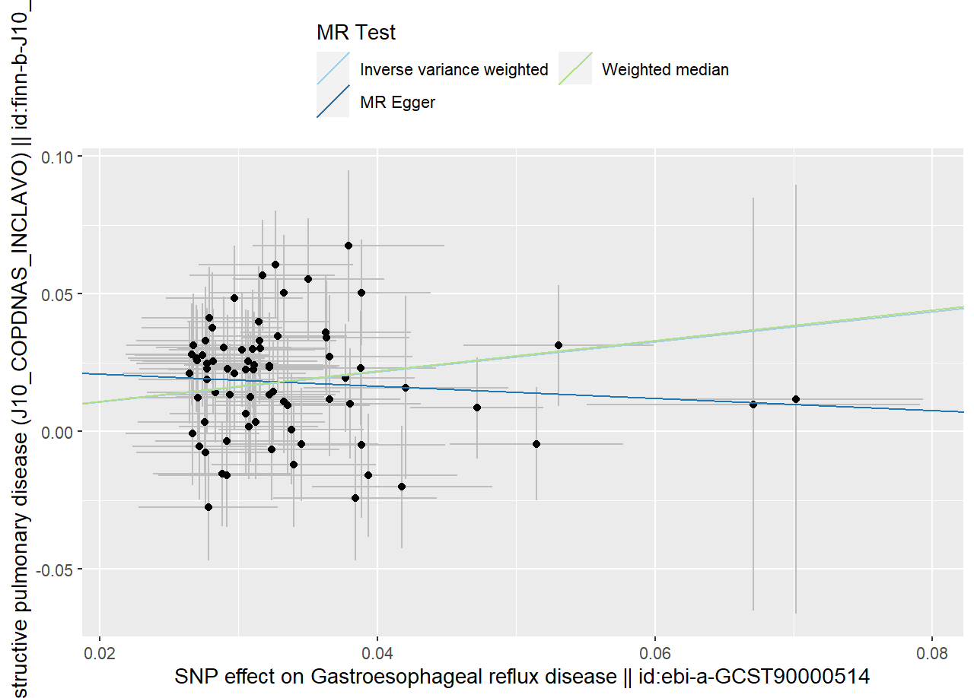
Figure S2 MR Scatter plot for the genetic association between GERD and risk of bronchitis
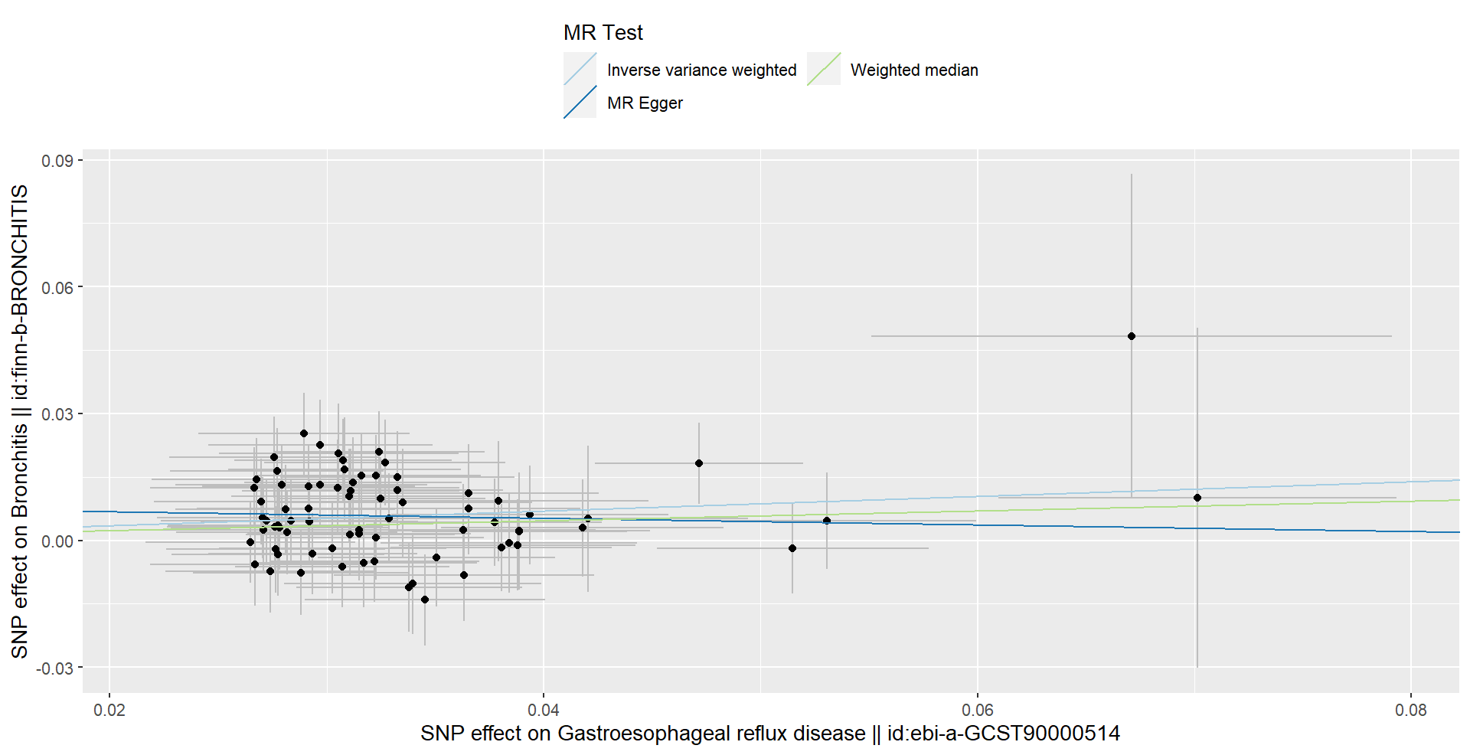

Figure S3 MR Scatter plot for the genetic association between GERD and risk of pneumonia
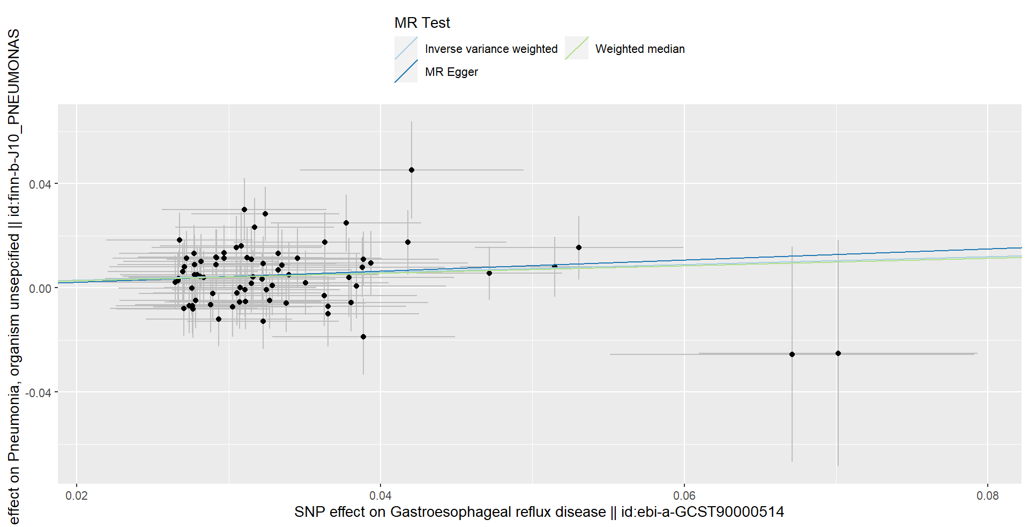

Figure S4 MR Scatter plot for the genetic association between GERD and risk of lung cancer
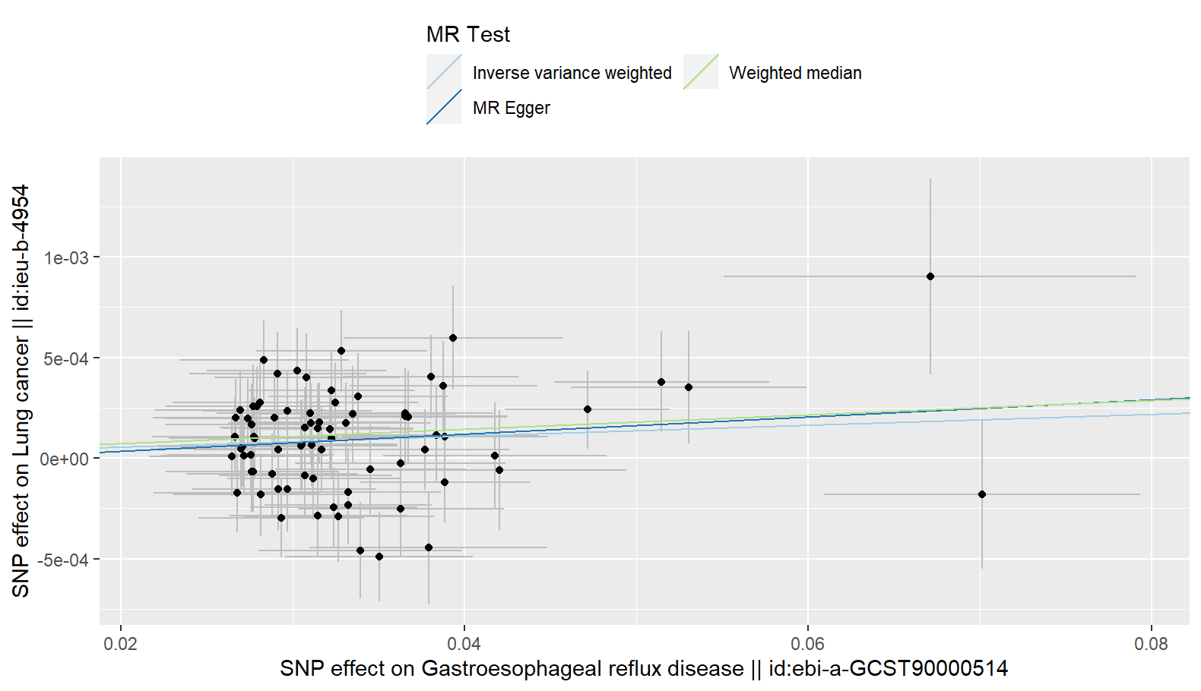

Figure S5 MR Scatter plot for the genetic association between GERD and risk of pulmonary embolism
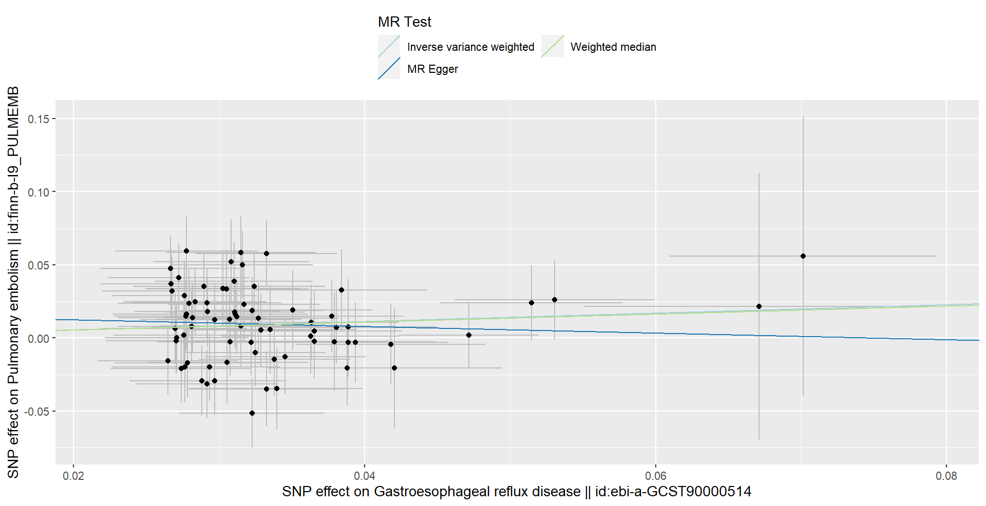

Figure S6 MR Funnel plot for the genetic association between GERD and risk of COPD
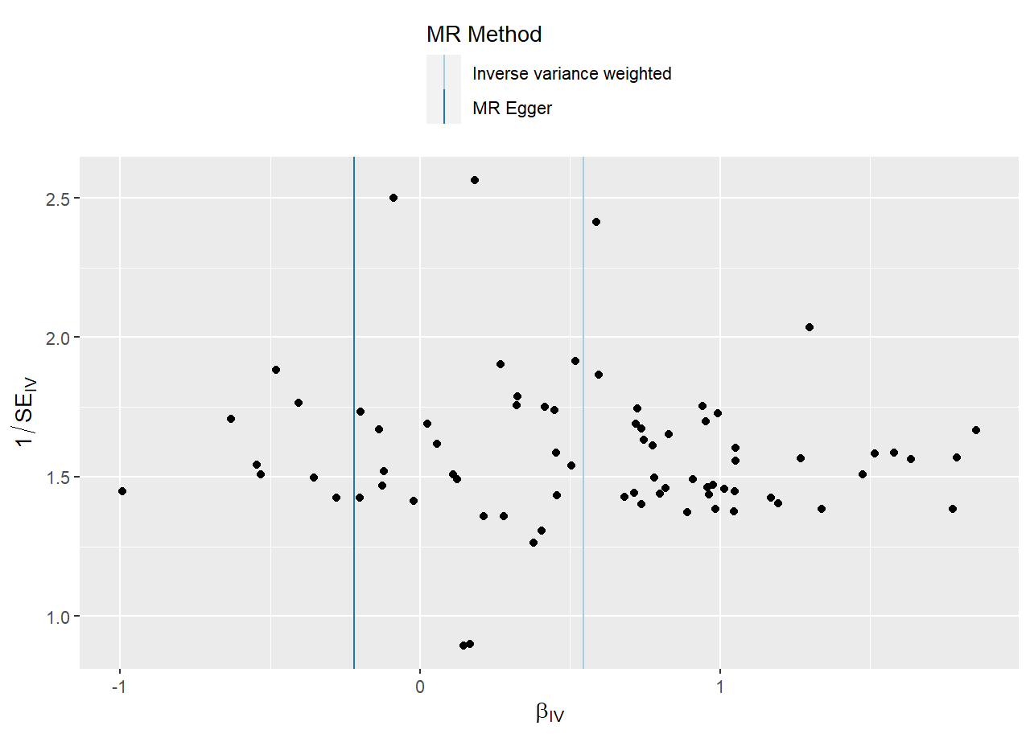

Figure S7 MR Funnel plot for the genetic association between GERD and risk of bronchitis
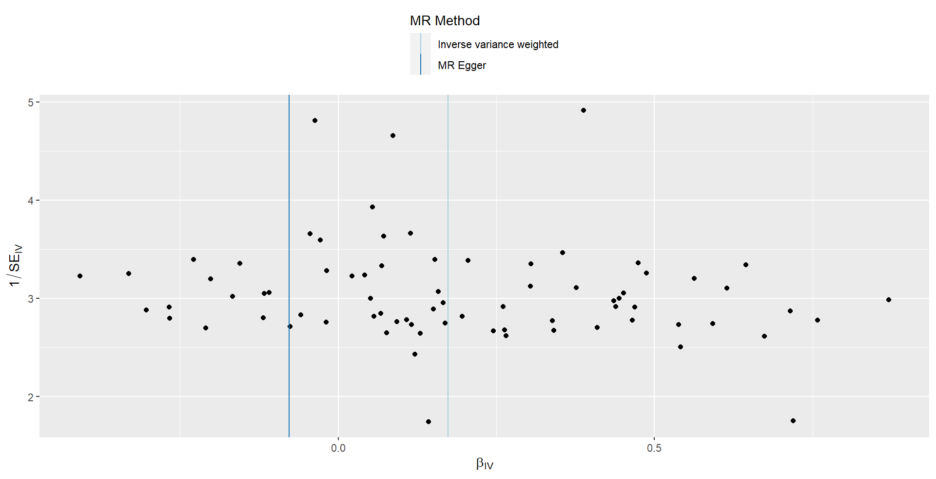

Figure S8 MR Funnel plot for the genetic association between GERD and risk of pneumonia
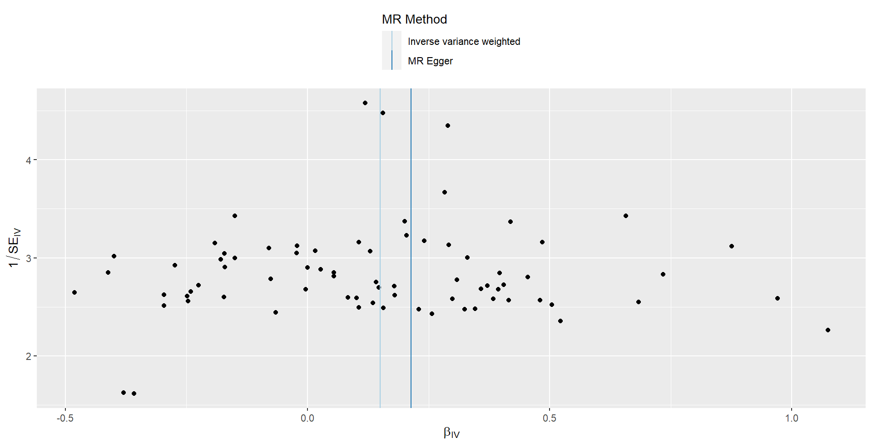

Figure S9 MR Funnel plot for the genetic association between GERD and risk of lung cancer
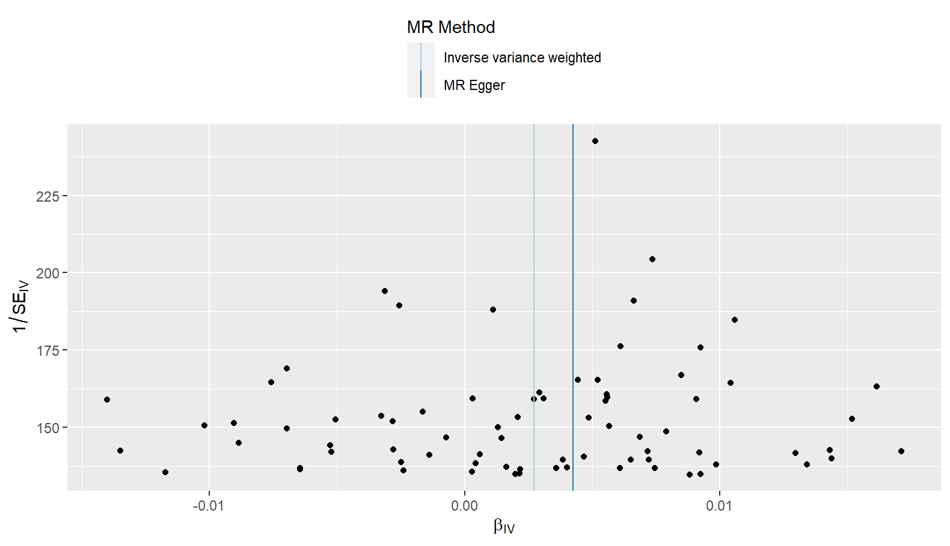

Figure S10 MR Funnel plot for the genetic association between GERD and risk of pulmonary embolism
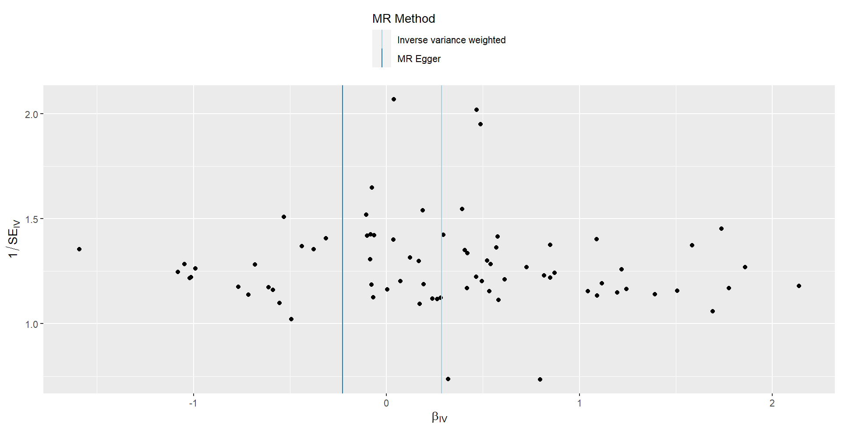

Figure S11 MR Leave-one-SNP-out plot for the genetic association between GERD and risk of COPD
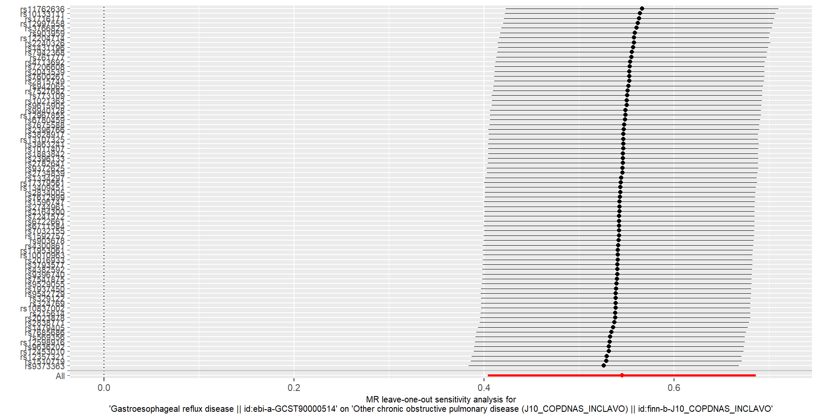

Figure S12 MR Leave-one-SNP-out plot for the genetic association between GERD and risk of bronchitis
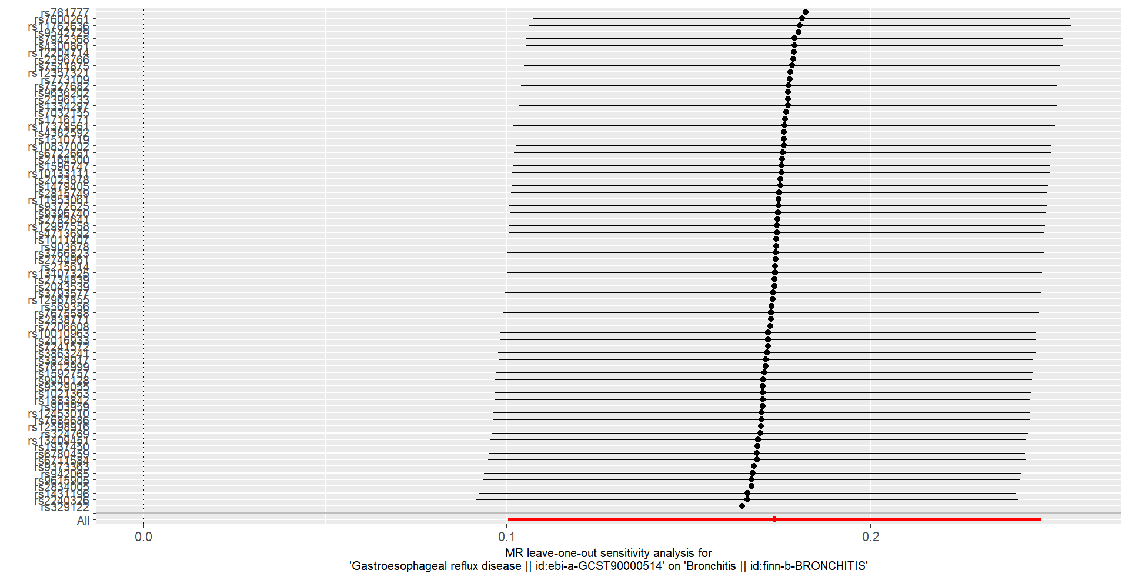

Figure S13 MR Leave-one-SNP-out plot for the genetic association between GERD and risk of pneumonia
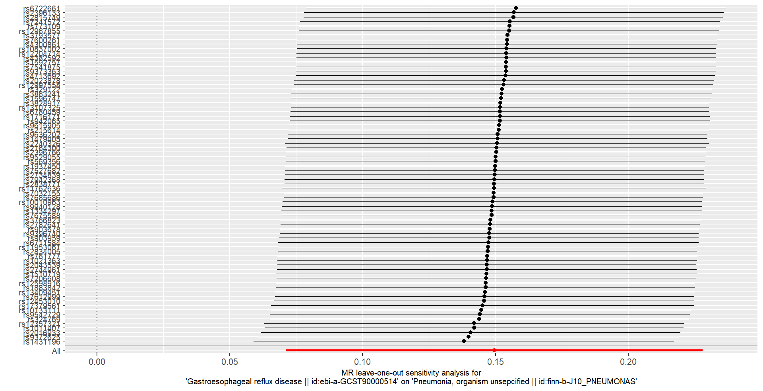

Figure S14 MR Leave-one-SNP-out plot for the genetic association between GERD and risk of lung cancer
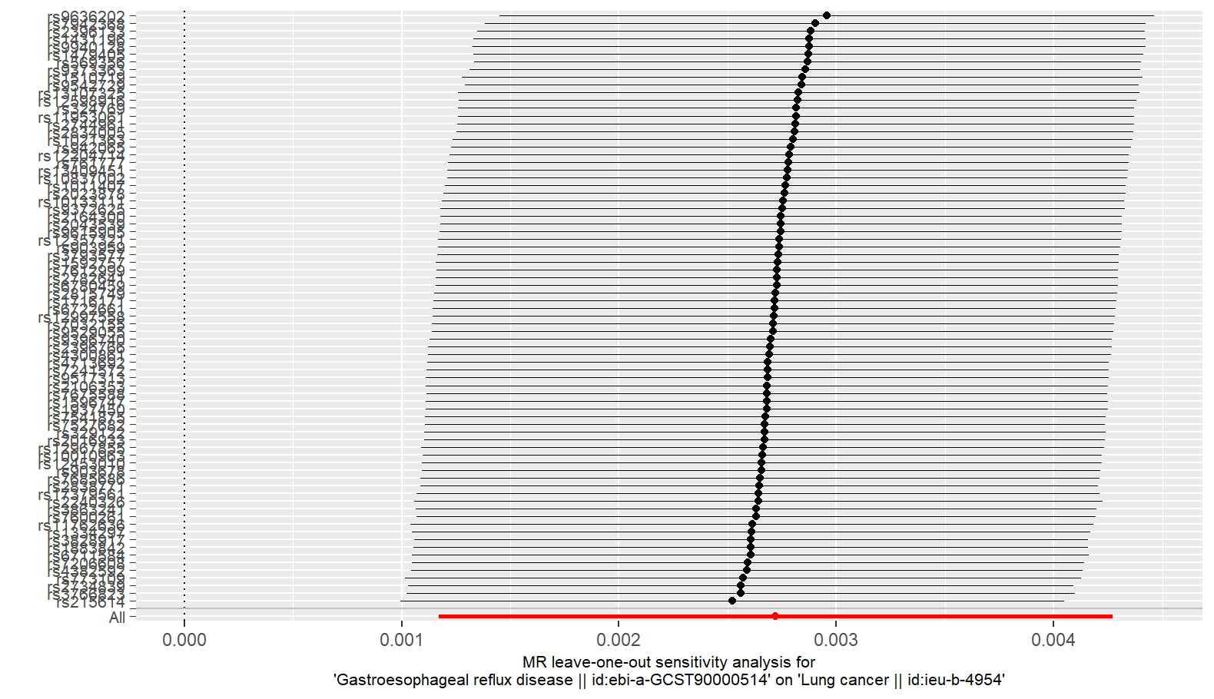

Figure S15 MR Leave-one-SNP-out plot for the genetic association between GERD and risk of pulmonary embolism
