Example of VLCKD diet therapy with meal replacement
(New Penta Srl, Cuneo, Italy)

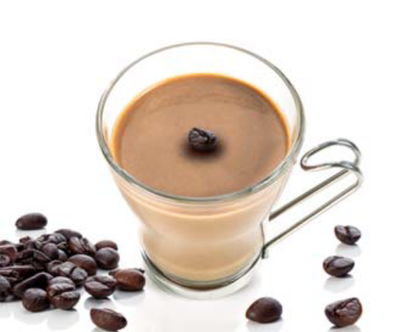
Breakfast (meal replacement, cappuccino drink)*
AVERAGE NUTRITIONAL ANALYSIS
Kcal/KJ | 91 / 386
Fat (g) | 0,5
of which saturated fatty acids (g) | 0,4
Carbohydrates (g) | 2,7
of which sugars (g) | 1,7
Fiber (g) | 1,7
Protein (g) | 18
Salt (g) | 0,33

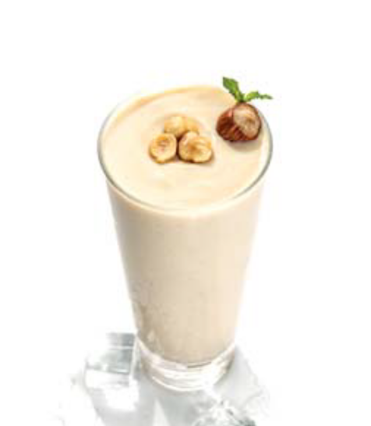
Mid-morning snack (meal replacement, milkshake-flavored drinks)*
AVERAGE NUTRITIONAL ANALYSIS
Kcal/KJ | 88 / 371
Fat (g) | 0,7
of which saturated fatty acids (g) | 0,2
Carbohydrates (g) | 1,4
of which sugars (g) | 1,1
Fiber (g) | 2,5
Protein (g) | 18
Salt (g) | 0,32

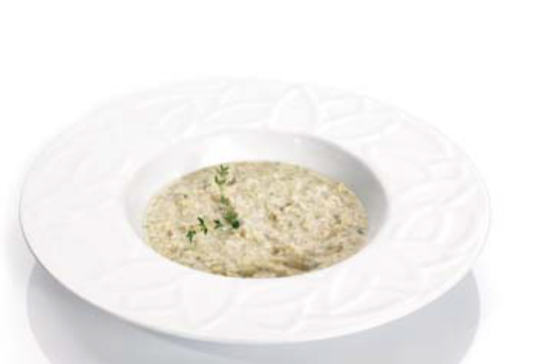
Lunch, meal replacement (protein pasta)*
AVERAGE NUTRITIONAL ANALYSIS
Kcal/KJ | 143 / 605
Fat (g) | 1,3
of which saturated fatty acids (g) | 0,9
Carbohydrates (g) | 1,6
of which sugars (g) | 1,2
Fiber (g) | 3,2
Protein (g) | 15
Salt (g) | 0,27

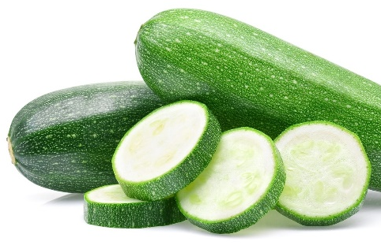
+ 200 g of low glycaemic index vegetables (e.g. courgettes)

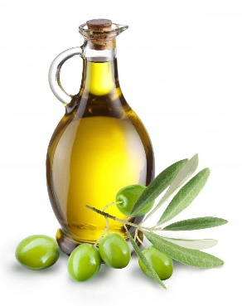

+ 15 g of extra virgin olive oil

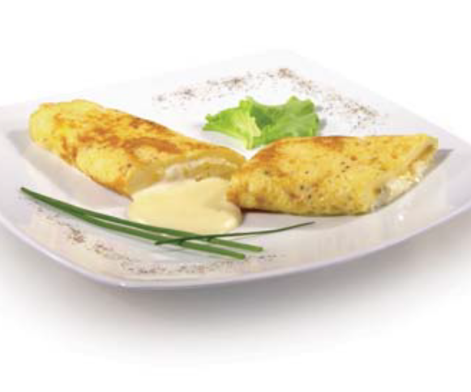
Dinner, meal replacement (type omelette)*
AVERAGE NUTRITIONAL ANALYSIS
Kcal/KJ | 113 / 476
Fat (g) | 2,6
of which saturated fatty acids (g) | 0,1
Carbohydrates (g) | 2,5
of which sugars (g) | 0,5
Fiber (g) | 0,5
Protein (g) | 20
Salt (g) | 1,4
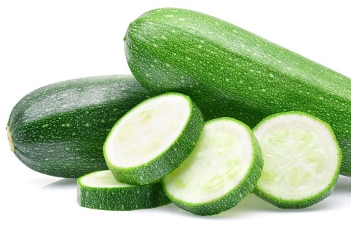
+ 200 g of low glycaemic index vegetables (e.g. courgettes)

+ 15 g of extra virgin olive oil

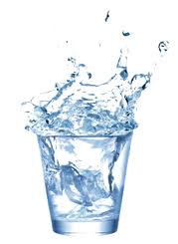
In addition:

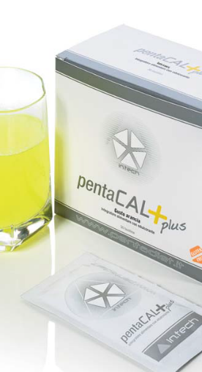
+ Drink at least 2.5 liters of water per day

+ Multivitamin and saline supplements to maintain physiological acid/base balance (PentaCal, New Penta, Srl., Cuneo, Italy) (B complex vitamins, C and E vitamins, minerals, including potassium, sodium, magnesium, calcium, and omega-3 fatty acids (250 mg/day for eicosapentaenoic acid –EPA- and docosahexaenoic acid –DHA-).

Calories and nutrients from meal replacements
Kcal/KJ | 435/1838
Fat (g) | 5,1
of which saturated fatty acids (g) | 1,6
Carbohydrates (g) | 8,2
of which sugars (g) | 4,5
Fiber (g) | 7,9
Protein (g) | 71
Salt (g) | 2,32

Calories and nutrients from EVOO and vegetables
 | EVOO  (30 g) | Vegetables (e.g. courgettes)  (200 g + 200 g)
Kcal/KJ | 269,7/1108,8 | 44/192
Fat (g) | 29,97 | 0,4
of which saturated fatty acids (g) | 0 | 0
Carbohydrates (g) | 0 | 5,6
of which sugars (g) | 0 | 0
Fiber (g) | 0 | 5,2
Protein (g) | 0 | 5,2
Salt (g) | 0 | 4

Average values of the VLCKD
Kcal/KJ | 748,7/3138,8
Fat (g) | 35,47
of which saturated fatty acids (g) | 1,6
Carbohydrates (g) | 13,8
of which sugars (g) | 4,5
Fiber (g) | 7,9
Protein (g) | 76,2
Salt (g) | 6,32

* https://pentadiet.it/prodotti

