SUPPLEMENTARY FIGURES AND TABLES

Supplementary Figure 1. Kaplan-Meier curves for progression free survival (PFS) (A) and overall survival (OS) (B) of total population and stratified by sex
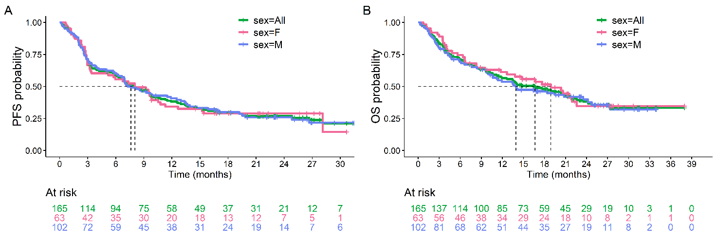

Supplementary Figure 2. Kaplan-Meier curves for progression free survival (PFS) of Melanoma patients (A) and NSCLC patients (B) of all population and stratified by sex
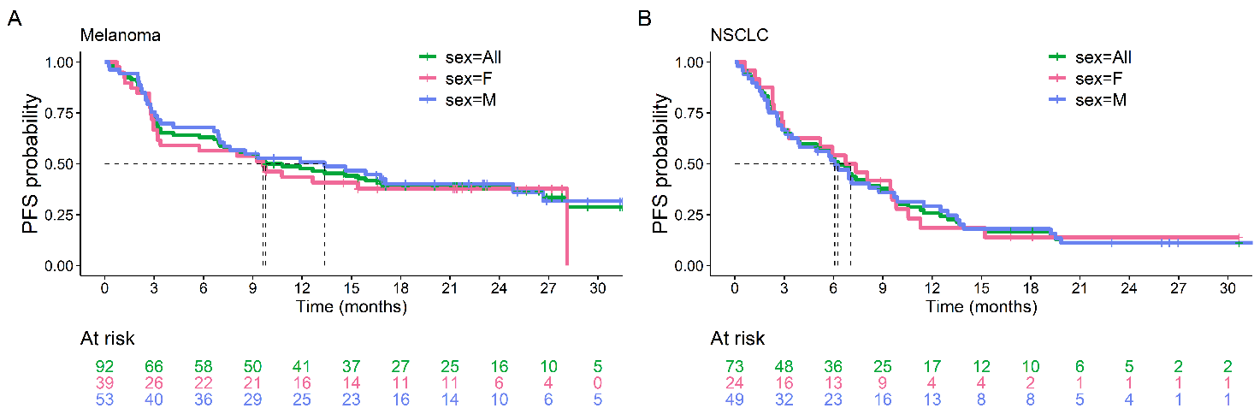

Supplementary Figure 3. Kaplan-Meier curves for overall survival (OS) of Melanoma patients (A) and NSCLC patients (B) of all population and stratified by sex
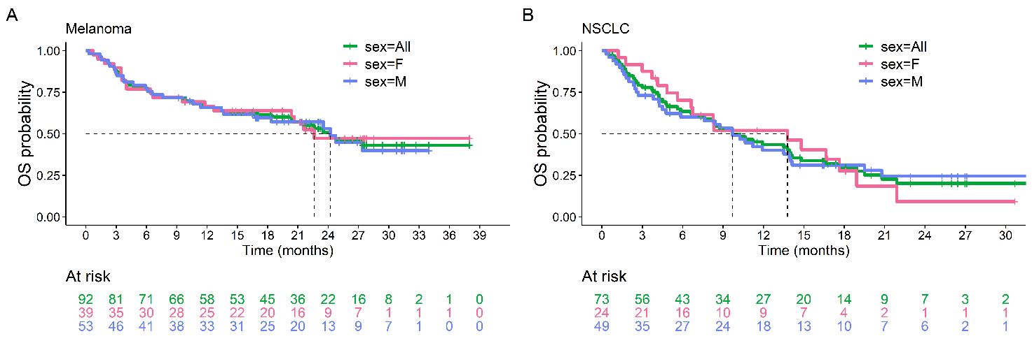
Supplementary Figure 4. Boxplot of circulating levels of biomarkers (pg/ml) in patients achieving disease control (CR/PR/SD) according to RECIST 1.1 criteria. Baseline values for the total population (A) and according to sex (B). Changes at cycle 2 from baseline values for the total population (C) and according to sex (D).
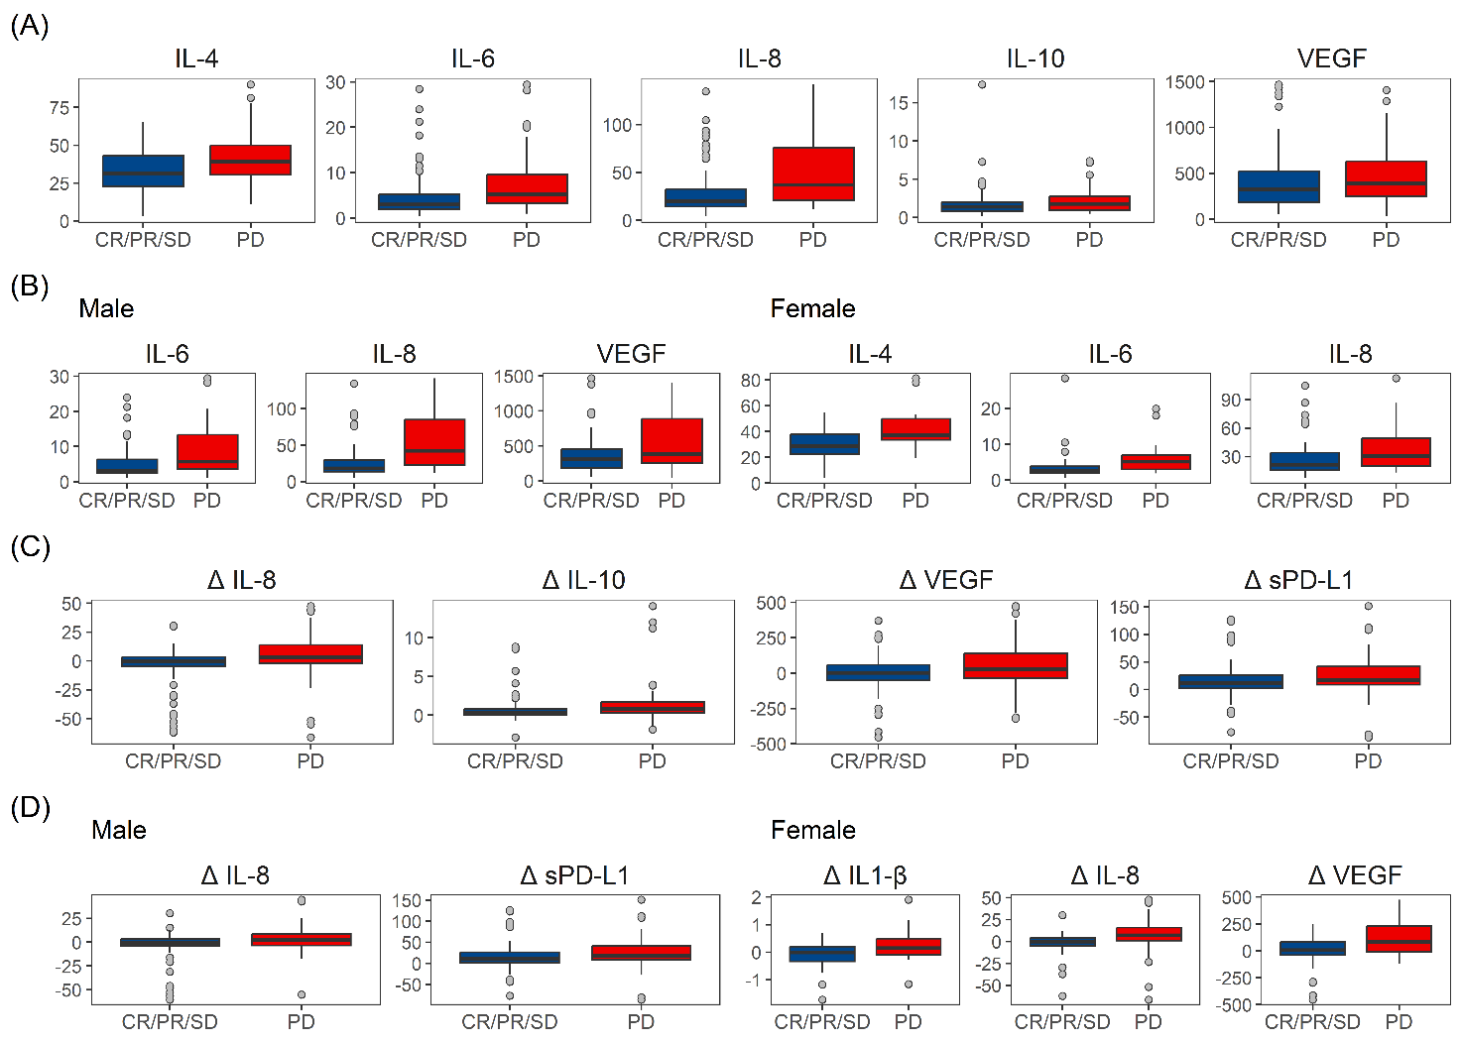

Supplementary Table 1. Italian Medicines Agency indications for Immune Checkpoint Inhibitors in Melanoma and NSCLC patients, at the time of study enrollment
ICI | Dose regimen | Timing | Treatment Line | Association with chemo | PD-L1 (TPS)
Melanoma patients
Nivolumab | 240 mg flat | Q2W | every | no | not required
Nivolumab | 480 mg flat | Q4W | every | no | not required
Pembrolizumab | 200 mg flat | Q3W | every | no | not required
NSCLC patients
Pembrolizumab | 200 mg flat | Q3W | 1st line | no | ≥50%
 | 200 mg flat | Q3W | 1st line | yes | 0-49%
 | 200 mg flat | Q3W | 2nd line | no | ≥1%
Atezolizumab | 1200 mg flat | Q3W | 1st line | no | ≥50%
 | 1200 mg flat | Q3W | 2nd line | no | ≥0% or ND
Nivolumab | 240 mg flat | Q2W | 2nd line | no | ≥0% or ND
 | 480 mg flat | Q4W | 2nd line | no | ≥0% or ND
Abbreviations:
Chemo, Chemotherapy; ICI, Immune Checkpoint Inhibitor; ND, Not Determined; NSCLC, Non-Small Cell Lung Cancer; PD-L1, Programmed Death - Ligand 1; Q2W, every 2 weeks; Q3W, every 3 weeks; Q4W, every 4 weeks; TPS, Tumor Proportion Score

Supplementary Table 2. Patient characteristics for the melanoma study population
Melanoma patients |  | Male (N=53) | Female (N=39) | Total (N=92) | p value
Age | Median (Q1, Q3) | 73.0 (56.0, 78.0) | 67.0 (55.5, 80.0) | 71.0 (56.0, 78.2) | 0.6550
ECOG Performance Status | N-Miss
 | 0 | 39 (73.6%) | 27 (69.2%) | 66 (71.7%) | 0.7060
 | 1 | 12 (22.6%) | 9 (23.1%) | 21 (22.8%)
 | 2 | 2 (3.8%) | 3 (7.7%) | 5 (5.4%)
Prior systemic treatment | N-Miss |  | 1 | 1
 | No | 48 (90.6%) | 32 (84.2%) | 80 (87.9%) | 0.3590
 | Yes | 5 (9.4%) | 6 (15.8%) | 11 (12.1%)
Current stage | N-Miss
 | III | 8 (15.1%) | 6 (15.4%) | 14 (15.2%) | 0.9690
 | IV | 45 (84.9%) | 33 (84.6%) | 78 (84.8%)
Treatment | Nivolumab | 41 (77.4%) | 31 (79.5%) | 72 (78.3%) | 0.8070
 | Pembrolizumab | 12 (22.6%) | 8 (20.5%) | 20 (21.7%)
RECIST | CR | 8 (15.1%) | 4 (10.3%) | 12 (13.0%) | 0.4030
 | PR | 19 (35.8%) | 9 (23.1%) | 28 (30.4%)
 | SD | 8 (15.1%) | 9 (23.1%) | 17 (18.5%)
 | PD | 18 (34.0%) | 17 (43.6%) | 35 (38.0%)
Progression of disease | No | 22 (41.5%) | 14 (35.9%) | 36 (39.1%) | 0.5860
 | Yes | 31 (58.5%) | 25 (64.1%) | 56 (60.9%)
Progression free survival (months) | Median (95%CI) | 13.4 (6.9,26.7) | 9.6 (3.0,-) | 9.8 (6.9,17.1) | 0.6215
Status | Alive | 27 (50.9%) | 21 (53.8%) | 48 (52.2%) | 0.7830
 | Death | 26 (49.1%) | 18 (46.2%) | 44 (47.8%)
Overall survival (months) | Median (95%CI) | 24.2 (13.4,-) | 22.6 (11.8,-) | 24.2 (18.4,-) | 0.8458
Follow-up (months) | Median (Q1, Q3) | 23.1 (18.9,31.3) | 22.3 (19.5,27.6) | 23.1 (18.9,28.5)

Supplementary Table 3. Patient characteristics for the NSCLC study population
NSCLC patients |  | Male (N=45) | Female (N=24) | Total (N=69) | p value
Age | Median (Q1, Q3) | 72.0 (65.0, 76.0) | 67.0 (63.0, 71.5) | 70.0 (65.0, 75.0) | 0.0690
ECOG Performance Status | N-Miss | 0 | 1 | 1 | 0.3010
 | 0 | 13 (28.9%) | 6 (26.1%) | 19 (27.9%)
 | 1 | 28 (62.2%) | 17 (73.9%) | 45 (66.2%)
 | 2 | 4 (8.9%) | 0 (0.0%) | 4 (5.9%)
Prior systemic treatment | N-Miss
 | No | 36 (80.0%) | 19 (79.2%) | 55 (79.7%) | 0.9350
 | Yes | 9 (20.0%) | 5 (20.8%) | 14 (20.3%)
Current stage | N-Miss | 2 |  | 2
 | III | 3 (7.0%) | 1 (4.2%) | 4 (6.0%) | 0.6420
 | IV | 40 (93.0%) | 23 (95.8%) | 63 (94.0%)
Treatment | Nivolumab | 5 (11.1%) | 2 (8.3%) | 7 (10.1%) | 0.5180
 | Pembrolizumab | 18 (40.0%) | 14 (58.3%) | 32 (46.4%)
 | Atezolizumab | 4 (8.9%) | 2 (8.3%) | 6 (8.7%)
 | Chemo-immuno | 18 (40.0%) | 6 (25.0%) | 24 (34.8%)
RECIST | PR | 15 (33.3%) | 5 (20.8%) | 20 (29.0%) | 0.4470
 | SD | 13 (28.9%) | 10 (41.7%) | 23 (33.3%)
 | PD | 17 (37.8%) | 9 (37.5%) | 26 (37.7%)
Progression of disease | No | 11 (24.4%) | 4 (16.7%) | 15 (21.7%) | 0.4560
 | Yes | 34 (75.6%) | 20 (83.3%) | 54 (78.3%)
Progression free survival (months) | Median (95%CI) | 6.1 (3.1,8.8) | 7.1 (2.9,9.8) | 6.3 (3.8,8.8) | 0.9976
Status | Alive | 14 (31.1%) | 7 (29.2%) | 21 (30.4%) | 0.8670
 | Death | 31 (68.9%) | 17 (70.8%) | 48 (69.6%)
Overall survival (months) | Median (95%CI) | 9.7 (4.5,13.9) | 13.8 (5.6,17.6) | 9.7 (6.6,14.0) | 0.9607
Follow-up | Median (Q1, Q3) | 22.9 (16.5,26.5) | 18.1 (11.5,--) | 22.9 (16.5,27.0)

Supplementary Table 4. Baseline levels of biomarkers (pg/ml) according to sex
Baseline marker levels | Male (N=98) | Female (N=63) | Total (N=161) | p value
MCP-1 | 432.5 (334.8, 540.8) | 454.0 (383.0, 546.0) | 448.0 (338.0, 545.0) | 0.5930
IP-10 | 170.5 (116.5, 244.0) | 209.0 (132.5, 324.0) | 177.0 (120.0, 280.0) | 0.0820
GM-CSF | 3.3 (2.0, 6.1) | 3.1 (1.9, 6.4) | 3.1 (1.9, 6.3) | 0.9100
IL-1β | 1.0 (0.7, 1.7) | 1.0 (0.6, 1.4) | 1.0 (0.7, 1.6) | 0.5200
IL-2 | 2.1 (1.4, 4.2) | 1.8 (1.3, 3.8) | 2.1 (1.4, 4.0) | 0.2940
IL-4 | 37.6 (24.9, 46.4) | 35.2 (25.4, 45.0) | 35.7 (25.3, 45.7) | 0.6330
IL-5 | 0.7 (0.4, 1.3) | 0.7 (0.4, 1.2) | 0.7 (0.4, 1.2) | 0.4920
IL-6 | 4.3 (2.8, 10.0) | 3.3 (2.1, 5.5) | 3.9 (2.5, 7.8) | 0.0250
IL-8 | 23.4 (15.2, 50.9) | 25.6 (18.1, 44.9) | 24.0 (15.9, 46.8) | 0.4110
IL-10 | 1.6 (1.0, 2.2) | 1.4 (0.8, 2.0) | 1.5 (0.9, 2.2) | 0.4130
TNF-α | 19.0 (15.7, 22.1) | 17.7 (15.3, 21.3) | 18.0 (15.7, 21.9) | 0.3660
VEGF | 328.5 (217.2, 545.0) | 427.0 (247.5, 599.0) | 371.0 (225.0, 578.0) | 0.3000
sPD-L1 | 97.1 (82.0, 118.5) | 92.6 (75.3, 111.0) | 94.5 (78.9, 117.0) | 0.2100

Supplementary Table 5. Baseline levels of biomarkers (pg/ml) according to diagnosis
Baseline marker levels | Melanoma (N=92) | NSCLC (N=69) | Total (N=161) | p value
MCP-1 | 443.5 (362.5, 524.0) | 454.0 (327.0, 590.0) | 448.0 (338.0, 545.0) | 0.7570
IP-10 | 173.0 (121.0, 280.0) | 188.0 (120.0, 279.0) | 177.0 (120.0, 280.0) | 0.8640
GM-CSF | 2.9 (1.9, 6.0) | 3.8 (1.8, 6.5) | 3.1 (1.9, 6.3) | 0.2990
IL-1β | 1.0 (0.7, 1.5) | 1.1 (0.6, 1.7) | 1.0 (0.7, 1.6) | 0.3030
IL-2 | 2.1 (1.4, 3.7) | 2.2 (1.3, 4.0) | 2.1 (1.4, 4.0) | 0.5340
IL-4 | 35.9 (26.1, 45.2) | 35.7 (25.2, 46.6) | 35.7 (25.3, 45.7) | 0.8750
IL-5 | 0.8 (0.5, 1.3) | 0.7 (0.4, 1.2) | 0.7 (0.4, 1.2) | 0.5940
IL-6 | 3.0 (2.0, 5.0) | 6.2 (3.2, 13.0) | 3.9 (2.5, 7.8) | < 0.001
IL-8 | 20.9 (15.4, 38.9) | 29.9 (19.7, 57.8) | 24.0 (15.9, 46.8) | 0.0190
IL-10 | 1.5 (1.0, 2.0) | 1.5 (0.8, 2.6) | 1.5 (0.9, 2.2) | 0.4610
TNF-α | 17.6 (15.4, 21.4) | 19.0 (15.8, 22.5) | 18.0 (15.7, 21.9) | 0.2930
VEGF | 332.0 (197.0, 558.2) | 396.0 (239.0, 674.0) | 371.0 (225.0, 578.0) | 0.1740
sPD-L1 | 89.4 (74.9, 111.8) | 104.0 (85.3, 123.0) | 94.5 (78.9, 117.0) | 0.0060

Supplementary Table 6. Multiple logistic regression predicting the objective response rate for biomarkers baseline levels (pg/ml) (A), and variation between cycle 2 and baseline (B)
A | Sex | Baseline marker levels | cut-off |  | OR (95%CI) | P value | P value interaction
 |  | IL-6 | 5.29 | low | Ref
 |  |  |  | high | 0.37 (0.17,0.81) | 0.0134
 | M | TNF-α | 19.75 | low | Ref |  | 0.0386
 |  |  |  | high | 1.57 (0.66,3.77) | 0.3111
 | F | TNF-α |  | low | Ref
 |  |  |  | high | 0.23 (0.05,1.16) | 0.0747
B |  | Δ of cycle 2 marker levels from baseline | cut-off |  | OR (95%CI) | P value
 |  | IL-8 | 3.23 | decrease | ref
 |  |  |  | increase | 0.36 (0.17,0.77) | 0.0086
 |  | VEGF | 45.00 | decrease | ref
 |  |  |  | increase | 0.32 (0.15,0.69) | 0.0040

Supplementary Table 7. Multiple logistic regression predicting disease control rate of biomarkers baseline levels (pg/ml) (A), and variation between cycle 2 and baseline (B)
A | Sex | Baseline marker levels | cut-off |  | OR (95%CI) | P value
 |  | IL-6 | 3.04 | low | Ref
 |  |  |  | high | 0.30 [0.14;0.66] | 0.0026
 |  | IL-8 | 19.86 | low | Ref
 |  |  |  | high | 0.30 [0.14;0.66] | 0.0026
B |  | Δ of cycle 2 marker levels from baseline | cut-off |  | OR (95%CI) | P value
 |  | sPD-L1 | 6.4 | decrease | Ref
 |  |  |  | increase | 0.40 [0.19,0.85] | 0.0180

Supplementary Table 8. Multiple Cox regression predicting the progression free survival (PFS) for biomarkers baseline levels (pg/ml) (A), and variation between cycle 2 and baseline (B)
A | Sex | Baseline marker levels | cut-off |  | PFS HR (95%CI) | P value | P value interaction
 |  | MCP-1 | 365 | low | Ref
 |  |  |  | high | 0.43 (0.28,0.66) | 0.0001
 |  | IL-5 | 1.07 | low | Ref
 |  |  |  | high | 0.39 (0.25,0.60) | 0.0001
 |  | IL-8 | 34.1 | low | Ref
 |  |  |  | high | 2.93 (1.77,4.84) | 0.0001
 | M | IL-4 | 28.6 | low | Ref |  | 0.0002
 |  |  |  | high | 0.98 (0.59,1.62) | 0.9339
 | F | IL-4 |  | low | Ref
 |  |  |  | high | 7.35 (2.95,18.28) | 0.0001
 | M | IL-6 | 2.97 | low | Ref |  | 0.0067
 |  |  |  | high | 4.45 (2.35,8.44) | 0.0001
 | F | IL-6 |  | low | Ref
 |  |  |  | high | 1.03 (0.45,2.36) | 0.9515
 | M | IL-10 | 1.43 | low | Ref |  | 0.0239
 |  |  |  | high | 0.92 (0.55,1.55) | 0.7635
 | F | IL-10 |  | low | Ref
 |  |  |  | high | 2.62 (1.24,5.55) | 0.0115
 | M | sPD-L1 | 111 | low | Ref |  | 0.0022
 |  |  |  | high | 0.69 (0.39,1.22) | 0.2063
 | F | sPD-L1 |  | low | Ref
 |  |  |  | high | 3.12 (1.37,7.13) | 0.0070
B | Sex | Δ of cycle 2 marker levels from baseline | cut-off |  | PFS HR (95%CI) | P value
 |  | IL-8 | 4.63 | decrease | Ref
 |  |  |  | increase | 2.18 (1.44,3.31) | 0.0001
 |  | TNF-α | 2.92 | decrease | Ref
 |  |  |  | increase | 0.59 (0.38,0.90) | 0.0144
 |  | VEGF | 69 | decrease | ref
 |  |  |  | increase | 2.43 (1.63,3.62) | 0.0001

Supplementary Table 9. Multiple Cox regression predicting the overall survival (OS) for biomarkers baseline levels (pg/ml) (A), and variation between cycle 2 and baseline (B)
A | Sex | Baseline marker levels | cut-off |  | OS HR (95%CI) | P value | P value interaction
 |  | MCP-1 | 365 | low | Ref
 |  |  |  | high | 0.52 (0.34,0.82) | 0.0043
 |  | IL-6 | 2.9 | low | Ref
 |  |  |  | high | 4.35 (2.55,7.41) | 0.0001
 |  | IL-8 | 34.12 | low | Ref
 |  |  |  | high | 3.13 (1.99,4.94) | 0.0001
 | M | GM-CSF | 4.03 | low | Ref |  | 0.0139
 |  |  |  | high | 0.24 (0.12,0.47) | 0.0001
 | F | GM-CSF |  | low | Ref
 |  |  |  | high | 0.81 (0.40,1.63) | 0.5598
 | M | IL-1β | 1.22 | low | Ref |  | 0.0013
 |  |  |  | high | 2.57 (1.37,4.82) | 0.0032
 | F | IL-1β |  | low | Ref
 |  |  |  | high | 0.53 (0.25,1.11) | 0.0918
B | Sex | Δ of cycle 2 marker levels from baseline | cut-off |  | OS HR (95%CI) | P value
 |  | IL-4 | 0.88 | decrease | Ref
 |  |  |  | increase | 1.92 (1.21,3.06) | 0.0060
 |  | IL-5 | 0.06 | decrease | Ref
 |  |  |  | increase | 0.47 (0.30,0.76) | 0.0018
 |  | IL-8 | 4.63 | decrease | Ref
 |  |  |  | increase | 2.24 (1.43,3.52) | 0.0001
 |  | VEGF | 69 | decrease | Ref
 |  |  |  | increase | 2.20 (1.40,3.46) | 0.0001

