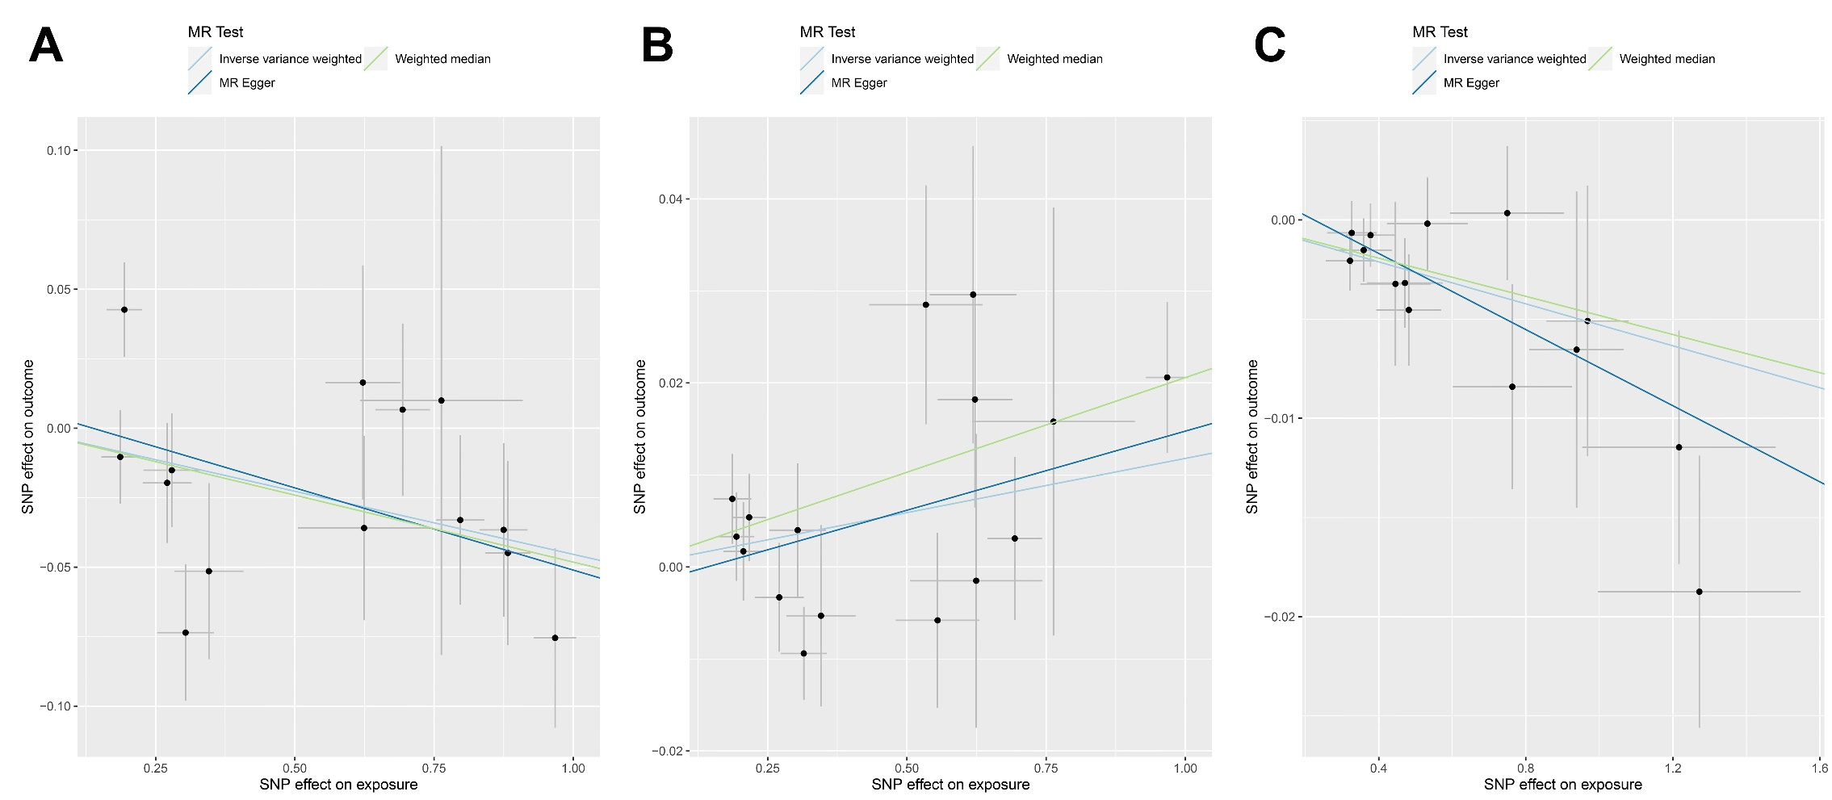
Fig. S1 Scatter plots. (A) genetically predicted primary sclerosing cholangitis on forearm bone mineral density; (B) genetically predicted primary sclerosing cholangitis on any site osteoarthritis; (C) genetically predicted hepatocellular carcinoma on grip strength.

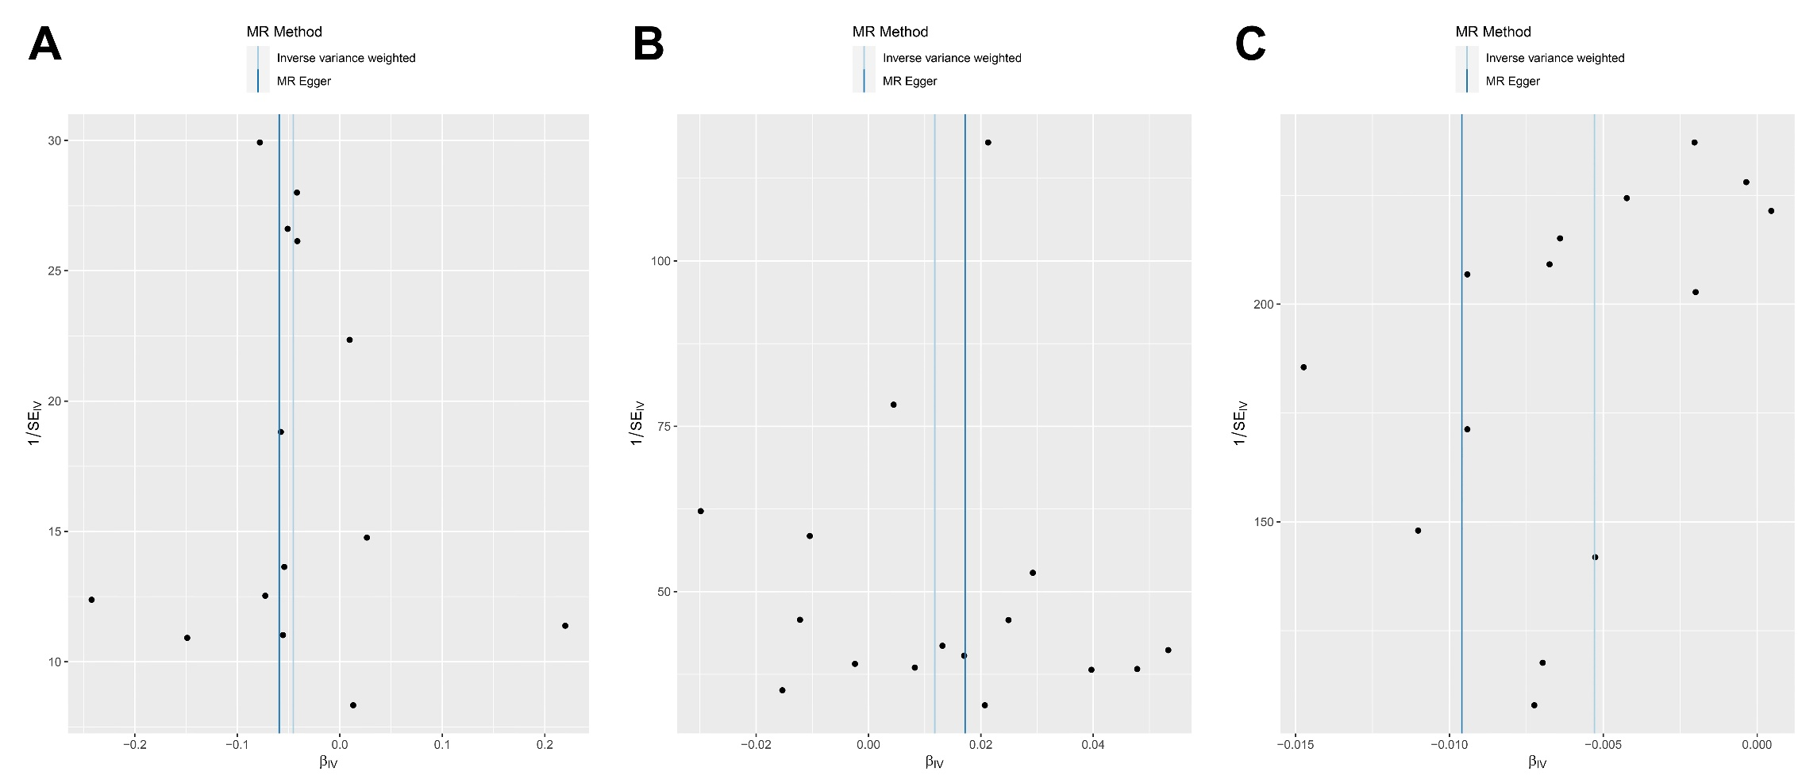
Fig. S2 Funnel plots. (A) genetically predicted primary sclerosing cholangitis on forearm bone mineral density; (B) genetically predicted primary sclerosing cholangitis on any site osteoarthritis; (C) genetically predicted hepatocellular carcinoma on grip strength.

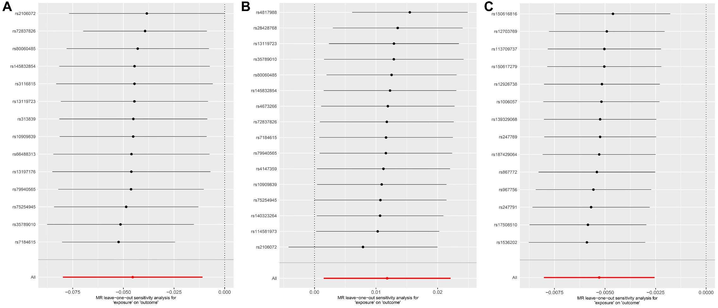
Fig. S3 Leave-one-out analyses. (A) genetically predicted primary sclerosing cholangitis on forearm bone mineral density; (B) genetically predicted primary sclerosing cholangitis on any site osteoarthritis; (C) genetically predicted hepatocellular carcinoma on grip strength.

