Table S1
ZNP1
Xhol-ZBP1-F: | ATACTCGAGCG-ATGGCCCAGGCTCCTGCTGACCCGG
Notl-ANKRD22-R: | ATAGCGGCCGC- CCAAGCCCCACGTGAGGCTGTGCAC
Promoter-U
cctctgggtg ggggcaaagg gtagggatgg ggagtggggg gattctgccc tccaagggga
aagggttgct tccagacccc cacagtccac ctttaCGgcC Gtcctgagaa tgaggacacc
tggatcaaag ctctcctgat ttccctgtac tctgatactt tctacctcat tttaaagttt aatttaattt ttatttttct a
Promoter-M
cctctgggtg ggggcaaagg gtagggatgg ggagtggggg gattctgccc tccaagggga
aagggttgct tccagacccc cacagtccac ctttaCmGgcCm Gtcctgagaa tgaggacacc
tggatcaaag ctctcctgat ttccctgtac tctgatactt tctacctcat tttaaagttt aatttaattt ttatttttct a

Table S2
shZNP1-1
top | CACCGGGCGGGACTGATCCTGAAGGCGAACCTTCAGGATCAGTCCCGCCC
bottom | AAAAGGGCGGGACTGATCCTGAAGGTTCGCCTTCAGGATCAGTCCCGCCC
shZNP1-2
top | CACCGCAACATGCAGCTACAATTCCCGAAGGAATTGTAGCTGCATGTTGC
bottom | AAAAGCAACATGCAGCTACAATTCCTTCGGGAATTGTAGCTGCATGTTGC
shZNP1-3
top | CACCGCAGGCACCTTCTGGACATGGCGAACCATGTCCAGAAGGTGCCTGC
bottom | AAAAGCAGGCACCTTCTGGACATGGTTCGCCATGTCCAGAAGGTGCCTGC

Table S3 PCR primers
cg09897064 Methylation
F | GGGTGGGGGTAAAGGGTA
R | CCTCATTCTCAAAACGACCG

Table S4 Patients’ basic information
Patient | ID | Age | Male | TNM stage
1 | 308253 | 78 | Male | T3N2M1c，IVB
2 | 435283 | 69 | Female | T2bN3M1c,IVB
3 | 436191 | 71 | Female | T3N2M1a，IVA
4 | 434326 | 46 | Female | T4N3M1c，IVB
5 | 321257 | 62 | Male | T3N2M1c，IVB
6 | 436179 | 69 | Male | T1aN0M0，IA1
7 | 439347 | 73 | Female | T2N3M1c，IVB
8 | 439087 | 66 | Female | T1bN2M1c，IVB
9 | 441176 | 62 | Female | T4N3M1c，IVB
10 | 408443 | 88 | Female | T3N2M1a，IVA
11 | 245271 | 69 | Female | T4N0M1a，IVA
12 | 439234 | 59 | Male | T1aN0M0，IA1
13 | 442409 | 60 | Female | T2bN2M1a，IVA
14 | 394460 | 62 | Male | T1bN0M0，IA2
15 | 039407 | 77 | Female | T1bN0M0，IA2
16 | 447088 | 71 | Male | T4N3M1c，IVB
17 | 447612 | 75 | Female | T4N3M1c，IVB
18 | 447325 | 82 | Male | T4N2M1b，IVA
19 | 447231 | 75 | Female | T4N0M0，IIIA
20 | 448993 | 52 | Female | T3N2M1b，IVA
21 | 106259 | 63 | Male | T1bN0M0，IA

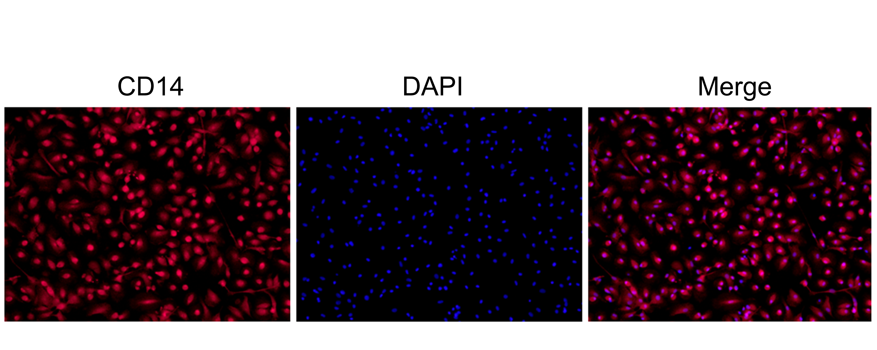
Figure S1. The immunofluorescence staining for validation of CD14⁺ cell

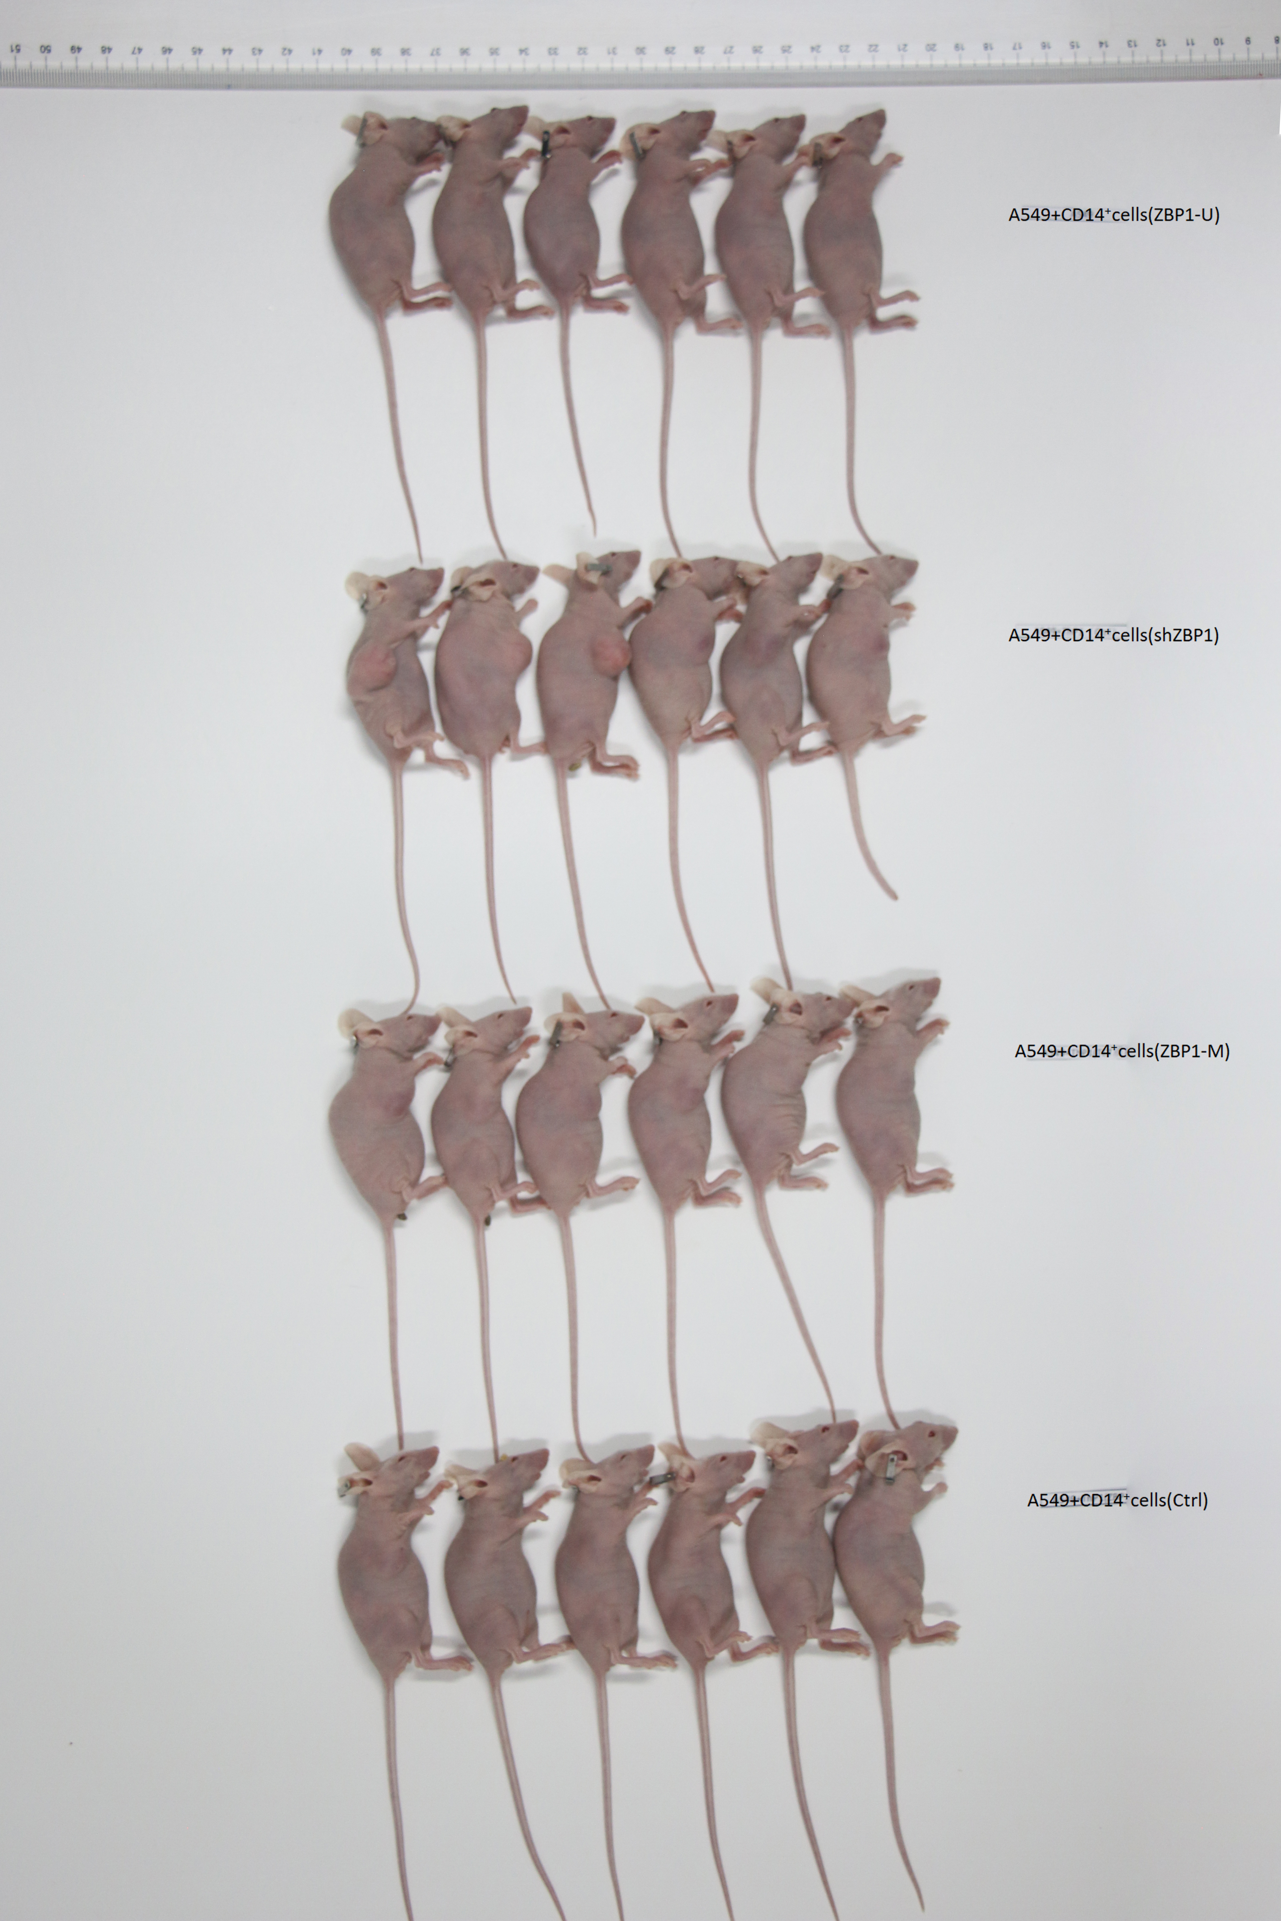
Figure S2. The body weight of the each mice
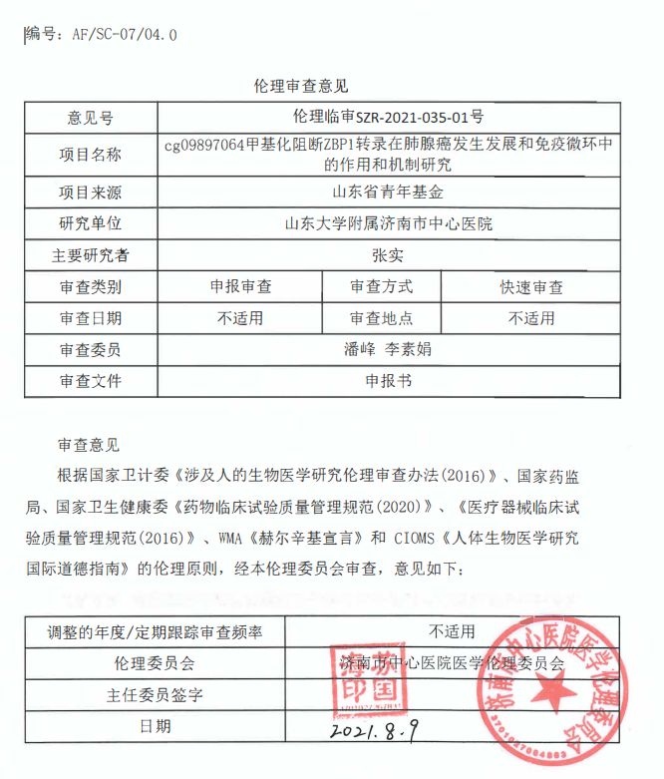
Figure S3. The Ethics approval and consent for investigation on human CD14⁺ cells

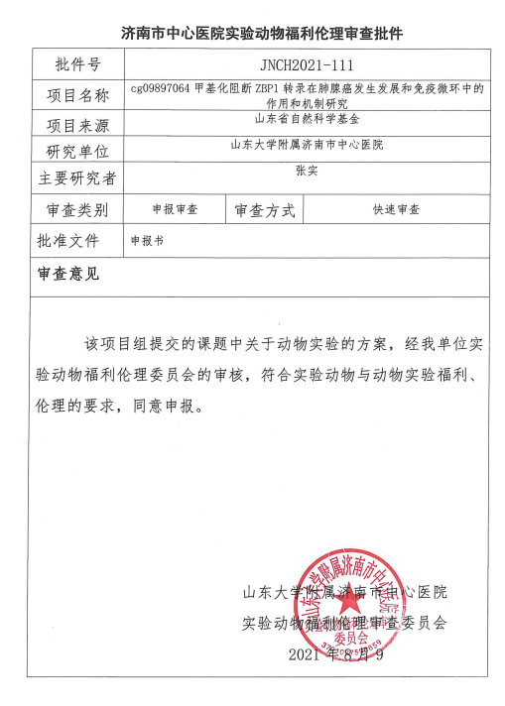
Figure S4. The Ethics approval and consent for animal experiments

