Rab32 facilitates Schwann cell pyroptosis in rats following peripheral nerve injury by elevating ROS levels
Jiayi Wang^{†1}, Pin Chen^{†3}, Guanjie Han^{†1}, Yongjie Zhou^{†4}, Xingdong Xiang⁵, Mengxuan Bian¹, Lei Huang¹, Xiang Wang*^{6,7}, Binfeng He*^{8,9}, Shunyi Lu*^{1,2}
¹ Department of Orthopedic Surgery, Zhongshan Hospital, Fudan University, Shanghai, China.
² Department of Orthopedic Surgery, The First Affiliated Hospital of Soochow University, Suzhou, Jiangsu, China.
³ Department of Neurosurgery, Zhongshan Hospital, Fudan University, Shanghai, China.
⁴ Department of Interventional Radiology, Zhongshan Hospital, Fudan University, Shanghai, China.
⁵ Department of Rehabilitation, Zhongshan Hospital, Fudan University, Shanghai, China.
⁶ Department of Cardiology, The First Affiliated Hospital of Nanchang University, Nanchang, Jiangxi Province, China.
⁷ Department of Cardiology, Zhongshan Hospital, Fudan University, Shanghai, China.
⁸ Department of Pulmonary and Critical Care Medicine, Zhongshan Hospital, Fudan University, Shanghai, China.
⁹ Department of Genel Practice, Xinqiao Hospital, Third Military Medical University, Chongqing, China
† Contributed equally.
Correspondence should be addressed to Binfeng He: ldhbf@126.com
Figure S1. The protective effect of Rab32 knockdown on mitochondria. (A) Representative transmission electron microscope image showing mitochondria morphological changes accompanying Schwann cell pyroptosis induced by LPS/ATP. Scale bar = 2 µm. (B) Quantitative data of the average number of mitochondria per unit area. (C) Quantitative data of the average volume of mitochondria per unit area. **p < 0.01 compared to the LA/shRab32 group. *p < 0.05 compared to the LA/shRab32 group.

Figure S2. Quantification of LDH release indicating Schwann cell damage. **p < 0.01 compared to the LA group. *p < 0.05 compared to the LA group.

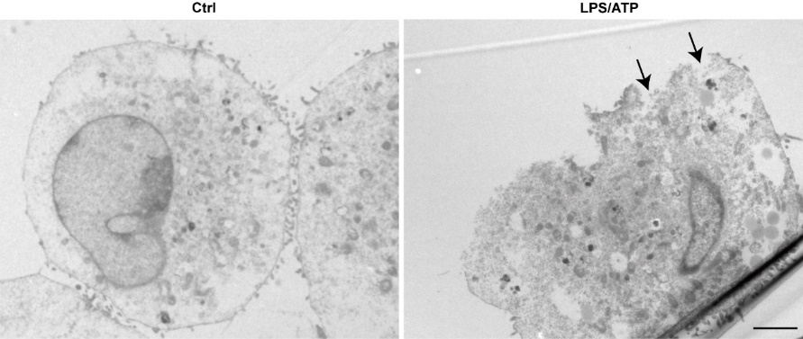
Figure S3. Representative transmission electron microscope image showing morphological changes accompanying Schwann cell pyroptosis induced by LPS/ATP. The black arrows represent the pores on the cell membrane, which is also one of the characteristic signs of pyroptosis. Scale bar = 2 µm.

Figure S4. The impact of Rab32 on mitochondrial morphology in Schwann cells following peripheral nerve injury. (A) Representative transmission electron microscope image showing mitochondrial morphological changes accompanying Schwann cell pyroptosis induced by PNI. Scale bar = 2 µm. (B) Quantitative data of the average number of mitochondria per unit area. (C) Quantitative data of the average volume of mitochondria per unit area. **p < 0.01 compared to the PNI/shRab32 group. *p < 0.05 compared to the PNI/shRab32 group.

Figure S5. Evaluation of the effect of MitoQ on pyroptosis in peripheral nerve injury. (A) Western blotting analysis was conducted to evaluate the levels of pyroptosis-associated proteins in nerve tissues. β-actin was used as an internal control. (B-D) Levels of pyroptosis-associated proteins were quantified based on semi-quantitative band analysis. (E) Representative immunofluorescence images displaying NLRP3 (red) and S100β (green) in nerve tissues. **p < 0.01 compared to the PNI/M group. *p < 0.05 compared to the PNI/M group. Scale bar = 20 µm.

